Steam flow control

Throttling
Throttling of the maneuvering valve leads to an unacceptable drop in efficiency This is caused by the constant enthalpy expansion of the steam passing through the partially open valve; this reduces the pressure and increases the superheat of the steam. The reduced pressure means that less energy is available for conversion to work, and the less efficient expansion through the turbine.
Hence, alternatives are provided whereby the mass of steam passing to the engine, and so power produced, can be altered.

Manual selective
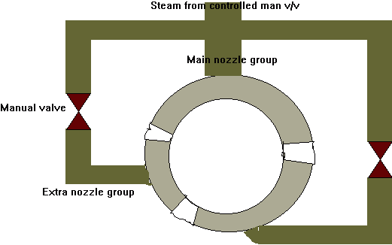
For commercial ships the above system is quite satisfactory, it can be seen that there is no control over the main group and hence losses will occur at lower loads. However, for ships which spend the bulk of their time at high loads between ports this is no a problem. Throttle losses are still incurred at loads between the opening and closing of nozzle groups but is reduced by shutting off the nozzles - opening the man v/v fully and controlling load on the boiler pressure.

Selective Nozzle control
This system works by sequentially opening and closing man v/vs to allow steam to pass to the turbine. The spiral groove cut in the wheels does not simply open on valve then the next. Rather by using the different nozzle numbers contained in the group, it can give variations in the number of nozzles in use by opening and closing groups as the wheel rotates in the same direction. This system would not have the controlled man v/v of the system above.
This system, due to inherent unreliability's, does not lend itself to bridge control.
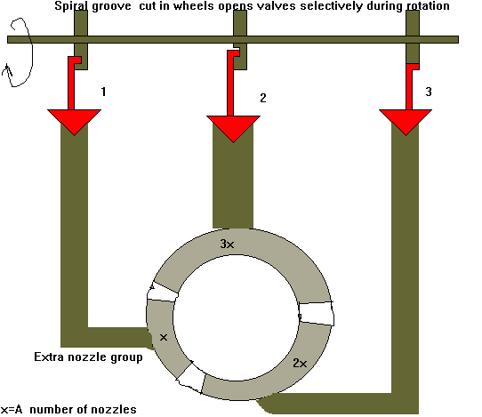
  - All shut
  - 1 open
  - 2 open
  - 3 open
  - 1 + 3 open
  - 2 + 3 open
  - 1 + 2 + 3 open

Sequential control - Bar lift type
This system has found much use on Turbo-alternator generator sets and is similar to Selective Nozzle control, but has much increased reliability.
It consists of a series of nozzle groups which are brought into line by the opening of their respective valve. The valves are operated by the lifting of a beam or bar, which is connected via a servo to the governor. Sequential control is gained by the adjusting of the height the bar must lift before contacting with the valve spindle nut; each valve, by adjustment of its spindle nut will start to open at varying bar lift.
Steam flow to the nozzles is at a maximum with little throttling effect.
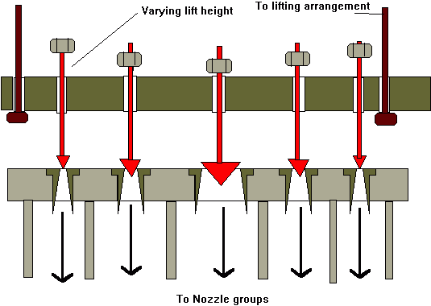
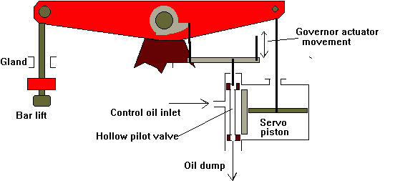
Some oil is allowed to leak past the servo and pilot valve, this improves the action and gives a cooling effect to these parts which are by necessity located close to the hot parts of the turbine.
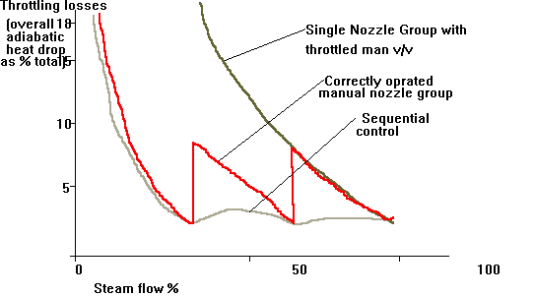

All round and partial admission
This refers to the steam flow around the circumference exiting the nozzles and entering the first stage of the turbine.
All round admission- This normally refers to Parsons reaction turbines with no impulse stages.
Steam is led to an inlet belt containing a complete 360º covering of fixed blades. Power variation is by closing of the manoeuvring valves.
Partial admission- Normally found on impulse turbines or reaction turbines having a curtis wheel first stage.
Due to the low specific volume of the steam at inlet conditions the requisite size of nozzles for full admission would be impracticably small.,p> Hence, the steam enters in sections, those area on the circumference not covered by nozzles are hooded to reduce windage and overheating.
For manoeuvring it is recommended that all the nozzle groups are opened. This reduces the blade loading otherwise all the steam passing through the man v/v would be acting on a small number of blades. Maximum efficiency is achieved with the man v/v full open and hence sets of nozzles are shut off at full away.
However some manufactures recommend that all of the nozzles are opened up to reduce the blade passing vibration caused by the flexing of the blades as they pass the steam jet.

Overload
For overload conditions in excess of normal a bypass v/v may be fitted which admits steam a number of stages down from the HP inlet.By introducing the low specific volume steam further down where the nozzle area are greater allows more steam flow. In this condition the main stop is closed and the first few stages idle.
Modern practice however is to leave the man v/v open so a small amount of power is produced over the first stages.

