Steam Surface Condenser

Water cooled condenser used in once through cooling system and in wet cooling system. The steam condenser is a major component of the steam cycle in steam power and combined cycle power plants. It is a necessary component of the steam cycle for two reasons:
- It converts the used steam back into feedwater for return to the boiler.
- It increases the cycle’s efficiency by allowing the cycle to operate with the largest possible Temperature and pressure difference between the boiler and the condenser.

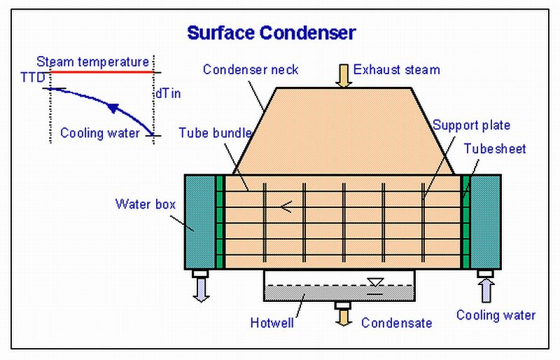

Design principle: There are different condenser designs which are defined by suppliers. Condenser tubes are arranged as tube bundles in condenser shell with a single-pass or two-pass. The bundle shape and air cooler location are optimized by the supplier.

The design of single-pass condenser provides cooling water flow through straight tubes from the inlet waterbox on one end, to outlet waterbox on the other end. The design of two-pass condenser provides cooling water flow through straight tubes from the inlet waterbox, reversed in the return waterbox to the outlet waterbox on the same end of Inlet waterbox.
In the condenser several thousand tubes are placed at low tube pitch in order to get acceptable dimensions. It is not favourable to increase friction losses in the steam flow; therefore the number of tube rows along the steam flow is limited. The separation between the water box areas and the steam condensing area is accomplished by two tube-sheet to which the cooling water tubes are attached. The cooling water tubes are supported within the condenser by the tube support plates.

The condenser tubes are made of brass or stainless steel to resist corrosion from either side. Nevertheless they may become internally fouled during operation by bacteria or algae in the cooling water or by mineral scaling, all of which inhibit heat transfer and reduce thermodynamic efficiency. Many plants include an automatic cleaning system that circulates sponge rubber balls through the tubes to scrub them clean without the need to take the system off-line.

The exhaust steam condenses on the outside of condenser tubes. The saturated liquid can continues to transfer heat to the cooling water. A few degrees of sub-cooling prevents the condensate pump cavitation. The condensate sub-cooling or depression decreases the operation efficiency of plant because the subcooled condensate must be reheated. The condensate sub-cooling can be avoided by using a suitable bundle design. The condensate is collected in the hotwell which is arranged in the bottom area of the condenser where the condensate pump takes its suction.

Condensation heat Load:
Q = Mcw x (hwout -hwin) = Mexh x (hsteam -hcond) [kW]
Condensing area: A = Q/(k x dTlog) [m2]
Log. temperature difference: dTlog = (dTin -TTD)/(dTin/TTD)
dTin=(Tsteam-Twin)
Overall heat transfer coefficient k-value: the value of "k" depends on the heat transfer rate inside the tubes and condensation heat transfer rate outside, which is known worldwide in several norms.

The condenser is maintained at a vacuum using either vacuum pumps or air ejectors. Cooling of the steam is provided by Condenser Cooling Water pumped through the condenser by Circulating Water Pumps, which take a suction from water supplied from the ocean, sea, lake, river, or Cooling Tower (shown in cooling systems). The temperature and flow rate of the cooling water through the condenser controls the saturation pressure (vacuum) and the temperature of the condensate.
To prevent the condensate level from rising to the lower tubes of the condenser, a hotwell level control system is employed.
The performance of the condenser is dependent on the efficiency of its air cooler section. The condenser should be equipped with a highly effective air cooler section. The non-condensable gases should be collected and removed by venting system.

