Indication of tank operating pressures in ballast and loaded passages
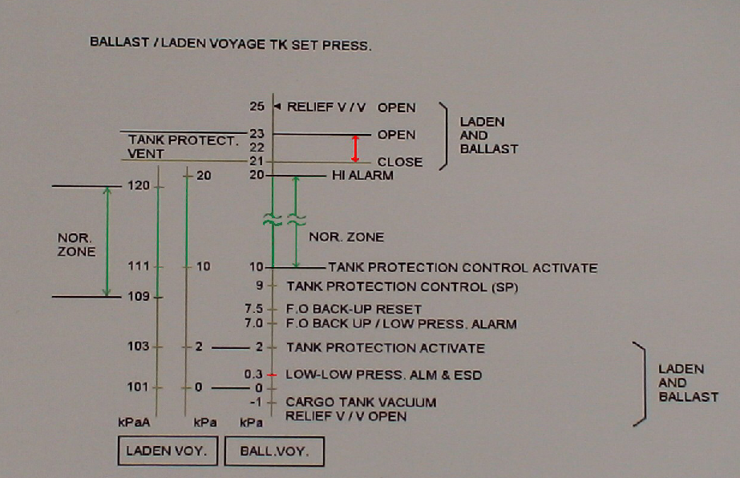

Cargo Tank Relief Valves
Each tank should be equipped with two diaphragm relief valves of the pilot operated type. Each relief valve should be provided with a means of manual operation. In the case of spherical cargo tanks, if the chosen means of emergency cargo discharge is by pressurisation of the tanks, then the relief valves shall be provided with a means to allow re-setting in situ. Suitable means should be provided for installing spade blanks on the inlet side of relief valves in an emergency. These should be provided with a highly visible means of indication when installed.

References:

- RINA GUIDE FOR THE DESIGN AND OPERATION OF LIQUIFIED NATURAL GAS (LNG) CARRIERS
- SS Raahi, NYK Shipping.

