High-duty Compressor

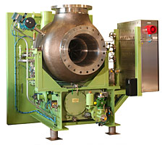
The High-duty Compressor consists of a single stage compressor with a heavy-duty wheel in forged aluminium alloy with adjustable inlet guide vanes, mounted to a heavy-duty speed-increasing gearbox.
Together with the complete lube oil and seal gas system the compressor is installed on a rigid single skid for shipboard application, with bulkhead and bulkhead seal mounted to the gearbox.
An intrinsically safe local control panel with gauge board is installed on the skid, and a remote control cabinet is supplied loose for installation in the safe area.
The compressor is driven by a single speed electric motor, which is typically yard-scope.

Low-duty Compressor

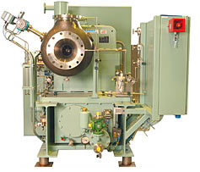
The Low-duty Compressor consists of a single stage compressor with a heavy-duty wheel in forged aluminium alloy with adjustable inlet guide vanes, mounted to a heavy-duty speed-increasing gearbox.
Together with the complete lube oil and seal gas system the compressor is installed on a rigid single skid for shipboard application, with bulkhead and bulkhead seal mounted to the gearbox.
An intrinsically safe local control panel with gauge board is installed on the skid, and a remote control cabinet is supplied loose for installation in the safe area.
To cover the wide temperature range of natural boil-off gas (-140 °C) and forced gas (-40 °C), the low-duty compressor is normally driven by a variable speed motor, which is typically yard scope.

Low-duty Compressor - "EcoBOT" Execution

The Low-duty Compressor consists of a single stage compressor with a heavy-duty wheel in forged aluminium alloy with adjustable inlet guide vanes, mounted to a heavy-duty speed-increasing gearbox.
Together with the complete lube oil and seal gas system the compressor is installed on a rigid single skid for shipboard application, with bulkhead and bulkhead seal mounted to the gearbox.
An intrinsically safe local control panel with gauge board is installed on the skid, and a remote control cabinet is supplied loose for installation in the safe area.
This special execution of the low-duty compressor is driven by a single speed motor, which is typically yard scope.

Low Duty Compressor - 2 stage Execution for Diesel-electric propulsion (LP dual-fuel engine)

The Low-duty Compressor consists of two compressor stages, each with heavy-duty wheels in forged aluminium and variable diffuser vanes, mounted to a common heavy-duty speed-increasing gearbox.
Together with the complete lube oil and seal gas system the compressor is installed on a rigid single skid for shipboard application, with bulkhead and bulkhead seal mounted to the gearbox.
An intrinsically safe local control panel with gauge board is installed on the skid, and a remote control cabinet is supplied loose for installation in the safe area.
The 2-stage low-duty compressor is driven by a single or variable speed motor, which is typically yard scope.

DATA SHEET (pdf file) - 230kb

