Boil-off Compressor/Warm-up Heaters

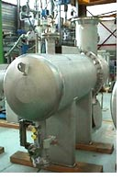
Two equally-sized gas heaters are installed. One unit is used for heating of the boil-off gas, both units in parallel are used for the warm-up duty.
To avoid thermal stress, the proven Shell and U-tube design is applied, directly heated by saturated steam. The equipment consists of a single-pass shell with stationary head, fully welded to the U-tube bundle, and is entirely fabricated from stainless steel (304L, or 316L as an option).

Warm-up Heaters (or: High-duty Heaters)

One large High-duty or Warm-up Heater is installed.
To avoid thermal stress, the proven Shell and U-tube design is applied, directly heated by saturated steam. The equipment consists of a single-pass shell with stationary head, fully welded to the U-tube bundle, and is entirely fabricated from stainless steel (304L, or 316L as an option). Cryostar's heaters are certified by all major classification societies.

Boil-off Compressor/Heaters (or: Low-duty Heaters)

One small Low-duty or Boil-off Heater is installed.
To avoid thermal stress, the proven Shell and U-tube design is applied, directly heated by saturated steam. The equipment consists of a single-pass shell with stationary head, fully welded to the U-tube bundle, and is entirely fabricated from stainless steel (304L, or 316L as an option). Cryostar's heaters are certified by all major classification societies.

Boil-off Compressor/Heaters (or: Low-duty Heaters)

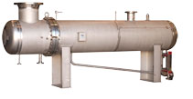
One large LNG vaporiser is installed.
To avoid thermal stress, the proven Shell and U-tube design is applied, directly heated by saturated steam. The equipment consists of a single-pass shell with stationary head, fully welded to the U-tube bundle, and is entirely fabricated from stainless steel (304L, or 316L as an option). Cryostar's vaporisers are certified by all major classification societies.
For a reliable temperature control, a Spray Pipe with integrated Spray Nozzle supplements the vaporiser for efficient mixing of bypassed LNG with the overheated gas.

Forcing Vaporiser

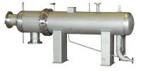
The Forcing Vaporiser is typically installed upstream of the L/D Compressors with a Mist Separator at the mixing point with the natural boil-off.
To avoid thermal stress, the proven Shell and U-tube design is applied, directly heated by saturated steam. The equipment consists of a single-pass shell with stationary head, fully welded to the U-tube bundle, and is entirely fabricated from stainless steel (304L, or 316L as an option). Cryostar's vaporisers are certified by all major classification societies.
For a reliable temperature control, a Spray Pipe with integrated Spray Nozzle supplements the vaporiser for efficient mixing of bypassed LNG with the overheated gas.

Mist Separator

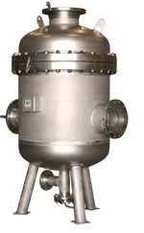
If forced gas is added to the natural boil-off gas from the tank, two gases with different gas compositions, and temperatures are mixed. In a large mixing range, mist is created at the mixing point, from two essentially dry gases.
The vertical separator vessel, with two inlet nozzles (from the gas header and Forcing Vaporiser) and one outlet nozzle (to the L/D Compressors), eliminates more than 99.5% of any mist. A drain connection and a level switch are included.
The Mist Separator is entirely fabricated from stainless steel (304L, or 316L as an option)

