Combustion Air Pre-Heater

Introduction
Heating combustion air can raise boiler efficiency about 1% for every 40F in temperature increase. The most common way to preheat the air is with a heat exchanger on the flue exhaust. The heat exchanger can be either air-to-air or air-to-liquid-to-air.
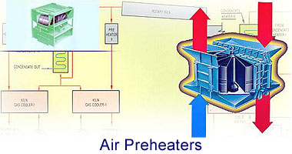
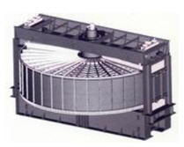
Combustion air pre-heater technology on large coal-fired boilers dates back to the early 1900's, and is used on most all large boilers today. With the increasing price of fuel and technology improvements, the size of a boiler that can be economically equipped with a pre-heater should become smaller. Although still a technology most applicable to large boilers, high energy prices will certainly motivate innovative new applications for economical combustion air pre-heaters on ever smaller boilers.

Types of air heaters

Lungstrom gas/air heater (regenerative)

Operation
From the Alstrom Air Preheater Company web site:
The basic component of the Ljungström® air preheater is a continuously rotating cylinder, called the rotor, which is packed with thousands of square feet of specially formed sheets of heat transfer surface which are commonly called elements.
The preheater structure consists of hot and cold end center sections, connected by two main pedestals on either end. The rotor is commonly supported on the cold end center section by a support bearing and maintained upright by a guide bearing located in the hot end center section. Sector sealing plates and axial seal plates are attached the center sections and main pedestals respectively to form separate gas and air passages through the heat exchanger.
The rotor is enclosed by housing panels connected to the main pedestals to form the preheater casing, with the drive unit, cleaning device mechanism, and sealing surface adjusters all located externally to be readily accessible while the unit is in operation. Upper and lower connecting plates are attached to the preheater casing to form a transition from the preheater rotor and casing shape to the clients ductwork connections.
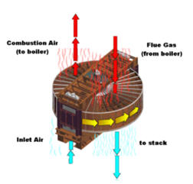
As the rotor revolves, waste heat is absorbed from the hot exhaust gas passing through one-half of the structure. This accumulated heat is released to the incoming air as the same surfaces pass through the other half of the structure. The heat transfer cycle is continuous as the surfaces are alternately exposed to the outgoing gas and incoming air streams.
The advanced sealing system of the Ljungström® air preheater is a result of an evolution of devices and methods to develop a sealing system that is capable of successfully controlling and minimizing air-to-gas leakage. The design takes advantage of normal thermal growths to achieve effective sealing with a minimum of maintenance requirements. The integrated sealing system comprises of proximity seals and stationary sealing surfaces arranged to inhibit leakage from the air side of the air preheater to the gas side.

Problems
The boiler flue gas contains lot of dust particles (due to high ash content) not contributing towards combustion, such as silica, which cause abrasive wear of the baskets, and may also contain corrosive gases depending on the composition of the coal.
In this RAPH the dust laden, corrosive boiler gases have to pass between the elements of air preheater baskets. The elements are made up of zig zag corrugated plates pressed into a steel basket giving sufficient annular space in between for the gas to pass through. These plates are corrugated to give more surface area for the heat to be absorbed and also to give it the rigidity for stacking them into the baskets. Hence frequent replacements are called for and new baskets are always kept ready. In the early days, Cor-ten® steel was being used for the elements. Today due to technological advance many manufacturers may use their own patents. Some manufacturers supply different materials for the use of the elements to lengthen the life of the baskets.
In certain cases the unburnt deposits may occur on the air preheater elements causing it to catch fire during normal operations of the boiler, giving rise to explosions inside the air preheater. Sometimes mild explosions may be detected in the control room by variations in the inlet and outlet temperatures of the combustion air.

Tubular type

Construction features
Tubular preheaters consist of straight tube bundles which pass through the outlet ducting of the boiler and open at each end outside of the ducting. Inside the ducting, the hot furnace gases pass around the preheater tubes, transferring heat from the exhaust gas to the air inside the preheater. Ambient air is forced by a fan through ducting at one end of the preheater tubes and at other end the heated air from inside of the tubes emerges into another set of ducting, which carries it to the boiler furnace for combustion.
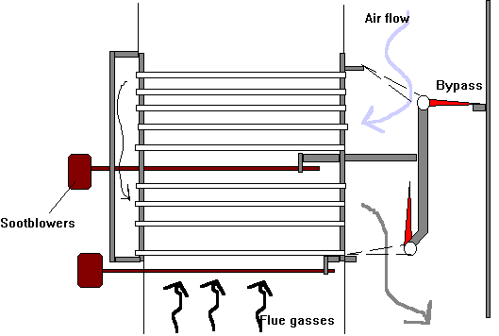

Problems
The ductings for cold and hot air all require additional space and structural supports compared with the Ljungstrom design. This construction is also such that hot air for carrying powdered coal has to be a separate arrangement, unlike in rotating types. Further, due to dust-laden abrasive flue gases, the tubes outside the ducting wear out faster on the side facing the gas current. This calls for frequent replacement of tubes by cutting and welding, a time consuming process.

Bled steam air heater
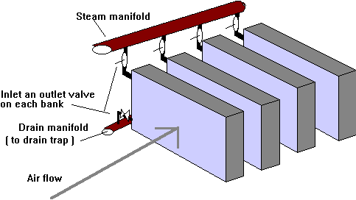
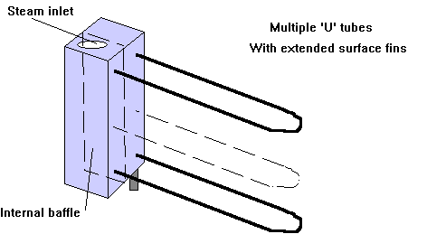
The use of individual banks and 'U' tubes allow for ease of isolation when these become perforated without large loss of heating surface. The tubes were expanded into the headers and made of cupronickel with copper fins.

