FURNACES
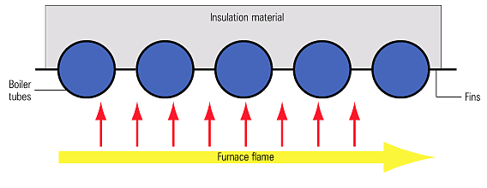
Heat transfer in the furnace or radiant section
The furnace or radiant section
This is an open area accommodating the flame(s) from the burner(s). If the flames were allowed to come into contact with the boiler tubes, serious erosion and finally tube failure would occur.
The walls of the furnace section are lined with finned tubes called membrane panels, which are designed to absorb the radiant heat from the flame. Convection section
This part is designed to absorb the heat from the hot gases by conduction and convection.
Large boilers may have several tube banks (also called pendants) in series, in order to gain maximum energy from the hot gases.
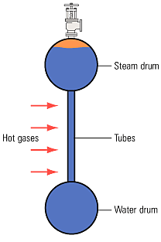
Heat transfer in the convection section

