Economizer

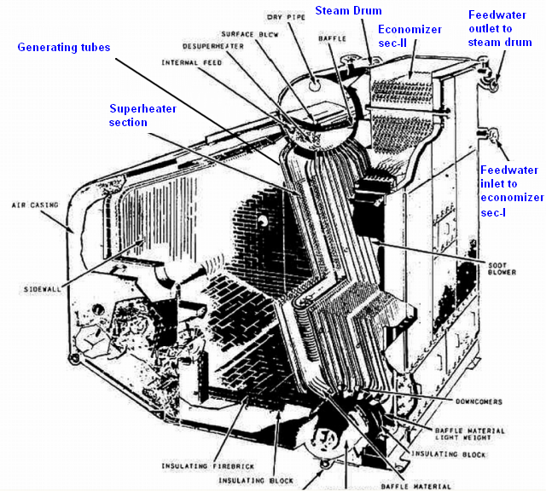

Economizers serve as traps for removing heat from flue gases at moderately low temperature, after they have left the steam generating and superheating sections of the boiler.

The general classification is:

- Horizontal or vertical tube, according to the direction of gas flow with respect to the tubes in the bank.
- Parallel-flow or counter-flow, with regard to the relative direction of gas and water flow.
- Plain-tube or extended surface types, according to the details of the design and the form of the heating surface.

The tube bank may be further designated as of the staggered or in-line arrangement, with regard to the pattern and spacing of tubes, which affect the path of the gas flow through the bank, its draft loss, heat transfer characteristics and ease of cleaning.

Theoretically, economizer heating surface could be added to a boiler until the exit temperature neared the outside temperature. This would however lead to an abnormally excessive heating surface area for the economizer. Further, each fuel burned has a dew point temperature which can cause moisture accumulation on the economizer and corrode the surface within a short time. The amount of heating surface which should be used in the economizer is limited by the final gas temperature at the exit. If the gas temperature is cooled below the dew point, condensation may result. Sulphur in the soot then unites with moisture to produce sulphurous acid, which is extremely corrosive to all steel construction contacted between the economizer and the stack.

Feed water of low oxygen content is recommended in using the steel-tube type economizers. Safety valves are required on economizers to protect them against excessive pressure that might be built up by the feed pump if the regulator or feed valve to the boiler were closed.

