Combustion Control for Liquid and Gaseous Fuel Boilers
The basic difference in the approach to combustion control for liquid or gaseous fuel boilers from that for solid fuel boilers is that the the fuel can easily be measured. This basic difference applies, however, only for systems that incorporate fuel flow/air flow ratio or difference as part of the control strategy. Simple systems such as the single-point positioning (jackshaft) or parallel positioning systems can be applied to all types of boilers in a similar fashion.
As discussed in Section 8, the combustion control loops for all boilers respond to the Btu demand signals generated in the master control loop. The Btu demand signal is assumed to be linear with respect to Btu flow. A fully modulating control is used for almost all industrial boiler applications.

21-1 Single-Point Positioning Control
As shown in Figure 21-1, a single-point positioning or "jackshaft" system is a mechanical one. The position of the fuel control valve and the combustion air flow damper are connected together in a fixed relationship and move in unison to the demands of the master regulator.
A basic requirement of this type of system is the careful mechanical alignment of the fuel valve and the air damper positions. Fuel valves and air dampers tend to have different flow characteristics. Typical characteristics are shown in Figure 21-2. If the master regulator were to move each to the 50% position, then air flow for approximately 75% capacity would be provided while fuel for 25% capacity was being supplied. By making the flow characteristics linear, they can then be aligned.
In the case of the air damper, the alignment tool is the use of linkage angularity as discussed in Section 14. In the case of the fuel flow, the control valve is usually supplied with a cam arrangement for changing the perceived flow characteristic. The procedure is to linearize the air flow characteristic and then to match the fuel flow characteristic to that of the air flow. To perform this alignment procedure properly, it is necessary to perform combustion tests at several different boiler loads.
On the surface it appears that such a proper alignment would complete the requirements and that no further improvement is necessary. One weakness of this system, from a fuel/air ratio standpoint, is that the position of the fuel valve is not always a true measure of fuel Btu flow. Another weakness is that the fan damper or inlet vane position is not always a true measurement of the flow of oxygen for combustion.
A variation in either the flow of oxygen or fuel changes the combustion conditions and the ratio of excess air for combustion. With the parallel arrangement discussed and using gaseous fuel as an example, this can happen in several ways:

(1) Change in the fuel unit (scfh) Btu value. The fuel flow in scfih may be constant but total Btu flow changes.
(2) Change in fuel temperature. The fuel density changes and the fuel flow volume (scfh) changes. Total Btu flow changes even though unit Btu value remains constant.
(3) Increase or decrease in fuel specific gravity. The fuel density changes, and simultaneously the unit Btu value changes. These combine to change total Btu flow.
(4) Increase or decrease in fuel pressure. This causes density to change, thus changing
Figure 21-1 Single-Point Positioning Control System
fuel flow volume (scfh). It also changes scth fuel volume through the changed pressure drop across the control valve. These combine to change total Btu flow.
(5) Increase or decrease in combustion air temperature. This changes the air density and delivers a changed amount of oxygen to the combustion process. Change in the density also affects fan delivery pressure and the total flow of combustion air.
(6) Change in the humidity of the combustion air. This changes the percentage of dry air in the total air, thus changing the flow of oxygen to the combustion process. The density of the air flow is also changed, affecting the fan delivery pressure and differential across the flow damper, thus affecting air flow.
(7) Changes in atmospheric pressure. This changes the fan total air flow delivery and pressure, thus affecting oxygen flow to the combustion process.
Since the fuel control valve and the combustion air damper are mechanically linked and the system does not include measurement of any of the above variables, the base system as shown cannot compensate for these variations. If we wish to compensate for these variations in fuel/air ratio, it is necessary to modify either the fuel pressure, the fuel control valve position, the combustion air control damper position, or the fan speed.
With the basic systems above, the fuel/air ratio may vary over a control error band of up to approximately 40% excess air. If the control system is adjusted for too low an excess air level, the control error band may at some time cause the boiler to operate with insufficient excess combustion air to burn all the fuel. Under such circumstances fuel may be wasted at 5 to 6 times that which would occur if the excess combustion air were too great by the same amount. With such systems it is, therefore, good practice to calibrate the system with sufficient excess air to accommodate the control error band.
Although the single-point positioning system is mechanically linked, a flue gas analysis trimming control loop can be applied to control the fuel/air ratio and reduce the control error
a, b - Basic flow characteristics of controlled devices c, d - Characteristics after linearization and alignment Figure 21-2 Flow Characteristics of Valves and Dampers
band. Figure 21-3 shows some typical arrangements for applying the trimming control. Other methods include changing the length of the link to the combustion air flow damper, changing the length of the drive arm connected to the link, or both.
In all of these arrangements the control signal from the trimming control originates in the control loops covered in Section 17. If there is a significant error in the basic system, the trimming control requires time to make the adjustment. If the basic system error is different at one load than it is at another load, time is required to readjust as the load is changed. This is usually not a problem unless the boiler load changes rapidly. In such cases the trimming control may have difficulty keeping up with the changes in excess air. This problem is demonstrated in Figure 21-4.
As shown in this plot, at 50% load, the trimming correction due to error in the basic system is 25% and is 12.5% at 25% boiler load. The controller output, therefore, must change by 12.5% as the boiler load is changed. This type of control is relatively slow due to the time delays described in Section 17. Sonic microprocessor-based "trim" control arrangements use memory of last time at this load vs. trim signal relationships to help move quickly to a new output signal as the load is changed. The plot also demonstrates that poor alignment of the basic system may create the need for an excessive amount of correction from the flue gas analysis trim control. In such cases trim control limits may prevent the amount of correction that is needed.
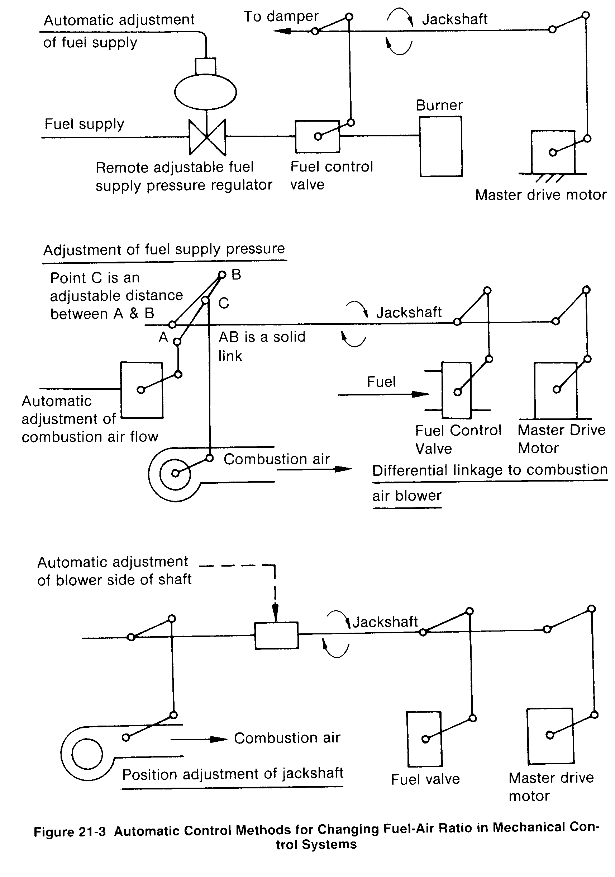

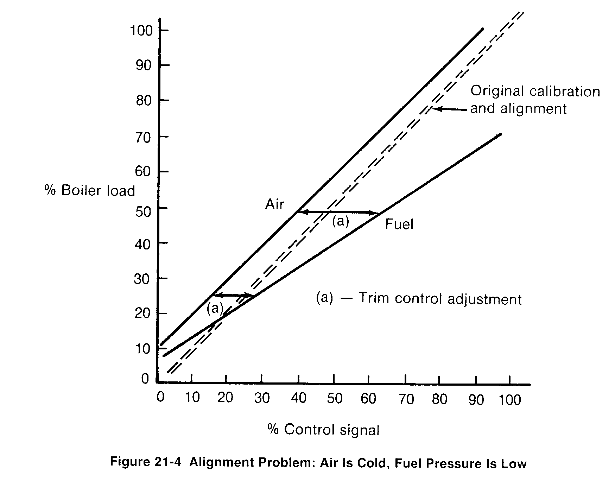
21-2 Parallel Positioning Control
The functions shown in the mechanical single-point positioning arrangement are also performed using instrumentation control. Such systems, called parallel positioning control systems, link the functions pneumatically or electrically. A SAMA control logic diagram of a parallel positioning system comparable to the single-point positioning system of Figure 2l-I is shown in Figure 21-5.
Such control systems must be aligned in the same manner as the single-point system. In this case, a cam in the positioner of the fuel control valve is used to linearize fuel flow and align it with air flow. For air flow calibration, linkage angularity and/or the cam in the positioner of the damper operator may be used to linearize the air flow signal vs. flow.
A parallel positioning system has the same weaknesses and same control error band as the single-point system. Note that such a system may have a simple means of biasing the fuel/air ratio through use of the manual loading function, (a) in Figure 21-5. This adjustment means is useless without the use of a flue gas analyzer or some other form of combustion guide. In order that the system be aligned with the operator adjustment in the midpoint of its range, the firing rate demand input to summer (b) is set at a gain of 1.0. Assuming that the operator is provided a plus or minus 15 percent bias, the gain of the input from (a) is set at 0.3. With both inputs at 50%, and with no bias, the output of summer (b) would be 65%. The bias in summer (b) is then set at minus IS% so that the signal to the air damper control device will always match the firing rate demand signal.
The ease with which a boiler operator makes such a fuel/air ratio adjustment also makes it easier for the operator to cause system misalignment. One advantage of the parallel system

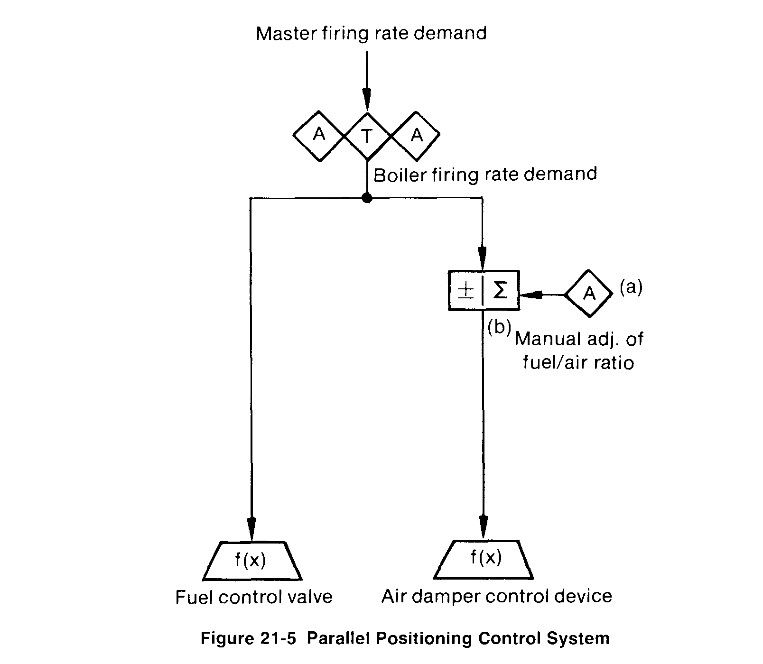
is that the timing of a fuel flow change or an air flow change can be modified by inserting a time constant into either of the two control signals to improve matching of actual fuel and air flow to the furnace. This makes possible improved dynamic operation.
Improvement of the control system in order to narrow the control error band is accomplished by the use of flue gas analysis trimming control. Since the basic system is an instrument control system, connection of the trimming control to the parallel positioning system is usually simpler than when connecting to a single-point positioning system. The arrangement of a parallel positioning system plus trim control is shown in Figure 21-6.
In the arrangement in Figure 21-6, the control signal (a) to fuel is used as the load signal in the flue gas analysis trimming control. The output of the trimming control (b) modifies the basic fuel control signal in the multiplier (c). The proportional plus positive bias (e) reduces the gain of the trimming control signal (b) and positions the output from (e).
Assuming that the trimming effect is to be an air flow multiplication of 0.85 to 1. 15, the gain setting of the proportional plus bias (e) would be 0.3 and the bias would be 0.85. This would provide a multiplication of 1.0 at the midpoint of the flue gas analysis trim control output. The output of the multiplier (c) is a modified basic signal that acts as the control signal for air flow. If the furnace is a balanced draft furnace, the connection to the furnace draft control loop is shown at (d). This connection is not necessary if the furnace draft is controlled with a simple feedback control loop.
In some cases a summer is substituted for the multiplier (c). This is theoretically incorrect since the effect of the flue gas analysis trim control would then be greater at lower boiler loads that at higher boiler loads.

21-3 Metering Control Systems
The weaknesses of the basic single-point positioning and parallel positioning systems can be overcome by including measurements of fuel and air flow in the control strategy. The evolution of several application methods for such metering systems has resulted in what is now generally recognized as a standard control arrangement. This control arrangement shown in the Figure 21-7 block diagram also includes active safety constraints. Such an arrangement is suitable for any liquid or gaseous fuel or fuel combination in which the unit Btu values do not vary by significant amounts (more than approximately 10 %). Several names, which all designate the same control logic, have been ascribed to this system. Such names are, "crosslimited," "lead-lag," "self-linearizing," and "flow-tieback"
In the type of system shown in the SAMA diagram of Figure 21-8, the firing rate demand signal (a) acts as a common set point for the fuel flow controller (b) and the air flow controller (c). Since the fuel flow measurement signal (d) and the relative air flow measurement signal (e) are linear, the base fuel/air ratio is established by the calibration of the air flow measuring device. As described earlier the relative air flow measurement is calibrated by combustion

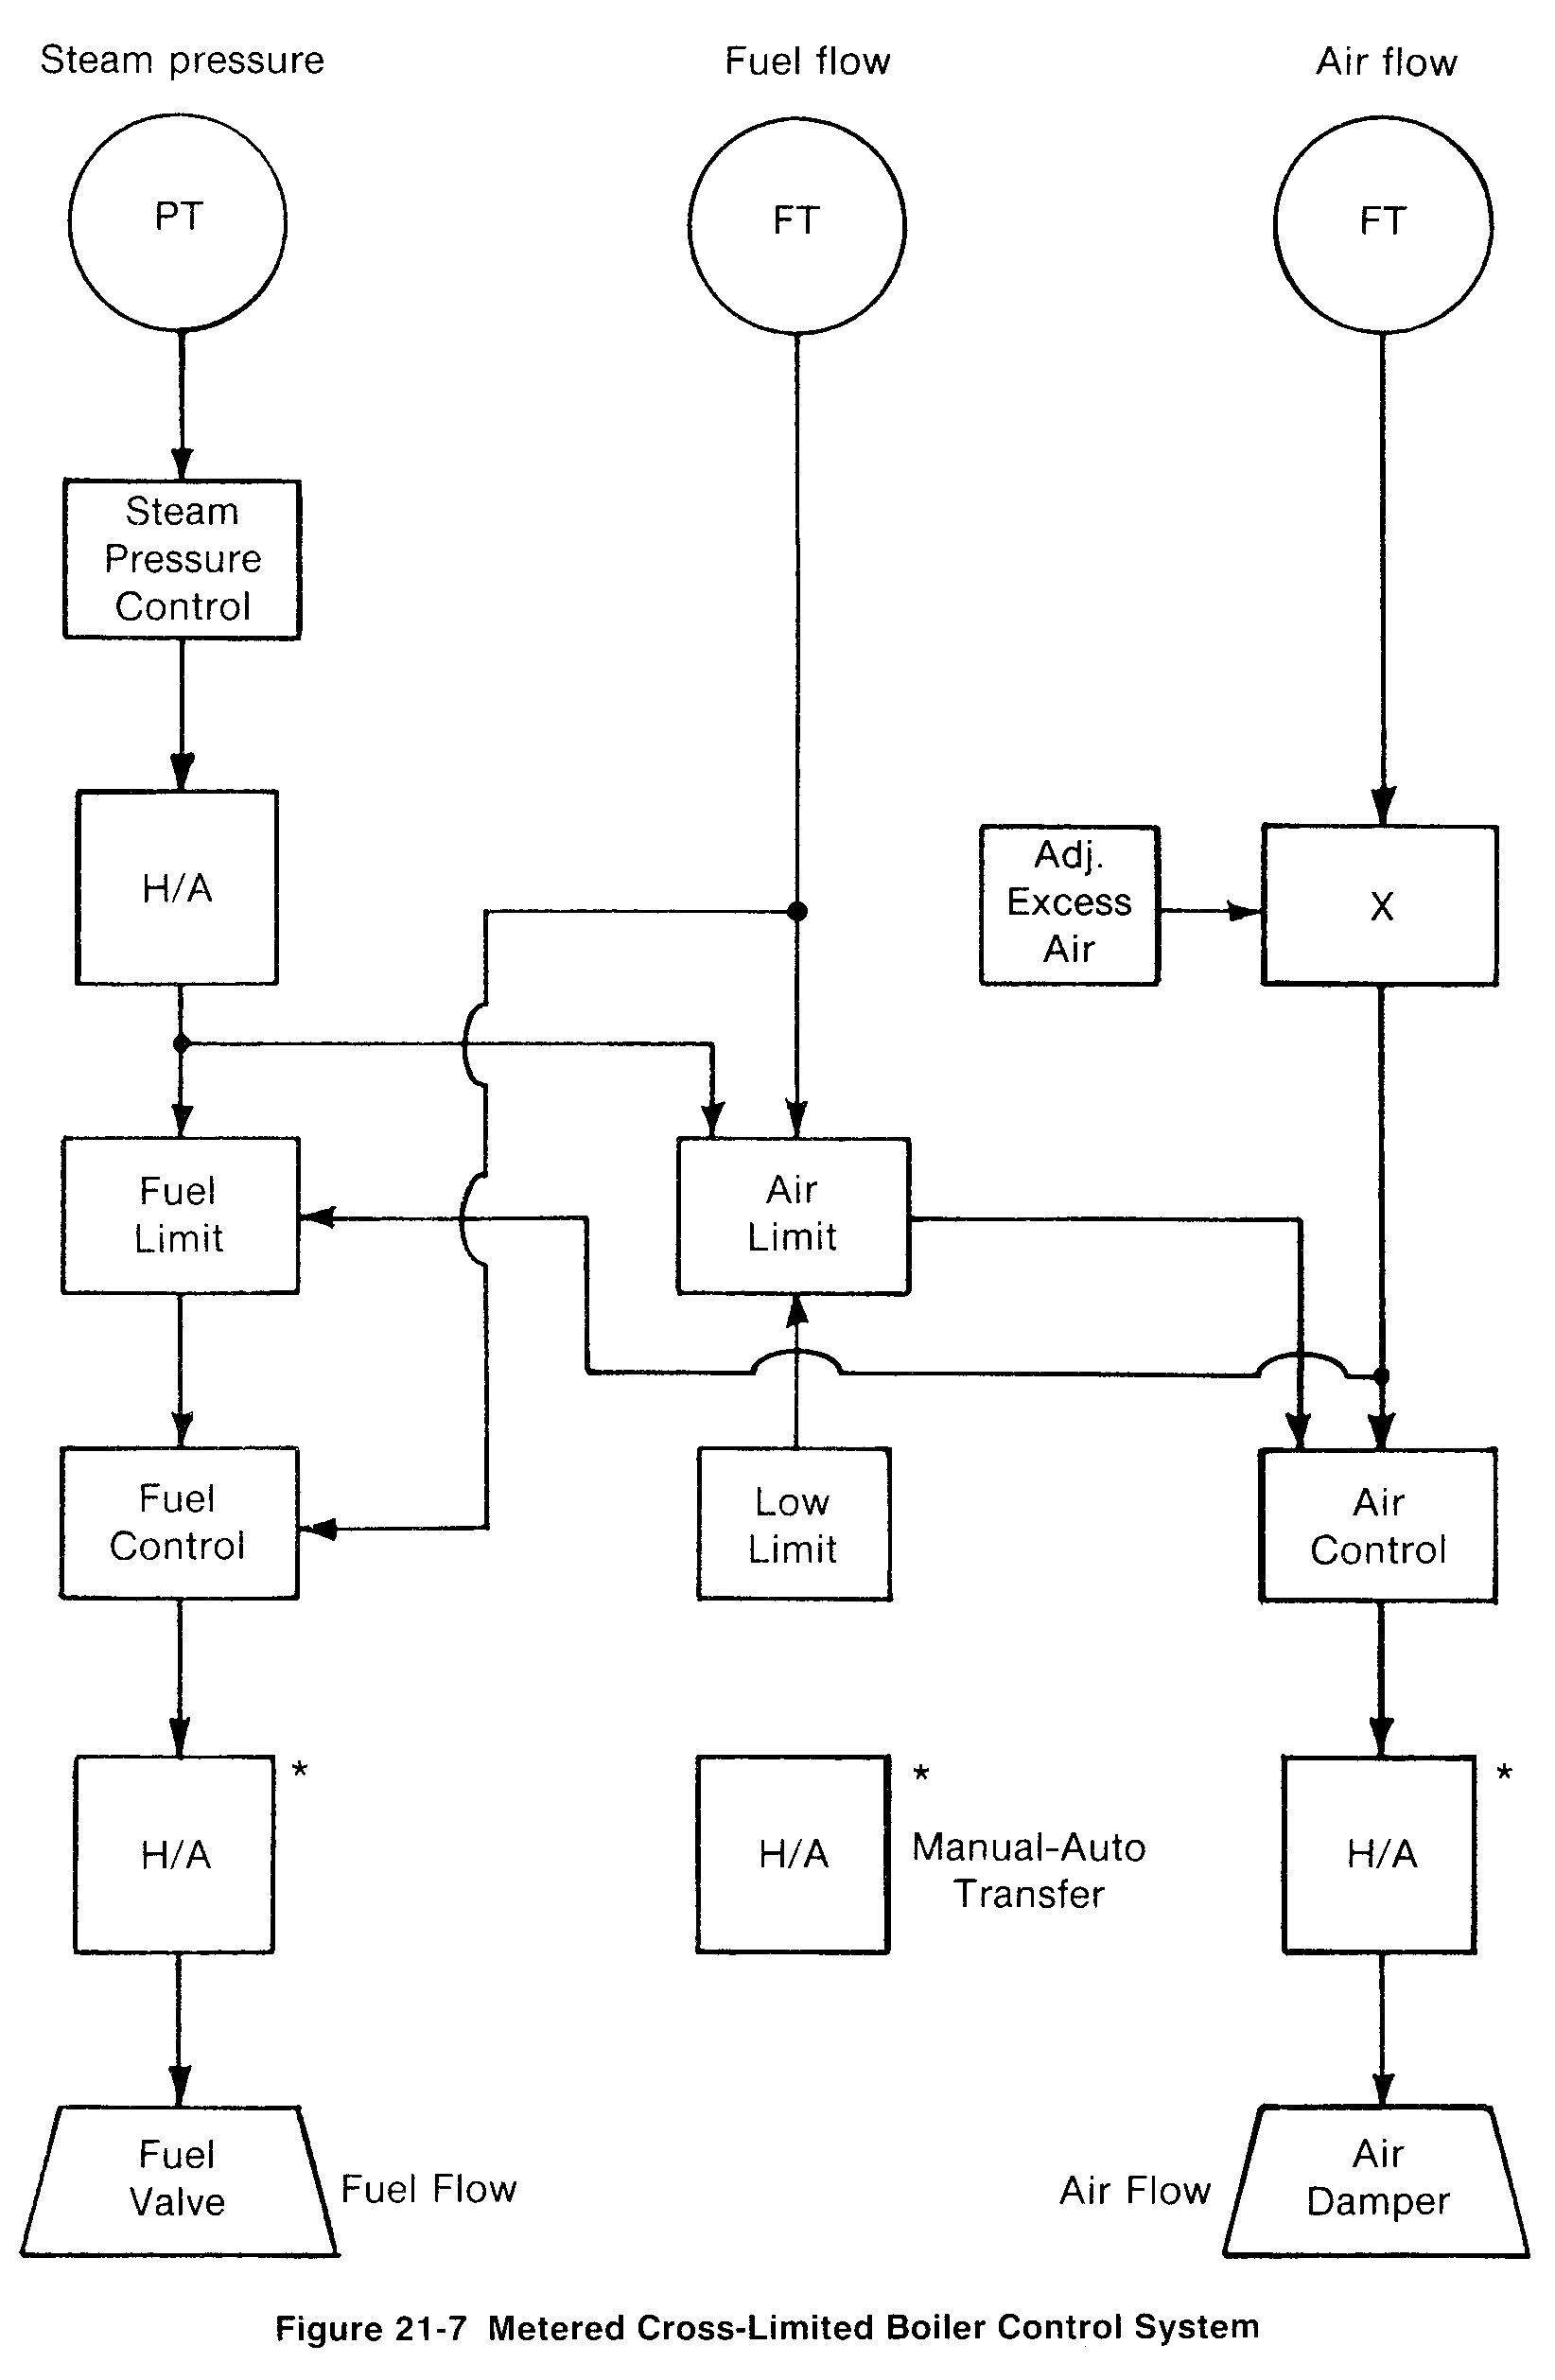
tests at various boiler loads. The result is that when the combustion conditions are correct, the percentage reading of both the fuel flow and the air flow measurements are equal. The manual signal (f) and the multiplier (g) provide a convenient means for the operator to alter the calibration of the air flow measurement and thus modify the fuel/air ratio.
To the basic parallel flow controller arrangement described above, high select, low select, bias, and gain functions are added as shown in Figure 21-9. These functions add active safety constraints to the system. The low select function (h) compares the firing rate demand signal (a) to the air flow measurement signal (e), and the lower of the two becomes the set point of the fuel controller (b). The result is that the fuel flow set point is limited to the level of the signal representing available combustion air flow. Similarly, the high select function (i) forces the air flow set point to the higher of the two signals that represent firing rate demand and fuel flow. The result is that actual fuel flow sets the minimum air flow demand.
The bias and gain functions (j) are added to provide a small 3 to 4% dead band between the application of the high and low select functions. This addition prevents the effect of process measurement "noise" from causing interaction between the fuel flow and the air flow control loops. The addition of the manual signal (k) connected to the high select (i) provides a minimum air flow control capability by preventing the air flow set point from being reduced below 25 % of full range. The 25 % minimum air flow setting is one part of the NFPA code.
This diagram also shows the application of a flue gas analysis trim control loop replacing the manual fuel/air ratio adjustment. By its control action, the air flow measurement signal (e)
is continuously calibrated so that the programmed flue gas analysis will be obtained. The firing rate demand signal (a) is used as the "boiler load" signal in the arrangement shown. The fuel flow signal (d) or a steam flow measurement signal could also have been used. The points marked A, B, and C are the points at which this control system arrangement can easily be modified for application to the use of other fuels or fuel combinations or for other air flow control arrangements as covered in Section 16.
The control system alignment consists of:

(1) calibration of the air flow function generator (n);
(2) setting the bias values of approximately ± 25 % and gains of 1.0 to items ( j); (3) setting the minimum air flow signal (k) at 25%; and
(4) setting the gain of proportional plus bias (o) to 0.3 and setting the bias to plus 85%.

After the alignment procedure, the next activity is to tune the flow controllers (b) and (c). This procedure is typical of the tuning of any flow control loop. The optimum gain setting will probably be in the 0.5 range and the optimum integral setting will probably be several rpm (repeats per minute). Dynamic load change testing may reveal a deviation in the desired

excess air during the load change. In this case, either the fuel flow or air flow control loops should be detuned until their dynamic response is the same.
The 25 % bias values of items (j ) avoid any effect from the limiting control during this tuning period. After the flow controller tuning operation, these settings are adjusted to their operational settings. This is accomplished by gradually reducing the bias values until inter- action with the flow controllers is indicated. This will normally show up best as the process noise band of flue gas analysis.
In some installations it may be necessary to alter the arrangement shown in Figure 21-9 because of excessive process flow measurement noise or the need for very rapid firing rate changes. By revising the control application to that shown in Figure 21-10, the primary control response is that of a feedforward system with a reduced-gain feedback trimming control from the flow control loops.
The additional items in the control logic are the summer and bias units (m) and (1). Both inputs to each of the summers are set at gains of 1 .0. This allows the detuning of the flow control loops to accommodate the process flow measurement noise without affecting the re- sponse of the system. Since the feedback portion of the control must provide only a small portion of any control output change, the flow controllers may be considerably detuned while still obtaining stable and responsive control.
One additional requirement has been added. In the system shown in Figure 21-9 it was not necessary to parallel the control signals to the fuel control valve and the air flow control device. In the system shown in Figure 21-10 the initial feedforward signal attempts to position these devices to obtain the desired fuel/air ratio. It is, therefore, necessary to calibrate these devices
for matching flow vs. control signal characteristics.
Tracking requirements are as follows:
(1) When the air flow is at the 25% minimum value, the percent oxygen controller should be in the tracking mode. A signal monitor on the air flow signal can initiate this.
(2) Whenever any one of the manual/auto stations shown is in the manual control mode, the input to the station should track the output. The implementation of this will vary depending on the control logic arrangement ahead of the station.
If a single fuel such as fuel oil is used instead of fuel gas, the modification consists of exchanging a linear fuel gas measurement (d) for a linear oil flow measurement and substitut- ing a fuel oil control valve for the fuel gas control valve. Figure 21-11 shows the functions connected to points A and B when using return-type fuel oil burners. In this case, the "supply" and "return" flow measurement transmitter must be very carefully calibrated so that the mea-

surement errors in the individual flows do not accumulate in the signal that represents oil flow to the furnace.
Other potential modifications at points A and B are those for combination fuel firm,". An example of this is the combination of fuel oil and natural gas or the combination of natural gas and a relatively stable process-generated gas such as coke oven gas. The modification for burning either fuel oil or natural gas is shown in Figure 2 1-12.
In this modification the two fuels are totalized in the summer (o) on a basis that combines the effect of difference in Btu flow ranges, differences in air required for combustion, and differences in excess air requirement for the individual fuels. The gain value applied to the individual fuel flow signals into the summer (o) are calculated as follows. Assume that there are two fuels, natural gas 4 1,000 Btu/scth and fuel oil @ 19.000 Btu/lb. The natural gas
flow range is 0 to 200,000 scth and the fuel oil flow range is 0 to 10,000 lb/hr. The primary fuel is used as the base input with a gain of 1.0.
Assuming that the primary fuel is natural gas, the 0 to 100% range of the total fuel flow signal is therefore 0 to 200 MBtu/hr. The oil flow range is 0 to 190 MBtu/hr. On a theoretical basis, fuel oil requires approximately 7.3 lbs of combustion air per 10,000 Btu, while natural gas requires approximately 7.2 lbs of air per 10,000 Btu. Assume that the base of total combustion air for the natural gas is 110% (10%o excess air) and 115% total air (15% excess air) for the fuel oil. The gain for the fuel oil flow input to the summer (o) can then be calculated by the following formula:

Gain = (190/200)*(7.3/7.2)*(115/I10)

The result is 1.0065. If there were 3 or more fuels, the primary fuel would be the base and the other two or more would be individually matched to the primary fuel.
The totalized fuel flow signal (p) then enters the control system in the same manner as the flow measurement of a single fuel. The interlock shown (n) prevents the fuel oil flow signal (q) from being used when fuel oil is being circulated prior to burner light-off.
This control arrangement should properly be used only when there is a capability for two fuels, but they are burned one at a time. Switchover from one fuel to the other can be accomplished properly on automatic control if only one fuel is on automatic. To use this arrangement with simultaneous automatic firing of both fuels causes the fuel flow control loop gain to double due to doubling the fuel capacity available to the total fuel control signal.
Simultaneous automatic firing of two or more fuels without altering the fuel control loop gain can be accomplished with the point A and B modifications shown in Figure 21-13. In this arrangement the fuel control signal is split so that the capacity available to this signal does not change. The manual signal (r) sets a ratio for one of the fuel control signals relative to the total fuel control signal. The delta block (s) subtracts this signal from 100% of' the signal value. The result is that the sum of the two fuel control signals is always equal to the fuel control signal from controller (b) of the system arrangement shown on Figure 21-9 or from summer (m) of the system arrangement shown on Figure 21-10.
An alternate control modification that will hold the fucl control loop gain constant while the boiler is simultaneously firing a combination of fuels is shown Figure 2 1-14. In this arrangement, the fuels are totalized on an "air required" basis, as in Figures 21-12 and 21-13. The control signals to the individual valves are added in the summer (t) and balanced against the basic fuel control si-nal in a controller (u), which produces the control signal to the control valves.
The fuel control valves will probably be of different capacities, the fuel stream ot'different fuels will have different Btu values, and the number of fuels being used at any one time must be accommodated. This is accomplished by adjusting the input gains of the individual valve control signals into the summer (t). These gains are the ratio of the individual valve capacities in Btu value to 100% of the desired total Btu range. The desired total Btu range is that required for achieving full boiler load plus necessary overfiring capability. For example, if the base fuel had 100% capability and two auxiliary fuels each had 50% capability, the gain for the base fuel would be 1.0 and for each of the others, 0.5.
When waste process-generated gases are available, it is usually desirable to burn these gases on a priority basis before using purchased fuels. Figure 21-15 is an example of one method of "as available" or "priority" fuel control, shown as a modification at points A and B of the basic control arrangement in Figure 21-9.
The pressure controller (v) is applied to the waste gas system. In operation with Sufficient waste gas available, the pressure of the waste gas is at or above the set point and the output of the pressure controller is 0. At this time the signal to the waste gas control valve subtracts from the signals to the fuel vas and fuel oil control valves, placing these signals at a minimum
value with only a pilot flame sustaining combustion of these fuels. With less waste fuel capability than that required for the boiler load, the pressure of the waste gas will fall below the set point of controller (v), causing its output to increase. This subtracts, causing the output of delta (w) to decrease and reduce the waste gas flow until the pressure controller (v) is satisfied.
The difference between the input from A and the output of delta (w), which is equal to the output of the controller (v), is then added to the fuel gas and fuel oil control signals. This satisfies the total firing rate demand with the waste gas as a priority fuel.
In the previous arrangements involving combination fuels, it is assumed that it is not necessary to ratio the flows of the fuels involved. If the ratioing of flow is needed for "least fuel

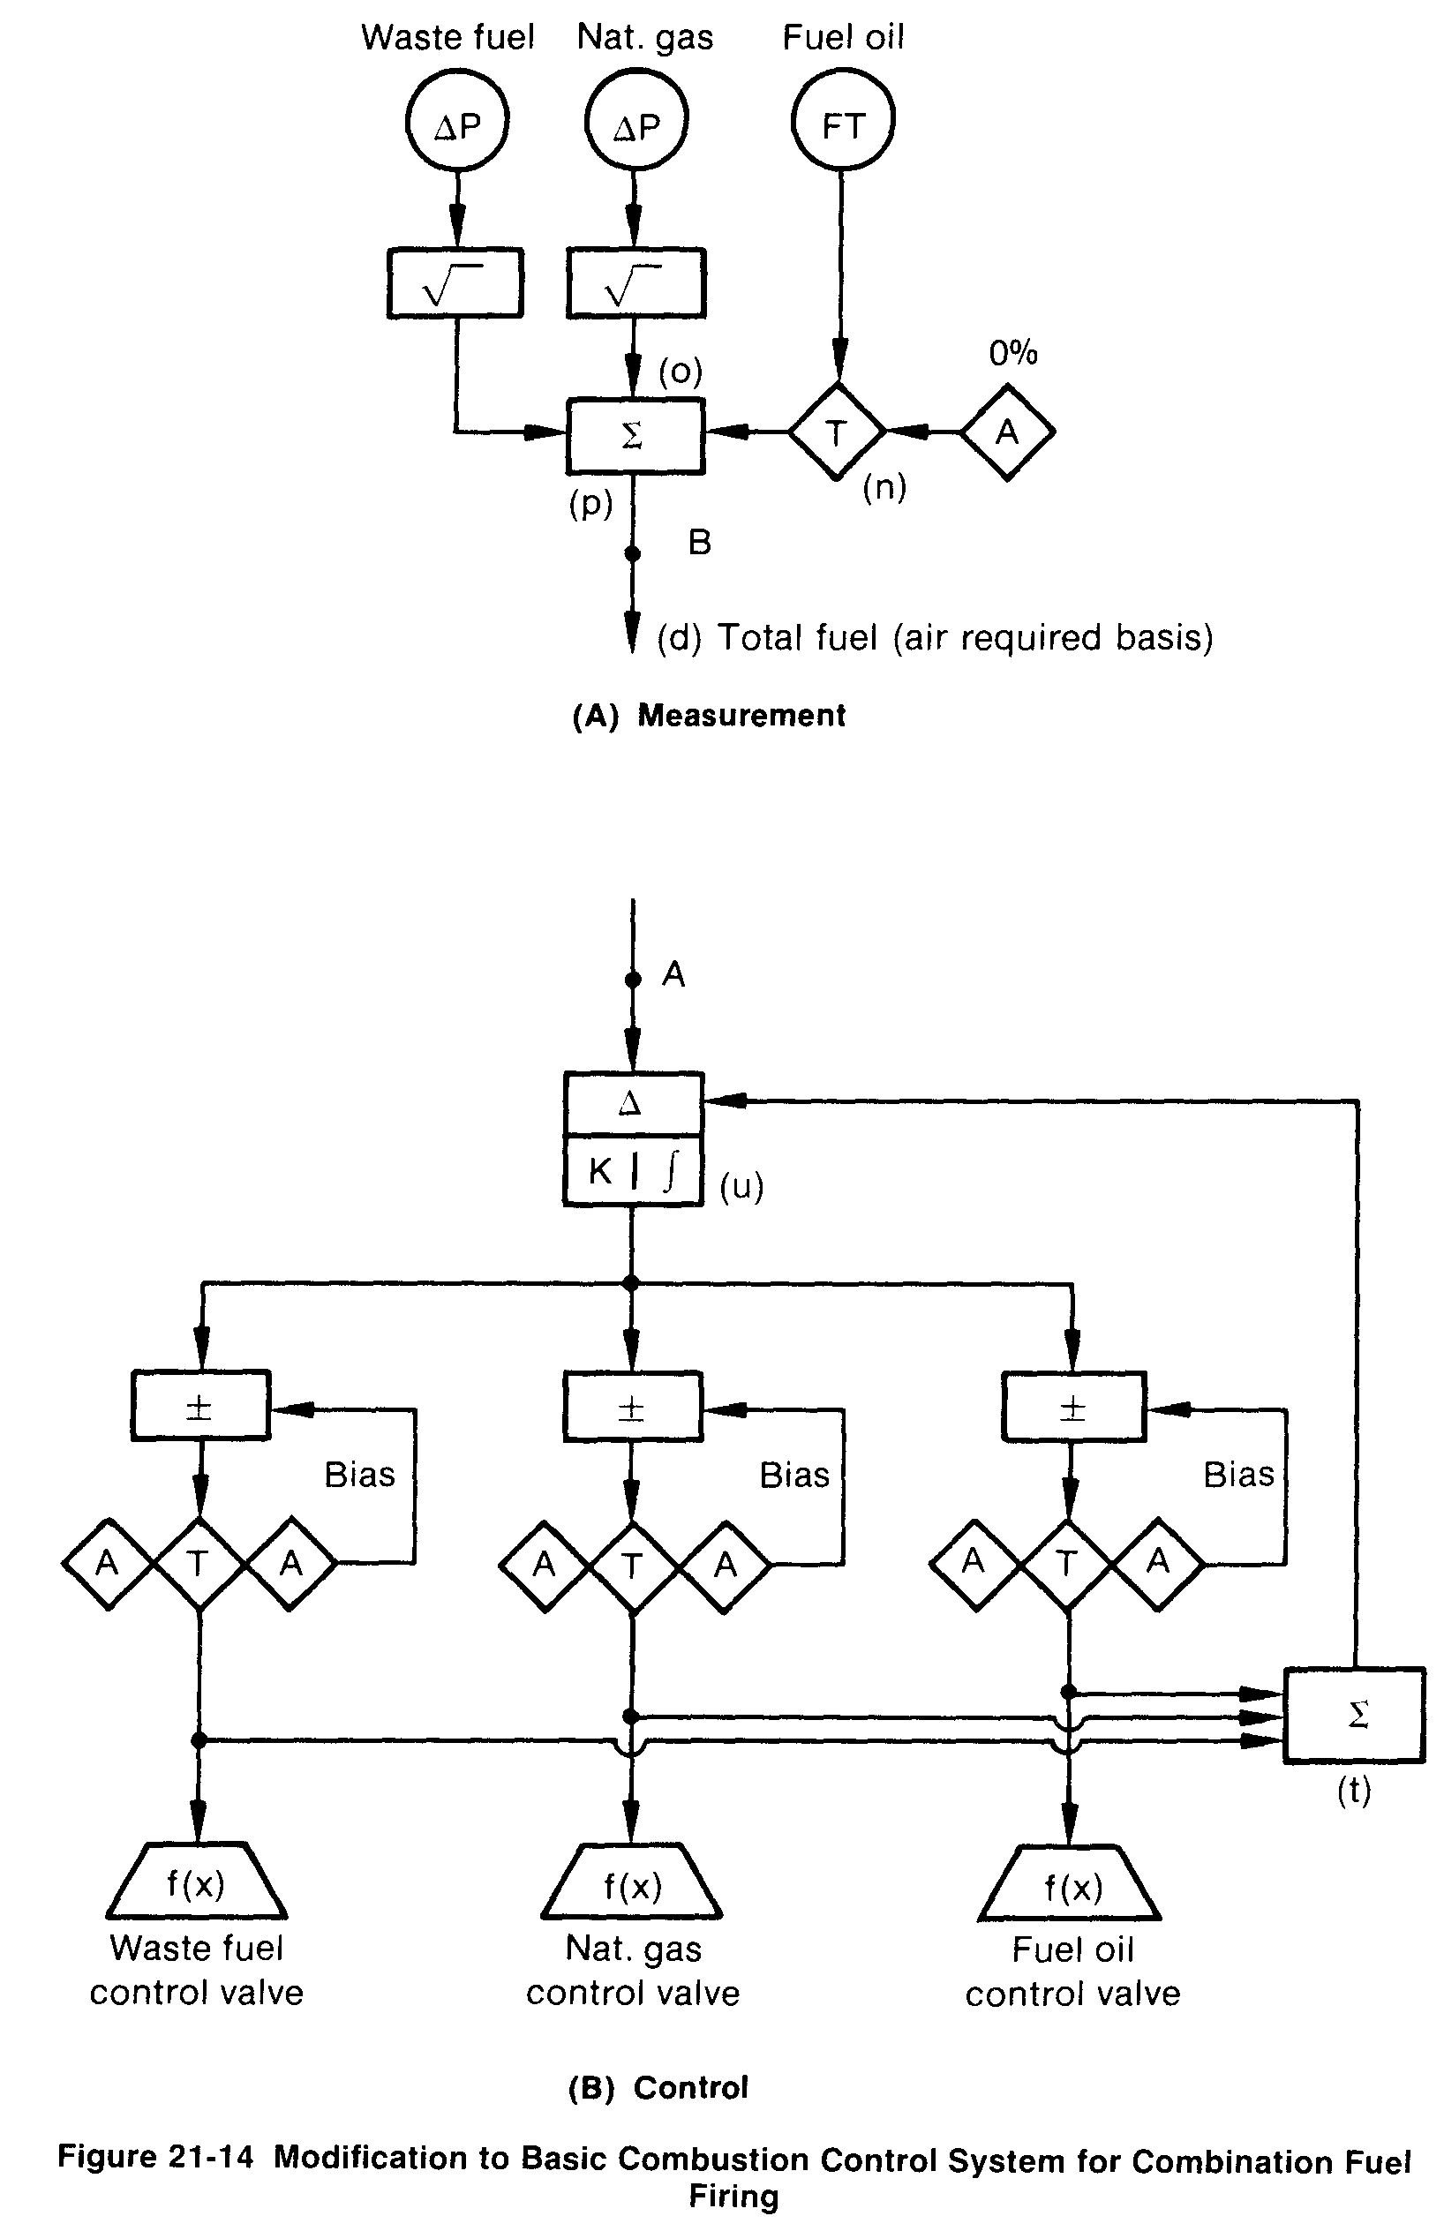

cost" control action or for other reasons, then the basic control of Figure 21-9 is altered in accordance with Figure 21-16. The flows are totalized as before on a "total air required" basis. The output of this totalization acts, however, only on the active constraint of "high select" function, which forces the air flow set point to the value of that required for the total fuel being burned. For the normal control functions, the fuel flow feedbacks respond to the individual set points of their controllers. The set points are generated through a set point ratio arrangement that is the same as that used for splitting the control signal, as shown in Figure 21-13. The ratio set may be generated manually, as shown, or through other control functions that are not shown here.

