Steam Load-based Control

1 Relationships

The demand or a change in demand on the boiler system is generated by the steam users' requirements for energy flow. As they open valves to get more of the energy locked into the steam energy carrier, the pressure drops in the total storage system, triggering the release of some of the heat energy from storage.
The magnitude of the pressure drop depends on the relationship between the boiler water volume, total volume of the steam system, the magnitude of the steam demand, and the magnitude of the change in steam demand. If the water volume is high, energy from the water is released to slow down the change in steam pressure. If the system volume is relatively low, the steam pressure change will be relatively high and vice versa.
The steam header pressure is the energy balance point between the energy demands of the steam users and the supply of fuel and air to the boilers to replenish the energy to the header system. At a constant steam flow or energy requirement, a constant pressure in the steam header indicates that energy supply and demand are in balance. While the actual requirements are for energy, control systems work on the physical properties of pressure and temperature. A 1: 1 relationship between steam flow and energy flow is normally assumed. This is not true if the pressure and temperature change significantly. With this caveat, the balance is represented by the statements that follow.
(1) Steam demand = steam flow plus or minus (K) * (pressure error). K is a function of the system volume and steam specific volume related to the demand flow rate.
(2) Supply side = fuel, air, and water energy to the boiler plus the change in energy storage.
(3) Demand side = steam to users.
(4) Balance point = steam header pressure.
(5) Pressure at set point-demand equals supply when energy storage is constant.
(6) Pressure increasing-supply exceeds demand (may equal demand if energy storage is decreasing)
(7) Pressure decreasing-demand exceeds supply (may equal supply if energy storage is increasing)

2 Linking the Steam Pressure Change to Changes in Firing Rate

The combustion, feedwater control, and steam temperature control systems determine how a boiler actually operates and whether it achieves its efficiency potential. The controls should be designed to regulate the fuel, air, and water to a boiler and maintain a desired steam pressure or hot water temperature while simultaneously optimizing the boiler efficiency.
During either normal or abnormal operation, the greater the sophistication of the controls, the greater the efficiency potential of the total boiler system. A control system can usually be upgraded in its functions by adding additional components or software. Improving a control system is usually a cost-effective way to improve the operating efficiency of any boiler.
Generally the boiler controls can be classified in two main groups: on/off and modulating. On/off controls are subdivided into basic on/off (full on and off) and high/low/off, which has a high and low fire "on" condition plus the "off" condition. Modulating controls are subdivided into two basic classes: positioning and metering.
The simplest, most basic, and least costly control and the one used to control firing rate on only the smaller firetube and watertube boilers is on/off. The control is initiated by a steam

pressure or hot water temperature switch. As the pressure or temperature drops to the switch setting, the gas valve is opened (or the fuel pump started) along with the combustion air fan motor. The fire is ignited usually with a continuous pilot Name. The fuel and air continue operating at full firing rate capacity, and the pressure or temperature rises until the switch contact is opened.
Although such a system may maintain steam pressure or hot water temperature within acceptable limits, combustion is not controlled because combustion efficiency (while firing) is a result of mechanical burner adjustment. When the burner is on, the excess air is subject to the following variations in the fuel supply.

• Pressure and temperature of the fuel
• Btu content of the fuel (hydrogen/carbon ratio)
• Fuel specific gravity
• Fuel Viscosity
• Mechanical adjustment tolerances

The excess air is also subject to variations in the combustion air supplied.

• Air temperature and relative humidity
• Air supply pressure
• Barometric pressure
• Mechanical adjustment tolerances

In addition, each time the burner is oil', cold air passes through the boiler carrying heat up the stack unless the flue damper is closed. Using this system, the "on" fire is at full firing rate and the flue gas temperature is at maximum. Figure 8-1 represents how the on/off system works.
The other on/off system is the high/low/off control in which the burner system has two firing rates called "high fire" and "low fire." If the Btu requirements are between those of high fire and low fire, the burner will stay on all the time, cycling between high and low. Unless the load is below low tire input, this eliminates the "off'' heat losses caused by cold air through the boiler. Such a system has three steam pressure or hot water temperature settings:
(I) Stop fire or off
(2) Start boiler and go to low fire or stop high fire and go to low fire (3) Start high fire
This system will hold the steam pressure or the hot water temperature within closcr tolerances of the desired steam pressure or hot water temperature. It will have a lower weighted average flue gas temperature than a straight on/otT system but a higher weighted average flue gas temperature than a fully modulating control.
The system can be tuned to burn the fuel efficiently when the burner is "on" at any time. It will get out of tune when any of the fuel and air conditions change from those present when the burner was set. Compromising some of the mechanical adjustments may be necessary in trying to optimize combustion at both the "low fire" and "high fire" settings of the high/ low/off system.
Using on/off control to add water to a boiler-based on the water level in the boiler intermittently cools and heats the boiler water, causing increased on/off or high/low cycling action of the firing rate control.
The action of the high/low/off control under the same load conditions as Figure 8-1 is shown in Figure 8-2.

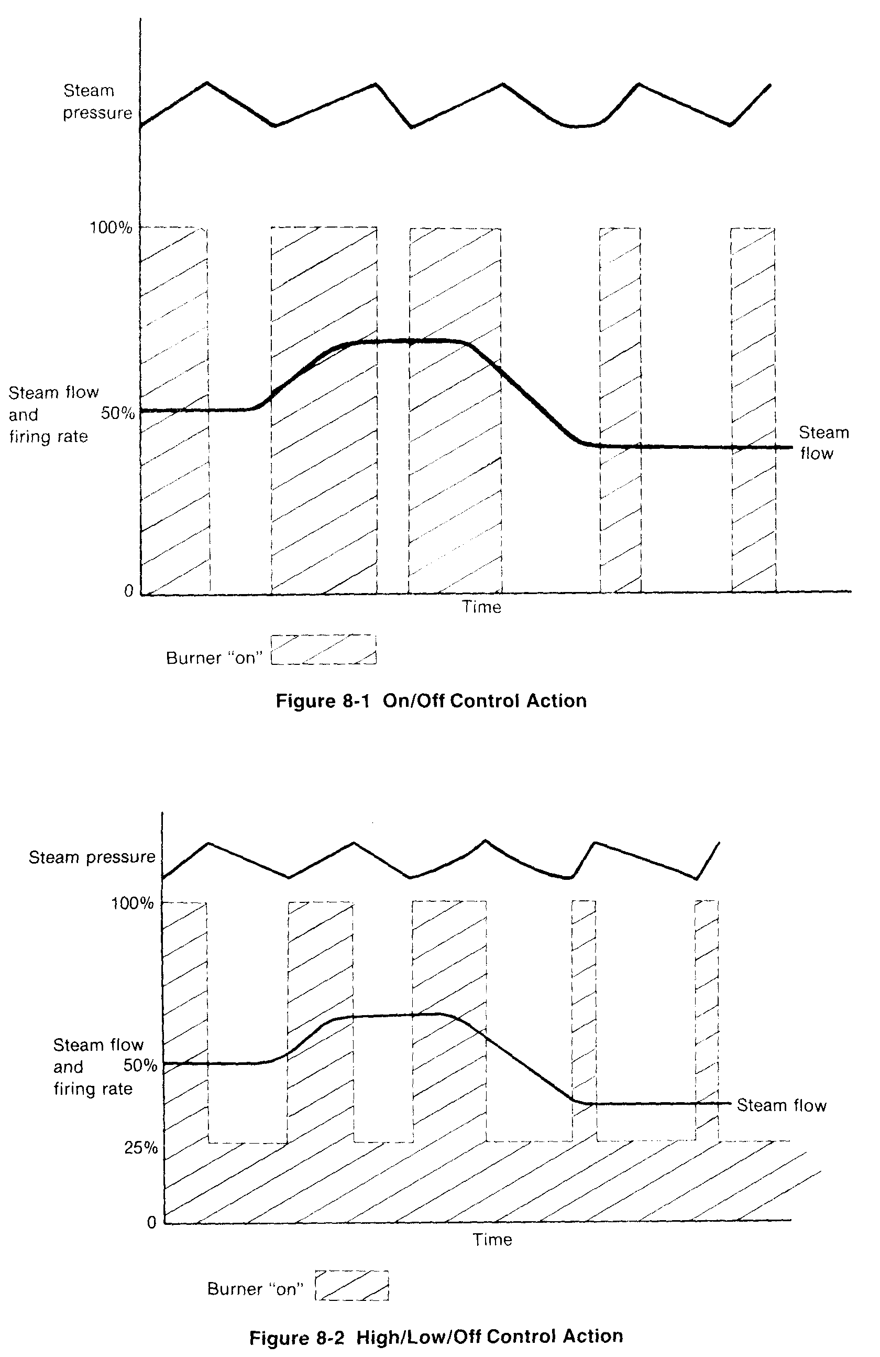

Modulating control is a basic improvement in controlling combustion and feedwater. A continuous control signal is generated by a controller connected to the steam or hot water piping system. Reductions in steam pressure or hot water temperature increase the output signal, which calls for a_proportionate increase in firing rate.
Modulating control is an improvement because the fuel and air Btu input requirements and the Btu of the steam or hot water output of the boiler are continuously matched. The action of such a control system under the same load conditions of Figure 8-1 and Figure 8-2 is shown in Figure 8-3.
Because matching the input and output Btu requirements is improved, the steam pressure or hot water temperature is maintained within closer tolerances than is possible with the previously discussed control systems. The weighted average flue gas temperature is lower, so boiler efficiency is greater. Table 8-1 compares the efficiency of boilers with the different systems while operating under the indicated load conditions. The influences of changes in the condition of fuel and air have been eliminated by assuming a 10 percent excess air and a constant flue gas temperature for each of the loads or firing rates that would occur.
Although each boiler will have its own characteristics of excess air as opposed to flue gas temperature, the table is typical for a gas-fired boiler with the efficiency calculations based on 450 to 600 degrees flue gas temperature over the 25 percent to 100 percent load range. The table represents control systems operating ideally with no variation in excess air. Excess air should be higher at loads less than 50 percent, and efficiencies would be lower than those shown for the high/low/off and modulating systems.
At 25 percent load, high/low/off and modulating have the same efficiency. Twenty-five percent would be considered low fire, which would be "on" full time, or the same continuous firing rate for both systems. At 100 percent, all systems would be "on" full time at 100 percent firing rate. Therefore, results are the same for all systems. In the middle range, efficiency clearly improves as control sophistication is increased. The benefit of modulating control is clearly established in Table 8-1. The type of modulating control and how it is implemented in developing the "firing rate demand" signal is next examined.

3 Steam Pressure or Steam Flow Feedback Control

Assuming that the equipment for generating a firing rate demand signal is of the modulating type, several different methods and considerations are involved. For the simpler systems, a
Table 1 Control System Performance Comparison

Efficiency at % load
Type of Control 25% 50% 75% 100%
On/off 70.28 74.28 75.61 76.28 On/off with flue damper 73.28 75.28 75.95 76.28 Hi/low/off 76.88 76.48 76.35 76.28 Modulating 76.88 77.68 77.15 76.28
simple proportional or proportional-plus-integral feedback controller may be used. Figure 8-4 demonstrates this method for regulating the firing rate using steam pressure. In some installations a constant steam flow may be required for one or more boilers in combination, while other boilers connected to the same header are used for controlling steam pressure.
It is also possible to arrange the system as shown in Figure 8-5 so that the control for a particular boiler can be switched between steam pressure and steam flow control. The switch- ing procedure would require the boiler operator to switch the control to manual, adjust the set point to the desired value of the variable being switched to, operate the transfer switch, and then transfer the control back to automatic operation. In either steam pressure or steam flow, a change in these variables is equated to a system demand for energy.
Figure 8-6 is a diagram of a change in steam flow rate, firing rate, and steam pressure with respect to time. This diagram is useful in analyzing the tuning requirements of the loop. Sup- pose, as shown, the steam pressure transmitter has a range of 0 to 300 psig for a 0 to 100 percent output signal and that at a constant steam flow rate the firing rate is 90 percent of its range when steam flow is 100 percent of its range. If 10 psig is the maximum desired pressure deviation for a 10 percent change in steam flow rate, such a deviation will produce a (10/300) 0.033 or 3.3 percent change in the signal from the steam pressure transmitter.
This signal must be amplified to produce a change in the firing rate. Under steady-state conditions the firing rate change for the 10 percent steam flow rate change is approximately 9 percent of its range.
As the load is increased, even a step change as shown here, the steam pressure will change
at a slower rate. This is the result of the initial load change being partly satisfied from energy storage. The initial firing rate change is thus a slightly delayed and reduced effect, since energy cannot be withdrawn from storage without a drop in pressure. In addition, the process takes time to convert the fuel energy and transfer it to the water in the boiler. Until the rate of withdrawal from storage balances the effect of increased firing rate, the steam pressure will continue to fall. When the pressure stabilizes, the net result is that energy storage has been
reduced.
200 j10 psig - 3.3% of 0 to 300 psig PT
psi -~g
T 2.25% Fuel and air flow,
% of FT range
jq% 11.25%

%
ti Steam flow, % of FT range
Slteam prepressure controller gain - 3.41
(for 0 to 400 psig PT, gain-4.5)
0 Time
Figure 8-6 Changes in Steam Flow Rate, Firing Rate, and Steam Pressure with Respect
to Time
This withdrawal from storage must be paid back by temporary overfiring. A load increase so requires over firing to add the required additional energy storage that will allow the pretiire to return to its set point. The magnitude of the desired temporary ovefirint is usually a inimum of approximately 25 percent of the steady-state firing rate change, or 2.25 percent i this case. The 9 percent steady-state firing rate increase is thus increased to a needed 11.25 ~rcent of maximum. Since the multiplier is (1 1.25/3.3) 3.4 a ^{gain} of 3.41 would be applied ) the steam pressure controller. Note that if the steam pressure transmitter had a maximum Ingc of 0 to 400 psig, the deviation would have been 0.025 or 2.5 percent and the multiplier ould have been (1 L25/2.5) 4.5. Upon a reduction in steam flow, underfiring would have en necessary to adjust the system energy storage.
For tuning such a steam pressure controller, a typical controller gain of 4.0 is a reasonable rating point with an integral setting of 0.25 repeats per minute. The optimum gain will be determined by the ratio of boiler capacity to boiler-header energy capacity and to scaling ictors of the transmitters used.
The optimum integral setting will be approximately equal to the time constant (one fifth f total time) of the particular steam generation process. In this case, since the time constant; several minutes, the integral value in repeats per ^{minute} will be less than 1.0.
The optimum controller tuning may not be that which will produce the optimum steam pressure pattern. In many cases it is possible to obtain improved steam pressure control at the expense of boiler operating efficiency. Increasing the controllei ~,am may produce oscillations if the fuel flow and the air flow that may improve steam pressure control while decreasing efficiency due to the oscillations. The degree to which this may occur is different for different installations. The resolution of this question must be based on the judgment of the process experienced individual who is responsible for the controller tuning.
If steam flow is the controlled variable, the gain of the controller can be greater than that if a typical flow control loop because the integral time is much longer. In this case a good tarting point is 1. 125 (11.25/ 10) for the gain setting. Since the integral value is related to the irocess time constant, it will approximate the value of the pressure control integral value.
The output of the controller is called the firing rate demand or the energy input demand or the boiler. Development of a proper firing rate demand signal is of primary importance ince all control of fuel and air is directed from this master signal. The controller is therefore alled the master controller. Because of the importance of this controller, a number of more ophisticated configurations are available. The use of these more complex arrangements results n greater precision of the firing rate demand (input energy demand) control signal and imirovement in the steam pressure control.
1-4 Feedforward-plus-Feedback - Steam Flow plus Steam Pressure
A feed forward-plus-fcedback arrangement is often used. One of the two most frequently ised variations is shown in Figure 8-7. In this arrangement the steam flow (a) is the fecclforvard demand. The proportional multiplier function (b) is adjusted at the input 01' summer (c) o that a change in steam flow will produce the correct steady-state change in firing rate lemand. The steam pressure controller (d) provides the correct adjustment of the firing rate iemand for the necessary overfiring or underfiring to adjust energy storage.
With any such feedforward system, the fuel flow signal change is directly linked to the team flow change. This results in immediate and faster action on the fuel flow change since he full fuel change occurs before appreciable change in the steam pressure. This results in ess energy withdrawal from storage. Since energy withdrawal from storage is directly related o drop in steam pressure, less withdrawal means that there has been a smaller steam pressure ieviation from set point.
Using the previous example, the gain of the proportional multiplier (b) would be adjusted
o a ^{minimum} f(1_(19/(1_ 11 0 9 The vain of the nreo~iire cnntrnllor would he 0 ?5/1 1l() 68 In

some installations, better performance may be obtained with a higher steam pressure controller gain to provide an increase in the over- and underfiring rates.
In this type of system, most of the control action that would be supplied by the integral in a simple feedback control loop is supplied by the feedforward signal. Since the feedback portion should essentially produce no effect under steady-state conditions, it is necessary that the steam pressure controller be essentially proportional in nature. Because of the dynamics involved, the calculated settings given for this type of system may not be optimum.
In order that the steam pressure will eventually return to set point when the steam flow versus firing rate relationship is imperfect, a small amount of integral is needed. This should be an amount less than that indicated by the process time constant to avoid developing an unwanted integral signal during the steam pressure deviation. An integral setting of 0.05 to 0. 1 repeats per minute is suggested.
Note that the steam flow signal is shown as the total steam flow for all boilers. Whenever more than one boiler feeds steam to a steam header, arranging one individual boiler feedforward from the steam flow of that boiler alone would result in unstable control due to positive feedback. If all boiler steam flow signals are compared in a high select function, an individual high select output can be used as the feedforward signal for control of all boilers.
In the arrangement above, a change in the steam flow feedforward signal provides the necessary magnitude of the steady-state change in firing rate demand. An alternate feedforward application shown in Figure 8-8 exchanges the functions of the steam flow and steam pressure signals.
In this case the derivative input from steam flow into summer (c) is adjusted to provide the temporary overfiring or underfiring, with the steam pressure controller (d) adjusted to provide the necessary changes in the steady-state firing rate demand. The calibration of summer (c) does not include a bias, since under steady-state operation the output of summer (c) should equal the input from controller (d) with the steam flow derivative signal returning to zero.

Using the previous example, the steam pressure controller would have a gain of (9/3.3)2.73. If the integral of the simple feedback controller were 0.25 repeat per minute, the integral would be 0.25 also for this arrangement. The derivative from steam flow would be adjusted so that the 2.25 percent magnitude under- or overfiring, adjusted by proportional (b), and the necessary time duration of that overfiring or underfiring, adjusted by derivative (e), would be correct.
While the selection between the two alternates is user choice, a high pressure drop between the boiler and the steam header would indicate that the alternate in Figure 8-8 would probably be a better choice. Under this condition the boiler pressure changes significantly with load even though the steam header may be controlled at a constant pressure. This is often the case with electric utility boilers.
In the normal industrial installation, the change in steam header pressure is almost entirely due to the change in steam flow rate on the user demand side of the header. If the pressure drop between boiler and steam header is high, then a change in steam flow rate may cause a larger change in steam header pressure due to changes in the supply side pressure drop. These two pressure changes mean different things to the system. A pressure change on the demand side means that firing rate should be changed because the user wants more steam. A change in pressure drop on the supply side may be an indication of a needed change in firing rate to change the stored energy that is represented by boiler pressure.
A third arrangement of a feedforward system decouples the steam pressure and the steam flow actions in the firing rate demand control. This arrangement is shown in Figure 8-9.
In this arrangement the deviation between steam pressure and its set point (steam pressure error) multiplies the feedforward signal. Thus, on a major demand for a change in firing rate, the initial effect comes from the feedforward signal without the delay in steam pressure change. As the steam pressure changes to create the steam pressure error, the feedforward magnitude is reduced and replaced by the steam pressure controller output. The steam pressure controller is tuned in a manner similar to that when only feedback control is used with respect to the

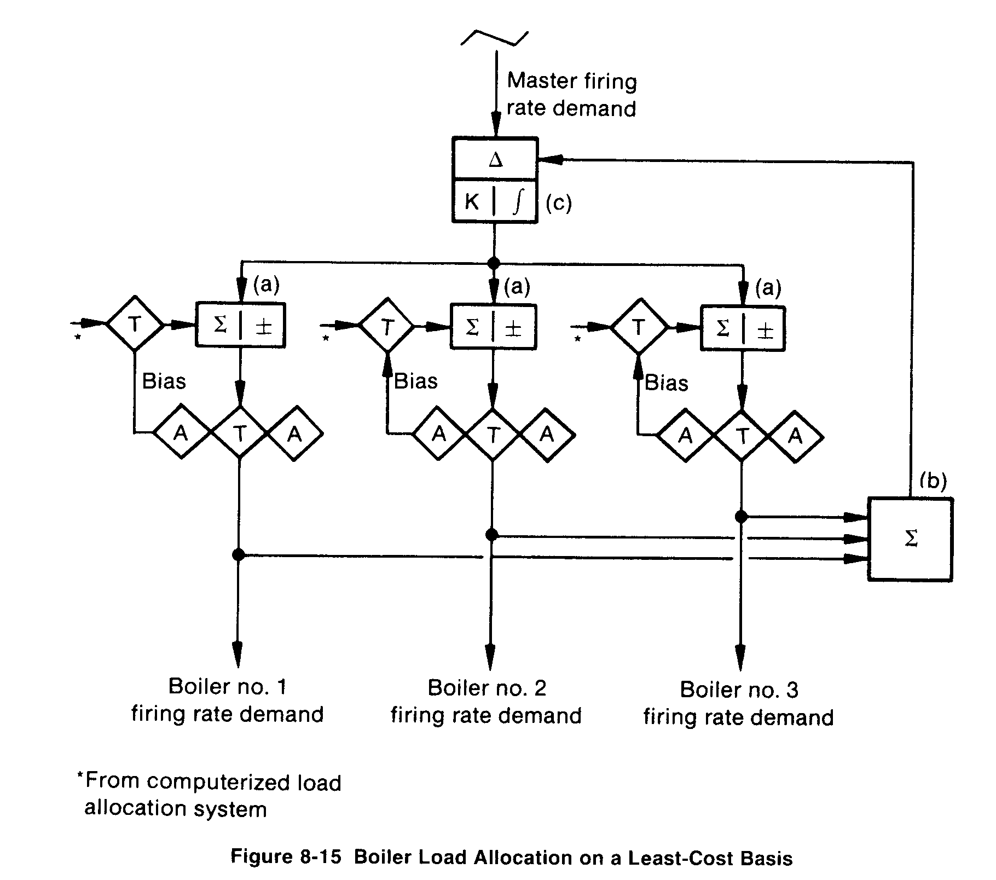
before any further changes are made to the load of boiler 1. Additional steam from this point is then obtained by loading boiler I from 55 percent to 100 percent.
If there were a greater number of boilers, loading them all at equal incremental cost rates would always result in the lowest additional increment of cost. Energy quantity is not the whole story. Different fuels may be used with the different boilers with different cost factors. Special operating cost factors may also bias the cost results between boilers. In general, for identical boilers that burn the same fuel, there is usually not enough potential gain to make the described technique of economic benefit.
Real-time calculations of incremental fuel usage cannot be made. The boiler operates at only one load at a time, so the entire load-fuel curve at any one time is unknown. The general practice is to develop the shape of the curve and apply the single load value to bias the curve up or down. Over a period of time as the boiler operates at various loads, the curve shape can be gradually updated.
8-9 Energy Management Involving Cogeneration Networks
Another aspect of energy management is economic loading of industrial turbines or turbogenerators. The design of these turbines and their arrangement in the overall heat cycle presents another opportunity for overall control simplicity and overall total energy management.

