
Boiler water treatment

Alkalinity
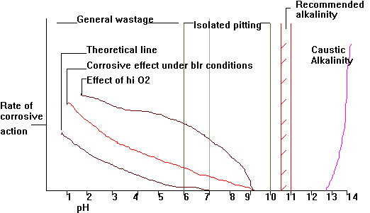

Treatment
For pressures below 20 bar dissolved O₂ in the feed does not cause any serious problems so long as the water is kept alkaline
However cold feed should be avoided as this introduces large amounts of dissolved O₂ are present, for pressures greater than 18.5 bar a dearator is recommended

Feed Treatment Chemicals
Sodium | Hydroxide
Calcium | Bicarbonate (CaCO₃ + Na₂CO₃)
Magnesium | Bicarbonate
Magnesium | Chloride.
. | .
Sodium | Phosphate
Calcium | Carbonate
Calcium | Sulphate
Magnesium | Sulphate
All in this column precipitated as hydroxide or phosphate based sludges | All in this column form sodium salts which remain in solution
- Sodium Hydroxide
  - Reacts with highly corrosive MgCl₂
  - Does not readily react with CaSO₄
  - Strongly alkaline
  - Produces heat when mixed with water
  - Absorbs CO₂ changing to Sodium Carbonate
  - Unsuitable for standard mixes
- Sodium Carbonate Na₂CO₃ ( soda ash )
  - Alkaline
  - At pressures above 14 bar some of the Sodium Carbonate decomposes to form NaOH and CO₂ . Increasing on pressure increase
  - Changes to Sodium Bi-Carbonate when exposed to air
  - Still usable but larger amounts make control difficult
  - Standard mix ingredient
- Sodium Hexa Meta Phosphate NaPO₃ (calgon)
  - Safe, soluble in water, slightly acidic
  - May be injected any where as will only react in the boiler
  - Suitable for LP blrs which require lower alkalinity
- DiSodium Phosphate Na₂HPO₄ (Cophos II)
  - Neutral used with alkaline additive
  - Combines with NaOH to give trisodium phosphate
  - Basic constituent
- TriSodium Phosphate Na₃ PO₄ (Cophos III)
  - Alkaline
  - When added to water decomposes to NaOH and Na₂ HPO₄
  - As water evaporated density increases and NaOH and Na₂ HPO₄ recombine
  - Phosphates can form Phosphides which can coat metal to form a protective barrier, with excessive phosphate levels, this coating can be excessive on highly rated boilers operating at higher steaming rates
Chemicals are normally added as a dilute solution fed by a proportioning pump or by injection from pressure pot.
Use of chemicals should be kept to a minimum.
Injection over a long period is preferable as this prevents foaming.
Excessive use of phosphates without blowdown can produce deposits of phosphides on a par with scale formations.
Therefore it is necessary to add sludge conditioners particularly in the forms of polyelectrolytes, particularly in LP blrs

Oxygen Scavengers
- Hydrazine N ₂ H ₄
  - Oxygen scavenger, continously injected to maintain a reserve within the boiler of 0.02 to 0.1 ppm and a feed water O₂ content of less than 10 ppb
  - At temperatures greater than 350ºC , will decompose to ammonia and nitrogen and will aid in maintaining balanced alkalinity in steam piping.Steam volatile, neutralises CO₂
  - Inherent alkalinity helps maintain feed water alkalinity within parameters of 8.6 to 9.0.
  - Used in boiler operating above 32 bar, will not readily react with O₂ below 50ºC hence risk of copper corrosion occurs with the ammonia stripping off the continuously reforming copper oxides.
  - Supplied as a 35% solution
- Carbohydrazide (N ₂ H₃)₂CO
  - Is a combined form of Hydrazine
  - It is superior to hydrazine in performace and is designed to minimise the vapours during handling
  - Carbohydrazide and its reaction products create no dissolved solids
  - Is an oxygen scavenger and metal passivator at both high (230'C) and low (65'C) temperatures
  - Can be used with boilers up to 170 bar
- Diethylhydroxylamine DEHA
  - Like hydrazine, provides a passive oxide film ( magnetite) on metal surfaces to minimise corrosion
  - Contributes to pH netralisation to an extent that seperate condensate control may not be necessary
  - Protects entire system-feedwater, boiler and condensate
- Sodium sulphite Na₂SO₃
  - Takes the form of a soft white powder
  - Slightly alkaline
  - Will react with oxygen to form Sodium Sulphate at about 8ppm Sodium Sulphite to 1ppm Oxygen
  - Use limited to low pressure boilers due to increasing TDS and reducing alkalinity by its action
- Tannins
  - Certain alkaline tannin solutions have a good oxygen absorbing ability with about 6ppm tannin able to remove 1ppm oxygen.
  - The reaction with oxygen is complex and unreliable, no official reserve levels exist for the maintenance of a system using tannin
- Erythorbic Acid (Sur-gard) R₁-C(OH)
  - An effective oxygen scavenger and metal passivator
  - It is the only non-volatile scavenger which can be used with spray attemperation
  - does not add measurable solids to the boiler water
  - May be used in boilers up to 122 bar
  - Officially recognised as a Safe Substance
  - As with hydrazine a small amount of ammonia is created in the boiler, it is not recommended for layup.

Polymer Treatment
Polymer is a giant molecular built up by stringing together simple molecules
E.G.
Polyelectrolytes-Formed from natural or synthetic ionic monomers
Polyacrylates - Polymers of acrylic acid
Polyamides - Polymers of amides
Polymer treatment prevents scale formation and minimises sludge formation. It can also loosen scale so established blrs introduced to this form of treatment may develop leaks where previously plugged with scale. Especially in way of expanded joints. Also can absorb trace oil
Use limited to LP blrs as no PO₄ present to prevent caustic alkalinity
For auxiliary blrs this is a superior form of treatment to the old alkaline and phosphate treatment. The correct level of alkalinity must be maintained as too low a level neutralises the electric charge of the polyelectrolyte. Too high causes caustic alkalinity.

Amine treatment
Compounds containing nitrogen and hydrogen.

Neutralising amines

Hydrazine N₂H₄
see above

Bramine ( cyclohexalamine )
(Bull & Roberts amine treatment)
Neutralising amine as with hydrazine. Used with hydrazine to maintain feed water alkalinity within parameters. As a knock on effect will slightly increase boiler water alkalinity.
Stable at high temperatures so is used more than hydrazine to control the steam line alkalinity as there is less chance of copper corrosion which occurs with the prescience of ammonia
Proper boiler water treatment eliminates sludge and scale deposits within the boiler. However, over along period of time a film of copper and iron oxides build up on the tube surface. Most of these oxides are transported from oxides of corrosion within the feed system to the boiler with the condensate.
Bramine reduces this corrosion and eliminates the build up of these oxide deposits.
Mechanism of function
Condensate from the condenser is very pure and slightly acidic, often referred to as 'hungry water'. It can dissolve metals in trace amounts to satisfy this hunger.
Distilled make up water aggravates this situation containing much dissolved CO2 and hence being acidic carries its own corrosion products.
Trace amounts of bramine are introduced into the system to establish an alkalinity level greatly reducing the effects of the hungry water.
Some of the bramine is used almost immediately, most however, passes on to the boiler where it is then transported through boiler water, boiler steam drum, steam lines back to the condenser. It has no effect anywhere except the condensate system.
Bramine also has a cleaning effect and may assist in the cleaning the film off the tube over a period of time.
Bramine is safer to handle than Bramine and will protect all metals.
Hydrazine however readily breaks down to form ammonia which whilst protecting ferrous metals will attack those containing copper

Filming amines
Shows neutralizing tendencies, main function however is to coat piping with a molecular water repellent protective film
Injection of amines
May be injected between HP and LP turbines in the X-over pipe or after the de-aerator.
Adding in X-over pipe-reduces corrosion of copper alloys
De-aerator only effective as a feed heater
Adding after de-aerator-Dearator correctly performing as a dearator and feed heater. If possible the best system is to have a changeover to allow norm inj into the X-over at sea and injection after the dearator when the turbine shut down

Limits of density/pressure
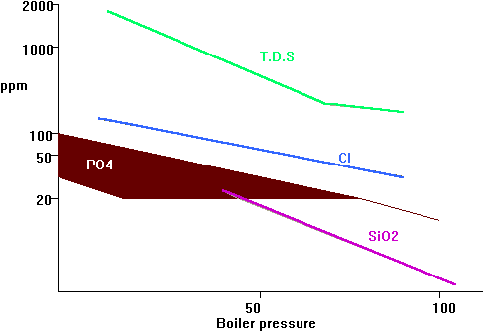

Sludge conditioning agents
- Coagulants-
  - Mainly polyelectrolyte
  - Prevents the precipitated sodium based particles forming soft scales
  - Will keep oil in an emulsion
  - the water must be kept alkaline
- Antifoams
  - Reduce the stability of water film around steam bubble and cause it to collapse.
  - Common type polyamide is an organic compound of high molecular weight.
  - In the event of severe contamination separate injection of an antifoam is recommended
- Dispersing agents
  - Sludge conditioners such as starch or tannin.
  - Prevent solid precipitates uniting to form sizeable crystals e.g. MgSO4

Treatment in boilers (non congruent)

LP tank blrs (<14 bar)
Na₂CO₃- precipitates salts, provides alkalinity
MgSO₄- Sludge conditioners
Na₂CO₃ can break down to form NaOH in higher rated boilers hence initial dose with Na₂SO₄

Medium pressure tank blrs (<17.5 bar)
Na₂CO₃(3) + sodium phosphate(4) + sludge conditioners(1)

Medium to High pressure water tube <60 bar
Na₂CO₃ + Na₂HPO4 +sludge conditioners
Oxygen scavengers also used to allow magnetite (Fe₃O₄) layer to form in the boiler
Boiler operating above 42 bar require a dearator.

HP to UHP blrs (42 to 80 bar)
Due to level of decomposition of Na₂CO₃. NaOH preferred for better controllability Na₂HPO₄
NaOH attacks the magnetite layer. Congruent treatment used.

Permissible limits
 |  | Shell | WT | WT | WT | WT | WT
TEST> | PPM | <17.5b | <17,5b | <32b | <42b | <60b | <85b
Hardness | CaCO₃ | <=5 | <=5 | <=5 | <=1 | <=1 | <=1
P.alk | CaCO₃ | 150-300 | 150-300 | 150-300 | 100-150 | 50-100 | 50-80
T.D.S. | CaCO₃ | <=7000 | <=1000 | <=1000 | <=500 | <=500 | <=300
Cl | CaCO₃ | <=1000 | <=300 | <=150 | <=100 | <=50 | <=30
PO₄ | PO₄ | 30-70 | 30-70 | 30-70 | 30-50 | 30-50 | 20-30
N₂H₄ | N₂H₄ | -- | -- | -- | 0.1 -1.0 | 0.1 - 1.0 | 0.1 - 1.0
SO₃ | SO₃ | 50-100 | 50-100 | 50-100 | 20-50 | -- | --
SiO₂ | SiO₂ | -- | -- | -- | -- | -- | <=6.0
Fe | Fe | -- | -- | -- | -- | -- | <=0.05
Cu | Cu | -- | -- | -- | -- | -- | <=0.02
pH | pH | 10.5-11 | 10.5-11 | 10.5-11 | 10.5-11 | 10.5-11 | 10.3-11
Limits for feed water
Cl | CL | <=10 | <=5 | <=1.0 | <=1.0 | <=1.0 | <=1.0
O₂ | O₂ | ---- | ---- | <=0.006 | <=0.003 | <=0.015 | <=0.01
NH₃ | NH₃ | ---- | ---- | ---- | ----- | ----- | <=0.5
Fe | Fe | ---- | ---- | ---- | ----- | <=0.01 | <=0.01
Cu | Cu | ---- | ---- | ---- | ----- | <=0.01 | <=0.01
pH | pH | ---- | ---- | ---- | 8.5-9.2 | 8.5-9.2 | 8.5-9.2

Co-ordinated and congruent Phosphate treatments

Alkalinity
NaOH under certain conditions dissolves boiler metal.
Co-ordinated treatment tries to avoid this by relying on the fact that NaOH and disodium phosphate combine to form trisodium phosphate. However, a small proportion of the NaOH always remains. Congruent treatment tries to avoid this by making a mix so that the Na⁺ to PO⁻³₄ ion ratio never exceeds 2.6 : 1 ( Na₃PO₄ has a sodium to phosphate ratio of 3 : 1 )
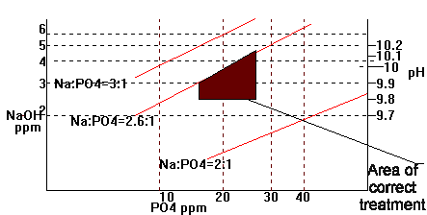

Co-ordinated phosphate treatment
- Purpose
  - to maintain a phosphate reserve to react with incoming hardness
  - To maintain sufficient alkalinity to minimise corrosion and aid in forcing the reaction with hardness salts.
For boiler pressures above 40bar problems of caustic alkalinity caused by addition of caustic soda as part of a feed treatment occur.
With caustic alkalinity, free hydroxides concentration in a thin film at the tube surface destroying the protective magnetite layer and attacking the metal to form caustic gouging craters, and intercrystaline cracking as it attacks the iron carbide in the iron grain boundaries.
Avoiding the prescience of free hydrides is the only prevention from this form of attack

Co-ordinated phosphate-pH control
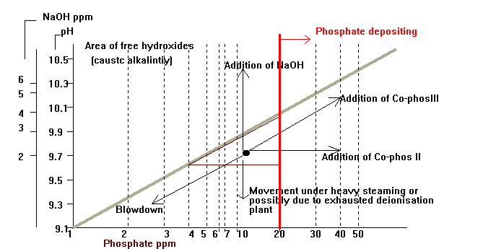
Maintaining within the control area is achieved by the addition of Co-phos III tri sodium phosphate based, and co-phos II, disodium phosphate based.
Co-Phos III is an alkaline product and in water decomposes to NaOH and Na2HPO4 increasing concentration recombine.
Co-Phos II is much less alkaline.
Falling into the area on the co-ordinated phosphate pH diagram below the lower dotted line means that normal treatment to bring back into the target area is impossible.
The only way of recovering the situation is by blowing large quantities of water out of the boiler
The ideal time for this is during trip testing when the boiler is isolated from the plant (and hence feed water flow to the boiler is much reduced). The flames are extinguished on the low low foxboro trip
It is also beneficial to blow down the headers at this time
Problems may arise when the mixed bed demineralisation plant is allowed to remain in need of regeneration for a long time. The make up water is so effected so as to lower the alkalinity of the boiler without a comparable drop in phosphate. This becomes particularly troublesome during periods of heavy make up, say during trip testing or heavy steaming.

Hide-out
It can be seen in high pressure boilers that as the steaming rate increases the levels of certain salts, particularly phosphate salts, does not raise in line with others. When the load is reduced the concentrations return to normal.
This is termed hide-out and is due to the reduced solubility of sodium phsophate at temperatures above 250'C
When phosphate hide-out occurs there is a risk of permenant scal deposition and/or evolution of free caustic which in turn could lead to severe corrosion due to caustic attack
Treatment using volatile solids free chemicals such as hydrazine, Eliminox and neutralising amines should be considered. This is termed All Volatile Treatment (AVT)

