REFRACTORY

Purpose
- To protect boiler casing from overheating and distortion and the possible resulting leakage of gases into the machinery space.
- To reduce the heat loss and ensure acceptable cold faced temperature for operating personnel.
- To protect exposed parts of drum and headers, which would otherwise become overheated, some tubes are similarly protected.
- Act as a heat reservoir
- To be used to from baffles for protective purposes or for directing gas flow

Properties

- Must have good insulating properties.
- Must be able to withstand high temperatures.
- Must have mechanical strength to resist the forces set up by the adjacent refractory.
- Must be able to withstand vibration.
- Must be able to withstand the cutting and abrasive action of the flame and dust.
- Must be able to expand and contract without cracking

Note: no one refractory can be used economically throughout the boiler

Types
- Acid materials- clay, silica, quartz, sandstone etc.
- Neutral materials – chromite, graphite, plumbago, alumina.
- Alkaline or base materials- lime, magnesia, zirconia

FORMS

Refractory lines the inside surface of the inner casing enclosing all of the furnace area and extending to the outer row of generating tubes. There are several different types of refractory which work together to protect the boiler.
- Firebrick is a heavy casted refractory used as the outer layer of refractory and is exposed to the direct flames of combustion. It has poor insulating qualities, but it will withstand direct flame contact.
- Insulating brick is a lightweight casted refractory used between the insulating block and firebrick. It has good insulating properties, but it will not withstand direct contact with flame.
- Insulating block is a pressed fiber material used next to the inner casing. It has the highest insulating properties of the various refractory, but it will not withstand direct contact with flame.
- Burner tiles are preformed refractory used to form burner cones around where the burner assembly protrudes into the furnace. Burner tiles are a specially shaped, heavy casted refractory used next to the insulating brick around the burner openings. They have poor insulating qualities, but they will withstand direct flame contact.
- High temperature castable refractory is used to fill in gaps in refractory or where shaping is needed to cover irregular shaped items. It is used to patch refractory or to smooth uneven areas between brickwork. It is packaged dry and must be mixed with water prior to use, very much like cement or plaster.
- Baffle tiles are a specially shaped refractory made of silicon carbide for use in some boilers to form baffles on superheater screen tubes. These baffles direct the flow of combustion gases across the superheater to help maintain the temperature within design parameters.
- When the refractory is installed and stacked, it must be held in place. Anchor bolts are used for preformed refractory. The anchor bolts are connected to the inner casing to support and retain the refractories in position.
- Since the boiler expands and contracts with heating and cooling, expansion joints are built into the refractory to allow for the thermal expansion and contraction.

Furnace linings

Studded tubes
  - these are lined with plastic chrome ore

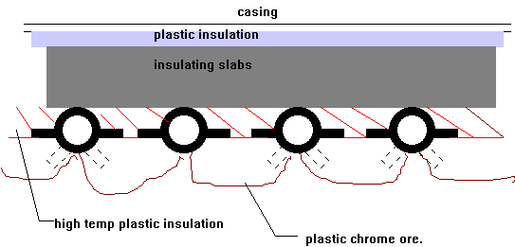

The amount of studding and the extent of tube surface covered with chrome ore is varied to suit the heat absorption rate required in the various zones of the boiler furnace.
Floor tubes may be situated beneath a 3" layer of brickwork, the tubes are embedded in chrushed insulating material below which is a layer of solid insulation and then layers of asbestos millboard and magnessia.

PRESENT DAY TYPES

TANGENT WALL.
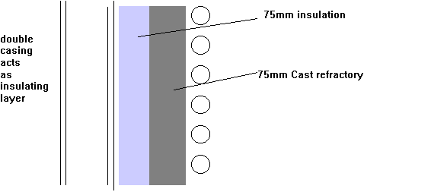

Membrane wall
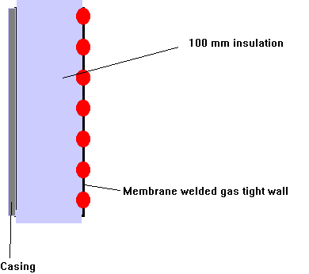

Furnace floors
- Two layers of 50 mm firebrick above the tubes and 100 mm slab insulation below. Tubes in castable insulation are covered with crushed firebrick. Note; Before castable insulation applied ,tubes coated with bitumen to allow expansion clearance when tubes are at working tempo

Front walls
- In front fired boilers these need additional insulation (200 mm) made up of 125 mm mouldable refractory backed by 50 mm castable or slab and 25 mm of asbestos millboard.

Burner openings
- These have specially shaped bricks called quarls or have plastic refractory

Brick bolts
There are two basic types:
- Using a hole right through the brick.
- Using a recess in the back of the brick.
A source of weakness is where bricks crack, bolts will be exposed to the direct heat which leads to failure. Adequate expansion arrangements must be provided. For floor tubes a coating of bitumastic is first applied before the castable refractory is applied. When the boiler is fired the bitumastic is burnt away then a space is left for expansion

Refractory failure
This is one of the major items of maintenance costs in older types of boiler

SPALLING
This is the breaking away of layers of the brick surface. It can be caused by fluctuating temperature under flame impingement or firing a boiler too soon after waterwashing or brick work repair.
May also be caused by failure to close off air from register outlet causing cool air to impinge on hot refractory.

SLAGGING
This is the softening of the bricks to a liquid state due to the prescience of vanadium or sodium ( ex sea water ) in the fuel. This acts as fluxes and lowers the melting point of the bricks which run to form a liquid pool in the furnace Eyebrows may form above quarls and attachment arrangements may become exposed Material falling to floor may critically reduce burner clearance and reduce efficiency
Flame impingement may lead to carbon penetrating refractory.

SHRINKAGE CRACKING
Refractories are weaker in tension than in compression or shear thus, if compression takes place due to the expansion of the brick at high temperature , if suddenly cooled cracking may occur.

Failure of brick securing devices

Boiler Refractory Care and Maintenance
According to the Refractory Institute, "Refractories are heat-resistant materials that constitute the linings for high-temperature furnaces and reactors and other processing units. In addition to being resistant to thermal stress and other physical phenomena induced by heat, refractories must also withstand physical wear and corrosion by chemical agents. Refractories are more heat resistant than metals and are required for heating applications above 1000°F (538°C)."
In a boiler the refractory protects the metal surfaces at critical points such as the rear door and in the furnace. This refractory should be inspected periodically to insure protection. Here is a list of what to look for and possible maintenance solutions:
- Visually inspect refractory. Look for large cracks or broken pieces. Small hairline cracks are to be expected.
- Wash coat the refractory with a high temperature bonding, air dry mortar.
- Face all cracks and joints with hi-temp bonding cement.
- If any bricks have fallen out or show signs of excessive wear, replace them.
- Remember, once the repair is complete it is important to follow the manufacturers recommendation for curing the refractory.
We also suggest that you inspect the refractory of your brand new boilers when they arrive on site. Check to be sure that the refractory has not been damaged in shipment. Report any defects to your boiler supplier immediately.

