Boiler economisers

Purpose
The purpose of the economiser is to increase plant efficiency by removing heat that would otherwise be lost in the flue gas and use it to indirectly feed heat the water. By heating the feed water it is also helping to prevent thermal shock as the water enters the steam drum.

Description
The flow of water is general counterflow. The exception to this is in the radiant heat boiler where the economiser is mounted immediately above the superheaters. The water flow in these so called 'Steaming economisers' is then parallel flow to decrease the tendency for the economiser to steam excessively above the design limits and lead to steam blockage , this is why these economisers are bare tube with no extended heating surface.
Vent and drains are fitted to header where isolating valves are fitted a safety valve must also be added.
The modern design involves the fabrication of the header and stub tubes which can then be heat treated. The tubes are then site welded to the stubs.
The previous use of expanded joints has now fallen out of failure due to the requirement of a multitude of hand hole doors with associated joints and hence possible area of leakage. The materials used are governed the materials susceptibility to cold end corrosion (see later notes), any metal having a surface temperature below the dew point will tend to have acidic deposits forming on its surface caused by the water absorbing sulphur trioxide and dioxide from the flue gases. Some metals are more resistant to this form of corrosion at lower temperatures, choice of material will initially depend on the minimum metal surface temperature and is calculated as the feed water temperature that is passing through the economiser plus 5ºC. For temperatures greater than 138ºC solid drawn mild steel tubing is used. Fitted to these are welded on extended surface steel fins or studs.
For temperatures between 115ºC to 138ºC shrunk on or cast iron gills must be used.
The temperature should not be allowed to fall below 115⁰C as this can lead to heavy fouling as well as corrosive attack.
Efficient sootblowing is absolutely essential to ensure that surface are kept clear of combustion products which can not only lead to heavy corrosion and a drop in efficiency , but also to the possibility of an economiser fire with potentially disastrous consequences. With this in mind it is not unusual to find provision for water washing, something which is carried out on a very regular basis on a Motor ship with waste heat recovery.
If due to failure it is required to run the economiser dry then the maximum gas inlet temperature should be limited to about 370ºC, vents and drains should be left open to ensure that there is no build up of pressure from any water that may be still located in the tubes.

Cast iron extended gill economiser

Inlet end
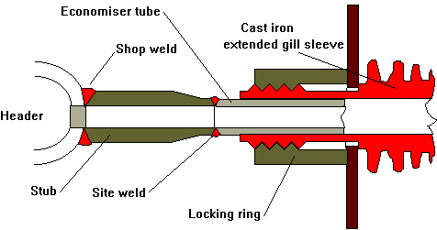

Return end
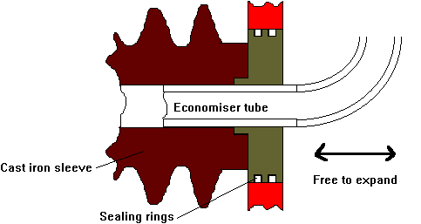
The unit is of the multiple pass 'melesco' style, the sleeves may be slid on before the bends are welded on.
The header is made out of mild steel.

Mild steel fin extended surface economiser
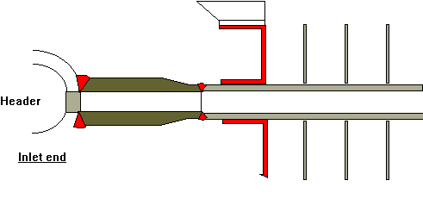
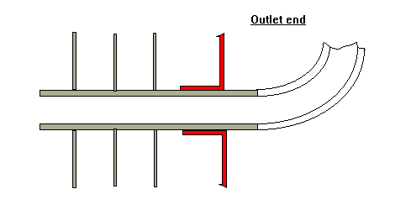
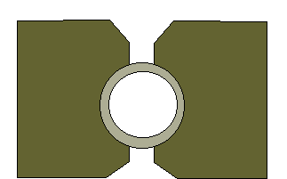

Plug
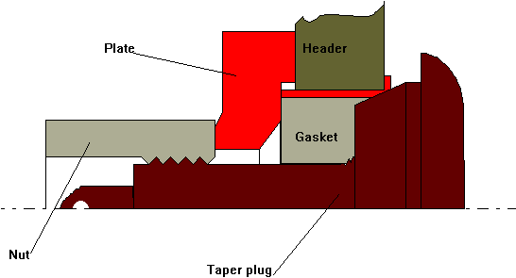

Heat Exchange on Boiler Feed Water
Whenever heat can be recovered from another source, feed water is one of the best streams to receive this heat. The higher the temperature of the feed water going to the boiler, the more efficiently the boiler operates. However, any type of migratory deposition can impede the heat exchange process. Consequently, the highest quality feed water provides the highest heat exchange rate in either economizers or heaters. It is important to understand that none of these heat exchangers can be blown down during boiler operation.

