Feedwater Level Control Systems
In drum-type boilers, the flow of feedwater to the boiler drum is normally controlled in order to hold the level of the water in the steam drum as close as possible to the normal water level (NWL) set point. A typical level control loop would measure level with a level sensor, process this measurement in a proportional or proportional-plus-integral controller, and regulate the flow with a control valve. This typical level control loop usually is inadequate for boiler drum level control.
This inadequacy results from the shrink and swell characteristics of the boiler, which produce level changes during boiler load changes in a direction opposite that to which level would be expected to change with the particular boiler load change. For this reason, control from level alone will produce an incorrect control action any time the boiler load changes.
If, however, the boiler is small, has a relatively large water storage, and the load changes slowly, the simple single element level control may produce control performance that can be tolerated. With larger boilers, relatively less water storage, and faster load changes, the effect of shrink and swell tend to make the simpler systems inadequate.

13-1 Measurement and Indication of Boiler Drum Level
The basic indication of the drum water level is that shown in a sight gage glass connected to the boiler drum. The typical arrangement is shown in Figure 13-1. Since the configuration of the boiler and the distance of the boiler drum from the operator may not provide a useful "line-of-sight" indication, the gage glass image can be projected with a periscope arrangement of mirrors so that the operator may easily view it. In many installations, the use of mirrors to project the water level image to a desired location for viewing may be mechanically complex or practically impossible, and other methods may be necessary. One such method is to use closed-circuit television; yet another is the use of a remote level indicator based on fiber optics.
While the gage glass is the basic measurement, the indication it provides usually is in error to some degree and is not as correct as a properly calibrated level-measuring instrument. The basis for the error can be recognized from Figure 13-1. Condensate from cooling boiler steam circulates through the gage glass. This cooling of the steam and its condensate results in cooler water in the gage glass than in the boiler drum. The greater density of the cool water in the gage glass then shows a lower height water column to balance the column of water in the boiler drum.
Assuming a typical industrial boiler, the gage glass reading often reads I to 3 inches of water below the actual level in the boiler drum. The deviation depends on the boiler pressure and the ambient temperature, plus piping and insulation between the boiler drum and the gage glass. For large high pressure electric utility boilers, the difference may be 5 to 7 inches. Some of the newer types of remote drum level-measuring instruments tend to compensate for the difference in readings described above. This may be in the mechanical design or the potential for moving the gage column closer to the drum.
When this fact is sufficiently understood, most of the error can be eliminated by physically lowering the gage glass. This potential for error must be well understood by anyone dealing with boiler drum level measurement and control, or much unproductive work may be performed in trying to make a gage glass and measuring instrument agree.
These types of drum measurement errors should not be confused with drum level measurement differences between the two ends of the drum. Because of water circulation-induced lateral flows inside the boiler drum, such differences are common. On large electric utility

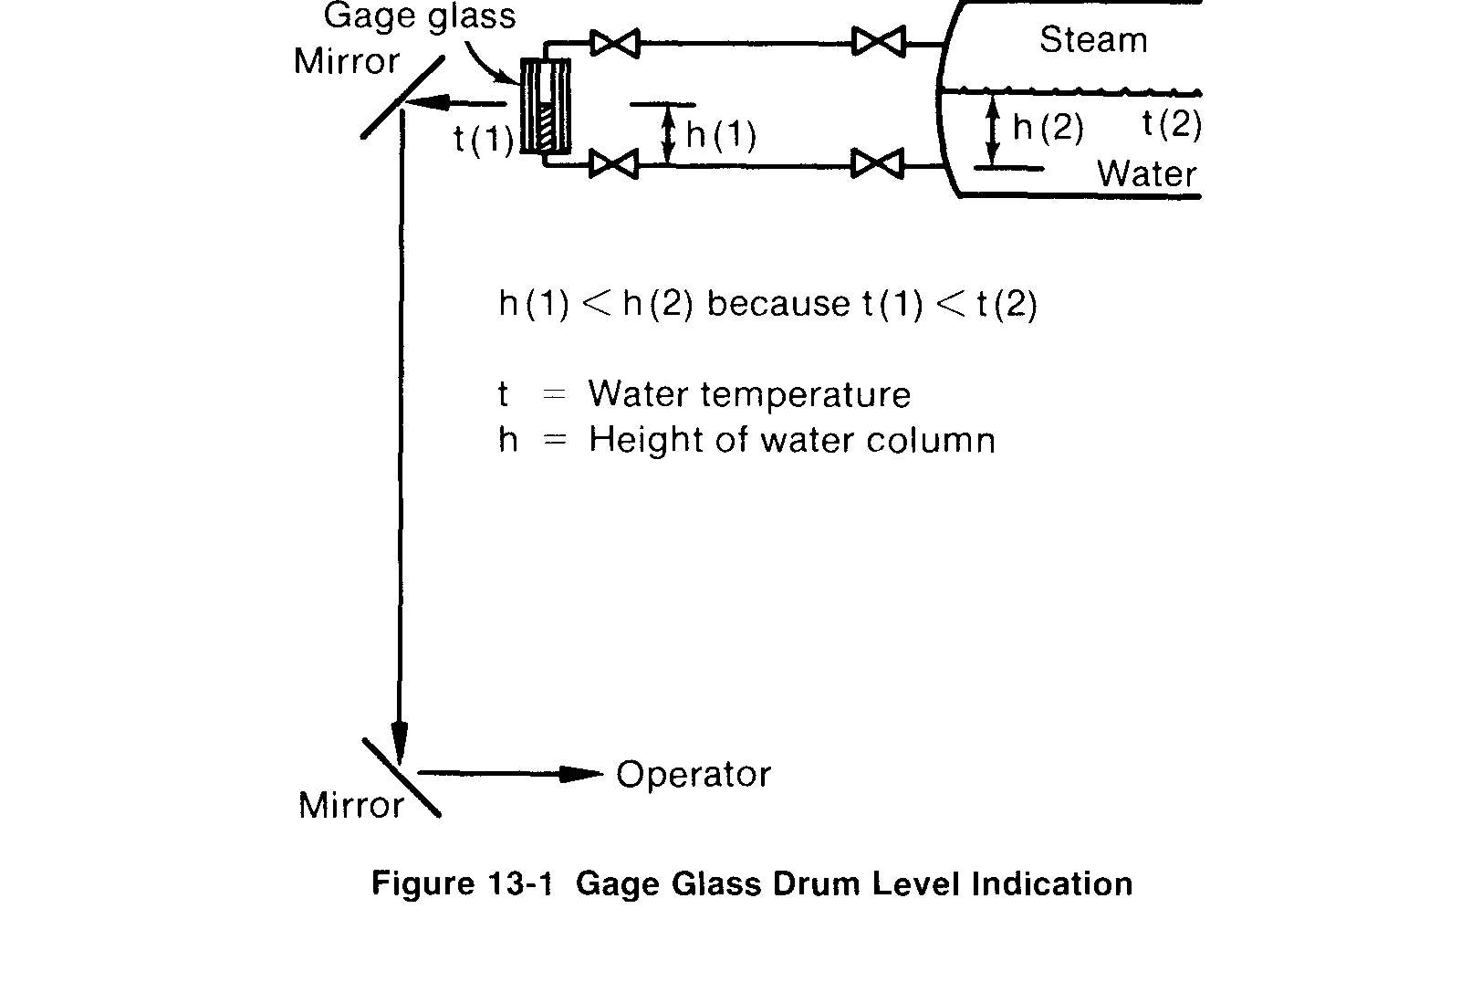

units, differences of six or more inches may be observed. In some cases the higher measure- ment may be at one end of the drum at low boiler loads and at the other end at high flows.
A typical arrangement of a drum level-measuring transmitter is shown in Figure 13-2. The transmitter is a differential pressure device in which the output signal increases as the differ- ential pressure decreases. Typically, the differential pressure range is approximately 30 inches with a zero suppression of several inches.
To determine the measuring instrument calibration, the necessary design data are the lo- cation of the upper and lower pressure taps into the boiler drum with respect to the normal water level, the operating pressure of the boiler drum, and the ambient temperature around the external piping. With these data and the desired range span of the tansmitter, the exact

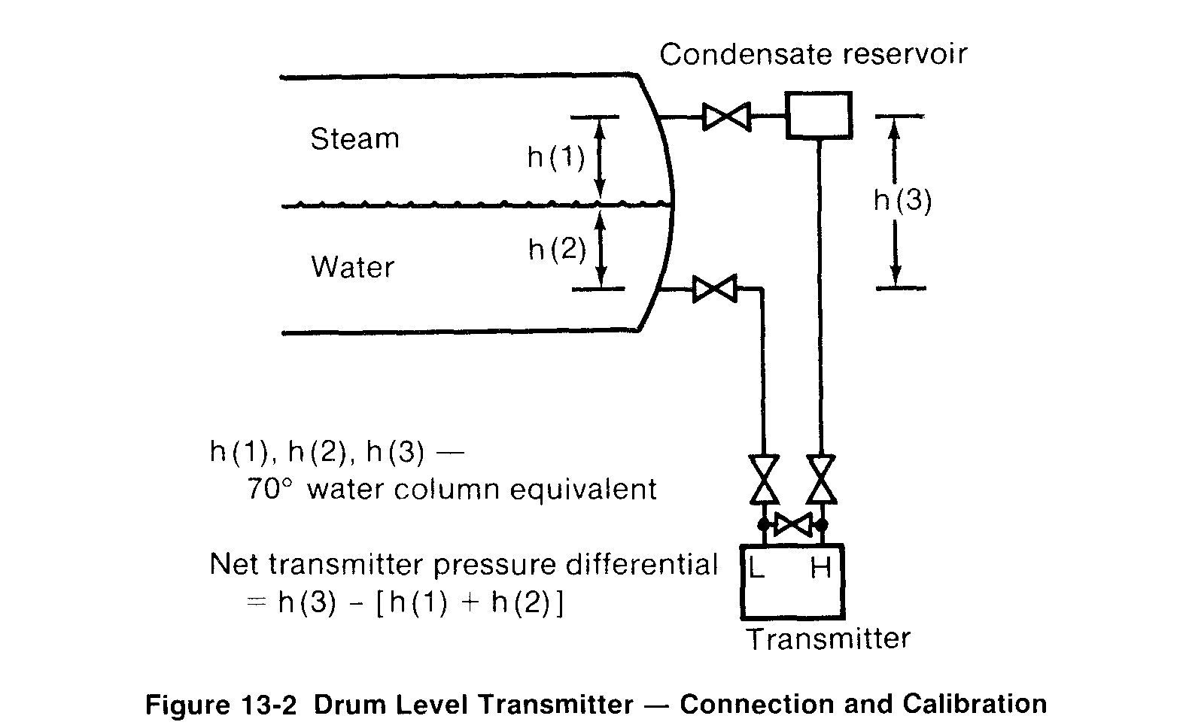

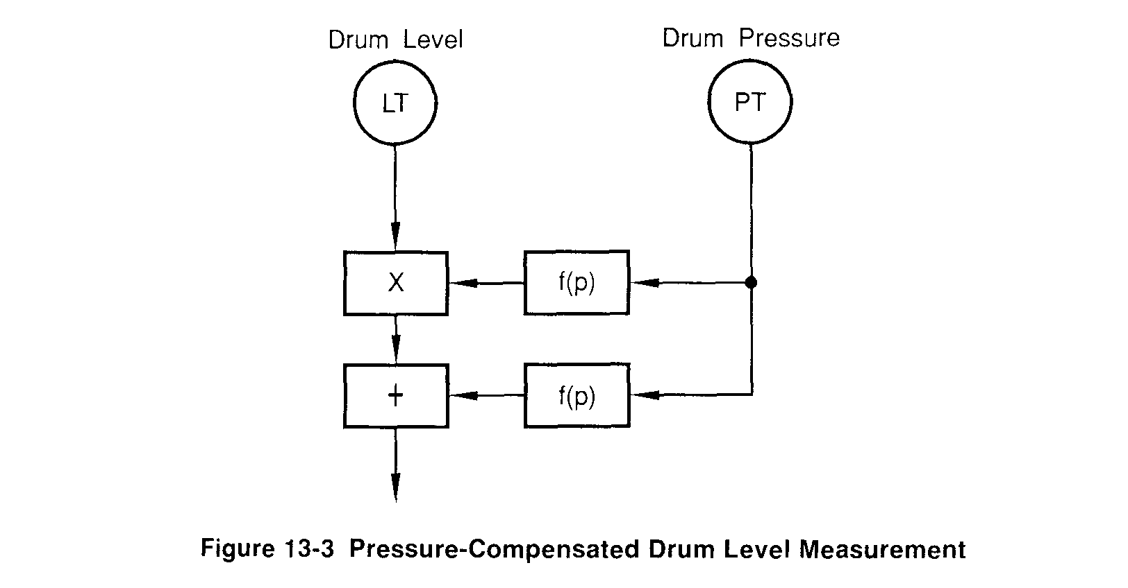
calibration can be calculated by using the standard thermodynamic properties of steam and water.
On the high-pressure side of the measuring device, the effective pressure equals boiler drum pressure plus the weight of a water column at ambient temperature having a length equal to the distance between the two drum pressure connections. On the low-pressure side, the effective pressure equals boiler drum pressure, plus the weight of a column of saturated steam having a length from the upper drum pressure connection to the water level, plus the weight of a column of water at saturation temperature having a length from the water level to the lower drum pressure connection.
Since the instrument measures differential pressure, the boiler drum pressure cancels out, leaving only the water column pressure difference. Since the density of saturated steam and water at saturation temperature changes as drum pressure changes, the level-calibration data will be correct at only a single boiler drum pressure. The signal from the measuring transmitter can be pressure compensated to be correct for all pressures by providing a drum pressure measurement and using it to multiply and bias the basic drum level measurement signal. The computation arrangement is shown in Figure 13-3.
The bias is a calibration value in inches of water that represents the difference in the 100 percent (high) level calibration at a particular pressure compared to the calibration value at the base pressure condition. The multiplication changes the calibration span as the water in the drum changes density due to a change in pressure. The values of bias and multiplication are based on a series of calculations that use different drum pressure data.
Pressure compensation of the boiler drum level measurement is used almost universally on utility boiler applications. Such compensation is usually of little benefit in the normal industrial application where boilers generally operate at a constant pressure throughout the load range.
Because drum level measurement is so important, and because of its measurement uncertainty on large utility boilers, median selecting networks from three separate measurements are often used. This arrangement is shown in Figure 13-4.
13-2 Feedwater Control Objectives
There are several basic objectives of feedwater control systems. Any judgment of performance of these systems should be related to how well these basic objectives are met. The feedwater control system must also cope with external influences or specific drum level characteristics that may tend to degrade the control performance. The major difficulties encountered are shrink and swell and variations in feedwater supply pressure.

In spite of these drawbacks, for drum-type boilers, the system should meet the following objectives:
(1) Control the drum level to a set point.
(2) Minimize the interaction with the combustion control system.
(3) Make smooth changes in the boiler water inventory as boiler load changes. (4) Properly balance the boiler steam output with the feedwater input.
(5) Compensate for feedwater pressure variation without process upset or set point shift.
Of particular importance is the elimination of interaction with the combustion control system. Such interaction is evidenced by uneven flow of feedwater. Such slugs of feedwater may cause upset to the steam pressure, thus resulting in firing rate changes with no changes in the steam flow rate. The firing rate changes cause shrink or swell and accentuate and continue the problem.
Just as there are basic objectives for good feedwater control, there is a basic pattern to the desired relationships of steam flow, feedwater flow, and boiler drum level that indicate good performance of a feedwater control system. The pattern of these relationships that indicate good feedwater control is shown in Figure 13-5. As steam flow increases, an increase in feedwater would be indicated if the boiler drum level did not swell. The drum level increase should cause a reduction in feedwater flow if the steam flow had not increased.
The proper adjustment of the feedwater control system balances these opposing influences so that the basic control objectives listed above are met. If the influence of drum level is too great, the initial control action will be to reduce feedwater flow. This will ultimately cause drum level to move beyond the control set point to make up for the lost water flow. If the influence of steam flow is too great, the initial control action will be to increase feedwater flow. This action will prolong the time period that the drum level is above set point. These two actions are shown in Figure 13-6.

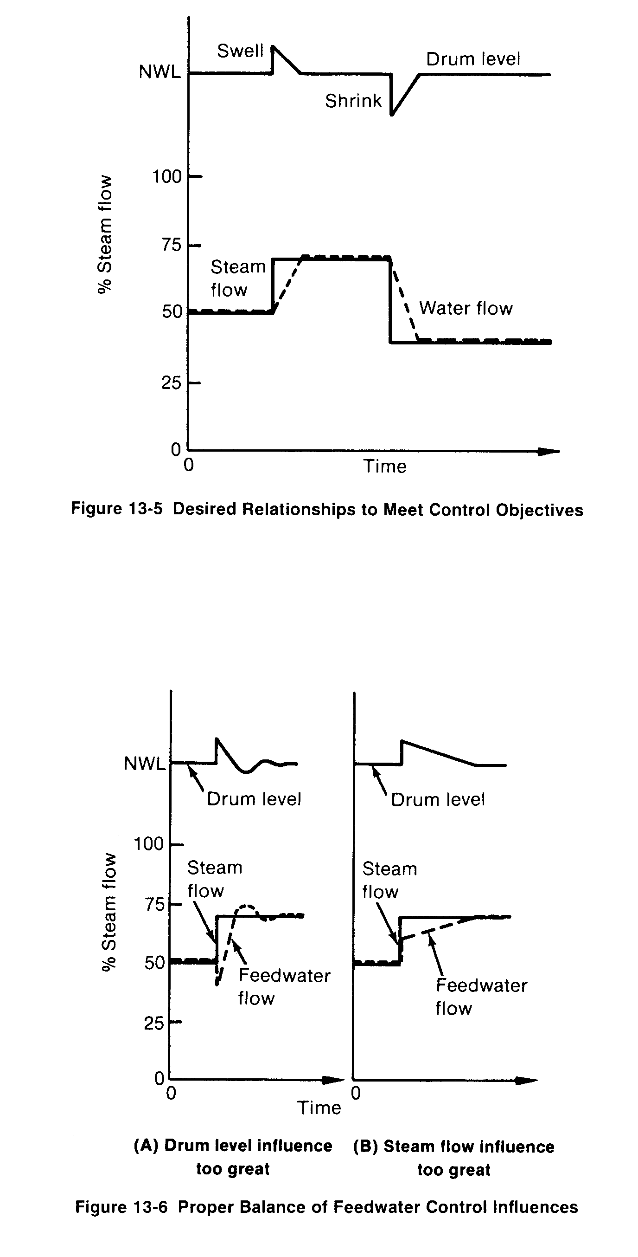
The correct action as shown in Figure 13-5 is for feedwater flow to make no immediate change but rather to gradually change the water inventory as indicated by the return of the drum water level to set point.

13-3 Single-Element Feedwater Control
As indicated above, control of feedwater that relies only on a measurement of drum level will probably be adequate only on smaller boilers with a relatively large water volume and with relatively slow changes in load. The most elementary of such control is the "on-off" control normally used with a firetube boiler.
As shown in Figure 13-7, the level is held within about 3/4 inch. In the typical installation, feedwater flow is 0 or 100 percent depending on whether or not the feedwater pump is running. Theoretically, this would cause interaction with the firing rate control. Though the arrangement has this drawback, the water volume is large, shrink and swell account for only a small amount, steam flow changes are usually slow, and this type of feedwater control is usually adequate. This type of control certainly does not meet the control objectives or the desired pattern of the level and flows involved.
Smooth feeding of the feedwater would tend to eliminate the interactions with combustion control and improve boiler efficiency. More power would be needed for the feedwater pump since it would operate continuously. Even though the potential gain may be small, complete operating data on any particulaF installation can help determine whether control improvement would be economically feasible. If an economizer is used, the feedwater control must be a continuous flow-modulating type to ensure that the feedwater flow continues through the economizer whenever the boiler is being fired. Continuous water flow is necessary to avoid damage to the economizer.
Two general types of mechanical feedwater regulators operate on the single-element (drum level only) basis. These are proportional controls with a permanent level set point offset that is associated with each feedwater control valve position.
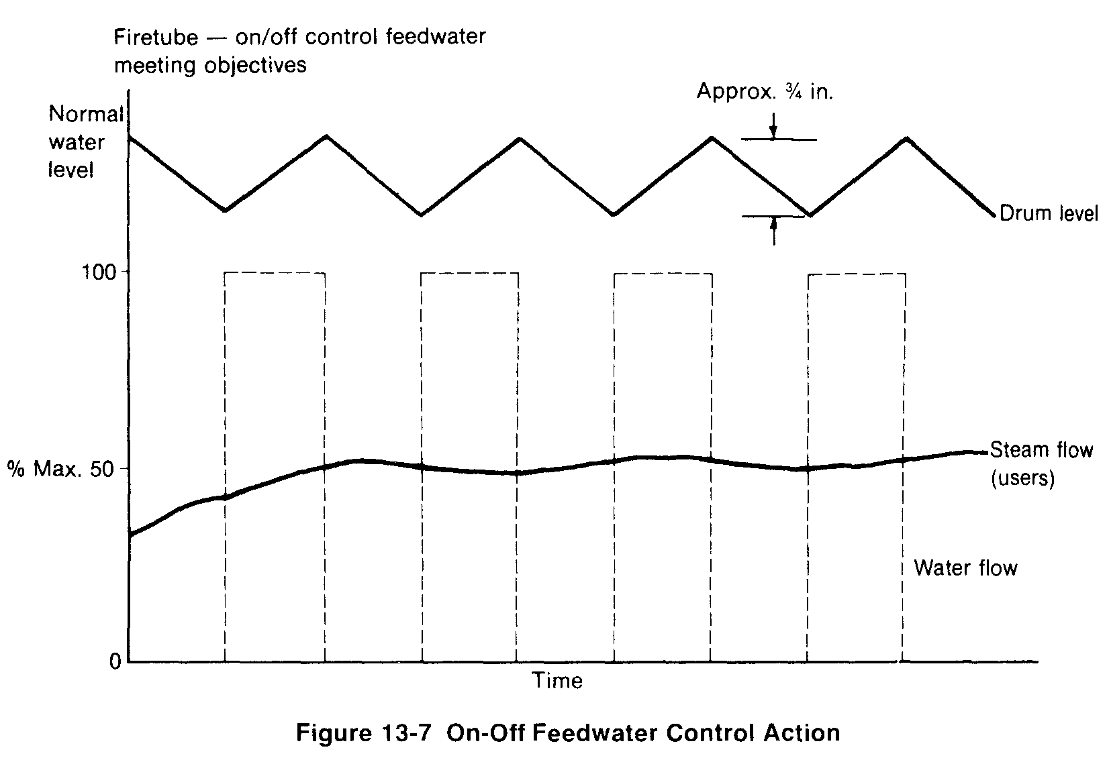

The first of these, called a thermostatic type, is an inclined tube, the ends of which are connected to the steam and water space in the boiler drum. Condensing steam in the upper part of the tube causes circulation and a corresponding water level to be established inside the tube. As drum water level falls, there is more steam in the tube, which causes it to heat and expand in length. The feedwater control valve is mechanically linked to one end of the tube, causing the valve to open or close as the tube expands or contracts. The elevation of the tube must be carefully located to obtain the proper set point range. The controller gain can be changed only by altering the slope of the inclined tube.
The second of the mechanical feedwater regulators is known as the thermohydraulic type. A cross section of this type of regulator is shown in Figure 13-8. As in the thermostatic type, this regulator also has an inclined tube connected to the steam and water space of the boiler. Around this tube is a closed jacket that contains water or other vaporizing fluid. This outer closed jacket is connected by copper tubing to a bellows-operated control valve. As the drum level falls, the water in the outer jacket is exposed to greater heat transfer, the outer jacket pressure increases, and the bellows-operated control valve opens. The gain of this control is fixed by the slope of the generating tube. The normal shift of drum level set point for these two proportional regulators is approximately 4 inches from low load to high load.
The performance of these two devices is very similar and can be recognized from a chart of their typical results shown in Figure 13-9.
While there are significant inadequacies in these results as compared to the basic objectives
of feedwater control, they can be tolerated in most installations of smaller size boilers with slower load changes. The most serious drawback is the interaction with the firing rate control since this would tend to degrade the boiler efficiency.
An improvement in performance over that of the single-element mechanical system can usually be obtained by using a standard feedback control loop as shown in Figure 13-10. Being able to reduce the controller gain results in less interaction. If the controller were proportionalonly as in the mechanical regulator, a greater drum level offset would occur as boiler load changed. Since the low to high load level change is approximately 4 inches, it can be assumed that the 0-100 percent flow change is approximately 5 inches. Assuming a typical measurement range of 30 inches, the gain of this controller would be 6.0. Halving this gain would produce greater stability and less interaction but also twice the proportional offset.
To avoid this unsatisfactory condition, integral control is added. The integral effect must be quite slow since the level signal moves incorrectly at times of boiler drum level swell and shrink. The result as shown in Figure 13-11 is a compromise that is an improvement over the mechanical control but has less than the desired performance. The specific improvement is that the level will return to set point, incorrect action of feedwater flow during load changes is reduced, and the system is generally more stable and less interactive with the firing rate control.
The controlled device, whether a control valve or pump speed control device, should have a linear signal vs. flow characteristic as shown in Figure 13-12. The basic reason for this is that drum level deviations around the set point represent a specific quantity of water over the entire boiler load range. In the case of signal vs. pump speed, this must be nonlinear, as shown, in order that the control signal vs. water flow be as linear as possible. The large increase in pump speed for an initial small increase in control signal brings the pump speed up to the required pressure for admitting water into the boiler.
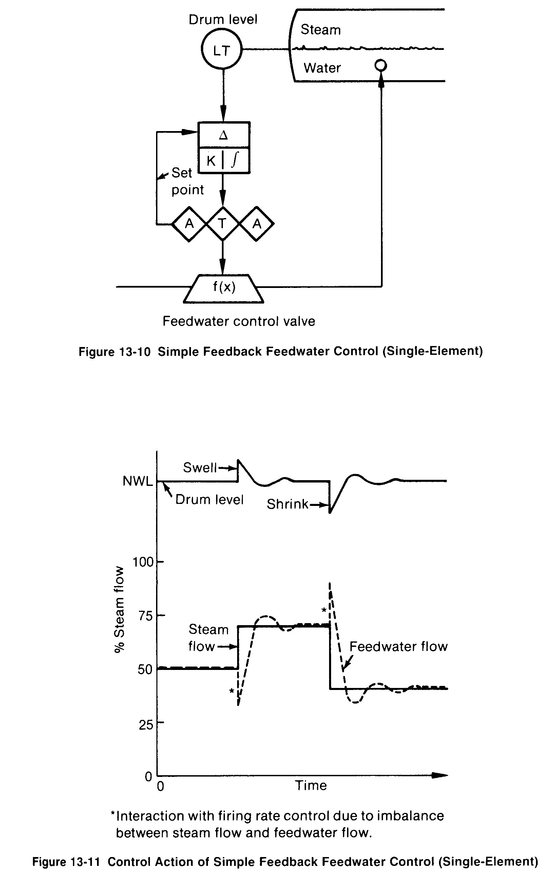

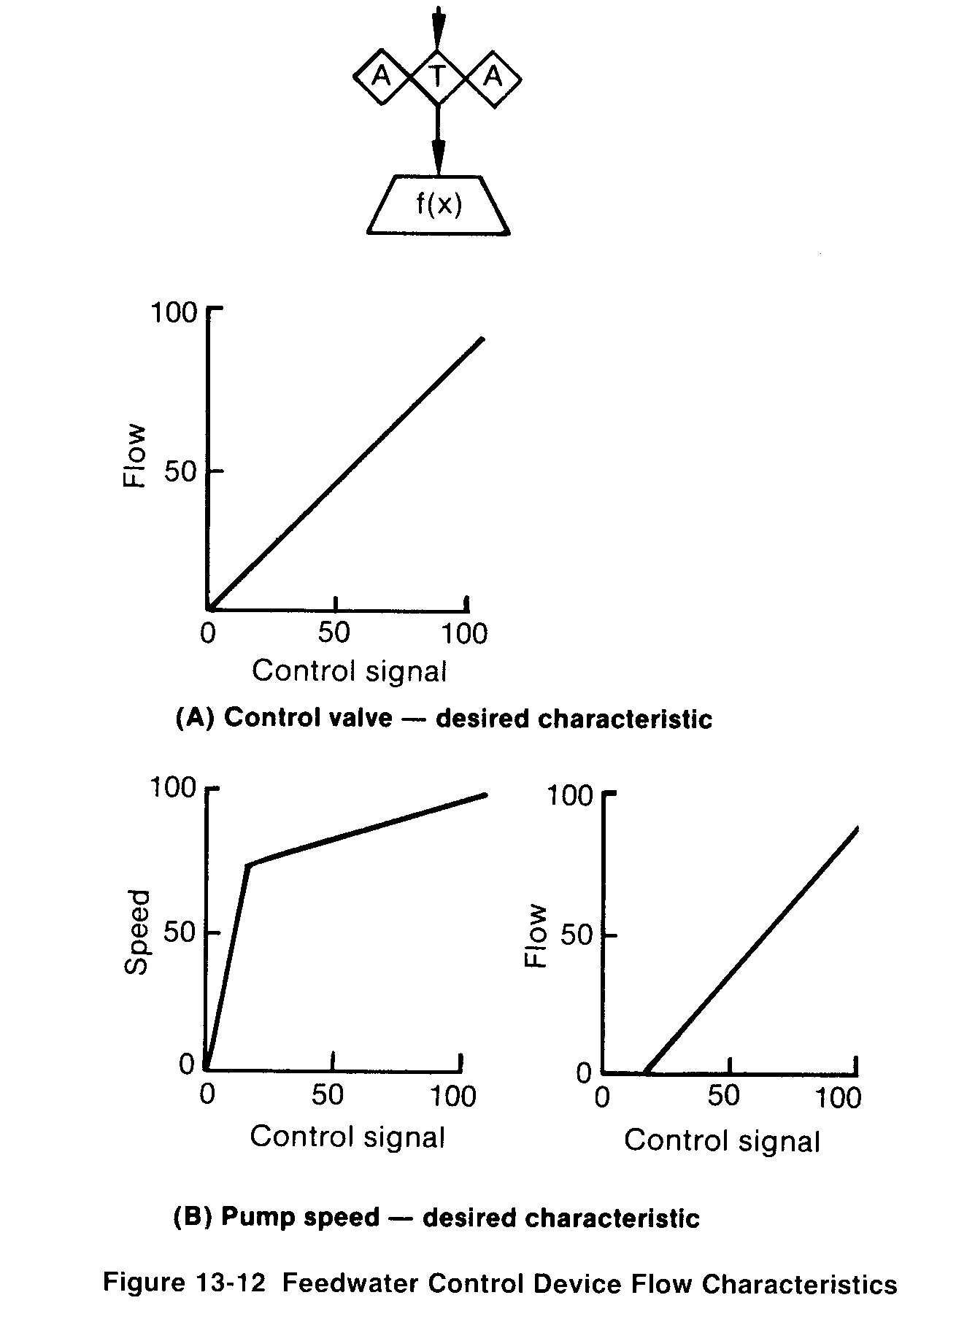
13-4 Two-Element Feedwater Control
A two-element feedwater control system is shown in Figure 13-13. This is easily recognized as a standard feedforward-plus-feedback control loop. In this case steam flow is the feedforward signal that anticipates a need for additional feedwater flow. The feedback control from drum water level is shown as proportional-only control. The control valve is characterized so that the control signal vs. fcedwater flow is linear. For this system to perform properly and hold the drum level at the set point, it is necessary that the differential pressure across the feedwater control valve be predictable at each flow and that the control valve signal vs. flow relationship does not change.
Under the above conditions the system can be tuned so that performance such as shown in Figure 13-14 can be achieved. This performance is recognized as having the desired pattern of flow and level relationships, and such performance meets the boiler feedwater control ob-

jectives that have been stated previously, except that of compensating for feedwater pressure variation.
Tuning such a system for proper action during the shrink and swell period requires the correct balance between the effects of steam flow and drum level. As stated before, the desired condition is for water flow to hold its flow rate during a load change and change only as the drum level begins to return to its set point. In this manner water inventory is smoothly adjusted to its new desired value.
Since the drum level control signal calls for a feedwater decrease as the steam flow signal is calling for an increase, the proper gain settings on steam flow and drum level should cause them to offset each other and affect no immediate change in the water flow control valve signal. As the drum level begins to change, the feedwater valve control signal is changed to keep the system in continuous balance until steam flow and water flow are again equal and drum level is at the set point. At this point, since steam flow and water flow are equal, there is no driving force to cause further changes in boiler drum water level.
Assume that the steam flow signal range is 0 to 100 percent for 0 to 200,000 lbs/hr. Assume that the feedwater control valve is sized for a maximum flow of 250,000 lbs/hr and that the control signal of 0 to 100 percent is linear with respect to this 250,000 lbs/hr flow. The correct feedforward gain in item (a) is 0.8. In this way, if steam flow was at 200.000 lbs/ hr, the 100 percent signal would be multiplied by 0.8 before going to the control valve. The resulting 80 percent of the 250,000 lbs/hr control valve capacity would provide the correct 200,000 lbs/hr of feedwater to match the steam flow.
Assume also that the range of the drum level transmitter is 30 inches with 0 or normal water level at the center with a 50 percent signal. The 0 percent signal corresponds to minus 15 inches and the 100 percent signal to plus 15 inches. A test of the particular boiler indicates that the boiler swell is 2.5 inches as the steam flow is rapidly increased by 20,000 lbs/hr.

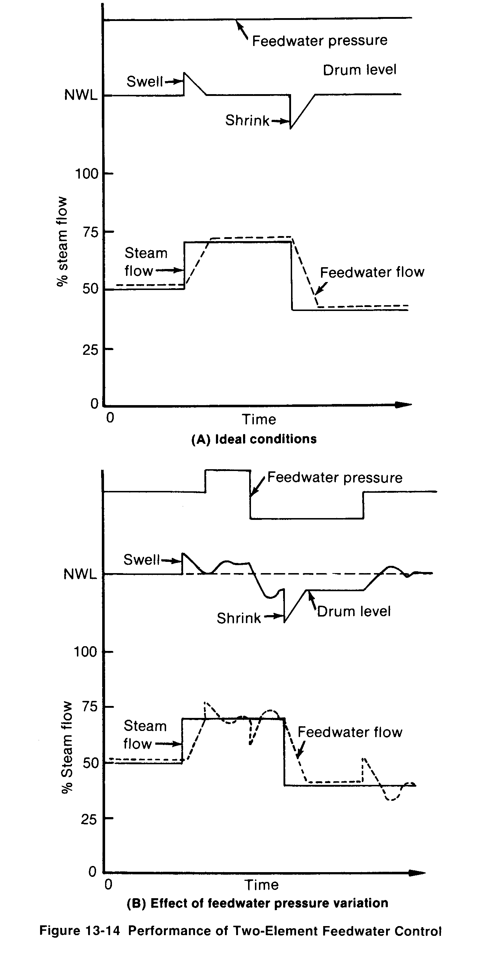

In determining the proper gains so that the steam flow and boiler drum level signals may exactly offset each other, the steam flow gain of 0.8 must remain fixed to correctly match the steam flow range to the control valve range (Figure 13-13, item (a)). The drum level gain in item (b) must therefore be adjusted to match the effect of the 0.8 steam flow gain. Since the steam flow change is 20,000 lbs/hr or 10 percent of maximum, the net effect from steam flow is 0.8 * 10 percent or 8 percent. The drum level has changed 2.5 inches, which is 8.33 percent (2.5/30) of its range. To match the steam flow effect, the gain on the drum level signal must be 0.96 (8/8.33). This gain is then applied to the transmitted signal in item (b) in Figure 13-13. If the swell had been 1.5 inches, the drum level gain would be 1.6 (0.08/0.05).
The calibration of the system includes a bias adjustment to the output signal of item (b) and item (c). The effect of the output of item (b) should have both positive and negative possibility. If the signals in a particular system can have only positive values, the effective output of item (b) at set point should be 50 percent so that it can change in both upward and downward directions. The 50 percent positive bias of the output signal from item (b) requires the normal water level 0 percent output signal to go to 50 percent. The 50 percent signal combines with the steam flow signal from item (a). This requires a negative 50 percent bias to the output signal of item (c) so that the control valve signal will be correct. These two bias values would be 0 for systems that can work with both positive and negative values.
While the system shown will achieve all of the desired control objectives under the con- ditions specified, it has a serious drawback if the feedwater control valve pressure differential and thus the control valve flow characteristic are not always the same. Figure 13-14(B) dem-
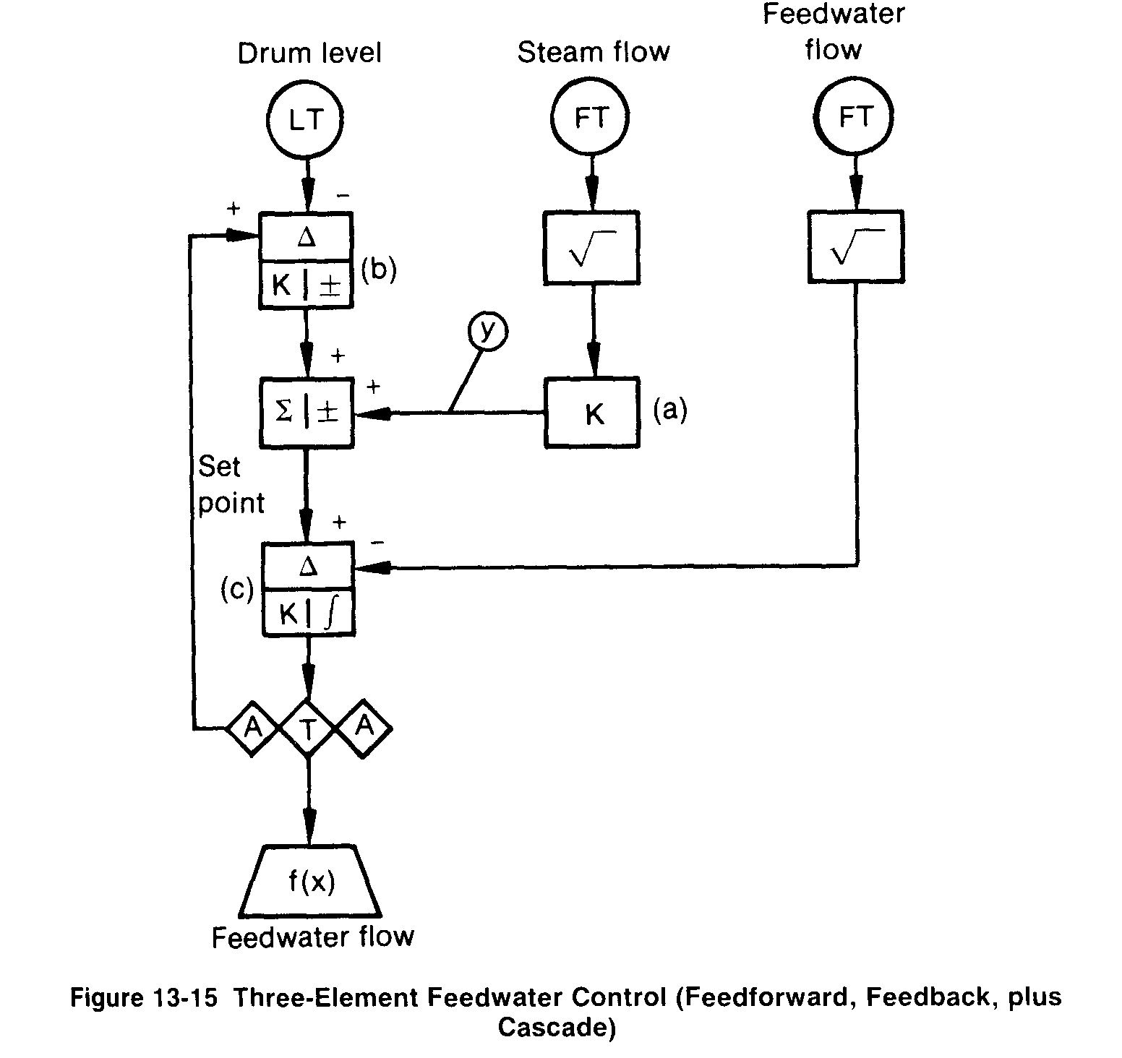

onstrates how the performance is seriously degraded by variations in feedwater pressure. Such feedwater pressure variations change the relationship between steam flow and feedwater flow. Boiler drum level is then forced to develop an offset from set point in order to bring the steam flow and feedwater flow into balance. Under conditions of unpredictable or variable feedwater pressure, three-element feedwater control is necessary ifthe desired results are to be achieved.
13-5 Three-Element Feedwater Control
Two-element feedwater control uses the two mcasuremcnts of steam flow and boiler drum level. Three-element control adds the measurement of fecdwater flow into the control strategy. In the preceding paragraphs, it was demonstrated that an unpredictable feedwater valve control signal vs. feedwater flow characteristic seriously degraded control performance. Three-element control assures that the signal vs. feedwater flow will have a constant relationship by replacing the open-loop flow characteristic of the feedwatcr control valve with a closed-loop feedback control of feedwater flow.
There is more than one way to arrange a three-clement feedwater control systcin, but the most common can be described as a feedforward-plus-feedback cascade control. This arrangement is shown in Figure 13-15. Two other arrangements are shown in Figures 13-16 and 13-17.

The most common arrangement (shown in Figure 13-15) is tuned usinL, the same thought process that is used with the two-element system except that the feedwater flow control is substituted for the control valve characteristic. If the feedwater flow measurement is 0 to 250,000 lbs/hr, and the steam flow measurement is 0 to 200.000 lbs/hr. the gain of item (a) would be 0.8. With the same drum level transmitter and swell effect of 8.33 percent of drum level span for a 10 percent change in steam flow rate, the gain of the proportional level control (b) would be 0.96.
The tuning of the feedwater control loop would be typical of a flow control loop. A reasonable starting point for the tuning of the flow controller (c) would be a gain of' 0.5 and an integral setting of 10 repeats per minute. The tuning and calibration constants of the control arrangements in Figures 13-16 and 13-17 should be identical to those of the arrangement in Figure 13-15.
Properly tuned, the performance of the three-element control should appear approximately as shown in Figure 13-18. Note that this performance, although the fecdwater supply pressure may vary, meets all the control objectives and contains the correct pattern of relationships between steam flow, teedwater flow, and boiler drum level.
In some applications, the drum level measurement contains process noise irom slight to severe fluctuations in drum level. In addition, the measured steam flow may contain fluctuations or process noise. These noise components may cancel or add depending on their characteristics. If they add, they often create control stability problems. The control arrangement in Figure 13-16 offers more flexibility in eliminating the undesirable process noise eNects. In

Cascade, Feed Forward and Boiler Level Control
By Allen D. Houtz ¹
One common application of cascade control combined with feed forward control is in level control systems for boiler steam drums.
The control strategies now used in modern industrial boiler systems had their beginnings on shipboard steam propulsion boilers. When boilers operated at low pressure, it was reasonably inexpensive to make the steam drum large. In a large drum, liquid level moves relatively slowly in response to disturbances (it has a long time constant). Therefore, manual or automatic adjustment of the feedwater valve in response to liquid level variations was an effective control strategy.
But as boiler operating pressures have increased over the years, the cost of building and installing large steam drums forced the reduction of the drum size for a given steam production capacity.
The consequence of smaller drum size is an attendant reduction in process time constants, or the speed with which important process variables can change. Smaller time constants mean upsets must be addressed more quickly, and this has led to the development of increasingly sophisticated control strategies.
As shown below (click for large view), most boilers of medium to high pressure today use a â€œ3-elementâ€ boiler control strategy. The term â€œ3-element controlâ€ refers to the number of process variables (PVs) that are measured to effect control of the boiler feedwater control valve. These measured PVs are:
- liquid level in the boiler drum,
- flow of feedwater to the boiler drum, and
- flow of steam leaving the boiler drum.
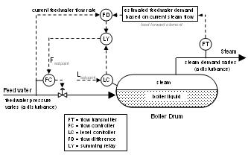
Maintaining liquid level in the boiler steam drum is the highest priority. It is critical that the liquid level remain low enough to guarantee that there is adequate disengaging volume above the liquid, and high enough to assure that there is water present in every steam generating tube in the boiler. These requirements typically result in a narrow range in which the liquid level must be maintained.
The feedwater used to maintain liquid level in industrial boilers often comes from multiple sources and is brought up to steam drum pressure by pumps operating in parallel. With multiple sources and multiple pumps, the supply pressure of the feedwater will change over time. Every time supply pressure changes, the flow rate through the valve, even if it remains fixed in position, is immediately affected.
So, for example, if the boiler drum liquid level is low, the level controller will call for an increase in feedwater flow. But consider that if at this moment, the feedwater supply pressure were to drop. The level controller could be opening the valve, yet the falling supply pressure could actually cause a decreased flow through the valve and into the drum.
Thus, it is not enough for the level controller to directly open or close the valve. Rather, it must decide whether it needs more or less feed flow to the boiler drum. The level controller transmits its target flow as a set point to a flow controller. The flow controller then decides how much to open or close the valve as supply pressure swings to meet the set point target.
This is a â€œ2-elementâ€ (boiler liquid level to feedwater flow rate) cascade control strategy. By placing this feedwater flow rate in a fast flow control loop, the flow controller will immediately sense any variations in the supply conditions which produce a change in feedwater flow. The flow controller will adjust the boiler feedwater valve position to restore the flow to its set point before the boiler drum liquid level is even affected. The level controller is the primary controller (sometimes referred to as the master controller) in this cascade, adjusting the set point of the flow controller, which is the secondary controller (sometimes identified as the slave controller).
The third element in a â€œ3-element controlâ€ system is the flow of steam leaving the steam drum. The variation in demand from the steam header is the most common disturbance to the boiler level control system in an industrial steam system.
By measuring the steam flow, the magnitude of demand changes can be used as a feed forward signal to the level control system. The feed forward signal can be added into the output of the level controller to adjust the flow control loop set point, or can be added into the output of the flow control loop to directly manipulate the boiler feedwater control valve. The majority of boiler level control systems add the feed forward signal into the level controller output to the secondary (feedwater flow) controller set point. This approach eliminates the need for characterizing the feed forward signal to match the control valve characteristic.
Actual boiler level control schemes do not feed the steam flow signal forward directly. Instead, the difference between the outlet steam flow and the inlet water flow is calculated. The difference value is directly added to the set point signal to the feedwater flow controller. Therefore, if the steam flow out of the boiler is suddenly increased by the start up of a turbine, for example, the set point to the feedwater flow controller is increased by exactly the amount of the measured steam flow increase.
Simple material balance considerations suggest that if the two flow meters are exactly accurate, the flow change produced by the flow control loop will make up exactly enough water to maintain the level without producing a significant upset to the level control loop. Similarly, a sudden drop in steam demand caused by the trip of a significant turbine load will produce an exactly matching drop in feedwater flow to the steam drum without producing any significant disturbance to the boiler steam drum level control.
Of course, there are losses from the boiler that are not measured by the steam production meter. The most common of these are boiler blow down and steam vents (including relief valves) ahead of the steam production meter. In addition, boiler operating conditions that alter the total volume of water in the boiler cannot be corrected by the feed forward control strategy. For example, forced circulation boilers may have steam generating sections that are placed out of service or in service intermittently. The level controller itself must correct for these unmeasured disturbances using the normal feedback control algorithm.
1. Allen D. Houtz
Consulting Engineer
Automation System Group
P.O. Box 884
Kenai, AK 99611
Email: ifadh@uaa.alaska.edu
Posted By: controlguru @ 5:27 am permalink

4 Responses to â€œCascade, Feed Forward and Boiler Level Controlâ€
- Fred_Thomasson Says:
February 20th, 2006 at 5:18 pm
Allen, I found that some power boilers have a significant â€œshrink-swell effectâ€ on the drum level that often causes drum-level trips. These boilers require particular attention to the drum level control. Consider the situation where the firing rate of the boiler must be increased rapidly to maintain steam header pressure. This causes the drum level to â€œswellâ€ while the boiler steam generation is suddenly increasing(because of a decreasing steam header pressure and increasing firing rate). The drum level element starts reducing the feedwater demand while the steam feed forward element is increasing the feedwater demand. I have found that it is advantageous to insert a first order lag of approximately 30 to 40 seconds in series with the steam feed forward. This allows the drum level element a little time to reduce the level before the feed forward picks up the feedwater(as it must ultimately do). This can make the difference of 1 to 2 inches on drum level excursions. If the â€œshrink-swellâ€ is bad, then I add a 4th element using the fuel flow. I think Iâ€™ll leave out the description of how this element works as it is fairly complicated to describe with just words.
Fred Thomasson
fthomasson@comcast.net
- Houtz Says:
February 24th, 2006 at 1:42 am
Fred Thomasson:
Yes, shrink/swell is a common problem. The normal approach to this problem is to provide a lead-lag relay on the feed forward signal from the flow difference relay.
From your comments, I gather that your boiler would trip out on a high level during a sudden load increase. In general, on boilers I have worked on, I had a lot more room to move in the upward direction than in the downward direction. Consequently, the big issue was normally avoiding a low level trip.
The insertion of the time lag that you describe is essentially the same as using a lead-lag with the lead set to zero. It is surprising to me that letting the level controller move the feedwater valve in the wrong direction for perhaps about a minute improves the control of a boiler, but I suppose it could happen that way. Generally, putting in time constants to delay a control signal seems to degrade control quality.
The shrink/swell behavior is always asymetrical, and in my experience, difficult to quantify. One thing I wondered about as I read your comment was whether the feedwater stream is much cooler than saturation temperature. I have worked on boilers where a sudden increase in boiler feedwater flow would significantly reduce the boil up from the boiler causing additional drop in drum pressure. Could this effect have anything to do with your experience?
In any event, thanks for your comments.
Allen Houtz
- Steve Says:
April 2nd, 2006 at 4:48 am
Allen, Fred,
Sometime a bit of swell isnâ€™t such a bad thing. We have a CCGT HRSG that does a very good job keeping drum level constant - too good in fact. This means that our condensor level has to swing, sometime by quite a bit (DA usually out of service). We think that a bit of â€œsliding mode level controlâ€ wouldnâ€™t be a bad thing. In the nuclear industry they call it constant inventory control (I thinkâ€¦). This means the drum level setpoint is some linear function of load, more load equates to more level in the drum. The idea being to have a constant mass of water in the drum. Have any of you come accross this before?
Any and all comments welcome.
Steve B.
- Houtz Says:
April 9th, 2006 at 11:17 pm
Steve,
In shipboard applications where I have encountered the â€œconstant massâ€ approach, it meant that the differential (from which level is inferred)is measured across the entire boiler rather than just the steam drum. The lower tap (HP tap) needs to be below the lowest steam generating tube. When level is measured in this way, the swell phenomenon is not even detected. The drop in density (or increase for shrink) in the risers exactly compensates for the higher level (or lower level for shrink) that is produced when the risers â€œburpâ€ a bunch of liquid into the steam drum.
The down side to this approach is that the ability to measure the liquid level at the steam disengaging surface is lost. Because of the higher spans involved, the resolution is poorer than when the steam drum alone is measured. In addition, the variation in density in the risers (and downcomers) means that even perfect differential measurement cannot reveal the physical location of the liquid-vapor interface.
My objective is to continue the discussion I began in the article Cascade, Feed Forward and Boiler Level Control. Here I explore the causes and cures of the dynamic shrink/swell phenomena in boilers.
Boiler Start-up
As high pressure boilers ramp up to operating temperature and pressure, the volume of a given amount of saturated water in the drum can expand by as much as 30%. This natural expansion of the water volume during start-up is not dynamic shrink/swell as discussed later in this article, though it does provide its own unique control challenges.
The expansion (or more precisely, decrease in density) of water during start-up of the boiler poses a problem if a differential pressure or displacer instrument is used for level measurement. Such a level transmitter calibrated for saturated water service at say, 600 psig, will indicate higher than the true level when the drum is filled with relatively cool boiler feedwater at a low start-up pressure.
If left uncompensated at low pressure conditions, the â€œhigher than true levelâ€ indication will cause the controller to maintain a lower than desired liquid level in the drum during the start-up period. If the low level trip device is actually sensitive to the interface (e.g. conductance probes or float switches), troublesome low level trip events become very likely during start-up.
This variation in the sensitivity of the level transmitter with operating conditions can be corrected by using the drum pressure to compensate for the output of the level transmitter. The compensation can be accomplished with great accuracy using steam table data. The compensation has no dynamic significance and can be used independent of boiler load or operating pressure.
Dynamic Shrink/Swell
Dynamic shrink/swell is a phenomenon that produces variations in the level of the liquid surface in the steam drum whenever boiler load (changes in steam demand) occur. This behavior is strongly influenced by the actual arrangement of steam generating tubes in the boiler.
I have significant experience with â€œwater wallâ€ boilers that have radiant tubes on three sides of the firebox. There is a steam drum located above the combustion chamber and a mud drum located below the combustion chamber (click for large view).
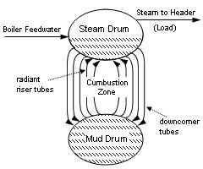
During operation, the tubes exposed to the radiant heat from the flame are always producing steam. As the steam rises in the tubes, boiler water is also carried upward and discharged into the steam drum. Tubes that are not producing significant steam flow have a net downward flow of boiler water from the steam drum to the mud drum.
The tubes producing large quantities of steam are termed risers and those principally carrying water down to the mud drum from the steam drum are termed downcomers. Excluding the tubes subject to radiant heat input from the firebox flame, a given tube will serve as a riser at some firing rates and a downcomer at other firing rates.
The mechanics of the natural convection circulation of boiler water within the steam generator is the origin of the dynamic shrink/swell phenomenon. Consider what happens to a boiler operating at steady state at 600 psig when it is subjected to a sudden increase in load (or steam demand).
A sudden steam load increase will naturally produce a drop in the pressure in the steam drum, because, initially at least, the firing rate cannot increase fast enough to match the steam production rate at the new demand level. When the pressure in the drum drops, it has a dramatic effect on the natural convection within the boiler. The drop in pressure causes a small fraction of the saturated water in the boiler to immediately vaporize, producing a large amount of boil-up from most of the tubes in the boiler. During the transient, most of the tubes temporarily become risers. The result is that the level in the steam drum above the combustion chamber rises.
However, this rise in level is actually an inverse response to the load change. Since, the net steam draw rate has gone up, the net flow of water to the boiler needs to increase, because the total mass of water in the boiler is falling. However, the level controller senses a rise in the level of the steam drum and calls for a reduction in the flow of feedwater to the boiler.
This inverse response to a sudden load increase is dynamic swell. Dynamic shrink is also observed when a sudden load decrease occurs. However, the dynamic shrink phenomenon does not disrupt the natural convection circulation of the boiler as completely as the dynamic swell effect. Consequently, the reduction in level produced by a sudden decrease in load is typically much smaller and of shorter duration than the effect produced by dynamic swell.
Control Strategy for Shrink/Swell
What control strategies are used to deal with this unpleasant inverse system response? The basic three-element control system we have previously discussed in the article Cascade, Feed Forward and Boiler Level Control provides the most important tool.
When a sudden load (steam demand) increase occurs, the feed forward portion of the strategy will produce an increase in the set point for the feedwater flow controller. This increase in feedwater flow controller set point will be countered to varying degrees by the level controller response to the temporary rise in level produced by the dynamic swell.
The standard tool used to minimize the impact of the swell phenomenon on the level in a three-element level control system is the lead-lag relay in the feed forward signal from the flow difference relay. This is the traditional means of dealing with mismatched disturbance and manipulated variable dynamics in feed forward systems, and is certainly applicable in this control strategy. When used in the three-element level control strategy, the lead-lag relay is commonly termed the â€œshrink/swell relay.â€
There are two significant limitations to the use of the lead-lag relay for shrink/swell compensation. To begin with, the response of most boilers to a load increase (swell event) is much more dramatic than the response to a load decrease (shrink event). In other words, the system response is very asymmetric. The lead-lag relay is perfectly symmetrical in responding to load changes in each direction and cannot be well matched to both directions.
Furthermore, the standard method of establishing the magnitudes of the lead time constant and lag time constant involves open loop tests of the process response to the disturbance (steam load) and to the manipulated variable (feedwater flow). A step test of the manipulated variable is generally not too difficult to conduct. However, changing the firing rate upward fast enough to actually produce significant swell is difficult without seriously upsetting the steam system, an event that is to be avoided in most operating plants. Therefore, the practitionerâ€™s only choice is to gather accurate data continuously and wait for a disturbance event that will exercise the shrink/swell relayâ€™s function.
When a lead-lag relay is to be added to an existing three-element boiler control scheme, operator knowledge of the boiler behavior in sudden load increase situations can guide the initial settings. For example, if the operators indicate that they must manually lead the feedwater valve by opening it faster than the control system will open it automatically, it is clear that a lead time constant larger than the lag time is required. Similarly, if the operator must retard the valve response to prevent excessively high level, the lead time constant must be less than the lag time. The lag time constant will typically fall in the range of one minute to three minutes. The ratio of the lead time constant to the lag time constant determines the magnitude of the initial response to the disturbance. If the ratio is one to one, the system behaves the same as a system with no lead-lag relay.
Ultimately, the system must be adjusted by watching the response to actual steam system upsets that require sudden firing increases. If the initial observed response of level to an upset is a rising level, the ratio of lead time to lag time should be decreased. The inverse is similarly true. If the recovery from an initial rise in level is followed by significant overshoot below the level target, the lag time should be reduced. If the recovery from an initial level drop is followed by a large overshoot above the level target, the lag time should be increased.

