Combustion and draught control
when considering fired boilers and heat-recovery steam generators it is clear that in the areas of their steam and water circuits there are many similarities between them (although the HRSG may have two or more pressure systems). But when the systems for controlling the heat input are examined, the two types of plant take on altogether different characteristics. The reason for this is fundamental: within the HRSG, no actual combustion process is involved, since all the heat input is derived from the gas-turbine exhaust (except where supplementary firing is introduced between the gas turbine and the HRSG). The subject of combustion control, which we shall be examining in this chapter, is therefore only relevant to fired plant.
Naturally, in a fired boiler the control of combustion is extremely critical In order to maximise operational efficiency combustion must be accurate, so that the fuel is consumed at a rate that exactly matches the demand for steam and it must be executed safely, so that the energy is released without risk to plant, personnel or environment. (The amount of energy involved in a power plant is considerable: in each second of its operation a large boiler releases around a billion joules, and in a process of this scale the results of an error can be catastrophic.)
In this chapter we shall see how the combustion process is controlled to meet the two objectives defined in the previous paragraph. We shall also examine the subsidiary systems that maintain the correct operational conditions in the fuel-handling plant of coal-fired boilers.
5.1 The principles of combustion control

In Chapter 3 we saw that the theoretically perfect combustion of 'a fuel requires the provision of exactly the right amount of air needed for complete combustion of the fuel. For the boiler as a whole this means that the total amount of air being delivered to the combustion chamber at any instant matches the total amount of fuel entering that chamber at that time. For an individual burner it means that the fuel and air being delivered to the burner are always in step with one another.
On the surface, therefore, it would appear that the matter of combustion control merely involves keeping the fuel and air inputs in step with each other, according to the demands of the master, and if this were true this role would be adequately addressed by a straightforward flow ratio controller. Unfortunately, when the realities of practical plant are involved, the situation once again becomes far more complex than this simple analysis would suggest.
When the relationship between the fuel and air flowing at any instant into the furnace is chemically ideal for combustion, the relationship between the two flows is known as the stoichiometric fuel/air ratio. However, as stated earlier, it is usually necessary to operate at a fuel/air ratio that is different from this theoretically optimal value, generally with a certain amount of excess air. All the same, even though more than the theoretical amount of air has to be provided, any overprovision of air reduces the efficiency of the boiler and results in undesirable stack emissions, and must therefore be limited.
The reduction in efficiency is due to losses which are composed of the heat wasted in the exhaust gases and the heat which is theoretically available in the fuel, but which is not burned. As the excess-air level increases, the heat lost in the exhaust gases increases, while the losses in unburned fuel reduce (the shortage of oxygen at the lower levels increasing the degree of incomplete combustion that occurs;. The sum of these two losses, plus the heat lost by radiation from hot surfaces in the boiler and its pipe work, is identified as the total loss.
Figure 5.1 shows that operation of the plant at the point identified at `A' will correspond with minimum losses, and from this it may be assumed that this is the point to which the operation of the combustion-control system should be targeted. However, in practice air is not evenly distributed within the furnace. For example, operational considerations require that a supply of cooling air is provided for idle burners and flame monitors, to prevent them being damaged by heat from nearby active burners and by ~4eneral radiation from the furnace. Air also enters the

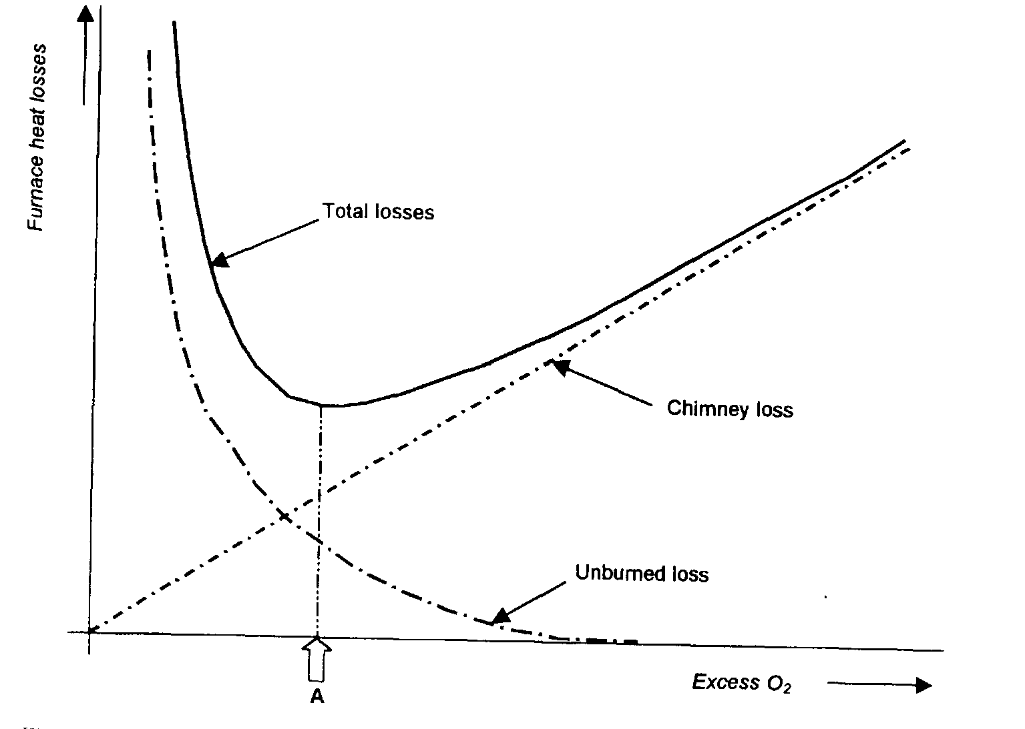
combustion chamber through leaks, observation ports, soot-blower entry Points and so on. The sum of all this is referred to as `tramp air' or `setting leakage'. If this is included in the total being supplied to the furnace, and if that total is apportioned to the total amount of fuel being fired, the implication is that some burners (at least) will be deprived of the air they need f()r (lie combustion of their fuel. In other words, the correct amount of air is being provided in total, but it is going to places where it is not available for the combustion process.
Operation of the firing system must take these factors into account, and froin then on the system can apportion the fuel and air flows. If these are maintained in a fixed relationship with each other over the full range °f flows, the amount of excess air will be fixed over the entire range.
5'1•1 A simple system: `parallel control'
11 he easiest way of maintaining a relationship between fuel flow and air flow is to use a single actuator to position a fuel-control valve and an air"ontrol damper in parallel with each other as shown in Figure 5.2. Here,

the opening of an air-control damper is mechanically linked to the opening of afuel control v/v to maintain a defined relationship between

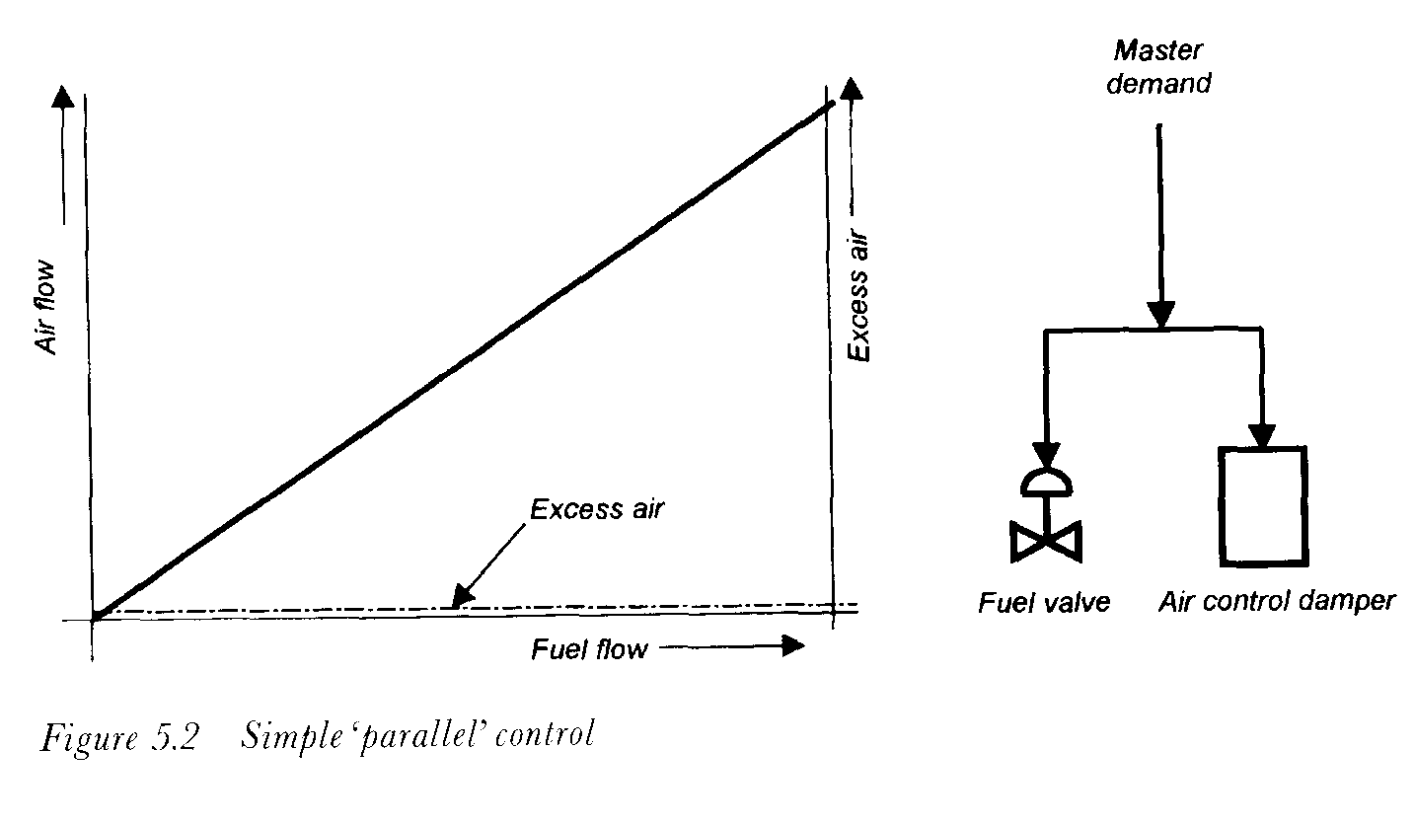
fuel flow and air flow. This system is employed in very small boilers, and a variant allows a non-linear relationship between valve opening and damper opening to be determined by the shape of a cam, with a range of cams offering a variety of relationships.
Although this simple system may be quite adequate for very small boilers burning fuels such as oil or natural gas, its deficiencies become increasingly apparent as the size of the plant increases.
One limitation of the system is that it assumes that the amount of fuel flowing through the valve and the quantity of air flowing past the damper will remain constant for a given opening of the respective devices. In practice, if a valve or damper is held at a given opening, the flow past it will change as the applied pressure changes. Furthermore, the flow will also be affected by changes in the characteristics of the fuel and air, notably their densities.
Another problem is that the response times of the fuel and air systems are never identical. Therefore, if a sudden load-change occurs and the two controlling devices are moved to predetermined openings, the flows through them will react at different rates. With an oil-fired boiler, a sudden increase in demand will cause the fuel flow to increase quickly, but the air system will be slower to react. As a result, if the fuel/air ratio was correct before the change occurred, the firing conditions after the change will tend to become fuel-rich until the air system has had time to catch Up. This causes characteristic puffs of black smoke to be emitted as unburned fuel is ejected to the chimney.
On a load decrease the reverse happens and the mixture in the combustion
chamber becomes air rich. The resulting high oxygen content could

figurations of Figure 5.3.
In each of these systems the master demand (not shown) is used to set the quantity of one parameter being admitted to the furnace, while a controller maintains an adjustable relationship between the two flows (fuel and air). Either of the flows can be selected to be the one that responds directly to the master and, in Section 5.1.2.1, we shall see the different effects that result when fuel flow or air flow is used in this way.
In the system shown in Figure 5.3a a gain block or amplifier in one of the flow-signal lines is used to adjust the ratio between the two flows. As the gain (g) of this block is changed, it alters the slope of the fuel-flow/airflow characteristic, changing the amount of excess air that is present at each flow. Note that when the gain is fixed, the amount of excess air is the same for all flows, as shown by the horizontal line.
In practice, this situation would be impossible to achieve, since some air inevitably leaks into the furnace, with the result that the amount of excess air is proportionally greater at low flows than high flows. This causes the excess-air line to curve hyperbolically upwards at low flows much as is shown in Figure 5.3b). Practical burner requirements demand that the quantity of air should always be slightly greater than that which the theoretical stoichiometric ratio would dictate. The characteristic F+: could therefore not pass through the origin of the graph as is shown in Figure 5.3a.
Figure 5.3b shows a different control arrangement working with the same idealised plant (i.e. one with no air leaking into the combustion chamber). Here, instead of a gain function, a bias is added to one of the signals. The effect of this is that a fixed surfeit of air is always present and this is proportionally larger at the smaller flows, with the result that the amount of excess air is largest at small flows, as shown. Changing the bias signal (b) moves the curve bodily as shown.
Each of these control configurations has been used in practical plant, although the version with bias (Figure 5.3b) exacerbates the effects of tramp air and therefore tends to be confined to smaller boilers. The ^{ar}rangement shown in Figure 5.3a therefore forms the basis of most
practical fuel/air ratio control systems.

In these illustrations it has been assumed that the master demand is fed to the fuel valve, leaving the air-flow controller to maintain the fuel/air ratio at the correct desired value. When this is done, the configuration is known as a`fuel lead' system since, when the load demand changes, the fuel flow is adjusted first and the controller then adjusts the air flow to match the fuel flow, after the latter has changed.
It doesn't have to be done this way. Instead, the master demand can be relayed to the air-flow controller, which means that the task of maintaining the fuel/air ratio is then assigned to the fuel controller. For obvious reasons this is known as an'air-lead' system.
J1.21 Comparing the fuel-lead' and 'air -lead' approaches
Of the two alternatives described above, the fuel-lead version will provide better response to load changes, since its action does not depend on the slower-responding plant that supplies combustion air to the furnace. However, because of this, the system suffers from a tendency to produce fuel-rich conditions on load increases and fuel-lean conditions on decreases in the load. Operating in the fuel-rich region raises the risk of unburned fuel being ignited in an uncontrolled manner, possibly causing a furnace c:xplosion. Whereas operating with too much excess air, while not raising the risk of an uncontrolled fire or an explosion, does cause a variety of other problems, including back-end corrosion of the boiler structure, and undesirable stack emissions.
The air-lead system is slow to respond because it requires the draught Plant to react before the fuel is increased. Although this avoids the risk of creating fuel-rich conditions as the load increases, it remains prone to such a risk as the load decreases. However, the hazard is less than for the fuellead system.
A further limitation of these systems (in either the fuel-lead or air-lead Versionl is that they offer no protection against equipment failures, since these cannot be detected and corrected without special precautions being taken. For example, in the fuel-lead version, if the fuel-flow transmitter fails in such a way that it signals a lower flow than the amount that is actually being delivered to the furnace the fuel/air ratio controller will attempt to reduce the supply of combustion air to match the erroneous measurement. This will cause the combustion conditions to become fuelrich, with the attendant risk of an explosion. Conversely, if the fuel-flow transmitter in the air-lead system fails low, the fuel controller will attempt to compensate for the apparent loss of fuel by injecting more fuel into the
furnace with similar risks.

These are just some of the failure characteristics which the basic system design cannot address. Although the self-diagnostic features incorporated in modern transmitters can be arranged to raise an alarm and trip the burners, or operate the plant in a protected mode, until the fault has been corrected, it would be preferable to employ a system which has greater inherent abilities to deal with failures both in the plant and in its control and instrumentation equipment.
The so-called 'cross-limited' combustion control system addresses these factors in a very comprehensive way, as described in the following section.
5.1.3 Cross-limited control
Figure 5.4 shows the principles of the cross-limited combustion control system. Individual flow-ratio controllers (7, 8) are provided for the fuel and air systems, respectively. Ignoring for the moment the selector units (5, 6) and the fuel/air ratio adjustment block (4), it will be seen that the master demand signal is fed to each of these controllers as the desired value signal, so that the delivery of fuel and air to the furnace continually matches the load. Because fuel flow and air flow are each measured as part of a closed loop, the system compensates for any changes in either of these flows that may be caused by external factors. For this reason it is sometimes referred to as a`fully metered' system. The effect of the fuel/air ratio adjustment block (4) is to modify the air-flow signal in accordance with the required fuel/air relationship.
So far, the configuration performs similarly to the basic systems shown in Figure 5.3. The difference becomes apparent when the maximum and minimum selectors are brought into the picture. Remembering the problems of the differing response-rates of the fuel and air supply systems, consider what happens when the master demand signal suddenly requests an increase in firing. Assume that, prior to that instant, the fuel and air controllers have been keeping their respective controlled variable in step with the demand, so that the fuel-flow and modified air-flow signals are each equal to the demand signal. When the master demand signal suddenly increases, it now becomes larger than the fuel-flow signal and it is therefore ignored by the minimum-selector block which instead latches onto the modified air-flow signal (from item 4). The fuel controller nov^' assumes the role of fuel/air ratio controller, maintaining the boiler's fuel input at a value that is consistent with the air being delivered to the furnace. The air flow is meanwhile being increased to meet the neH' demand, since the maximum-selector block (6) has latched onto the rising
.master signal
On a decrease in load, the system operates in the reverse manner. The minimum-selector block locks onto the collapsing master and quickly reduces the fuel flow, while the maximum-selector block chooses the fuelAOW signal as the demand for the air-flow controller (8), which therefore starls to operate as the fuel/air ratio controller, keeping the air flow in step with the fuel flow.
Analysis of the system will show that it is much better able to deal with Plant or C&I equipment failures. For example, if the fuel valve fails open,
the air controller will maintain adequate combustion air to meet the quantity of the fuel being supplied to the combustion chamber.this may

result in overfiring but it cannot cause fuel-rich conditions to be created in the furnace. Similarly, if the fuel-flow transmitter fails low, although the fuel controller will still attempt to compensate for the apparent loss of fuel, the air flow controller will ensure that adequate combustion air is supplied.
The system cannot compensate for all possible failures, but it provides a much higher level of protection than any of the simpler systems described earlier, and when coupled with self-checking diagnostics and proper fault-detection techniques it provides a high degree of safety.
5.1.3.1 Using gas analysis to vary the fuel/air ratio
In the systems shown in Figures 5.3 and 5.4, the relationship between the fuel and air quantities is manually adjusted, either the gain or the bias is altered to change the combustion conditions. With such systems, if the adjustment factor is set wrongly, or if changes outside the system dictate that the fuel/air ratio should be altered, no provision exists for automatic correction, and the right combustion conditions can only be restored by manual intervention. To improve performance and safety, some form of automatic recognition and correction of these factors would be preferable.
If the fuel/air ratio is incorrect, combustion of the fuel will be affected and the results will be observable in the flue gases. This indicates that an effective way of optimising the combustion process is to change the fuel/air ratio automatically in response to measurements of the flue-gas content.
For all fossil-fuelled boilers, the oxygen content of the flue gases increases as the excess-air quantity is increased, while the carbon dioxide and water content decreases. The carbon monoxide content of the boiler's flue gases is a direct indication of the completeness of the combustion process and systems based on the measurement of this parameter have long been recognised as an effective mechanism for improving combustion performance in coal and oil-fired boiler plant [1]. However, experience indicates that the use of this gas as a controlling parameter is less advantageous in boilers fired on natural gas [2].
Measurement of the flue-gas oxygen content often provides a good indication of combustion performance, but it must be appreciated that the presence of `tramp air' due to leakages into the combustion chamber can lead to anomalous readings. In the presence of significant leakage, reducing the air/fuel ratio to minimise the flue-gas oxygen content ^{cal}l.; result in the burners being starved of air. This is an area where systems
based on carbon monoxide measurements provide better results since the
carbon monoxide content of the gases is a direct indication of combustion performance and is unaffected by the presence of tramp air.
A system which adjusts the fuel/air ratio in relation to the flue-gas oxygen content is shown in Figure 5.5. The oxygen measurement is fed to a controller (5) whose output adjusts the fuel/air ratio by varying the multiplying factor of a gain block (8).
The transmitters used for measuring flue-gas oxygen are usually based on the use of zirconium probes, whose conductivity is affected by the oxygen content of the atmosphere in which they are installed. True twowire 4-20 mA analysers are now available (Figures 5.6 and 5.7), and are both accurate and reliable.
The flue gases leave the combustion chamber through ducts of considerable cross-sectional area and it is inevitable that a significant degree of stratification will occur in the gases as they flow to the chimney. Air entering the furnace through the registers of idle burners will tend to produce a higher oxygen content in the gases flowing along one area of the duct than will be present in another area, where fewer burners may be idle.
It is therefore necessary to take considerable care that any gas analysis provides a truly representative sample of the average oxygen content, and this demands that great care should be exercised over the selection of the

