D-Type Boiler - Boiler Furnace & Refractories
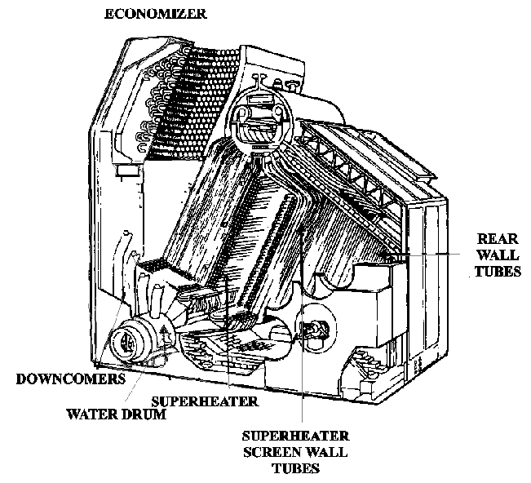

# The D-type boiler uses the principle of accelerated natural circulation to circulate water through the boiler. To enable this principle to work, relatively cool water will naturally circulate through large diameter pipes to distribution points low in the boiler.

Downcomers are these large diameter pipes connecting the steam drum with the water drum and lower headers to ensure proper circulation by delivering water from the steam drum to the water drum and lower headers. The downcomers are located between the inner and outer air casing to protect them from the direct radiant heat of the furnace.

# The water drum is located at the bottom of the boiler below the main generating bank and acts as a lower reservoir of water for distribution to the main generating bank. Also, this large drum serves as a collection point for solids (sludge) that precipitate to the bottom that are removed by bottom blowdown.

# The sidewall header is located along the furnace sidewall connecting sidewall tubes from the furnace floor to the steam drum. It distributes water to the sidewall tubes and provides another blowdown point for sludge removal. The sidewall tubes are two inch tubes which protect the boiler sidewall refractory from the direct heat of combustion and generate a small amount of steam.
# The lower rearwall header is located along the furnace rearwall from the furnace floor to the steam drum or upper header to provide a lower junction for rearwall tubes. It distributes water to the rearwall tubes and provides yet another blowdown point for removal of sludge. The rearwall tubes are two inch tubes which protect the boiler rearwall refractory from the heat of combustion and generate some steam.

NOTE: By using wall tubes, more of the heat in the furnace is absorbed by water and less refractory material is required, thereby increasing boiler efficiency and reducing the boiler weight.

# The upper rearwall header is often called the "floating header" because of its free-standing design. It is located along the rearwall of the furnace roof to provide an upper junction for the rearwall tubes. It collects the steam generated in the rearwall tubes and directs it to the steam drum through riser tubes.
# Riser tubes are large tubes located above the furnace roof to provide a connection between the upper rearwall header and the steam drum.
# Superheater screenwall tubes help protect the superheater from direct radiant heat of the furnace. The screen tubes consist of two to three staggered rows of two inch tubes which are usually connected from the steam drum to the water drum. Some boilers have a screenwall header installed parallel to the superheater along the furnace floor as a lower connection and a blowdown point for sludge.
# The steam passes through the superheater picking up sensible heat (about 300-400° F) which increases the energy of the steam, allowing it to perform more work. The superheater is composed of superheater headers which distribute steam to the superheater tubes or elements and direct it from the inlet to outlet piping. These headers and elements can be either vertically or horizontally mounted. (Refer to Figure 5).

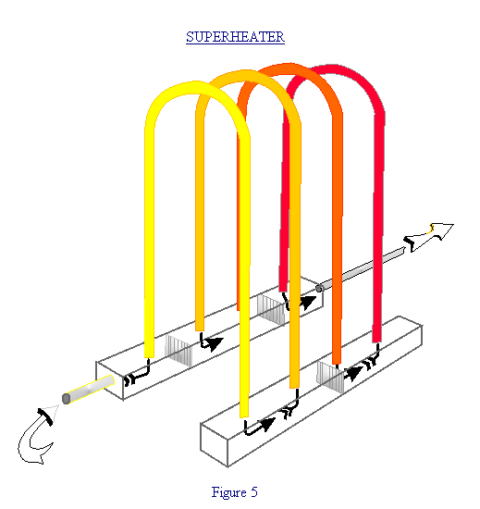
# The bulk of the steam generated by the boiler is formed in the main generating bank because it has the largest heating surface. This is a large group of one inch tubes which run from the water drum to the steam drum and are located behind the superheater.
# Since these boilers are uncontrolled superheat and the plant is designed to use lower temperature steam in many applications to help reduce construction and maintenance costs, the steam needed for these services must pass through a desuperheater. The desuperheater is a multi-pass tube bundle which is located in the water drum in most boilers. There are several boilers which have the desuperheater in the steam drum. As the superheated steam passes through the tube bundle, it gives up heat to the boiler water in the water drum.
# The boiler is protected from the high temperatures of combustion by the refractory. Refractory lines the inside surface of the inner casing enclosing all of the furnace area and extending to the outer row of generating tubes. There are several different types of refractory which work together to protect the boiler.

1. Firebrick is a heavy casted refractory used as the outer layer of refractory and is exposed to the direct flames of combustion. It has poor insulating qualities, but it will withstand direct flame contact.
2. Insulating brick is a lightweight casted refractory used between the insulating block and firebrick. It has good insulating properties, but it will not withstand direct contact with flame.
3. Insulating block is a pressed fiber material used next to the inner casing. It has the highest insulating properties of the various refractory, but it will not withstand direct contact with flame.
4. Burner tiles are preformed refractory used to form burner cones around where the burner assembly protrudes into the furnace. Burner tiles are a specially shaped, heavy casted refractory used next to the insulating brick around the burner openings. They have poor insulating qualities, but they will withstand direct flame contact.
5. High temperature castable refractory is used to fill in gaps in refractory or where shaping is needed to cover irregular shaped items. It is used to patch refractory or to smooth uneven areas between brickwork. It is packaged dry and must be mixed with water prior to use, very much like cement or plaster.
6. Baffle tiles are a specially shaped refractory made of silicon carbide for use in some boilers to form baffles on superheater screen tubes. These baffles direct the flow of combustion gases across the superheater to help maintain the temperature within design parameters.
7. When the refractory is installed and stacked, it must be held in place. Anchor bolts are used for preformed refractory. The anchor bolts are connected to the inner casing to support and retain the refractories in position.
8. Since the boiler expands and contracts with heating and cooling, expansion joints are built into the refractory to allow for the thermal expansion and contraction.

# Since the boiler expands and contracts as it heats up and cools down, sliding feet are installed to allow the boiler to move easily. The feet are located below the boiler, usually under the front end of the sidewall header and water drum. There is a greased phosphor-bronze friction plate on which these feet will move. The planned maintenance system (PMS) requires lubricating the sliding feet every month. Some newer ships have permalube sliding feet which never require lubrication. Failure of the sliding feet to move can cause cracks in the air casing and can cause header handhole plug leaks. Movement indicators are installed on the sliding feet which have to be checked prior to light off, during warm up, and after the boiler is on line to ensure positive movement of the sliding feet. Each time sliding feet are checked the results should be logged in the fireroom operating log. (Refer to figure 6)

SLIDING FEET CONFIGURATION

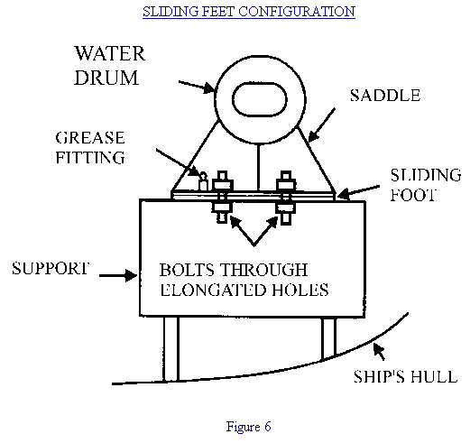

# The boiler is enclosed by casings which provide an airtight boundary from the boiler furnace up through to the stack area. The inner casing encloses the boiler fireside area to the base of stack to provide an airtight lining between the combustion air space and furnace to contain the products of combustion within the boiler and support the refractory materials. The outer casing encloses the entire boiler from the bilge to the stack to provide double encasement so the boiler air pressure is not affected by the fireroom atmosphere. The combustion air flows through this space between the inner and outer casing and is directed to the air registers. The stack is located above the boiler economizer and extends to above the superstructure to carry boiler combustion products safely away from the ship. The inner stack or smoke pipe provides a path for combustion gases to the atmosphere, the outer stack supports the inner stack and provides a space to receive incoming combustion air to the boiler and protects personnel from the hot inner stack surfaces.
# The fireroom watch team must be able to monitor the exhaust gases to help maintain a clear smoke free stack. Smoke indicators and periscopes are installed to allow monitoring of the stack gases leaving the boiler. The smoke indicator is an electro-mechanical device and the periscope is an optical device. All ships have periscopes and many have electro-mechanical smoke indicators or stack gas analyzers. These devices are located above the economizer at the base of the stack so that combustion gases leaving the boiler must pass through its line of sight or the sensing element. From monitoring the stack gases, the combustion process can be adjusted for maximum efficiency or a casualty situation can be detected (Refer to Figure 7)
