ECONOMIZER
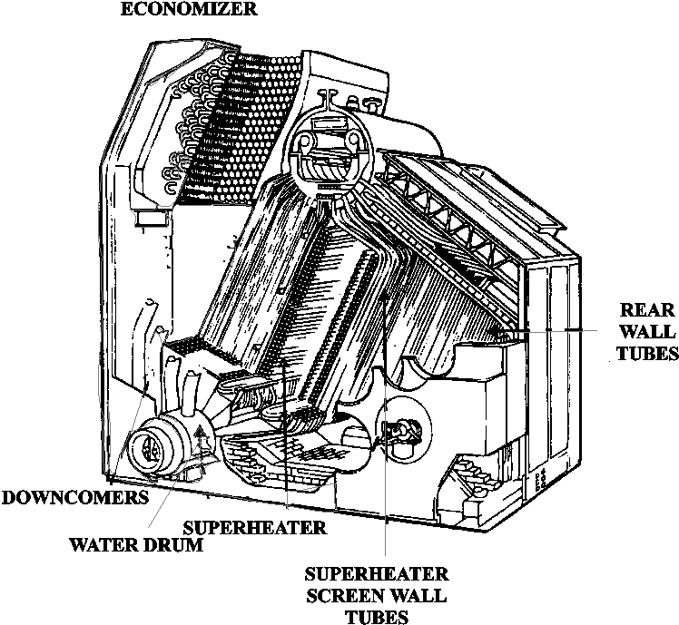
Figure 1
The flue gases, having passed through the main boiler and the superheater, will still be hot. The energy in these flue gases can be used to improve the thermal efficiency of the boiler. To achieve this flue gases are passed through an economiser.
The economiser is a heat exchanger through which the feedwater is pumped. The feedwater thus arrives in the boiler at a higher temperature than would be the case if no economiser was fitted. Less energy is then required to raise the steam. Alternatively, if the same quantity of energy is supplied, then more steam is raised. This results in a higher efficiency. In broad terms a 10°C increase in feedwater temperature will give an efficiency improvement of 2%.
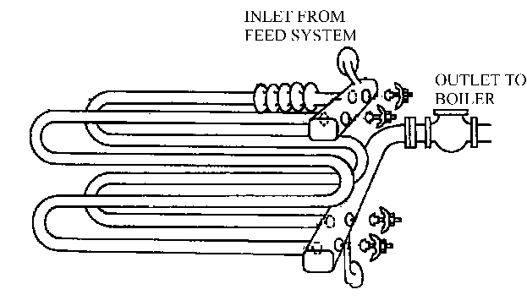
Note:
- Because the economiser is on the high-pressure side of the feed pump, feedwater temperatures in excess of 100°C are possible. The boiler water level controls should be of the ‘modulating’ type, (i.e. not ‘on-off’) to ensure a continuous flow of feedwater through the heat exchanger.
- The heat exchanger should not be so large that:

  - The flue gases are cooled below their dew point, as the resulting liquor may be acidic and corrosive.
  - The feedwater boils in the heat exchanger.

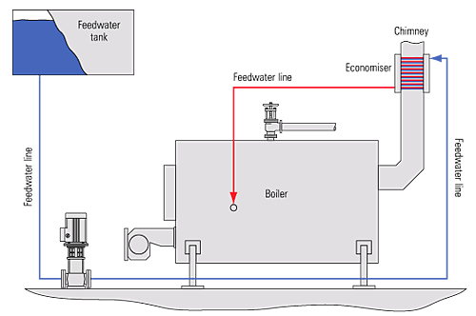
Shell boiler with an economiser

Economics
The savings potential is a function of how much heat can be recovered, which is a function of how much cold water needs to be heated. A generally accepted "rule of thumb" is that about 5% of boiler input capacity can be recovered with a properly sized economizer. A higher percentage can be recovered with a Flue Gas Condenser, assuming there is enough cold water to condense all of the flue gas that is available. Therefore, for 'ball parking' purposes, start by comparing boiler input capacity with the need to heat water.

