Membrane walls

Membrane walls were originally introduced for land power stations and are being increasingly used in marine boilers. Originally, experience gained when making the lower parts of furnaces sufficiently tight to hold liquid ash, proved that this could be done by welding in steel strips between the floor tubes. Further development of this technique resulted in completely gas-tight furnace wall panels being constructed by welding together either finned tubes or normal tubes with steel strip interspaced between them.
In both methods the longitudinal welds are done by an automatic process and panels of the required size are built up ready for welding directly to headers, or, in some cases to stubs on drums see Figure below.
The use of welded, in lieu of expanded, tube connections has obviated the necessity of providing a series of handholes each with

.Its own gasket, along each header, for tube expander access. One or two cleaning out holes are all that is now necessary.
It will be apparent from the foregoing that with boilers embodying membrane walls it is more important than ever to operate them under proper conditions particularly with regard to feed water treatment.
A membrane wall tube failure at sea in a boiler of this type is, owing to the welded construction and lack of handholes, difficult to repair, and in the case of vessels with a single main boiler can produce an emergency situation.

The advantages claimed for these types of water-walls are:

- The walls for the entire furnace and, if necessary, the convection sections can be prefabricated in the shop.
- They are stronger and more gastight than any other type.
- Maintenance is low as refractories are practically eliminated.
- Water washing of furnace walls and tube banks is facilitated.
- The gas-tightness of the furnace eliminates the possibility of corrosion of the outer casings by corrosive gases (see figure below).

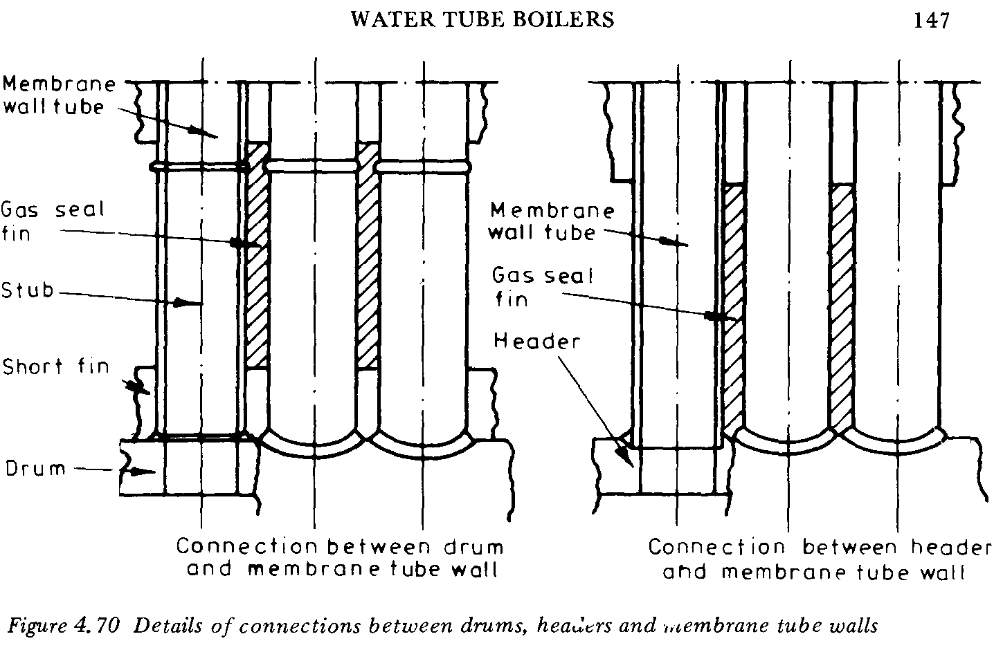

Water Walls

Water walls are used in water tube boilers to contain the heat of the furnace and reduce the amount of refractory material required. They also contribute to the evaporation rate by receiving radiant heat; indeed, in radiant heat boilers the water walls provide the bulk of steam generation.
As a design factor, the tube pitch is critical: too small, and the corresponding attachment holes unduly weaken tube plates and headers: too large a pitch, and the amount of radiant heat passing through the gaps between the tubes overheats the boiler casing. Four basic designs of water walls to overcome these problems are illustrated below.
The partially studded water wall has a relatively wide pitch and so does not unduly weaken the tube plates or headers, but to seal the gaps between the tubes a refractory material must be used, this being keyed in place by steel studs resistance-welded to the water wall tubes.
In the case of the tangential type water wall a much smaller pitch is used, the off-set tube ends allowing the use of staggered holes to prevent undue weakening of tube plates and headers. However, some radiant heat can still penetrate the wall and a layer of suitable refractory material must he placed behind the water to protect the boiler casing.
Diaphragm type water walls are constructed by welding longitudinal fins between adjacent plain tubes, as in the membrane wall, or alternatively welding finned tubes together along the line of contact, as in the monowall. In both cases similar gastight panels are formed which can be used to surround the furnace, the welded runs being omitted in way of any required gas passages.

As no radiant heat can penetrate these walls, no refractory material need be fitted behind them and a single boiler casing can he used.
Again tube pitch remains a critical factor; too narrow a pitch not only unduly weakens the tube plates, but can also overcool the furnace flame leading to unstable combustion conditions. Too wide a pitch can result in overheating of the longitudinal fins. The intense short flames suitable for use with tangential or partially studded water walls is not suitable for diaphragm water walls, which need a low furnace heat flux.

