Boiler Tubes
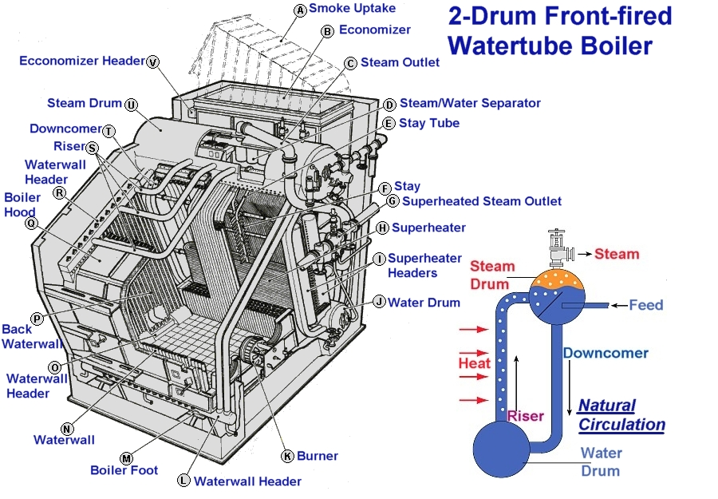
Generating Tubes

These consists of numerous small diameter tubes placed in the main flow of hot gases, so forming a large heat exchange surface; the generation of steam takes place mainly by convection.
For a given rate of water circulation the minimum allowable tube diameter is limited, as below a certain value the ratio of steam to water becomes excessive and leads to possible overheating.
Another limitation is imposed by the fact that, while sufficient heat exchange surface must be provided for the gas exit temperature to be low enough to ensure economic operation, if there is too much the gases will fall below their dew point temperature. This will lead to corrosion of the heating surfaces.
In general the number of generating tubes tends to be reduced in modern boilers, until indeed in radiant heat boilers no generating tubes as such are fitted. Water walls receiving radiant heat are used instead.

Screen Tubes

These are placed adjacent to the furnace, so receiving heat from the flame together with heat from the hot gases leaving the furnace; therefore they need a relatively larger diameter to keep the ratio of steam to water low enough to prevent overheating.
The duty of the screen tubes is to protect the super heater tubes from the direct radiant heat of the furnace flame.

Water Wall Tubes

These are used basically to contain the heat of the furnace, thus reducing the amount of refractory material required.
In some types of boilers, water cooled refractory cells are used. These consist of tubes with studs welded onto them, covered with refractory material, which can now withstand the high temperatures without damage. In other designs part of the tube surface is exposed to radiant heat which helps to generate steam. In some radiant heat boilers the tubes are welded together along their length by fins or strips, and na refractory is required.

Downcomer Tubes

These consist of large diameter, unheated tubes placed outside the gas stream which act as feeders to the water drum and headers.

Riser or Return Tubes

These return steam and water from the top water wall headers to the steam drum.

Superheater Tubes

These consist of small diameter tubes placed in the main gas stream, after the screen tubes. Their duty is to superheat the saturated steam leaving the drum to a temperature suitable for use in the main turbines. They must be protected from direct radiant heat as they are liable to overheating due to the much smaller specific heat of steam compared to that of water.

Superheater Support Tubes

This relatively large diameter tubes act basically as water cooled supports for the superheater tubes.
The metal surface temperature of all these boiler tubes must be considered and, for all tubes containing water, the working temperature is assumed to be the saturation temperature corresponding to the boiler pressure, plus 15°C. Thus solid-drawn mild steel tubes can be used. In the case of superheater tubes, however, the temperature is considered to be the maximum superheat temperature, plus a value in the order of 30°C for convection type superheaters and in excess of this figure for radiant heat type superheaters. For steam temperatures above 455°C heat resisting alloy steel, containing small amounts of chrome and molybdenum must be used. In the majority of cases boiler tubes are expanded, and then bell-mouthed into drums or headers. For large diameter tubes, such as downcomers, grooved seats are used to assist the expansion in forming a tight seal. Where high temperatures are involved, as with superheater tubes, welding may be used in place of expanding.

Tubes Attachments

There are three main methods of arranging boiler tubes:

Straight tubes are easy to clean and replace but can only be used in conjunction with headers as, if used with drums, the tubes will not enter perpendicular to the tube plate, and the holes would have to be recessed, or arbored, in order to keep the bell-mouthing near the drum surface. These recesses would act as stress risers, and are banned.

Curved tubes can be used with drums, but even here the tubes will not normally enter perpendicular to the tube plate, but at an angle; this makes expanding more difficult, and also results in a thicker tube plate.
In the third method, often referred to as bent tube, all the tubes are bent so as to enter perpendicular to the surface of the tube plate. This gives the advantage of easier expansion and bell-mouthing, and also enables a thinner tube plate to be used. The disadvantage lies in the relatively sharp bends, which make cleaning and tube replacement more difficult, and also means more spares must be carried as tube curvature varies from row to row. However, the high quality feed available for modern boilers gives little risk of scale formation, enables this method to be used to advantage.

Headers

These perform a similar duty to that of the drums, only size forming a distinction between them. In general the drums are large enough to be entered through manholes, whereas access to the interior of the headers is only provided by handholes.

