STEAM DRUM

The steam drum is a cylinder located at the top of the boiler. It runs lengthwise (fig. 4-1) from the front to the back of the boiler. The steam drum provides a space for the saturated steam generated in the tubes and for the separation of moisture from the steam. (Remember, saturated steam is steam that has not been heated above the temperature of the water from which it was generated). The steam drum also serves as a storage space for boiler water, which is distributed from the steam drum to the downcomer tubes. During normal operation, the steam drum is kept about half full of water. The steam drum either contains or is connected to many of the important controls and fittings required for the operation of the boiler. At the bottom right side of the boiler you will find the water drum, and on the bottom left side is the sidewall header (fig. below). Notice the header is smaller than the water drum. Most boilers have more than one header. They are identified by their location. For example, a header at the back of the boiler is called a rear wall header. A header on a screen wall is called a screen wall header.

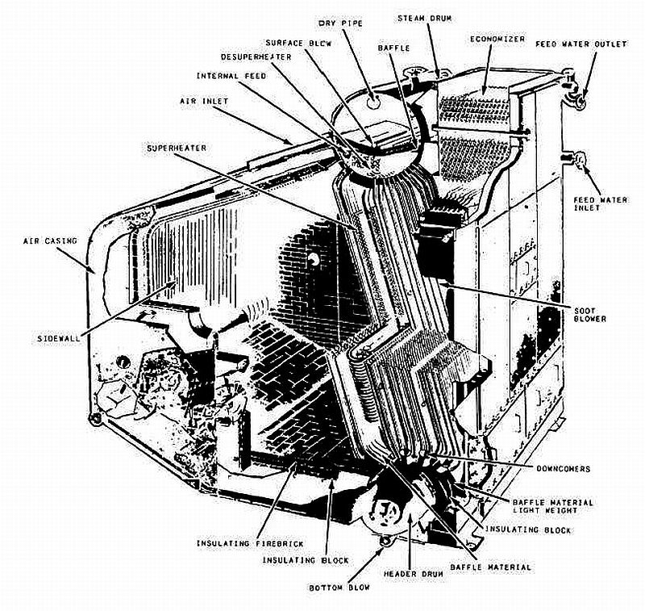
WATER DRUM
The water drum is larger than the header, but both are smaller than the steam drum. The water drum equalizes the distribution of water to the generating tubes. Both the water drum and the header collect the deposits of loose scale and other solid matter present in the boiler water. Both the drum and the header have bottom blowdown valves. When these valves are opened, some of the water is forced out of the drum or header and carries any loose particles with it. DO NOT OPEN THE BOTTOM BLOWDOWN VALVES ON A STEAMING BOILER. Opening these valves will interrupt the circulation of the steam cycle. DOWNCOMER TUBES At each end of the steam drum are a number of large tubes (fig. below) that lead to the water drum and side wall header. These tubes are the downcomers through which water flows down- ward from the steam drum to the water drum and the header. The downcomers range in diameter from 3 to 8 inches (76 mm to 200 mm).

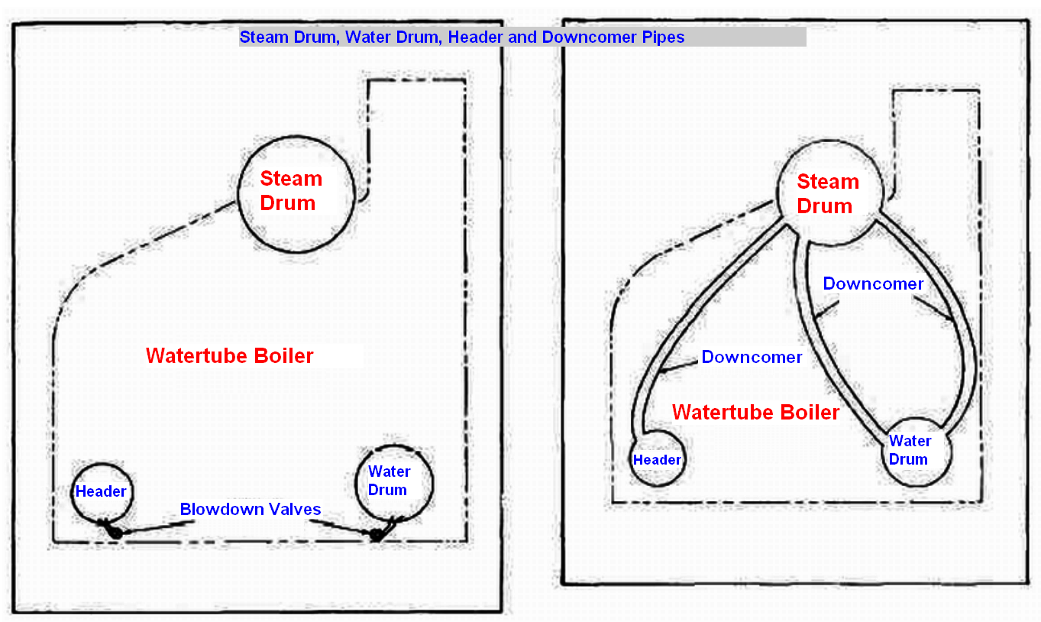

GENERATING TUBES

Many tubes link the steam drum to the water drum and to the header. The tubes that lead from the water drum to the steam drum are the generating tubes (fig. 4-4). They are arranged in the furnace so the gases and the heat of combustion can flow around them. The large arrows in figure 4-4 show the direction of flow of the combustion gases. The generating tubes are made of steel that is strong enough to withstand the high pressures and temperatures within the boiler. In most boilers these tubes are usually 1 to 2 inches in diameter, but some may be 3 inches. These small tubes present a large surface area to absorb furnace heat. A 2-inch tube has twice the surface area of a 1-inch tube but four times the volume. A 3-inch tube has three times the surface area of a 1-inch tube but nine times the volume. The smaller the diameter of the tube, the higher is the ratio of absorption surface to the volume of water.

Normally, only one row of tubes leads from the steam drum to the sidewall header. These are the sidewall (water wall) tubes. Their function is to cool and protect the side wall of the furnace. So far, we have assembled the drums, header, downcomers, and generating tubes. Before going any further with the assembly, let us trace the path of the water through the boiler. As the water is heated, it becomes less dense, and steam is formed in the tubes. The water in the steam drum is much cooler than the steam and has greater density. As the hotter water and steam rise through the generating tubes, the cooler more dense water drops through the downcomers to the water drum and headers. The arrows in figure below show the circulation path of the water as it leaves the steam drum and returns to the steam drum as steam. Notice that the circulation is an accelerated type. This is indicated by the inclination of the tubes. The tubes shown are almost vertical. The greater the incline, the greater the acceleration.
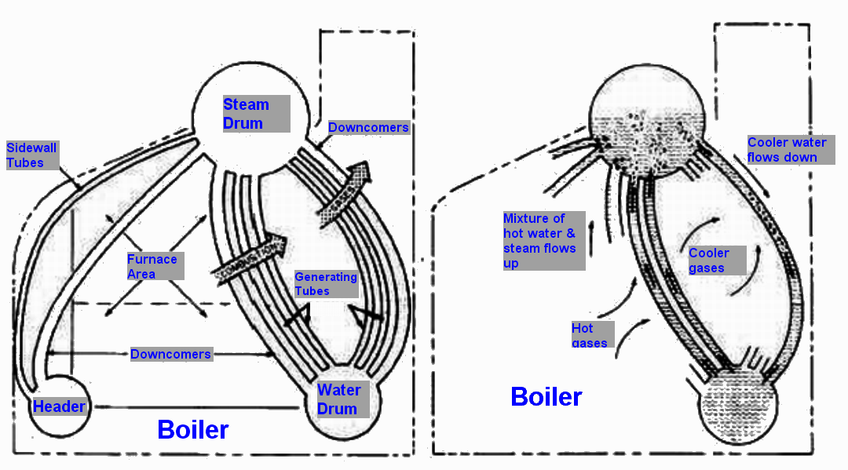

So far, we have learned how the steam is formed in a boiler. Next, let’s find out what happens to the steam once it returns to the steam drum from the generating tubes.

INTERNAL FITTINGS

Components of the steam drum area are known as INTERNAL FITTINGS. The internal fittings we will discuss are the feedwater distribution, the chemical injection, and the steam and water separator. This equipment is used to direct the flow of steam and water within the steam drum and the desuperheaters, which are located either in the steam drum or the water drum. We will also discuss the economizer in this section. This component is not considered an internal fitting, but its role is important to the function of the steam drum. The design drum’s internal and arrangement of steam fittings will vary somewhat from one type of boiler to another and from one boiler manufacturer to another. Figure 4-6 shows the arrangement of the steam drum internal fittings in a single-furnace boiler.

- The feedwater pipe receives feedwater from the economizer and distributes it throughout the length of the steam drum.
- The chemical feed pipe is used to inject chemicals into the boiler to maintain the proper pH and phosphate balance in the boiler water.
- The surface blow pipe is used to remove suspended solid matter that floats on top of the water and to lower the steam drum water level, when necessary.
- The surface blow pipe is also used to blow water out to lower the chemical level in the boiler when it becomes too high.
- The dry pipe is used to direct the steam to the steam drum outlet nozzle after it leaves the scrubbers.
- The vortex eliminators are used to reduce the swirling motion of the water as it enters the downcomers. It also prevents the steam from being drawn from the upper portion of the drum into the downcomer.
- The baffle plates are used to direct the steam to the steam separators.
- The cyclone steam separators remove moisture from the steam.
- This is accomplished by the steam spinning or changing direction.
- The water drains back into the steam drum while the steam continues upward through a screen and scrubber that removes still more moisture.

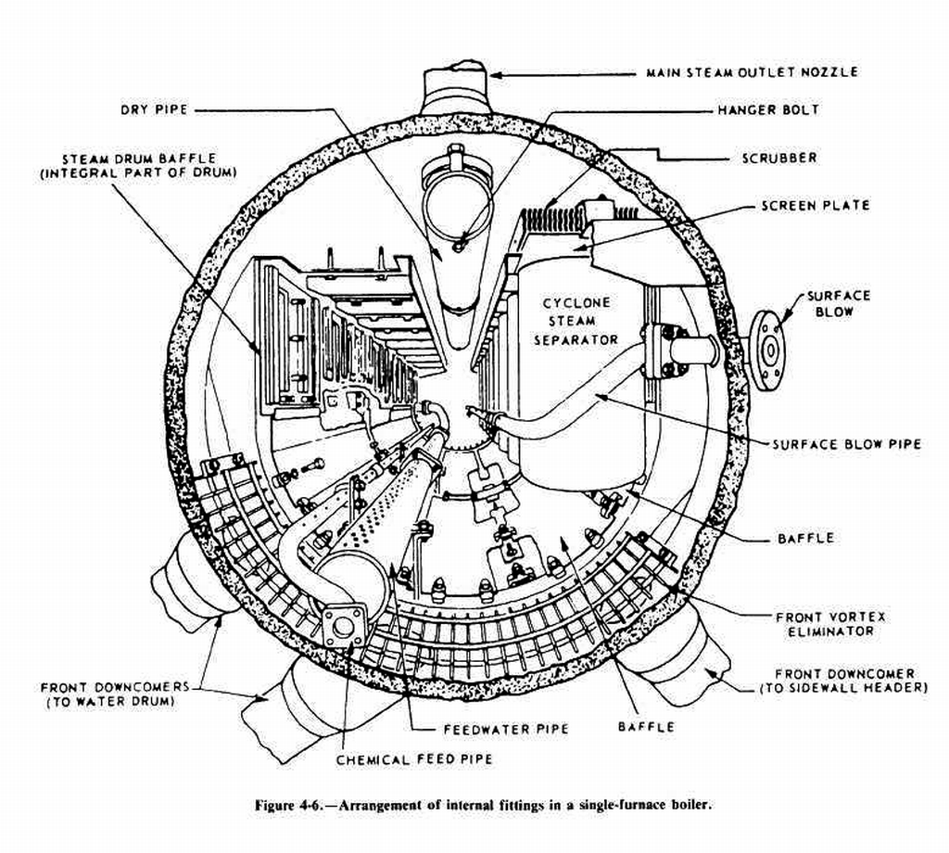

After the steam leaves the scrubbers, it goes to the dry pipe (fig. 4-6). From there it leaves the steam drum through the steam drum outlet. Figure 4-7, view A, shows the steam going to the inlet header of the superheater and passing through the U-shaped tubes of the superheater to the next header (fig. 4-7, view B). This header is called the first pass or intermediate header. Steam may pass through the U-shaped tubes several times before passing to the outlet header. Each time the steam goes from one header to the next header it is called a pass. The number of passes the steam makes in a superheater varies with different boilers and the degree of superheat that is required for a particular ship.

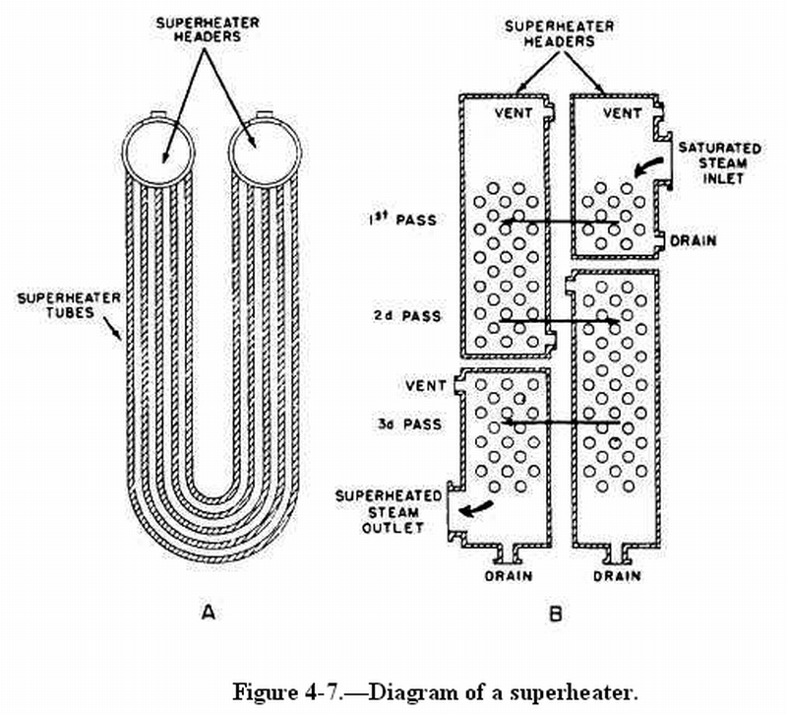

As the steam passes through the super- heater tubes, it is heated by the hot gases from combustion, which flow around the tubes. In some boilers, the superheater headers are installed parallel with the water drum; and the tubes are installed vertically (fig. 4-8). These are called vertical superheaters. Another boiler internal fitting is the desuperheater. It maybe located either in the steam drum or in the water drum. All the steam generated in a single-furnace boiler is led through the superheater. However, since some auxiliary machinery is not designed for superheated steam, the steam must be cooled down. This is done with a desuperheater. The desuperheater gets steam from the superheater outlet, as shown in figure 4-9. The desuperheater is submerged in water either in the steam drum or in the water drum. As the steam passes through the desuperheater, it is cooled for use in the auxiliary steam systems.
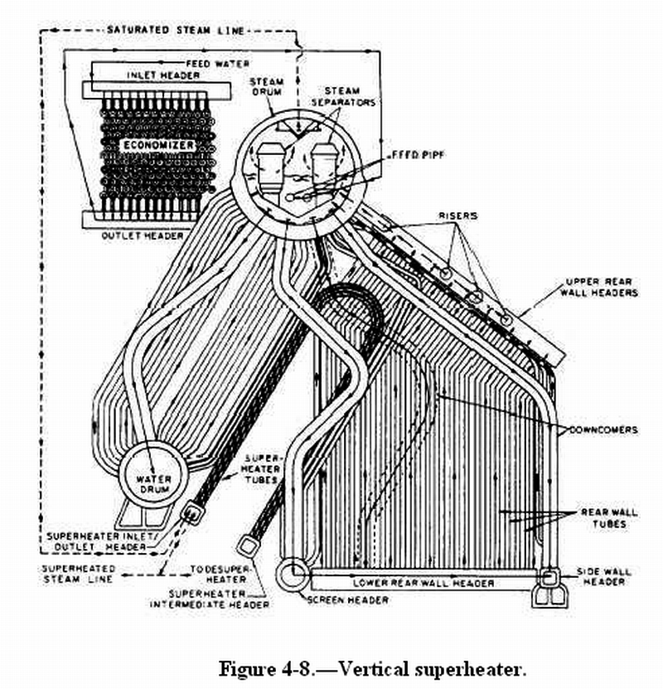

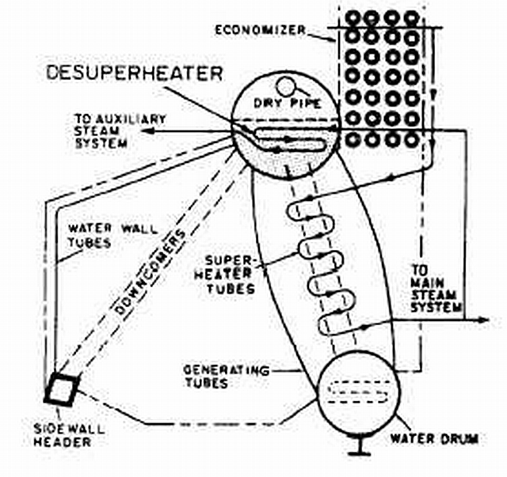
Internal Desuperheater [also called Attemperator]

