Several key boiler attachments will now be explained, together with their associated legislation where appropriate.

Boiler name-plate

In the latter half of the 19th century explosions of steam boilers were commonplace. As a consequence of this, a company was formed in Manchester with the objective of reducing the number of explosions by subjecting steam boilers to independent examination. This company was, in fact, the beginning of today’s Safety Federation (SAFed), the body whose approval is required for boiler controls and fittings in the UK.
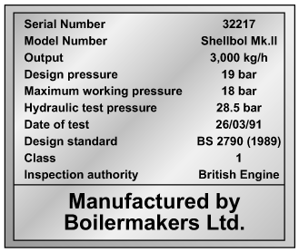
Fig. 1 Boiler name-plate
After a comparatively short period, only eight out of the 11 000 boilers examined exploded. This compared to 260 steam boiler explosions in boilers not examined by the scheme. This success led to the Boiler Explosions Act (1882) which included a requirement for a boiler name-plate. An example of a boiler name-plate is shown in Figure 1.
The serial number and model number uniquely identify the boiler and are used when ordering spares from the manufacturer and in the main boiler log book.

Boiler stop valves

A steam boiler must be fitted with a stop valve (also known as a crown valve) which isolates the steam boiler and its pressure from the process or plant. It is generally an angle pattern globe valve of the screw-down variety. Figure 2 shows a typical stop valve of this type.
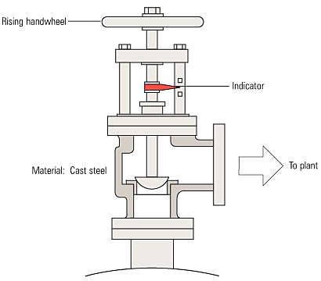
Fig. 2 Boiler stop valve
In the past, these valves have often been manufactured from cast iron, with steel and bronze being used for higher pressure applications. In the UK, BS 2790 states that cast iron valves are no longer permitted for this application on steam boilers. Nodular or spheroidal graphite (SG) iron should not be confused with grey cast iron as it has mechanical properties approaching those of steel. For this reason many boilermakers use SG iron valves as standard.
The stop valve is not designed as a throttling valve, and should be fully open or closed. It should always be opened slowly to prevent any sudden rise in downstream pressure and associated water hammer, and to help restrict the fall in boiler pressure and any possible associated priming.
To comply with UK regulations, the valve should be of the ‘rising handwheel’ type. This allows the boiler operator to easily see the valve position, even from floor level. The valve shown is fitted with an indicator that makes this even easier for the operator.
On multi-boiler applications an additional isolating valve should be fitted, in series with the crown valve. At least one of these valves should be lockable in the closed position. The additional valve is generally a globe valve of the screw-down, non-return type which prevents one boiler pressurizing another. Alternatively, it is possible to use a screw-down valve, with a disc check valve sandwiched between the flanges of the crown valve and itself.

Boiler Safety Valves
Will be covered separately in detail.
Feedwater check valves
The feedwater check valve (as shown in Figures 3 and 4) is installed in the boiler feedwater line between the feedpump and boiler. A boiler feed stop valve is fitted at the boiler shell.
The check valve includes a spring equivalent to the head of water in the elevated feedtank when there is no pressure in the boiler. This prevents the boiler being flooded by the static head from the boiler feedtank.
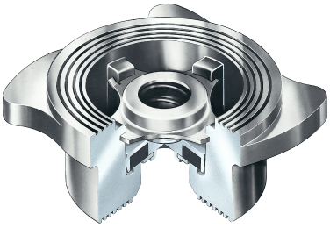
Fig. 3 Boiler check valve
Under normal steaming conditions the check valve operates in a conventional manner to stop return flow from the boiler entering the feedline when the feedpump is not running. When the feedpump is running, its pressure overcomes the spring to feed the boiler as normal.
Because a good seal is required, and the temperatures involved are relatively low (usually less than 100°C) a check valve with a EPDM (Ethylene Propylene) soft seat is generally the best option.
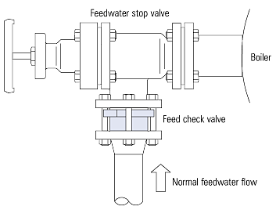
Fig. 4 Location of feed check valve

Air vents

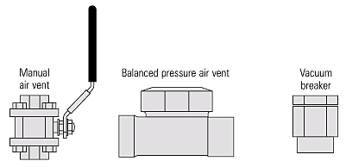
When a boiler is started from cold, the steam space is full of air. This air has no heat value, and will adversely affect steam plant performance due to its effect of blanketing heat exchange surfaces. The air can also give rise to corrosion in the condensate system, if not removed adequately.
The air may be purged from the steam space using a simple cock; normally this would be left open until a pressure of about 0.5 bar is showing on the pressure gauge.
Pressure gauge
All boilers must be fitted with at least one pressure indicator.
The usual type is a simple pressure gauge constructed to BS 1780 Part 2 - Class One.
The dial should be at least 150 mm in diameter and of the Bourdon tube type, it should be marked to indicate the normal working pressure and the maximum permissible working pressure / design pressure.
Pressure gauges are connected to the steam space of the boiler and usually have a ring type siphon tube which fills with condensed steam and protects the dial mechanism from high temperatures.
Pressure gauges may be fitted to other pressure containers such as blowdown vessels, and will usually have smaller dials as shown in Figure 5.
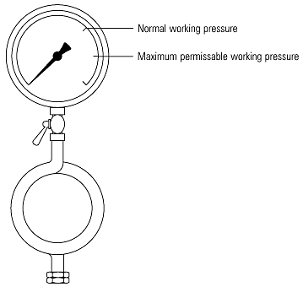
Fig. 5 Typical pressure gauge with ring siphon

Gauge glasses and fittings
All steam boilers are fitted with at least one water level indicator, but those with a rating of 100 kW or more should be fitted with two indicators. The indicators are usually referred to as gauge glasses complying with BS 3463.
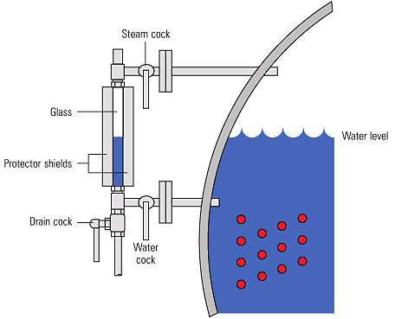
Fig. 6 Gauge glass and fittings
A gauge glass shows the current level of water in the boiler, regardless of the boiler’s operating conditions. Gauge glasses should be installed so that their lowest reading will show the water level at 50 mm above the point where overheating will occur. They should also be fitted with a protector around them, but this should not hinder visibility of the water level. Figure 6 shows a typical gauge glass.
Gauge glasses made from tubular glass or plastic are used for service up to 450 psig and 400°F. If it is desired to measure the level of a vessel at higher temperatures and pressures, a different type of gauge glass is used. The type of gauge glass utilized in this instance has a body made of metal with a heavy glass or quartz section for visual observation of the liquid level. The glass section is usually flat to provide strength and safety. Figure A2 illustrates a typical transparent gauge glass.
Another type of gauge glass is the reflex gauge glass (Figure A3). In this type, one side of the glass section is prism-shaped. The glass is molded such that one side has 90-degree angles which run lengthwise. Light rays strike the outer surface of the glass at a 90-degree angle. The light rays travel through the glass striking the inner side of the glass at a 45-degree angle. The presence or absence of liquid in the chamber determines if the light rays are refracted into the chamber or reflected back to the outer surface of the glass.

When the liquid is at an intermediate level in the gauge glass, the light rays encounter an air-glass interface in one portion of the chamber and a water-glass interface in the other portion of the chamber. Where an air-glass interface exists, the light rays are reflected back to the outer surface of the glass since the critical angle for light to pass from air to glass is 42 degrees. This causes the gauge glass to appear silvery-white. In the portion of the chamber with the water-glass interface, the light is refracted into the chamber by the prisms. Reflection of the light back to the outer surface of the gauge glass does not occur because the critical angle for light to pass from glass to water is 62-degrees. This results in the glass appearing black, since it is possible to see through the water to the walls of the chamber which are painted black.
A third type of gauge glass is the refraction type (Figure A4). This type is especially useful in areas of reduced lighting; lights are usually attached to the gauge glass. Operation is based on the principle that the bending of light, or refraction, will be different as light passes through various media. Light is bent, or refracted, to a greater extent in water than in steam. For the portion of the chamber that contains steam, the light rays travel relatively straight, and the red lens is illuminated. For the portion of the chamber that contains water, the light rays are bent, causing the green lens to be illuminated. The portion of the gauge containing water appears green; the portion of the gauge from that level upward appears red.

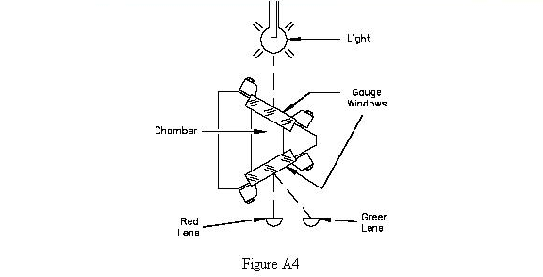
Gauge glasses are prone to damage from a number of sources, such as corrosion from the chemicals in boiler water, and erosion during blowdown, particularly at the steam end. Any sign of corrosion or erosion indicates that a new glass is required.
When testing the gauge glass steam connection, the water cock should be closed. When testing the gauge glass water connections, the steam cock pipe should be closed.
To test a gauge glass, the following procedure should be followed:
- Close the water cock and open the drain cock for approximately 5 seconds.
- Close the drain cock and open the water cock
Water should return to its normal working level relatively quickly. If this does not happen, then a blockage in the water cock could be the reason, and remedial action should be taken as soon as possible.
- Close the steam cock and open the drain cock for approximately 5 seconds.
- Close the drain cock and open the steam cock.
If the water does not return to its normal working level relatively quickly, a blockage may exist in the steam cock. Remedial action should be taken as soon as possible.
The authorised attendant should systematically test the water gauges at least once each day and should be provided with suitable protection for the face and hands, as a safeguard against scalding in the event of glass breakage.
Note: that all handles for the gauge glass cocks should point downwards when in the running condition.
Gauge glass guards
The gauge glass guard should be kept clean. When the guard is being cleaned in place, or removed for cleaning, the gauge should be temporarily shut-off.
Make sure there is a satisfactory water level before shutting off the gauge and take care not to touch or knock the gauge glass. After cleaning, and when the guard has been replaced, the gauge should be tested and the cocks set in the correct position.
Maintenance
The gauge glass should be thoroughly overhauled at each annual survey. Lack of maintenance can result in hardening of packing and seizure of cocks. If a cock handle becomes bent or distorted special care is necessary to ensure that the cock is set full open. A damaged fitting should be renewed or repaired immediately. Gauge glasses often become discoloured due to water conditions; they also become thin and worn due to erosion. Glasses, therefore, should be renewed at regular intervals.
A stock of spare glasses and cone packing should always be available in the boiler house. Remember:
- If steam passes are choked a false high water level may be given in the gauge glass. After the gauge has been tested a false high water level may still be indicated.
- If the water passages are choked an artificially high water level may be observed due to steam condensing in the glass. After testing, the glass will tend to remain empty unless the water level in the boiler is higher than the top connection, in which case water might flow into the glass from this connection.
Gauge glass levels must be treated with the utmost respect, as they are the only visual indicator of water level conditions inside the boiler. Any water level perceived as abnormal must be investigated as soon as it is observed, with immediate action taken to shut down the boiler burner if necessary.

Air vents and vacuum breakers
When a boiler is started from cold, the steam space is full of air. This air has no heat value, and will adversely affect steam plant performance due to its effect of blanketing heat exchange surfaces. The air can also give rise to corrosion in the condensate system, if not removed adequately.
The air may be purged from the steam space using a simple cock; normally this would be left open until a pressure of about 0.5 bar is showing on the pressure gauge. An alternative to the cock is a balanced pressure air vent which not only relieves the boiler operator of the task of manually purging air (and hence ensures that it is actually done), it is also much more accurate and will vent gases which may accumulate in the boiler. Typical air vents are shown in Figure 3.7.14.
When a boiler is taken off-line, the steam in the steam space condenses and leaves a vacuum. This vacuum causes pressure to be exerted on the boiler from the outside, and can result in boiler inspection doors leaking, damage to the boiler flat plates and the danger of overfilling a shutdown boiler.

