A number of items must be fitted to steam boilers, all with the objective of improving:
- Operation.
- Efficiency.
- Safety.
While this Module can offer advice on this subject, definitive information should always be sought from the appropriate standard. In the UK, the standard relating to the specification of valves, mountings and fittings in connection with steam boilers is BS 759: Part 1. BS 6759 also refers to safety valves for steam and process fluids.
Several key boiler attachments will now be explained, together with their associated legislation where appropriate.

Boiler name-plate
In the latter half of the 19th century explosions of steam boilers were commonplace. As a consequence of this, a company was formed in Manchester with the objective of reducing the number of explosions by subjecting steam boilers to independent examination. This company was, in fact, the beginning of today’s Safety Federation (SAFed), the body whose approval is required for boiler controls and fittings in the UK.
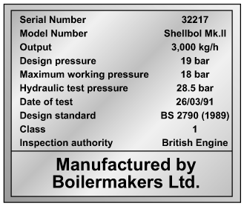
Fig. 3.7.1 Boiler name-plate
After a comparatively short period, only eight out of the 11 000 boilers examined exploded. This compared to 260 steam boiler explosions in boilers not examined by the scheme. This success led to the Boiler Explosions Act (1882) which included a requirement for a boiler name-plate. An example of a boiler name-plate is shown in Figure 3.7.1.
The serial number and model number uniquely identify the boiler and are used when ordering spares from the manufacturer and in the main boiler log book.
The output figure quoted for a boiler may be expressed in several ways, as discussed in previous Modules within this Block.

Safety valves
An important boiler fitting is the safety valve. Its function is to protect the boiler shell from over pressure and subsequent explosion. In the UK:
- BS 6759 (related to but not equivalent to ISO 4126) is concerned with the materials, design and construction of safety valves on steam boilers.
- BS 2790 relates to the specification for the design and manufacture of shell boilers of welded
construction, with Section 8 specifically referring to safety valves, fittings and mountings.
Many different types of safety valves are fitted to steam boiler plant, but they must all meet the following criteria:
- The total discharge capacity of the safety valve(s) must be at least equal to the ‘from and at 100°C’ capacity of the boiler. If the ‘from and at’ evaporation is used to size the safety valve, the safety valve capacity will always be higher than the actual maximum evaporative boiler capacity.
- The full rated discharge capacity of the safety valve(s) must be achieved within 110% of the boiler design pressure.
- The minimum inlet bore of a safety valve connected to a boiler shall be 20 mm.
- The maximum set pressure of the safety valve shall be the design (or maximum permissible working pressure) of the boiler.
- There must be an adequate margin between the normal operating pressure of the boiler and the set pressure of the safety valve.

Safety valve regulations (UK)
A boiler shall be fitted with at least one safety valve sized for the rated output of the boiler. (Refer to BS 278, Section 8.1 for details.)
The discharge pipework from the safety valve must be unobstructed and drained at the base to prevent the accumulation of condensate. It is good practice to ensure that the discharge pipework is kept as short as possible with the minimum number of bends to minimise any backpressure, which should be no more than 12% of the safety valve set pressure. It will be quite normal for the internal diameter of the discharge pipework to be more than the internal diameter of the safety valve outlet connection, but under no circumstances should it be less.
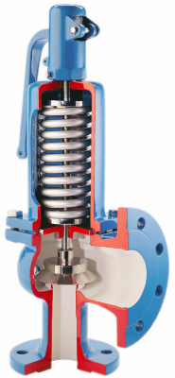
Fig. 3.7.2 Boiler safety valve

Boiler stop valves
A steam boiler must be fitted with a stop valve (also known as a crown valve) which isolates the steam boiler and its pressure from the process or plant. It is generally an angle pattern globe valve of the screw-down variety. Figure 3.7.3 shows a typical stop valve of this type.
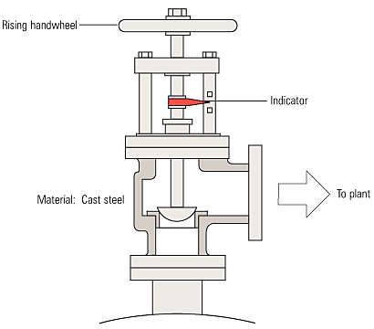
Fig. 3.7.3 Boiler stop valve
In the past, these valves have often been manufactured from cast iron, with steel and bronze being used for higher pressure applications. In the UK, BS 2790 states that cast iron valves are no longer permitted for this application on steam boilers. Nodular or spheroidal graphite (SG) iron should not be confused with grey cast iron as it has mechanical properties approaching those of steel. For this reason many boilermakers use SG iron valves as standard.
The stop valve is not designed as a throttling valve, and should be fully open or closed. It should always be opened slowly to prevent any sudden rise in downstream pressure and associated waterhammer, and to help restrict the fall in boiler pressure and any possible associated priming.
To comply with UK regulations, the valve should be of the ‘rising handwheel’ type. This allows the boiler operator to easily see the valve position, even from floor level. The valve shown is fitted with an indicator that makes this even easier for the operator.
On multi-boiler applications an additional isolating valve should be fitted, in series with the crown valve. At least one of these valves should be lockable in the closed position. The additional valve is generally a globe valve of the screw-down, non-return type which prevents one boiler pressurising another. Alternatively, it is possible to use a screw-down valve, with a disc check valve sandwiched between the flanges of the crown valve and itself.

Feedwater check valves
The feedwater check valve (as shown in Figures 3.7.4 and 3.7.5) is installed in the boiler feedwater line between the feedpump and boiler. A boiler feed stop valve is fitted at the boiler shell.
The check valve includes a spring equivalent to the head of water in the elevated feedtank when there is no pressure in the boiler. This prevents the boiler being flooded by the static head from the boiler feedtank.
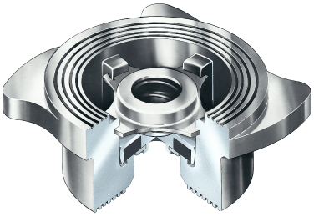
Fig. 3.7.4 Boiler check valve
Under normal steaming conditions the check valve operates in a conventional manner to stop return flow from the boiler entering the feedline when the feedpump is not running. When the feedpump is running, its pressure overcomes the spring to feed the boiler as normal.
Because a good seal is required, and the temperatures involved are relatively low (usually less than 100°C) a check valve with a EPDM (Ethylene Propylene) soft seat is generally the best option.
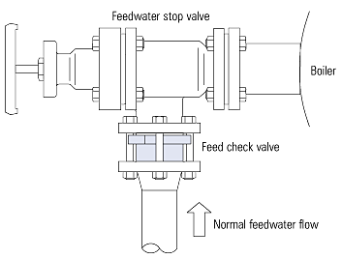
Fig. 3.7.5 Location of feed check valve

Boiler water quality control
The maintenance of water quality is essential to the safe and efficient operation of a steam boiler. The measurement and control of the various parameters is a complex topic, which is also covered by a number of regulations. It is therefore covered in detail later in this Block. The objective of the next few Sections is simply to identify the fittings to be seen on a boiler.

TDS control
This controls the amount of Total Dissolved Solids (TDS) in the boiler water, and is sometimes also referred to as ‘continuous blowdown’. The boiler connection is typically DN15 or 20. The system may be manual or automatic. Whatever system is used, the TDS in a sample of boiler water is compared with a set point; if the TDS level is too high, a quantity of boiler water is released to be replaced by feedwater with a much lower TDS level. This has the effect of diluting the water in the boiler, and reducing the TDS level.
On a manually controlled TDS system, the boiler water would be sampled every shift.
A typical automatic TDS control system is shown in Figure 3.7.6
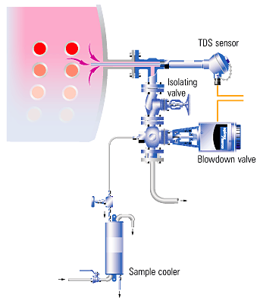
Fig. 3.7.6 Typical automatic TDS control system

Bottom blowdown
This ejects the sludge or sediment from the bottom of the boiler. The control is a large (usually 25 to 50 mm) key operated valve. This valve might normally be opened for a period of about 5 seconds, once per shift.
Figure 3.7.7 and Figure 3.7.8 illustrate a bottom blowdown valve and its typical position in a blowdown system.
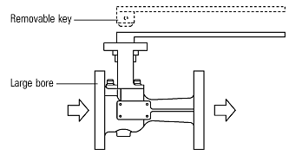
Fig. 3.7.7 Key operated bottom blowdown valve

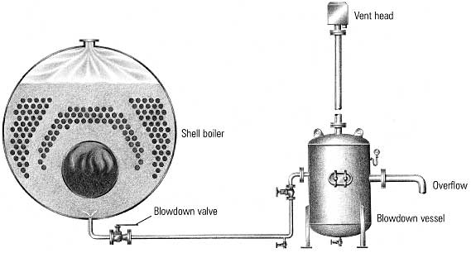
Fig. 3.7.8 Typical position for a bottom blowdown valve

Pressure gauge
All boilers must be fitted with at least one pressure indicator.
The usual type is a simple pressure gauge constructed to BS 1780 Part 2 - Class One.
The dial should be at least 150 mm in diameter and of the Bourdon tube type, it should be marked to indicate the normal working pressure and the maximum permissible working pressure / design pressure.
Pressure gauges are connected to the steam space of the boiler and usually have a ring type siphon tube which fills with condensed steam and protects the dial mechanism from high temperatures.
Pressure gauges may be fitted to other pressure containers such as blowdown vessels, and will usually have smaller dials as shown in Figure 3.7.9.
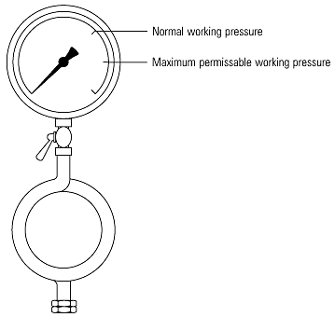
Fig. 3.7.9 Typical pressure gauge with ring siphon

Gauge glasses and fittings
All steam boilers are fitted with at least one water level indicator, but those with a rating of 100 kW or more should be fitted with two indicators. The indicators are usually referred to as gauge glasses complying with BS 3463.
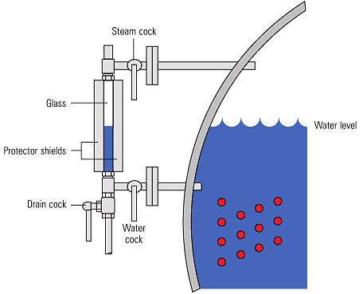
Fig. 3.7.10 Gauge glass and fittings
A gauge glass shows the current level of water in the boiler, regardless of the boiler’s operating conditions. Gauge glasses should be installed so that their lowest reading will show the water level at 50 mm above the point where overheating will occur. They should also be fitted with a protector around them, but this should not hinder visibility of the water level. Figure 3.7.10 shows a typical gauge glass.
Gauge glasses are prone to damage from a number of sources, such as corrosion from the chemicals in boiler water, and erosion during blowdown, particularly at the steam end. Any sign of corrosion or erosion indicates that a new glass is required.
When testing the gauge glass steam connection, the water cock should be closed. When testing the gauge glass water connections, the steam cock pipe should be closed.
To test a gauge glass, the following procedure should be followed:
- Close the water cock and open the drain cock for approximately 5 seconds.
- Close the drain cock and open the water cock
Water should return to its normal working level relatively quickly. If this does not happen, then a blockage in the water cock could be the reason, and remedial action should be taken as soon as possible.
- Close the steam cock and open the drain cock for approximately 5 seconds.
- Close the drain cock and open the steam cock.
If the water does not return to its normal working level relatively quickly, a blockage may exist in the steam cock. Remedial action should be taken as soon as possible.
The authorised attendant should systematically test the water gauges at least once each day and should be provided with suitable protection for the face and hands, as a safeguard against scalding in the event of glass breakage.
Note: that all handles for the gauge glass cocks should point downwards when in the running condition.

Gauge glass guards
The gauge glass guard should be kept clean. When the guard is being cleaned in place, or removed for cleaning, the gauge should be temporarily shut-off.
Make sure there is a satisfactory water level before shutting off the gauge and take care not to touch or knock the gauge glass. After cleaning, and when the guard has been replaced, the gauge should be tested and the cocks set in the correct position.

Maintenance
The gauge glass should be thoroughly overhauled at each annual survey. Lack of maintenance can result in hardening of packing and seizure of cocks. If a cock handle becomes bent or distorted special care is necessary to ensure that the cock is set full open. A damaged fitting should be renewed or repaired immediately. Gauge glasses often become discoloured due to water conditions; they also become thin and worn due to erosion. Glasses, therefore, should be renewed at regular intervals.
A stock of spare glasses and cone packing should always be available in the boiler house. Remember:
- If steam passes are choked a false high water level may be given in the gauge glass. After the gauge has been tested a false high water level may still be indicated.
- If the water passages are choked an artificially high water level may be observed due to steam condensing in the glass. After testing, the glass will tend to remain empty unless the water level in the boiler is higher than the top connection, in which case water might flow into the glass from this connection.
- Gauge glass levels must be treated with the utmost respect, as they are the only visual indicator of water level conditions inside the boiler. Any water level perceived as abnormal must be investigated as soon as it is observed, with immediate action taken to shut down the boiler burner if necessary.

Water level controls
The maintenance of the correct water level in a steam boiler is essential to its safe and efficient operation. The methods of sensing the water level, and the subsequent control of water level is a complex topic that is covered by a number of regulations. The following few Sections will provide a brief overview, and the topic will be discussed in much greater detail later.

External level control chambers
Level control chambers are fitted externally to boilers for the installation of level controls or alarms, as shown in Figure 3.7.11.
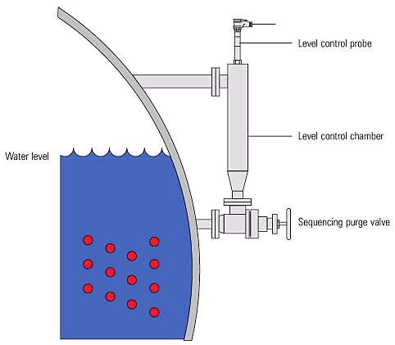
Fig. 3.7.11 External level control chamber
The function of the level controls or alarms is checked daily using the sequencing purge valves. With the handwheel turned fully anticlockwise the valve is in the ‘normal working’ position and a back seating shuts off the drain connection. The handwheel dial may look similar to that shown in Figure 3.7.12. Some handwheels have no dial, but rely on a mechanism for correct operation.
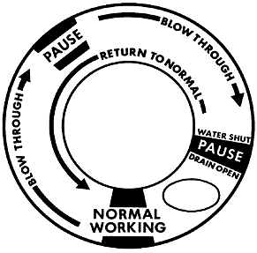
Fig. 3.7.12 Purge valve handwheel
The following is a typical procedure that may be used to test the controls when the boiler is under pressure, and the burner is firing:
- Slowly turn the handwheel clockwise until the indicating pointer is at the first ‘pause’ position. The float chamber connection is baffled, the drain connection is opened, and the water connection is blown through.
- Pause for 5 to 8 seconds.
- Slowly move the handwheel further clockwise to full travel. The water connection is shut-off, the drain valve remains open, and the float chamber and steam connections are blown through. The boiler controls should operate as for lowered water level in boiler i.e. pump running and / or audible alarm sounding and burner cut-out. Alternatively if the level control chamber is fitted with a second or extra low water alarm, the boiler should lock-out.
- Pause for 5 to 8 seconds.
- Slowly turn the handwheel fully anticlockwise to shut-off against the back seating in the ‘normal working’ position.
Sequencing purge valves are provided by a number of different manufacturers. Each may differ in operating procedure. It is essential that the manufacturer’s instructions be followed regarding this operation.

Internally mounted level controls
Level control systems with sensors (or probes) which fit inside the boiler shell (or steam drum) are also available. These provide a higher degree of safety than those fitted externally. The level alarm systems may also provide a self-checking function on system integrity.
Because they are mounted internally, they are not subject to the procedures required to blow down external chambers. System operation is tested by an evaporation test to ‘1st low’ position, followed by blowing down to ‘2nd low’ position.
Protection tubes are fitted to discourage the movement of water around the sensor.
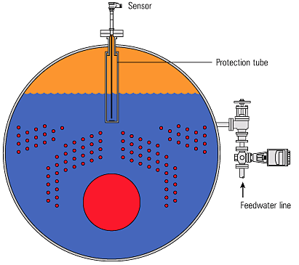
Fig. 3.7.13 Internally mounted level controls

Air vents and vacuum breakers
When a boiler is started from cold, the steam space is full of air. This air has no heat value, and will adversely affect steam plant performance due to its effect of blanketing heat exchange surfaces. The air can also give rise to corrosion in the condensate system, if not removed adequately.
The air may be purged from the steam space using a simple cock; normally this would be left open until a pressure of about 0.5 bar is showing on the pressure gauge. An alternative to the cock is a balanced pressure air vent which not only relieves the boiler operator of the task of manually purging air (and hence ensures that it is actually done), it is also much more accurate and will vent gases which may accumulate in the boiler. Typical air vents are shown in Figure 3.7.14.
When a boiler is taken off-line, the steam in the steam space condenses and leaves a vacuum. This vacuum causes pressure to be exerted on the boiler from the outside, and can result in boiler inspection doors leaking, damage to the boiler flat plates and the danger of overfilling a shutdown boiler. To avoid this, a vacuum breaker (see Figure 3.7.14) is required on the boiler shell.
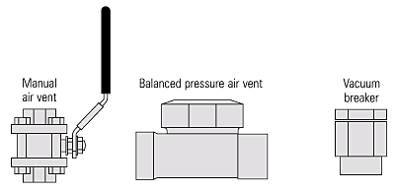
Fig. 3.7.14 Typical air vents and vacuum breakers

Introduction
As soon as mankind was able to boil water to create steam, the necessity of the safety device became evident. As long as 2000 years ago, the Chinese were using cauldrons with hinged lids to allow (relatively) safer production of steam. At the beginning of the 14th century, chemists used conical plugs and later, compressed springs to act as safety devices on pressurised vessels.
Early in the 19th century, boiler explosions on ships and locomotives frequently resulted from faulty safety devices, which led to the development of the first safety relief valves.
In 1848, Charles Retchie invented the accumulation chamber, which increases the compression surface within the safety valve allowing it to open rapidly within a narrow overpressure margin. Today, most steam users are compelled by local health and safety regulations to ensure that their plant and processes incorporate safety devices and precautions, which ensure that dangerous conditions are prevented.
The primary function of a safety valve is therefore to protect life and property.
The principle type of device used to prevent overpressure in plant is the safety or safety relief valve. The safety valve operates by releasing a volume of fluid from within the plant when a predetermined maximum pressure is reached, thereby reducing the excess pressure in a safe manner. As the safety valve may be the only remaining device to prevent catastrophic failure under overpressure conditions, it is important that any such device is capable of operating at all times and under all possible conditions.
Safety valves should be installed wherever the maximum allowable working pressure (MAWP) of a system or pressure-containing vessel is likely to be exceeded. In steam systems, safety valves are typically used for boiler overpressure protection and other applications such as downstream of pressure reducing controls. Although their primary role is for safety, safety valves are also used in process operations to prevent product damage due to excess pressure. Pressure excess can be generated in a number of different situations, including:
- An imbalance of fluid flowrate caused by inadvertently closed or opened isolation valves on a process vessel.
- Failure of a cooling system, which allows vapour or fluid to expand.
- Compressed air or electrical power failure to control instrumentation.
- Transient pressure surges.
- Exposure to plant fires.
- Heat exchanger tube failure.
- Uncontrollable exothermic reactions in chemical plants.
- Ambient temperature changes.
The terms ‘safety valve’ and ‘safety relief valve’ are generic terms to describe many varieties of pressure relief devices that are designed to prevent excessive internal fluid pressure build-up. A wide range of different valves is available for many different applications and performance criteria. Furthermore, different designs are required to meet the numerous national standards that govern the use of safety valves.
A listing of the relevant national standards can be found at the end of this module.
In most national standards, specific definitions are given for the terms associated with safety and safety relief valves. There are several notable differences between the terminology used in the USA and Europe. One of the most important differences is that a valve referred to as a ‘safety valve’ in Europe is referred to as a ‘safety relief valve’ or ‘pressure relief valve’ in the USA. In addition, the term ‘safety valve’ in the USA generally refers specifically to the full-lift type of safety valve used in Europe.
The ASME / ANSI PTC25.3 standards applicable to the USA define the following generic terms:
- Pressure relief valve - A spring-loaded pressure relief valve which is designed to open to relieve excess pressure and to reclose and prevent the further flow of fluid after normal conditions have been restored. It is characterised by a rapid-opening ‘pop’ action or by opening in a manner generally proportional to the increase in pressure over the opening pressure. It may be used for either compressible or incompressible fluids, depending on design, adjustment, or application.
This is a general term, which includes safety valves, relief valves and safety relief valves.
- Safety valve - A pressure relief valve actuated by inlet static pressure and characterised by rapid opening or pop action.
Safety valves are primarily used with compressible gases and in particular for steam and air services. However, they can also be used for process type applications where they may be needed to protect the plant or to prevent spoilage of the product being processed.
- Relief valve - A pressure relief device actuated by inlet static pressure having a gradual lift generally proportional to the increase in pressure over opening pressure.
Relief valves are commonly used in liquid systems, especially for lower capacities and thermal expansion duty. They can also be used on pumped systems as pressure overspill devices.
- Safety relief valve - A pressure relief valve characterised by rapid opening or pop action, or by opening in proportion to the increase in pressure over the opening pressure, depending on the application, and which may be used either for liquid or compressible fluid.
In general, the safety relief valve will perform as a safety valve when used in a compressible gas system, but it will open in proportion to the overpressure when used in liquid systems, as would a relief valve.
The European standards (BS 6759 and DIN 3320) provide the following definition:
- Safety valve - A valve which automatically, without the assistance of any energy other than that of the fluid concerned, discharges a certified amount of the fluid so as to prevent a predetermined safe pressure being exceeded, and which is designed to re-close and prevent the further flow of fluid after normal pressure conditions of service have been restored.
Typical examples of safety valves used on steam systems are shown in Figure 9.1.1.
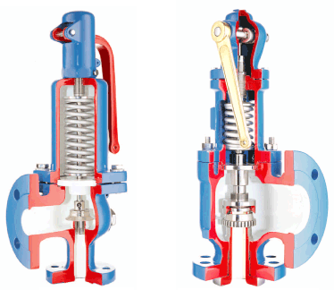
Fig. 9.1.1 Typical safety valves

Safety valve design
The basic spring loaded safety valve, referred to as ‘standard’ or ‘conventional’ is a simple, reliable self-acting device that provides overpressure protection.
The basic elements of the design consist of a right angle pattern valve body with the valve inlet connection, or nozzle, mounted on the pressure-containing system. The outlet connection may be screwed or flanged for connection to a piped discharge system. However, in some applications, such as compressed air systems, the safety valve will not have an outlet connection, and the fluid is vented directly to the atmosphere.
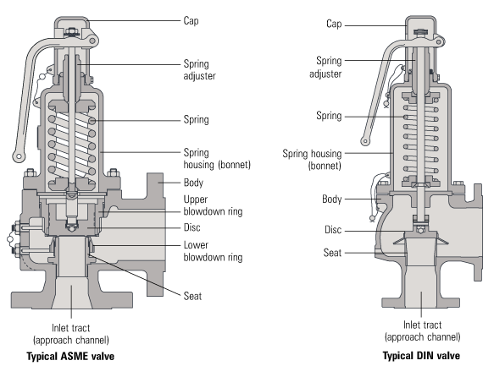
Fig. 9.1.2 Typical safety valve designs
The valve inlet (or approach channel) design can be either a full-nozzle or a semi-nozzle type. A full-nozzle design has the entire ‘wetted’ inlet tract formed from one piece. The approach channel is the only part of the safety valve that is exposed to the process fluid during normal operation, other than the disc, unless the valve is discharging.
Full-nozzles are usually incorporated in safety valves designed for process and high pressure applications, especially when the fluid is corrosive.
Conversely, the semi-nozzle design consists of a seating ring fitted into the body, the top of which forms the seat of the valve. The advantage of this arrangement is that the seat can easily be replaced, without replacing the whole inlet.
The disc is held against the nozzle seat (under normal operating conditions) by the spring, which is housed in an open or closed spring housing arrangement (or bonnet) mounted on top of the body. The discs used in rapid opening (pop type) safety valves are surrounded by a shroud, disc holder or huddling chamber which helps to produce the rapid opening characteristic.
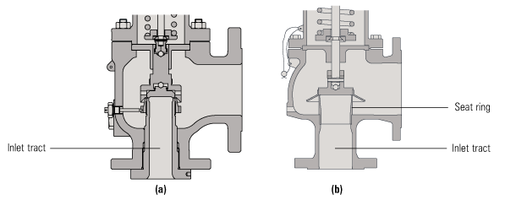
Fig. 9.1.3 A full-nozzle valve (a) and a semi-nozzle valve (b)
The closing force on the disc is provided by a spring, typically made from carbon steel. The amount of compression on the spring is usually adjustable, using the spring adjuster, to alter the pressure at which the disc is lifted off its seat.
Standards that govern the design and use of safety valves generally only define the three dimensions that relate to the discharge capacity of the safety valve, namely the flow (or bore) area, the curtain area and the discharge (or orifice) area (see Figure 9.1.4).
1. Flow area - The minimum cross-sectional area between the inlet and the seat, at its narrowest point. The diameter of the flow area is represented by dimension ‘d’ in Figure 9.1.4.
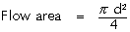
Equation 9.1.1
2. Curtain area - The area of the cylindrical or conical discharge opening between the seating surfaces created by the lift of the disk above the seat. The diameter of the curtain area is represented by dimension ‘d1’ in Figure 9.1.4.
Equation 9.1.2
3. Discharge area - This is the lesser of the curtain and flow areas, which determines the flow through the valve.
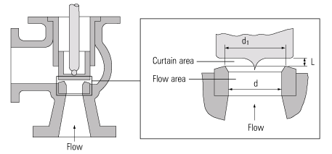
Fig. 9.1.4 Illustration of the standard defined areas
Valves in which the flow area and not the curtain area determines the capacity are known as full lift valves. These valves will have a greater capacity than low lift or high lift valves. This issue will be discussed in greater depth in Module 9.2.
Although the principal elements of a conventional safety valve are similar, the design details can vary considerably. In general, the DIN style valves (commonly used throughout Europe) tend to use a simpler construction with a fixed skirt (or hood) arrangement whereas the ASME style valves have a more complex design that includes one or two adjustable blowdown rings. The position of these rings can be used to fine-tune the overpressure and blowdown values of the valve.
For a given orifice area, there may be a number of different inlet and outlet connection sizes, as well as body dimensions such as centreline to face dimensions. Furthermore, many competing products, particularly of European origin have differing dimensions and capacities for the same nominal size.
An exception to this situation is found with steel ASME specification valves, which invariably follow the recommendations of the API Recommended Practice 526, where centreline to face dimensions, and orifice sizes are listed. The orifice area series are referred to by a letter. It is common for valves with the same orifice letter to have several different sizes of inlet and outlet connection. For example, 2” x J x 3” and 3” x J x 4” are both valves which have the same size (‘J) orifice, but they have differing inlet and outlet sizes as shown before and after the orifice letter respectively. A 2” x J x 3” valve would have a 2” inlet, a ‘J’ size orifice and a 3” outlet.
This letter series is also referenced in other standards, for example, BS 6759 part 3, which deals with valves for process type applications and NFE- E 29-414.

Basic operation of a safety valve
Lifting
When the inlet static pressure rises above the set pressure of the safety valve, the disc will begin to lift off its seat. However, as soon as the spring starts to compress, the spring force will increase; this means that the pressure would have to continue to rise before any further lift can occur, and for there to be any significant flow through the valve.
The additional pressure rise required before the safety valve will discharge at its rated capacity is called the overpressure. The allowable overpressure depends on the standards being followed and the particular application. For compressible fluids, this is normally between 3% and 10%, and for liquids between 10% and 25%.
In order to achieve full opening from this small overpressure, the disc arrangement has to be specially designed to provide rapid opening. This is usually done by placing a shroud, skirt or hood around the disc. The volume contained within this shroud is known as the control or huddling chamber.
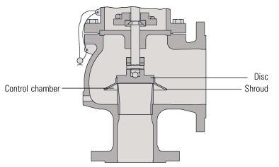
Fig. 9.1.5 Typical disc and shroud arrangement used on rapid opening safety valves
As lift begins (Figure 9.1.6b), and fluid enters the chamber, a larger area of the shroud is exposed to the fluid pressure. Since the magnitude of the lifting force (F) is proportional to the product of the pressure (P) and the area exposed to the fluid (A); (F = P x A), the opening force is increased. This incremental increase in opening force overcompensates for the increase in spring force, causing rapid opening. At the same time, the shroud reverses the direction of the flow, which provides a reaction force, further enhancing the lift.
These combined effects allow the valve to achieve its designed lift within a relatively small percentage overpressure. For compressible fluids, an additional contributory factor is the rapid expansion as the fluid volume increases from a higher to a lower pressure area. This plays a major role in ensuring that the valve opens fully within the small overpressure limit. For liquids, this effect is more proportional and subsequently, the overpressure is typically greater; 25% is common.
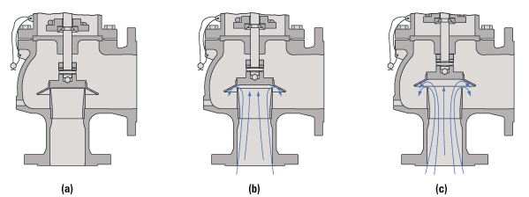
Fig. 9.1.6 Operation of a conventional safety valve
Reseating
Once normal operating conditions have been restored, the valve is required to close again, but since the larger area of the disc is still exposed to the fluid, the valve will not close until the pressure has dropped below the original set pressure. The difference between the set pressure and this reseating pressure is known as the ‘blowdown’, and it is usually specified as a percentage of the set pressure. For compressible fluids, the blowdown is usually less than 10%, and for liquids, it can be up to 20%.
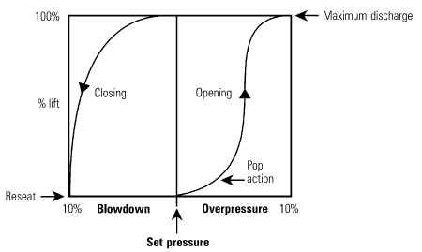
Fig. 9.1.7 Relationship between pressure and lift for a typical safety valve
The design of the shroud must be such that it offers both rapid opening and relatively small blowdown, so that as soon as a potentially hazardous situation is reached, any overpressure is relieved, but excessive quantities of the fluid are prevented from being discharged. At the same time, it is necessary to ensure that the system pressure is reduced sufficiently to prevent immediate reopening.
The blowdown rings found on most ASME type safety valves are used to make fine adjustments to the overpressure and blowdown values of the valves (see Figure 9.1.8). The lower blowdown (nozzle) ring is a common feature on many valves where the tighter overpressure and blowdown requirements require a more sophisticated designed solution. The upper blowdown ring is usually factory set and essentially takes out the manufacturing tolerances which affect the geometry of the huddling chamber.
The lower blowdown ring is also factory set to achieve the appropriate code performance requirements but under certain circumstances can be altered. When the lower blowdown ring is adjusted to its top position the huddling chamber volume is such that the valve will pop rapidly, minimising the overpressure value but correspondingly requiring a greater blowdown before the valve re-seats. When the lower blowdown ring is adjusted to its lower position there is minimal restriction in the huddling chamber and a greater overpressure will be required before the valve is fully open but the blowdown value will be reduced.
