Super heaters

Reason for superheating steam

Whatever type of boiler is used, steam will leave the water at its surface and pass into the steam space. Steam formed above the water surface in a shell boiler is always saturated and cannot become superheated in the boiler shell, as it is constantly in contact with the water surface.
If superheated steam is required, the saturated steam must pass through a super heater. This is simply a heat exchanger where additional heat is added to the saturated steam.
The maximum efficiency possible for a plant is given by the Carnot cycle and can be calculated using the formula
Efficiency = T1- T2/ T1
Where T1 is the maximum temperature in a cycle (Kelvin) and T2 is the minimum temperature in a cycle.
For the steam plant these equate to blr outlet temperature and the exhaust temperature of the turbine.
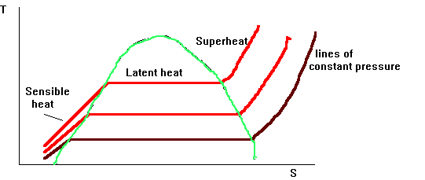
Hence, to increase final temperatures at boiler outlet conditions either; the boiler pressure can be increased, or the degree of superheat can be increased. Boiler pressure increase is ultimately limited by the scantling requirements, more importantly however; the energy stored within the steam is little increased due to the reduction in the latent heat.
Increasing the degree of Superheat not only increases the temperature but also greatly increases the heat energy stored within contained another advantage would be that the onset of condensation through the turbine would be delayed. However this increases the specific volume which would require excessively large plant. Also there would be insufficient pressure drop for efficient expansion through the turbine. There would also be little allowance for feed heating.
There is therefore a combination of increased Pressure and Superheat to give the increased efficiency potential allied with practical design parameters.
Since these boilers are uncontrolled superheat and the plant is designed to use lower temperature steam in many applications to help reduce construction and maintenance costs, the steam needed for these services must pass through a desuperheater. The desuperheater is a multi-pass tube bundle which is located in the water drum in most boilers. There are several boilers which have the desuperheater in the steam drum. As the superheated steam passes through the tube bundle, it gives up heat to the boiler water in the water drum.

Limit of Superheat
Superheated steam, having a lower specific heat capacity then water does not conduct heat away as efficiently as in water cooled tubes, and hence the tube metal surface temperature is higher.
This has led to the external superheat design and parallel steam flows in an effort to keep metal temperatures within limits. For mild steel, up to 455ºC superheat is possible; for higher temperatures, up to 560ºC the use of chrome molybdenum steels is required. The use of special alloy steels introduces manufacturing and welding difficulties.
It can be seen that there is a requirement for some form of superheat temperature control

Positioning of the super heater

Integral (FW D-type)
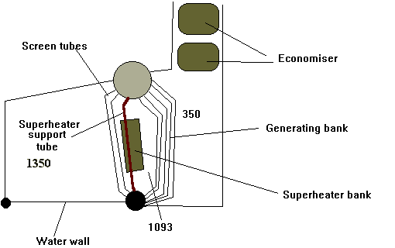

This design suffered from heavy slagging of the tubes, particularly the super heater bank, caused by the vanadium bearing ash of the increasingly poorer quality fuel blends.
This ash caused a heavy bonding slag deposit which often bridged the gap between the tubes. This slagging attached to the hot surfaces of the super heater support tube led to wastage and failure. Increasing slagging would eventually lead to blockage and hence reduced gas path with increased gas velocities over the smaller number of tubes, this led to overheating and failure. Access for cleaning was limited, this and the problems outlined above led to the external super heater design

External (FW ESD III)

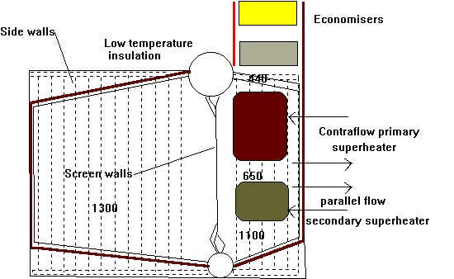
In this position the super heater was protected from the radiant heat of the flame and with roof firing complete combustion was ensured within the furnace space with no flame impingement, this allied to reduced gas temperatures meant that conditions for the super heater bank was less arduous.
The new positioning of the super heater banks allowed for easier inspection and cleaning. More effective sootblowing could also be employed.
With the positioning of the bank changing to external meant that the surface area of the nest had to increase to give the same heating effect.
Mounting of the tubes in the athwartships direction allowed for a simpler mounting arrangement. The secondary super heater, mounted below that of the primary super heater was of the parallel flow type, this ensured that the lower temperature attemperated steam was in the tubes in the highest temperature zone. In modern Radiant Heat boilers it is common to mount the primary super heater below that of the secondary and use parallel flow throughout; this ensures adequate cooling throughout.

Designs of Super heater banks and mounting arrangements

U-Tubes

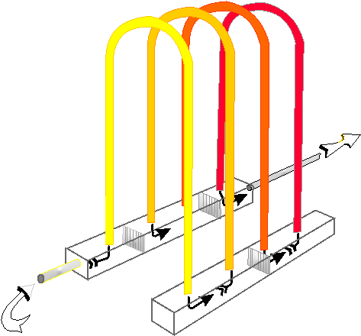

Use limited to the integral positioning fort he superheat bank, the modern method is to hang the tubes vertically, this prevents the sagging that can occur with the tubes in the horizontal.
The tubes were supported by a support plate which hung off a special increased diameter water cooler tube called the support tube. As the supports were situated in a high temperature zone they were susceptible to failure.
Division plates were welded into the headers, these allowed the steam to make many passes increasing the efficiency of the bank. Small hole were formed in these plates to allow for proper drainage, failure of these plates caused short circuiting, overheating and subsequent failures. Failure of a single tube, although possible leading to a restriction in the flow meant that the heating surface was reduced by only a small amount.
The super heater inlet and outlet flange were mounted on the same side.

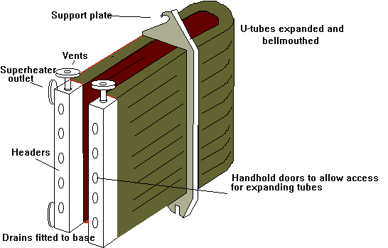

External (melesco type)
In this design there are no baffles fitted inside the header, instead the steam makes a multipass over the gas by way of the many limbs or bends of each tube. The disadvantage of this system is that if a tube should fail then a significant reduction in heating surface would occur. Simpler, more reliable support methods are possible allied to the easier access and sootblowing arrangement. This type of super heater has the advantage that the, number of expanded or welded joints are reduced.
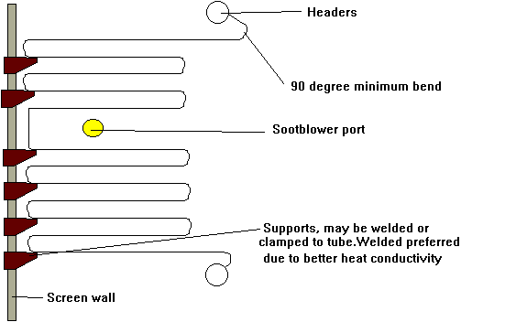
With this design the initial passes are made of Chrome Molybdenum steel. a transition piece attaches this to the mild steel passes.
The inlet header is made out of mild steel and the outlet an alloy steel.

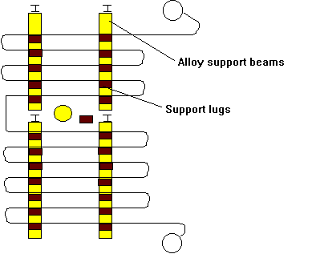

Methods of attachment

Expanded
Only used in super heaters fort temperatures upto 450ºC Tube ends must be cleaned and degreased and then drifted and roller expanded into the hole, the end of the tube must be projecting by at least 6mm. The bell mouth must have an increase of diameter of 1mm per 25mm plus an additional 1.5mm.
It is important that the tube enter perpendicular into the head, a seal will be assured if the contact length is greater than 10mm, if it is not possible to enter perpendicularly then the contact length should be increased to 13mm.
For larger diameter pipes then grooved seats are used.
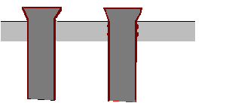

Welded
Welding gives advantages over expanding in that access to the internal side of the header is not so important and so the number of hand hole doors can be much reduced eliminating a source of possible leakage. Welding also generally provides a more reliable seal.
The disadvantage is that heat treatment following welding is required.
The purpose of the backing ring fitted to the conventional attachment method is to prevent the weld metal breaking through into the tube
The Melric joint offers the following advantages over the conventional method;
  - Dispenses with butt joints and internal backing rings
  - Allows for maximum access for welding
  - The joints can be annealed locally by electric heat muff or torch according to manufacturers recommendtions
  - The stub bosses can be readily blanked off externally in the event of tube failure and so do not require the access to the header internal side
