Steam drum
In the early designs the drums were riveted or solid forged from a single ingot, but for modern boilers the drum is generally fabricated from steel plate of differing thicknesses and welded. The materials used are governed by classification society rules. Test pieces must be provided.
The cylindrical drum is normally constructed from four plates. Two dished End plates, a thick wall tube plate (thicker to accommodate the holes drilled in it without increased stress) and completed with a thinner wrapper plate.
Construction takes the form of rigidly clamping the descaled, bent wrapper and tube plates together. In addition test pieces cut from the original material are attached to the construction in such away that the longitudinal weld extends either sided of the join. These pieces are later removed and shaped test shapes cut out from specified areas including across the weld.
The longitudinal weld is critical (taking twice the circumferential stress) and is normally carried out by specialized automatic machinery using submerged arc techniques.
The dished end pieces are accurately aligned and welded.
On completion the construction is cleaned and non-destructive testing- such as x-ray photography, carried out. Final machining is carried out and any stub pieces and doublers attached. The now complete drum is heat treated at 600 to 650'C.
The final process is hydraulic testing to classification requirements. Natural circulation within a boiler is due to the differing specific gravities of the water at the differing temperatures, the steam drum provides a reservoir of cool water to give the gravitational head necessary for natural circulation. Cool water entering the steam drum via the feed lines provides the motive effect for the circulation distributing it to the downcomers.
Also the space within the drum provides for the separation of the steam and water emulsions formed in the water walls and the generating tubes. Water droplets entrained with the separated steam are removed by separating components fitted in the drum as well as the perforated baffle plates fitted at the water line.
The space above the water line provides for a reserve steam space needed to maintain plant stability during manoeuvring conditions.
Also fitted are the chemical injection distributing pipe and the scuming plate.
The smaller the drum is made, the less thickness of material that is required. However, the limitation to how small is that sufficient space must be allowed for the separation of water from the steam before passing out to the superheater space otherwise dryers must be used. Also, due to the smaller reserve of water, larger fluctuations in water level occur during manoeuvring.
SAFETY VALVE CONFIGURATION
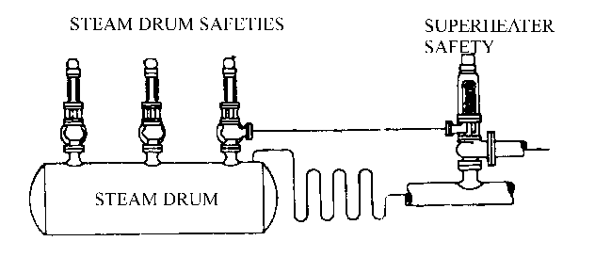
Figure 1

The internal fittings in the steam drum help distribute the water evenly throughout the drum, separate the generated steam from the water and remove moisture from the steam before it leaves the boiler (refer to Figure 2).
- Lower baffle plates or apron plates Separate the incoming feedwater and generated steam and direct the steam to the separators.
- Primary separators (cyclone separators) separate most of the water from the steam by giving it a cyclone or rotary motion so that the water particles are expelled from the steam by the centrifugal forces. These separators are vertically mounted in the steam drum so that the steam rises out the top and the water falls back into the steam drum.
- Secondary separators (chevron dryers) remove additional moisture from the steam by changing the direction of steam flow several times. The steam passes on but the moisture cannot make the direction change with the steam. These separators are mounted above the primary separators and direct steam to the dry box which collects the steam at the top of the steam drum, directing it to the steam outlet piping to the superheater.
- Feedwater leaves the economizer and enters the boiler through the internal feed pipe and becomes "boiler water." Perforations along the side of the feed pipe allow water to be distributed evenly throughout the steam drum (refer to Figure 2)

STEAM DRUM INTERNALS
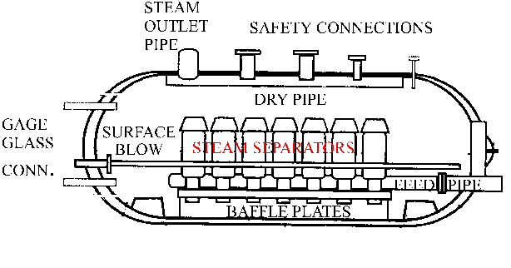
Figure 2

- Since suspended solids may accumulate on the surface of the water in the steam drum, there must be means of removing them. The surface blow pipe is used to remove these light suspended solids from the surface of the water and to reduce the total dissolved solid content of the boiler water. Suspended solids usually consist of oil, salt contaminants, or excessive treatment chemicals which can cause foaming on the water surface. Dissolved solids usually consist of salt contaminants and treatment chemicals that are in solution.

Water drum
Distributes feed water from the downcomers to the headers and generating tubes. Provides a space for accumulating precipitates and allows them to be blown down.
Water drum size is limited to that required to receive the generating tubes, for modern radiant heat boilers with only a single bank of screen tubes and no generating tubes between the drums, the water drum has been replaced by a header and the downcomers fed straight to the waterwall headers. With system blow down is done at the steam drum. Too small a water drum can cause problems of maintaining ideal water level and little steam reserve

