Why steam-temperature control is needed?
The rate at which heat is transferred to the fluid in the tube banks of a boiler or HRSG will depend on the rate of heat input from the fuel or exhaust from the gas turbine. This heat will be used to convert water to steam and then to increase the temperature of the steam in the superheat stages. In a boiler, the temperature of the steam will also be affected by the pattern in which the burners are fired, since some banks of tubes pick up heat by direct radiation from the burners. In both types of plant the temperature of the steam will also be affected by the flow of fluid within the tubes, and by the way in which the hot gases circulate within the boiler.
As the steam flow increases, the temperature of the steam in the banks of tubes that are directly influenced by the radiant heat of combustion starts to decrease as the increasing flow of fluid takes away more of the heat that falls on the metal. Therefore the steam-temperature/steam-flow profile for this bank of tubes shows a decline as the steam flow increases.
On the other hand, the temperature of the steam in the banks of tubes in the convection passes tends to increase because of the higher heat transfer brought about by the increased flow of gases, so that this temperature/flow profile shows a rise in temperature as the flow increases. By combining these two characteristics, the one rising, the other falling, the boiler designer will aim to achieve a fairly flat temperature/flow characteristic over a wide range of steam flows.
No matter how successfully this target is attained, it cannot yield an absolutely flat temperature flow characteristic. Without any additional control, the temperature of the steam leaving the final superheater of the boiler or HRSG would vary with the rate of steam flow, following what is known as the `natural characteristic' of the boiler. The shape of this
will depend on the particular design of plant, but in general, the temperature will rise to a peak as the load increases, after which it will fall.
The steam turbine or the process plant that is to receive the steam usually requires the temperature to remain at a precise value over the entire load range, and it is mainly for this reason that some dedicated means of regulating the temperature must be provided. Since different banks of tubes are affected in different ways by the radiation from the burners and the flow of hot gases, an additional requirement is to provide some means of adjusting the temperature of the steam within different parts of the circuit, to prevent any one section from becoming overheated.
In theory, the design of the plant should be targeted on arranging for the natural characteristic to attain the correct steam temperature when the rate of steam flow is that at which the boiler will normally operate. If this is possible, it means that spray water is used only while the unit is being brought up to load or when it operates at off-design conditions. In practice this objective can be attained only to a limited extent, because the boiler's natural characteristic changes with time due to factors such as fouling of the metal surfaces, which affects the heat transfer. In general, it is common to operate with continuous spraying, which has the advantage of allowing the steam temperature to be adjusted both upwards and downwards. If the required temperature were to be met solely by employing the natural characteristic as described, it would not be possible to produce temperature increases.
Before looking at the types of steam-temperature control systems that are applied, it will be useful to examine some of the mechanisms which are employed to regulate the temperature according to the controller's commands. Depending on whether or not the temperature of the steam is lowered to below the saturation point the controlling devices are known as attemperators or desuperheaters. (Strictly speaking, the correct term to use for a device which reduces the steam temperature to a point which is still above the saturation point is an attemperator, while one that lowers it below the saturation point may be referred to either as an attemperator or a desuperheater. However, in common engineering usage both terms are applied somewhat indiscriminately.)

The spray-water attemperator

One way of adjusting the temperature of steam is to pump a fine spray of comparatively cool water droplets into the vapour. With the resultingy
so that the final mixture comprises an increased volume of steam at a temperature which is lower than that prior to the water injection point. This cooling function is achieved in the attemperator.
The attemperator is an effective means of lowering the temperature of the steam, though in thermodynamic terms it results in a reduction in the performance of the plant because the steam temperature has to be raised to a higher value than is needed, only to be brought down to the correct value later, by injecting the spray water.
Although the inherent design of the attemperation system may, in theory, permit control to be achieved over a very wide range of steam flows, it should be understood that the curve of the boiler's natural characteristic will restrict the load range over which practical temperature control is possible, regardless of the type of attemperator in use. It is not unusual for the effective temperature-control range of a boiler to be between only 75% and 100% of the boiler's maximum continuous rating (MCR). This limitation is also the result of the spray-water flow being a larger proportion of the steam flow at low loads.
7.2.1 The mechanically atomised attemperator
Various forms of spray attemperator are employed. Figure 7.1 shows a simple design where the high-pressure cooling water is mechanically atomised into small droplets at a nozzle, thereby maximising the area of contact between the steam and the water. With this type of attemperator the water droplets leave the nozzle at a high velocity and therefore travel for some distance before they mix with the steam and are absorbed. To avoid stress-inducing impingement of cold droplets on hot pipework, the length of straight pipe in which this type of attemperator needs to be installed is quite long, typically 6 m or more.
With spray attemperators, the flow of cooling water is related to the flow rate and the temperature of the steam, and this leads to a further limitation of a fixed-nozzle attemperator. Successful break-up of the water into atomised droplets requires the spray water to be at a pressure which exceeds the steam pressure at the nozzle by a certain amount (typically 4 bar). Because the nozzle presents a fixed-area orifice to the spray water, the pressure/flow characteristic has a square-law shape, resulting in a restricted range of flows over which it can be used (this is referred to as limited turn-down or rangeability). The turn-down of the mechanically atomised type of attemperator is around 1.5: 1.
The temperature of the steam is adjusted by modulating a separate
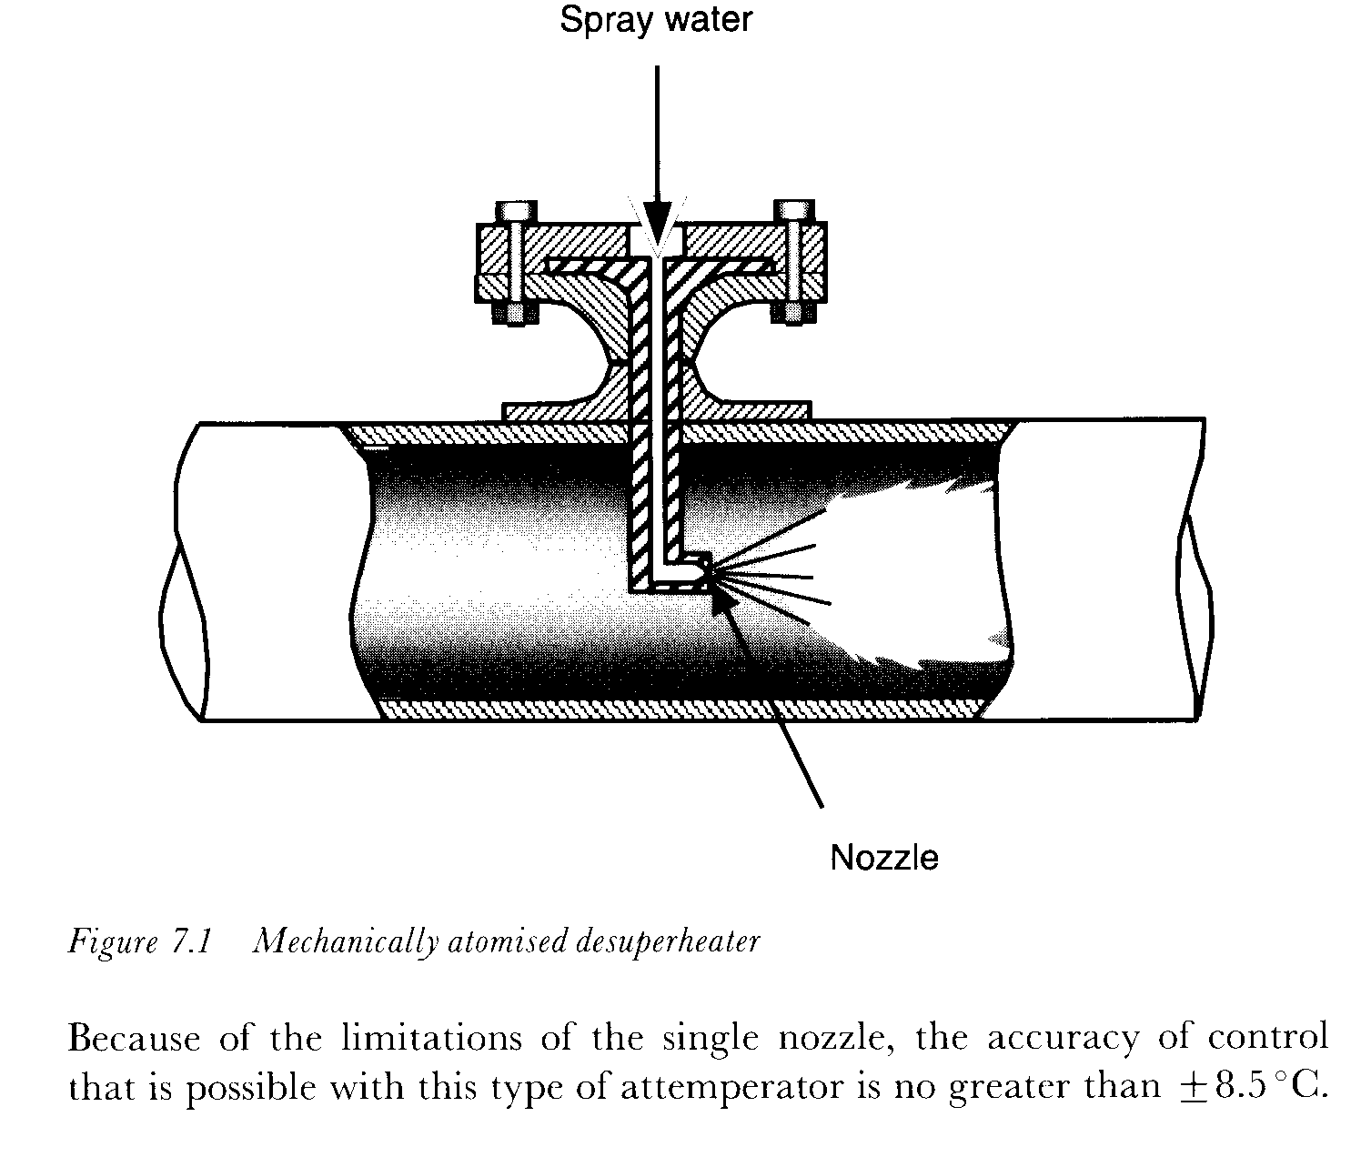
The variable-area attemperator
One way of overcoming the limitations of a fixed nozzle in an attemperator is to use an arrangement which changes the profile as the throughput of spray water alters. Figure 7.2 shows the operating principle of a variable area, multinozzle attemperator. This employs a sliding plug which is moved by an actuator, allowing the water to be injected through a greater or smaller number of nozzles. With this type of device, the amount of water injected is regulated by the position of the sliding plug, a separate spray-water control valve is therefore not needed.
Adequate performance of this type of attemperator depends on the velocity of the vapour at the nozzles being high enough to ensure that the coolant droplets remain in suspension for long enough to ensure their absorption by the steam. For this reason, and also to provide thermal protection for the pipework in the vicinity of the nozzles, a thermal liner is often included in the pipe extendine- from the plane of the nozzles to a
Principle of a multinozzle desuperheater

The accuracy of control and the turndown range available from a multi-nozzle attemperator is considerably greater than that of a singlenozzle version, allowing the steam temperature to be controlled to -f- 5.5°C over a flow range of 40: 1.
7.2.3 The variable -annulus desuperheater
Another way of achieving accurate control of the steam temperature over the widest possible dynamic range is provided by the variable-annulus desuperheater (VAD) (produced by Copes-Vulcan Limited, Road Two, Winsford Industrial Estate, Winsford, Cheshire, CW7 3QL.). Here, the approach contour of the VAD head is such that when the inlet steam flows through an annular ring between the spray head and the inner wall of the
coolant enters at this point and undergoes an instant increase in velocity and a decrease in pressure, causing it to vapourise into a micron-thin layer which is stripped off the edge of the spray head and propelled downstream. The stripping action acts as a barrier which prevents the coolant from impinging on the inner wall of the steam pipe. The downstream portion of the VAD head is contoured, creating a vortex zone into which any unabsorbed coolant is drawn, exposing it to a zone
of low pressure and high turbulence, which therefore causes additional evaporation.
Due to the Venturi principle, the pressure of the cooled steam is quickly restored downstream of the vena contracta point, resulting in a very low overall loss of pressure.
An advantage of the VAD is that, due to the coolant injection occurring at a point where the steam pressure is lowered, the pressure of the spray water does not have to be significantly higher than that of the steam.
7.2.4 Other types of attemperator
At least two other designs of attemperator will be encountered in powcrstation applications. The vapour-atomising design mixes steam with the cooling water, thus ensuring more effective break-up of the water droplets and shrouding the atomised droplets in a sheath of steam to provide rapid attemperation.
Variable-orifice attemperators include a freely floating plug which is positioned above a fixed seat a design that generates high turbulence and more efficient attemperation. The coolant velocity increases simultaneously with the pressure drop, instantly vaporising the liquid. Because of the movement of the plug, the pressure drop across the nozzle remains constant (at about 0.2 bar). The design of this type of attemperator is so efficient that complete mixing of the coolant and the steam is provided within 3 to 4 m of the coolant entry point, and the temperature can he controlled to ± 2.5 °C, theoretically over a turndown range of 100: 1.
Because the floating plug moves against gravity, this type of attemperator must be installed in a vertical section of pipe with the steam through it travelling in an upward direction. However, because of the efficient mixing of steam and coolant, it is permissible to provide a bend almost immediately after the device. Figure 7.3 shows a typical installa-
Figure 7.3 Variable-orifice attemperalor installation 7.2.5 Location of temperature sensors
Because the steam and water do not mix immediately at the plane of the nozzle or nozzles, great care must be taken to locate the temperature sensor far enough downstream of the attemperator for the measurement to accurately represent the actual temperature of the steam entering the next stage of tube banks. Direct impingement of spray water on the temperature sensor will result in the final steam temperature being higher than desired. Figure 7.4 shows a typical installation, in this case for a variable-annulus desuperheater.

7.2.6 Control systems for spray-water attemperators
The simplest possible type of control would be based on measuring the
the flow of cooling water to the spray attemperator so as to keep the temperature constant at all flow conditions. Unfortunately, because of the long time constants associated with the superheater, this form of control would produce excessive deviations in temperature, and a more complex arrangement is required.
Two time constants are associated with the superheater. One represents the time taken for changes in the firing rate to affect the steam temperature, the other is the time taken for the steam and water mixture leaving the attemperator to appear at the outlet of the final superheater. In terms of temperature control it is the latter effect which predominates because, although changes in heat input will affect the temperature of the steam, a fast-responding temperature-control loop will be able to compensate for the alterations and keep the temperature constant. It is the reaction time between a change occurring in the spray-water flow and the effects being observed in the final temperature that determines the extent of the temperature variations that will occur.
Another problem with a simple system, as outlined above, is that it does not permit any monitoring and control of the temperature to occur within the steam circuit only at the exit from the boiler.
These difficulties are addressed by the application of a cascade control system as shown in Figure 7.5. This shows a simple steam-temperature control system based on the use of an interstage attemperator which is located in the steam circuit between the primary and secondary banks of superheater tubes.
Since it is the temperature of the steam leaving the secondary superheater that is important, this parameter is measured and a corresponding signal fed to a two- or three-term controller (proportional-plus-integral or proportional-plus-integral-plus-derivative). In this controller the measured-value signal is compared with a fixed desired-value signal and the controller' s output forms the desired-value input for a secondary controller. (Because the output from one controller `cascades' into the input of another, this type of control system is commonly termed `cascade control'.)
The secondary controller compares this desired-value signal with a measurement representing the temperature of the steam immediately after the spray-water attemperator.
It is a matter of some debate as to whether a two-term or three-term controller should be used in this type of application. Because the steamtemperature sensors used are subjected to the high pressures and temperatures of the superheater, they have to be enclosed in substantial steel pockets. Even with the best designs, pockets are usually slow-responding, with the result that any high-speed fluctuations in the measured-value
signal will be smoothed out and the resultant signal will be fairly stable. The use of a derivative term is therefore easier than in, say, flow measurement applications where small-scale but sudden changes in flow can occur. When rapid input changes are differentiated, the controller output changes by a large amount, and for this reason tuning three-term flow controllers for optimum response can become difficult. This is not a problem with the temperature controllers described here, and the application of derivative action may be viable if it is felt that this could provide improved performance. As usual, it is important that the controller design should be such that the derivative term affects only the measured-value signal (not the desired-value or error signals), since differential response to operatorinduced setpoint changes is always undesirable.
In Chapter 6, reference was made to the requirement for the spray water to enter the attemperator at a pressure which exceeds the steam pressure by a minimum value. It is worth remembering the point made there: that, where a variable-speed feed pump is used, care must be taken
to ensure that adequate water/steam differential pressure is available under all operational conditions.
7.2.6.1 Controller saturation effects
The type of control system described above is commonly encountered in a wide variety of applications, and it is subject to an effect which must be understood and adequately addressed by the design of the controllers used in the system. The effect is known as `integral saturation' or `reset windup', and it is a characteristic of integral-action controllers whose output commands are fed into the inputs of cascade or secondary controllers. It sometimes confuses people when they are first introduced to this saturation effect in steam-temperature control applications since the word 'saturation' is also applied to a thermodynamic property of steam. It is therefore important that the point is clearly understood that in this context the word `saturation' refers to a controller output reaching a limiting value and then attempting to exceed that figure.
Whether the implementation of a controller is achieved in hardware or by software its output must always be constrained by some design limit or other. At first sight, it may appear that the exception to this rule is the socalled pulse or incremental controller, where the output commands dictate a change in the position of the controlled device. However, if the controller and actuator are considered together as a system it will be seen that saturation will still occur when the actuator reaches the limit of its movement.
With a gain of x, the output of a controller will be the input error multiplied by x, but what happens if either x or the error is so large that the resulting output is outside the range of signals that the controller can handle (i.e. beyond the limiting value of the output range)? In this case the controller output will adopt a magnitude which is fixed at the limiting value, in which condition the output is no longer representative of the input error.
The range of inputs within which the controller output is representative of the input error is inversely proportional to the gain: with a large gain, a small input error may force the output signal to the limiting value, and vice versa.
It is for this reason that control engineers refer to the `proportional band' of the controller, the proportional band of a controller being the reciprocal of its gain, with a gain of 1 being equivalent to a proportional band of 100%. It is worth exploring the significance of this statement with the following example.
In Figure 7.6a the controller has a gain of 1. The input error is defined as being in the range 0- 100% and the output is also in the range 0--100%.
If the input error is slowly swung from one extreme limit to the other (i.e. from -100% to +100%), the output also moves from one limit to the other (in the above case from -100% to +100%).
In Figure 7.6b the controller gain has been increased to 2, and this time the output reaches its limiting value of + 100% when the input error is only +50%, and it becomes -100% when the input is -50%. In other words, the output moves from one limit to the other with an input swing of 50% of the maximum range. If the input is increased beyond the value of 50% in either direction, as shown by the dotted lines, the output cannot respond, since the output has reached the limit of its range and the controller has become saturated.
The significance of the expression `proportional band' should now be apparent. It is the range of input signals within which the output is proportional to the input.
A good way of understanding what is happening is to think of the input in terms of a window. Every change that occurs within the window
will be reacted to, but any change that occurs when the input is outside of the window is invisible to the controller. The size of the window is inversely proportional to the controller gain: the higher the gain, the smaller the window.
With a simple loop, the effects of controller saturation are not too severe since the output has reached the limit of movement of the actuator and it starts to react as soon as the controller input error has re-entered the proportional-band window. In a cascade loop, however, the presence of the two controllers leads to highly undesirable results.
To illustrate this point, Figure 7.7 shows a cascade loop with practical values of temperature and gain added. As is common with this type of system, the temperature transmitter has a suppressed range, with 4 mA being transmitted when the temperature is 300'C and 20 mA when the temperature is 600'C. When the steam temperature is 400'C the error
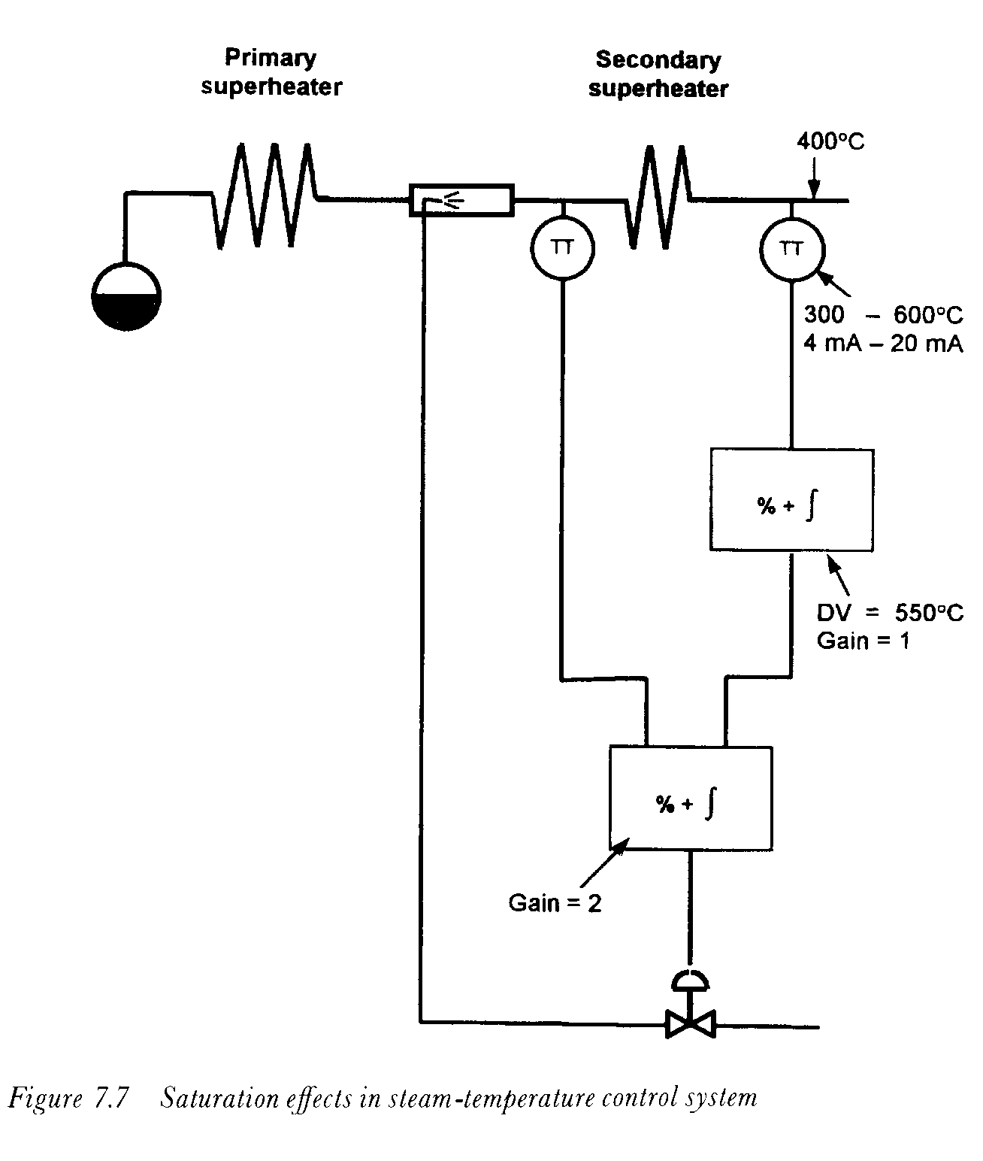
between the measured and desired value signals is 150'C, which is 50% of the 300'C input range and with a gain of 1 the controller output is also 50%. Since the secondary controller has a gain of 2, the 50% signal from the primary controller is right at the edge of its own proportional-band window.
Now let us see what happens when the temperature is outside the proportional-band window when, as stated above, the secondary controller cannot react to any changes in it. If the temperature is at, say, 350 °C and rising, the primary controller will react to the rise in temperature and produce output commands which should start increasing the flow of cooling spray-water. However, these commands are initially invisible to the secondary controller, and the spray valve will not be moved until the signal eventually enters the proportional-band window of the secondary controller. By then it is far too late, and the situation is exacerbated by the long time constant of the final superheater (up to 1 2 minutes in some cases). As a result, the temperature continues to rise, and when the spray valve finally opens the result is a severe overcorrection. The result is that the final steam temperature and the spray valve opening will both begin to oscillate.
This is a classical example of the effects of controller saturation, but the problem is not always understood by DCS vendors who are unfamiliar with boiler control systems. On the other hand, vendors who do recognise the problem offer a variety of solutions. These usually involve the use of `track' and `reset' facilities in the controllers (or the software function blocks which assume the duty of controllers). With such solutions the controller output is forced to follow a signal which is connected to its `track' terminal when the reset (integration) function is disabled. In one configuration, the system monitors the output signal of the primary controller, and when this reaches 100% the controller output is forced to track the input temperature.
7.2.6.2 Prevention of over-cooling
In steam-temperature control applications it is important to prevent the temperature being reduced too far. If the temperature at the inlet of the secondary superheater falls to a value approaching the saturation temperaturc, water droplets could form in the flowstream, raising the possibility of thermal shock to the pipework, and in addition the steam circuit could become partially plugged. The flow through the obstructed tubes will then be reduced and their surface temperature will rise, possibly causing
Some boilers have several banks of superheater tubes. In these cases spray attemperators are normally provided between the major banks, as shown in Figure 7.8.
It will be seen that the control systems around each superheater comprise cascade loops that are quite similar to those discussed earlier. However, the set-value signal for the first stage of spraying is derived from the output of the controller regulating the final steam temperature. In fact, the signal may be characterised in some way to accurately represent the relationship between the temperature of the steam leaving the second stage of attemperation and that at the exit of the first stage. When the system is operating correctly, with the final slave controller maintaining its desired-value and measured-value signals at the same value, the effect is to maintain a constant temperature-differential across the second attemperator. The temperature drop across the attemperator is a measure of the
work being done by it, and by controlling this to a known value the cooling load through the entire string of tubes can be apportioned as required.
The function of the maximum-selector unit (item 9) is to prevent chilling as described in Section 7.2.6.2. The steam pressure at the drum is measured and its value characterised (8) to produce a signal which repre- sents the saturation temperature. Item 8 also incorporates a bias to represent a safe margin of operation and the resultant signal is fed to the maximum-selector unit. If the output of the second ary-superheater con- troller should fall to a value that is at or below the safety margin above the saturation temperature, it is ignored by the maximum-selector unit, which clamps the desired value signal for the first stage attemperator at this limit.
Another feature of the system shown in this diagram is the programming signal which presets the opening of the first-stage spray-water valve according to a characteristic that the boiler designer has predicted. The temperature-control systems then trim this opening to eliminate any residual error. These programming signals can overcome some of the boiler's time-delays, producing a better and faster response to changes in load.
Controlling the temperature of reheated steam

In boilers with reheat stages, changes in firing inevitably affect the temperature of both the reheater and the superheater. If a single control mechanism were to be used for both temperatures the resulting interactions would make control-system tuning difficult, if not impossible, to optimise. Such boilers therefore use two or more methods of control.
Because of the lower operating pressure of reheat steam systems, the thermodynamic conditions are significantly different from those of superheaters, and the injection of spray water into the reheater system has an undue effect on the efficiency of the plant. For this reason, it is preferable for the reheat stages to be controlled by tilting burners (if these are available) or by apportioning the flow of hot combustion gases over the various tube banks. However, if the superheat temperature is controlled by burner tilting, gas apportioning or spray attemperation must then be used for the reheat stages.
In boilers with fixed burners, steam-temperature control may be achieved by adjusting the opening of dampers that control the flow of the furnace gases across the various tube banks. In some cases two separate sets of dampers are provided: one regulating the flow over the superheater banks, the other controlling the flow over the reheater banks.
Between them, these two sets of dampers deal with the entire volume of combustion gases passing from the furnace to the chimney. If both were to be closed at the same time, the flow of these gases would be severely restricted, leading to the possibility of damage to the structure due to over
relationship between the cold reheat temperature and the required spraywater flow can be defined by the boiler designer or process engineer.
If a turbine trip occurs the reheat flow will collapse. In this situation the reheat sprays must be shut immediately in order to prevent serious damage being caused by the admission of cold spray water to the turbine.

7.4.1 Spray attemperators for reheat applications
At first, it may seem that reheat spray-water attemperator systems should be similar to those of the superheater. This is untrue, because reheat attemperators have to cope with the lower steam pressure in this section of the boiler, which renders the pressure of the water at the discharge of the feed pumps too high for satisfactory operation. Although a pressure-reducing valve could be introduced into the spray-water line, this would be an expensive solution whose long-term reliability would not be satisfactory because of the severe conditions to which such a valve would be subjected. A better solution would be to derive the supply from the feed-pump inlet. In some cases, even this is ineffective, and separate pump sets have to be provided for the reheat sprays.

Gas recycling

Where boilers are designed for burning oil, or oil and coal in combination, they are frequently provided with gas-recirculation systems, where the hot gases exiting the later stages of the boiler are recirculated to the bottom part of the furnace, close to the burners. This procedure increases the mass-flow of gas over the tube banks, and therefore increases the heat transfer to them.
Because the gas exiting the furnace is at a low pressure, fans have to be provided to ensure that the gas flows in the correct direction. Controlling the flow of recycled gases provides a method of regulating the temperature of the superheated and reheated steam, but interlocks have to he provided to protect the fan against high-temperature gases flowing in a reverse direction from the burner area if the fan is stopped or if it trips.
Summary

This ends our system-by-system survey of boiler and HRSG control and instrumentation systems, and we will now turn our attention to some of the design aspects relating to the equipment that is used in implementing these svstems

