Water-tube boiler plant
Water-tube boiler plant is much less tolerant of high TDS levels, and even less so as the pressure increases. This is due to a number of reasons, including:
- Water-tube boilers have a limited water surface area in the steam drum, relative to the evaporation rate.
This results in very high steam release rates per unit of water area, and turbulence.
- Water-tube boilers tend to be higher rated, perhaps over 1 000 tonnes / h of steam. This means that even a small percentage blowdown can represent a high mass to be blown down.
- Water-tube boilers tend to operate at higher pressures, usually up to 150 bar g. The higher the pressure, the greater the energy contained in the blowdown water.
Higher pressures also mean higher temperatures. This means that the materials of construction will be subjected to higher thermal stresses, and be operating closer to their metallurgical limitations. Even a small amount of internal contamination hindering the heat transfer from tubes to water may result in the tubes overheating.
- Water-tube boilers often incorporate a superheater.
The dry saturated steam from the steam drum may be directed to a superheater tubes situated in the highest temperature area of the furnace. Any carryover of contaminated water with the steam would coat the inside of the superheater tubes, and inhibit heat transfer with potentially disastrous results.
The above factors mean that:
- High quality water treatment is essential for the safe operation of this type of plant.
- It may be economically viable to invest in a water treatment plant that will minimise blowdown rates.
The operating objectives for steam boiler plant include:
- Safe operation.
- Maximum combustion and heat transfer efficiency.
- Minimum maintenance.
- Long working life.
The quality of the water used to produce the steam in the boiler will have a profound effect on meeting these objectives.
There is a need for the boiler to operate under the following criteria:
- Freedom from scale - If hardness is present in the feedwater and not controlled chemically, then scaling of the heat transfer surfaces will occur, reducing heat transfer and efficiency - making frequent cleaning of the boiler necessary. In extreme cases, local hot spots can occur, leading to mechanical damage or even tube failure.
- Freedom from corrosion and chemical attack - If the water contains dissolved gases, particularly oxygen, corrosion of the boiler surfaces, piping and other equipment is likely to occur.
If the pH value of the water is too low, the acidic solution will attack metal surfaces. If the pH value is too high, and the water is alkaline, other problems such as foaming may occur.
Caustic embrittlement or caustic cracking must also be prevented in order to avoid metal failure. Cracking and embrittlement are caused by too high a concentration of sodium hydroxide. Older riveted boilers are more susceptible to this kind of attack; however, care is still necessary on modern welded boilers at the tube ends.

Good quality steam
If the impurities in the boiler feedwater are not dealt with properly, carryover of boiler water into the steam system can occur. This may lead to problems elsewhere in the steam system, such as:
- Contamination of the surfaces of control valves - This will affect their operation and reduce their capacity.
- Contamination of the heat transfer surfaces of process plant - This will increase thermal resistance, and reduce the effectiveness of heat transfer.
- Restriction of steam trap orifices - This will reduce steam trap capacities, and ultimately lead to waterlogging of the plant, and reduced output.
Carryover can be caused by two factors:
- Priming - This is the ejection of boiler water into the steam take-off and is generally due to one or more of the following:
  - Operating the boiler with too high a water level.
  - Operating the boiler below its design pressure; this increases the volume and the velocity of the steam released from the water surface.
  - Excessive steam demand.

- Foaming - This is the formation of foam in the space between the water surface and the steam off-take. The greater the amount of foaming, the greater the problems which will be experienced.
The following are indications and consequences of foaming:
  - Water will trickle down from the steam connection of the gauge glass; this makes it difficult to accurately determine the water level.
  - Level probes, floats and differential pressure cells have difficulty in accurately determining water level.
  - Alarms may be sounded, and the burner(s) may even ‘lockout’. This will require manual resetting of the boiler control panel before supply can be re-established.

These problems may be completely or in part due to foaming in the boiler. However, because foaming is endemic to boiler water, a better understanding of foam itself is required:
- Surface definition - Foam on a glass of beer sits on top of the liquid, and the liquid / foam interface is clearly defined. In a boiling liquid, the liquid surface is indistinct, varying from a few small steam bubbles at the bottom of the vessel, to many large steam bubbles at the top.
- Agitation increases foaming - The trend is towards smaller boilers for a given steaming rate. Smaller boilers have less water surface area, so the rate at which steam is released per square metre of water area is increased. This means that the agitation at the surface is greater. It follows then that smaller boilers are more prone to foaming.
- Hardness - Hard water does not foam. However, boiler water is deliberately softened to prevent scale formation, and this gives it a propensity to foam.
- Colloidal substances - Contamination of boiler water with a colloid in suspension, for example. milk, causes violent foaming. Note: Colloidal particles are less than 0.000 1 mm in diameter, and can pass through a normal filter.
- TDS level - As the boiler water TDS increases, the steam bubbles become more stable, and are more reluctant to burst and separate.
Corrective action against carryover
The following alternatives are open to the Engineering Manager to minimise foaming in the boiler:
- Operation - Smooth boiler operation is important. With a boiler operating under constant load and within its design parameters, the amount of entrained moisture carried over with steam may be less than 2%.
If load changes are rapid and of large magnitude, the pressure in the boiler can drop considerably, initiating extremely turbulent conditions as the contents of the boiler flash to steam. To make matters worse, the reduction in pressure also means that the specific volume of the steam is increased, and the foam bubbles are proportionally larger.
If the plant conditions are such that substantial changes in load are normal, it may be prudent to consider:
  - Modulating boiler water level controls if on / off are currently fitted.
  - ‘Surplussing controls’ that will limit the level to which the boiler pressure is allowed to drop.
  - A steam accumulator (see Module 22 of this Block).
  - ‘Feed-forward’ controls that will bring the boiler up to maximum operating pressure before the load is applied.
  - ‘Slow-opening’ controls that will bring plant on-line over a pre-determined period.

- Chemical control - Anti-foaming agents may be added to the boiler water. These operate by breaking down the foam bubbles. However, these agents are not effective when treating foams caused by suspended solids.
- Control of TDS - A balance has to be found between:
  - A high TDS level with its attendant economy of operation.
  - A low TDS level which minimises foaming.

- Safety - The dangers of overheating due to scale, and of corrosion due to dissolved gases, are easy to understand. In extreme cases, foaming, scale and sludge formation can lead to the boiler water level controls sensing improper levels, creating a danger to personnel and process alike.

Keep your feedwater steaming hot
Corroding salts, gases and oxygen occur in boiler water but can be kept in check if the temperature
is kept sufficiently high.

Water - friend or foe
The majority of ships run with ineffective or improperly operated water treatment systems. This leads to:
Extensive damage to boilers
High repair costs
Dramatic reduction in boiler life
A proper system for boiler feedwater will maintain normal boiler life expectancy up to 30 years.
The enemy within
Untreated water is never pure. It contains a cocktail of salts and gases. Salts, if not removed or altered by chemicals and water softening treatment, cause scaling on boiler heat transfer surfaces.
Carbon dioxide gas will combine with water to form carbonic acid, which attacks the boiler and the condensation system.
Oxygen in the feedwater is the major cause of corrosion in boilers. The oxygen can, however, be removed by keeping the feedwater temperature above 85ºC.
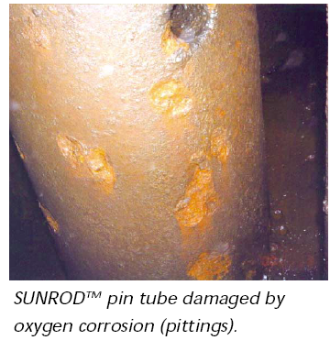
Fighting oxygen
Thermal deaeration will remove up to 75 percent of the unwanted oxygen in feedwater. Chemical oxygen scavengers can absorb the remaining oxygen.

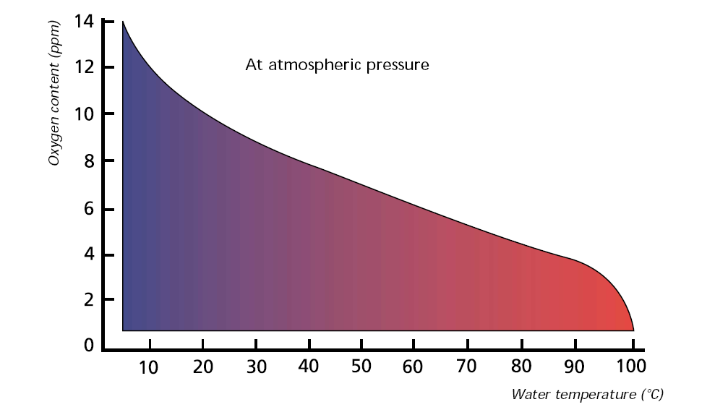

Fighting carbon dioxide
Heating of boiler feedwater can keep the carbon dioxide in check. At a temperature of 85 to 90°C, carbon dioxide is in its steam phase, and the gas is harmless in this state. The temperature must be maintained, or corrosion will be triggered by the changes in the carbon dioxide contents. Alkaline boiler water and chemical treatment can help neutralise the effects of the gas as well as handle the salt problem.
Keep your feedwater steaming hot and you will gain
A longer boiler life
Lower operating costs
Higher steam output
Less maintenance
Lower consumption of chemicals

Seawater and oil contamination
Attention is drawn to the damage caused by contamination from seawater and oil. Both promote heat transfer resistance on the water side of the boiler, causing the steel structure facing the flame and flue gas to be heated beyond its design point. Structural damage/rupture will occur when the contamination becomes sufficiently high, resulting in a leaking boiler.

Recommended boiler water charactistics
for boilers working at pressures up
to 20 bar
Appearance clear and free of mud
Chloride content <100 ppm Cl
"P" alkalinity 100-150 ppm CaCO3
Total alkalinity <2 x "P" alkalinity
pH at 25°C 10.5-11.5
Hydrazine excess 0.2-0.5 ppm N2H4
Phosphate excess 20-50 ppm PO4
Specific gravity (20°C) <1.003 kg/m3
Conductivity (25°C) <2000 micromhos
Oil content nil
Feedwater characteristics recommended
for boilers
Appearance clear and free of mud
Hardness 0-0.5 ppm CaCO3
Chloride content <15 ppm
pH at 25°C 8.5-9.5
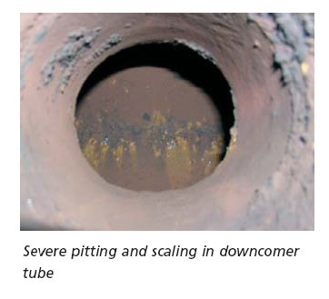
Oil content nil
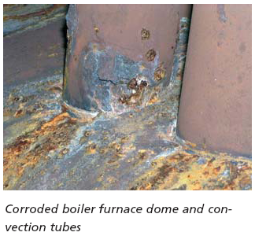
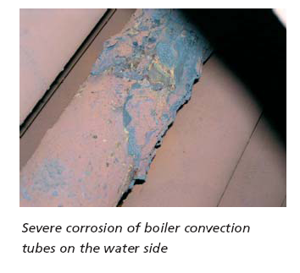

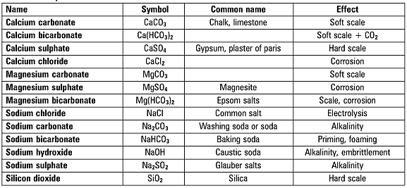
Table 3.9.1 Impurities in water
The common impurities in raw water can be classified as follows:
- Dissolved solids - These are substances that will dissolve in water.
The principal ones are the carbonates and sulphates of calcium and magnesium, which are scale-forming when heated.
There are other dissolved solids, which are non-scale forming.
In practice, any salts forming scale within the boiler should be chemically altered so that they produce suspended solids, or sludge rather than scale.
- Suspended solids - These are substances that exist in water as suspended particles.
They are usually mineral, or organic in origin.
These substances are not generally a problem as they can be filtered out.
- Dissolved gases - Oxygen and carbon dioxide can be readily dissolved by water.
These gases are aggressive instigators of corrosion.
- Scum forming substances - These are mineral impurities that foam or scum.
One example is soda in the form of a carbonate, chloride, or sulphate.
The amount of impurities present is extremely small and they are usually expressed in any water analysis in the form of parts per million (ppm), by weight or alternatively in milligrams per litre (mg/l).
The following sections within this Module describe the characteristics of water.

Hardness
Water is referred to as being either ‘hard’ or ‘soft’. Hard water contains scale-forming impurities while soft water contains little or none. The difference can easily be recognised by the effect of water on soap. Much more soap is required to make a lather with hard water than with soft water.
Hardness is caused by the presence of the mineral salts of calcium and magnesium and it is these same minerals that encourage the formation of scale.
There are two common classifications of hardness:
- Alkaline hardness (also known as temporary hardness) - Calcium and magnesium bicarbonates are responsible for alkaline hardness. The salts dissolve in water to form an alkaline solution. When heat is applied, they decompose to release carbon dioxide and soft scale or sludge.
The term ‘temporary hardness’ is sometimes used, because the hardness is removed by boiling. This effect can often be seen as scale on the inside of an electric kettle.
See Figures 3.9.3 and 3.9.4 - the latter representing the situation within the boiler.
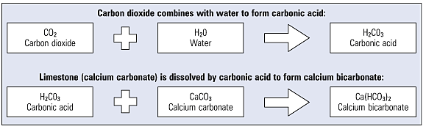
Fig. 3.9.3 Alkaline or temporary hardness

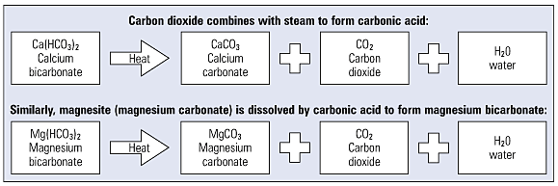
Fig. 3.9.4 Non-alkaline or permanent hardness (scale + carbonic acid)
- Non-alkaline hardness and carbonates (also known as permanent hardness) - This is also due to the presence of the salts of calcium and magnesium but in the form of sulphates and chlorides. These precipitate out of solution, due to their reduced solubility as the temperature rises, and form hard scale, which is difficult to remove.
In addition, the presence of silica in boiler water can also lead to hard scale, which can react with calcium and magnesium salts to form silicates which can severely inhibit heat transfer across the fire tubes and cause them to overheat.

Total hardness
Total hardness is not to be classified as a type of hardness, but as the sum of concentrations of calcium and magnesium ions present when these are both expressed as CaCO₃. If the water is alkaline, a proportion of this hardness, equal in magnitude to the total alkalinity and also expressed as CaCO₃, is considered as alkaline hardness, and the remainder as non-alkaline hardness. (See Figure 3.9.5)
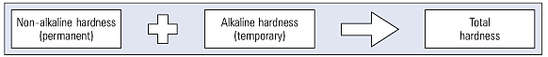
Fig. 3.9.5 Total hardness

Non-scale forming salts
Non-hardness salts, such as sodium salts are also present, and are far more soluble than the salts of calcium or magnesium and will not generally form scale on the surfaces of a boiler, as shown in Figure 3.9.6.
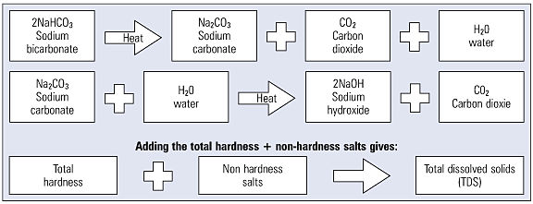
Fig. 3.9.6 The effects of heat
Comparative units
When salts dissolve in water they form electrically charged particles called ions.
The metallic parts (calcium, sodium, magnesium) can be identified as cations because they are attracted to the cathode and carry positive electrical charges.
Anions are non-metallic and carry negative charges - bicarbonates, carbonate, chloride, sulphate, are attracted to the anode.
Each impurity is generally expressed as a chemically equivalent amount of calcium carbonate, which has a molecular weight of 100.

pH value
Another term to be considered is the pH value; this is not an impurity or constituent but merely a numerical value representing the potential hydrogen content of water - which is a measure of the acidic or alkaline nature of the water. Water, H₂O, has two types of ions - hydrogen ions (H⁺) and hydroxyl ions (OH⁻).
If the hydrogen ions are predominant, the solution will be acidic with a pH value between 0 and 6. If the hydroxyl ions are predominant, the solution will be alkaline, with a pH value between 8 and 14. If there are an equal number of both hydroxyl and hydrogen ions, then the solution will be neutral, with a pH value of 7.
Acids and alkalis have the effect of increasing the conductivity of water above that of a neutral sample. For example, a sample of water with a pH value of 12 will have a higher conductivity than a sample that has a pH value of 7.
Table 3.9.3 shows the pH chart and Figure 3.9.7 illustrates the pH values already mentioned both numerically and in relation to everyday substances.
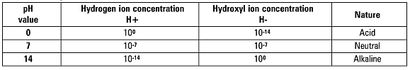
Table 3.9.3 The pH scale

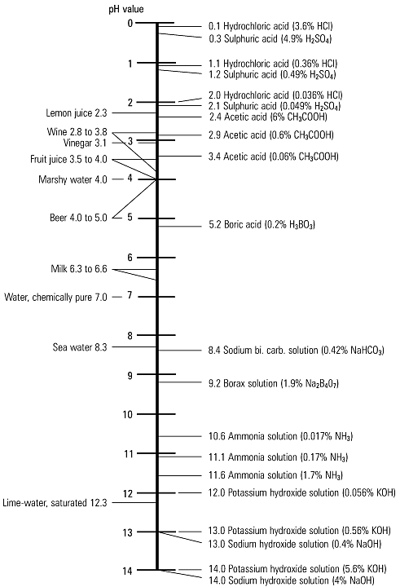
Fig. 3.9.7 pH chart

Sampling for external analysis
When taking a sample of boiler water it is important to ensure that it is representative. It is not recommended that the sample be taken from level gauge glasses or external control chambers; the water here is relatively pure condensate formed by the continual condensation of steam in the external glass / chamber. Similarly, samples from close to the boiler feedwater inlet connection are likely to give a false reading.
Nowadays, most boilermakers install a connection for TDS blowdown, and it is generally possible to obtain a representative sample from this location.
If water is simply drawn from the boiler, a proportion will violently flash to steam as its pressure is reduced. Not only is this potentially very dangerous to the operator, but any subsequent analysis will also be quite wrong, due to the loss of the flash steam concentrating the sample.
Since a cool sample is required for analysis, a sample cooler will also save considerable time and encourage more frequent testing.
A sample cooler is a small heat exchanger that uses cold mains water to cool the blowdown water sample.
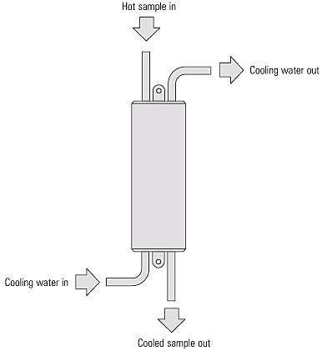
Fig. 3.12.1 A sample cooler

pH Treatment

Introduction
What is pH?
Acidic and basic (alkaline) are two extremes that describe chemicals, just like hot and cold are two extremes that describe temperature. Mixing acids and bases (alkaline) can cancel out their extreme effects, much like mixing hot and cold water can even out the water temperature. A substance that is neither acidic nor basic (alkaline) is neutral.
The pH scale measures how acidic or basic (alkaline) a substance is. It ranges from 0 to 14. A pH of 7 is neutral. A pH less than 7 is acidic, and a pH greater than 7 is basic (alkaline). Each whole pH value below 7 is ten times more acidic than the next higher value. For example, a pH of 4 is ten times more acidic than a pH of 5 and 100 times (10 times 10) more acidic than a pH of 6. The same holds true for pH values above 7, each of which is ten times more alkaline (another way to say basic) than the next lower whole value. For example, a pH of 10 is ten times more alkaline than a pH of 9.
Pure water is neutral, with a pH of 7.0. When chemicals are mixed with water, the mixture can become either acidic or basic (alkaline). Vinegar and lemon juice are acidic substances, while laundry detergents and ammonia are basic (alkaline).
Chemicals that are very basic or very acidic are called "reactive." These chemicals can cause severe burns. Automobile battery acid is an acidic chemical that is reactive. Automobile batteries contain a stronger form of some of the same acid that is in acid rain. Household drain cleaners often contain lye, a very alkaline chemical that is reactive.

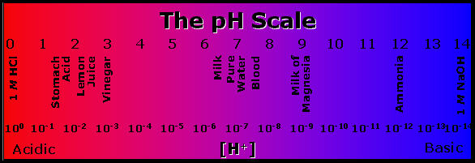
An Acid is a substance that produces H3O+ (H+) when it is dissolved in water. It is a proton donor and an electron pair acceptor or a species that donates protons. For example: HCl, NH4, AlCl3.
A Base is a substance that produces an OH- when it is dissolved in water (Arrhenius). A proton acceptor (Brønsted), or a electron donor. For example: NaOH, KOH, CH3NH2.
H2O can act as an acid or a base because it auto-ionizes itself, meaning it gives protons back and forth within itself, thus acting as both an acid and a base.

Boiler pH
Natural water is usually between 6.5 and 7.5 pH. A common recommendation is to maintain boiler water at 8.5 pH.
Acidic water is corrosive. Alkalinic water is more prone to scaling.
Alkalinity is a measure of the bicarbonate (HCO3), carbonate (CO3) and hydroxyl (OH) ions in the water. pH and alkalinity ratings are NOT the same and are NOT proportional. pH is rated on the Scale and alkalinity is measured in parts per million (ppm). A typically recommended alkalinity rating is 140 - 700 ppm for boilers operating below 300 psi.

Controlling pH
pH is controlled by either removing water impurities or adding other chemicals to neutralize the condition. For example, Caustic Soda, an alkaline, is added to neutralize CO3, carbonic acid.

pH Related Corrosion
Acid Attack
When the boiler water pH drops below about 8.5, a corrosion called acid attack can occur. The effect exhibits rough pitted surfaces. The presence of iron oxide deposits on boiler surfaces can encourage this kind of corrosion. A low boilerwater pH is usually caused by contamination of the boiler feedwater, from sources such as hydrochloric or sulfuric acid from leaks in demineralizers and condenser leaks of cooling tower water. Contamination can also occur from process leaks of acid or acid-forming materials into the return condensate system.

Caustic Attack
Caustic attack on boilers is a localized attack due to extremely high pH (12.9 +). It can take two forms: caustic gouging or caustic cracking, also called caustic embrittlement. Caustic attack or caustic corrosion, is often encountered in phosphate treated boilers in which deposits of phosphates or other 'scale' occur in high heat transfer areas. Boiler water can permeate the porous deposit resulting in localize corrosion. When it is coupled with significant heat flux, concentration of the boiler water occurs rapidly speeding the corrosion.
The corrosion action is a result of the formation of caustic-ferritic compounds through the dissolving of the protective magnetite film. Once the process begins, the iron in contact with the boiler water will attempt to restore the protective magnetite film. Caustic corrosion (typically in the form of gouging) continues until the deposit is removed or the caustic concentration is reduced to normal.
Caustic soda (NaOH) is the only normal boiler water constituent that has high solubility and does not crystallize under typical boiler conditions. Its caustic concentration can be as high as 10,000-100,000 ppm.
Careful control of boiler water chemistry can prevent caustic gouging. If the “free hydroxide alkalinity”
is set too high or uncontrolled, then caustic gouging may result. Prevention of porous deposit formation (such as iron oxide) eliminates a place for caustic gouging to occur.

Water Chemicals

Oxygen Scavengers
Sulfites - typically for boilers up to 800 psi; sulfites react with oxygen to form sulfates that are removed from the boiler via blowdown. There are two forms of sulfite: Catalyzed - uses a catalyst to improve reaction time; Non-catalyzed - slower reaction time and must be used in hot water
Hydrazine - typically for boilers over 800 psi. At pressure higher than 800 psi, sulfite begins to break down into acidic gases of sulfur. Sulfite also creates additional Total Dissolved Solids (TDS) which is a problem for high pressure applications. Hydrazine removes O2 without producing acidic gases or TDS, but is considered a possible carcinogen.

Hydroxides
Sodium Hydroxide - NaOH or Caustic Soda, or Soda Ash - used to maintain boiler water pH in the 10.0 - 11.5 range. Hydroxide increase boiler alkalinity to prevent acidic corrosion. If heavy scale is present, caustic soda can accumulate to cause Caustic Attack. See pH Treatment
Calcium-Hydroxide - reacts with calcium and magnesium bicarbonates to form sludge that is removed via blowdown.

Phosphates
Phosphate treatment causes calcium and magnesium to precipitate into sludge where it can be removed via blowdown.

Polymers
Polymers are long, complex molecules that attach to impurities and prevent them from sticking to boiler metal to form scale. This creates TDS that are removed via blowdown.

Chelants
Chelants can prevent scale from forming and over time, remove existing scale. Chelants in contact with 02 is corrosive. It must therefore be used in an 02- free environment.

Neutralizing Amines
Neutralizing amines hydrolyze in water to generate the necessary hydroxide ions required for neutralization of the carbon dioxide. The normal approach to treating systems with these amines is to feed sufficient quantity to neutralize the carbon dioxide and then provide small additional amounts to buffer the pH to 8.5 or 9.0. At this pH, continued preservation of the magnetite film (boiler metal) is also achieved. It is also implied that corrosion will not exist at a pH>8.0-8.5.

Filming Amines
Filming amines function by forming a protective barrier against both oxygen and carbon dioxide attack. These amines form films directly with the condensate line metal and develop a barrier to prevent contact of the corrosive condensate with the return piping. By design, film formers have been developed to function best at a pH of 5.5-7.5. In addition, these amines are highly surface-active and will slough loosely adherent iron oxide and other corrosion products back to receiving points or to the boiler. Care must be exercised with the feed of filming amines.
Combination Amines. Over the past several years, combinations of filming and neutralizing amines have been shown to be extremely effective, particularly in complex systems. While the combination amine is still functionally a filmer, the neutralizing amine portions provide for reduction in fouling potential and more uniform coverage of the filmer.
Filming amines and combination amines are generally fed to steam headers. Dosages are based on steam production.

Energy Losses From Scale Deposits
The following table is an estimate of how scale effects fuel usage:

Scale Thickness  (Inches) | Additional Fuel Usage  (Percentage)
1/32 | 8.5%
1/25 | 9.3%
1/20 | 11.1%
1/16 | 12.4%
1/8 | 25.0%
1/4 | 40.0%
3/8 | 55.0%
1/2 | 70.0%
