Attemperator Located in the Steam Drum

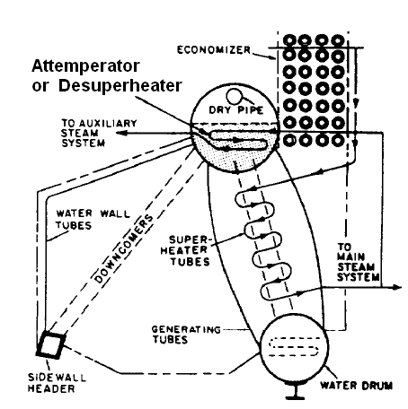
In lieu of an external attemperator, another arrangement of attemperator (also called desuperheater) could be located in the boiler drum itself. All the steam generated in a single-furnace boiler is led through the superheater. However, since some auxiliary machinery is not designed for superheated steam, the steam must be cooled down. This is done with a desuperheater/ attemperator, which basically consists of some piping, submerged in the steam drum to reduce the steam temperature. The desuperheater gets steam from the superheater outlet, as shown in figure above. The desuperheater is submerged in water either in the steam drum or in the water drum. As the steam passes through the desuperheater in the steam drum, it is cooled for use in the auxiliary steam systems. The desuperheated steam can be further used to control the final steam outlet temperature from the superheater by mixing desuperheated steam at the superheater outlet.

