Safety valves

An important boiler fitting is the safety valve. Its function is to protect the boiler shell from over pressure and subsequent explosion. The primary function of a safety valve is therefore to protect life and property.
The principle type of device used to prevent overpressure in plant is the safety or safety relief valve. The safety valve operates by releasing a volume of fluid from within the plant when a predetermined maximum pressure is reached, thereby reducing the excess pressure in a safe manner. As the safety valve may be the only remaining device to prevent catastrophic failure under overpressure conditions, it is important that any such device is capable of operating at all times and under all possible conditions.
Safety valves should be installed wherever the maximum allowable working pressure (MAWP) of a system or pressure-containing vessel is likely to be exceeded. In steam systems, safety valves are typically used for boiler overpressure protection and other applications such as downstream of pressure reducing controls. Although their primary role is for safety, safety valves are also used in process operations to prevent product damage due to excess pressure. Pressure excess can be generated in a number of different situations, including:
- An imbalance of fluid flowrate caused by inadvertently closed or opened isolation valves on a process vessel.
- Failure of a cooling system, which allows vapour or fluid to expand.
- Compressed air or electrical power failure to control instrumentation.
- Transient pressure surges.
- Exposure to plant fires.
- Heat exchanger tube failure.
- Uncontrollable exothermic reactions in chemical plants.
- Ambient temperature changes.
The terms ‘safety valve’ and ‘safety relief valve’ are generic terms to describe many varieties of pressure relief devices that are designed to prevent excessive internal fluid pressure build-up. A wide range of different valves is available for many different applications and performance criteria. Furthermore, different designs are required to meet the numerous national standards that govern the use of safety valves.
In the UK:
- BS 6759 (related to but not equivalent to ISO 4126) is concerned with the materials, design and construction of safety valves on steam boilers.
- BS 2790 relates to the specification for the design and manufacture of shell boilers of welded
construction, with Section 8 specifically referring to safety valves, fittings and mountings.
Many different types of safety valves are fitted to steam boiler plant, but they must all meet the following criteria:
- The total discharge capacity of the safety valve(s) must be at least equal to the ‘from and at 100°C’ capacity of the boiler. If the ‘from and at’ evaporation is used to size the safety valve, the safety valve capacity will always be higher than the actual maximum evaporative boiler capacity.
- The full rated discharge capacity of the safety valve(s) must be achieved within 110% of the boiler design pressure.
- The minimum inlet bore of a safety valve connected to a boiler shall be 20 mm.
- The maximum set pressure of the safety valve shall be the design (or maximum permissible working pressure) of the boiler.
- There must be an adequate margin between the normal operating pressure of the boiler and the set pressure of the safety valve.
Safety valve regulations (UK)
A boiler shall be fitted with at least one safety valve sized for the rated output of the boiler. (Refer to BS 278, Section 8.1 for details.)
The discharge pipework from the safety valve must be unobstructed and drained at the base to prevent the accumulation of condensate. It is good practice to ensure that the discharge pipework is kept as short as possible with the minimum number of bends to minimise any backpressure, which should be no more than 12% of the safety valve set pressure. It will be quite normal for the internal diameter of the discharge pipework to be more than the internal diameter of the safety valve outlet connection, but under no circumstances should it be less.
The European standards (BS 6759 and DIN 3320) provide the following definition:
- Safety valve - A valve which automatically, without the assistance of any energy other than that of the fluid concerned, discharges a certified amount of the fluid so as to prevent a predetermined safe pressure being exceeded, and which is designed to re-close and prevent the further flow of fluid after normal pressure conditions of service have been restored.
Typical examples of safety valves used on steam systems are shown in Figure 1.
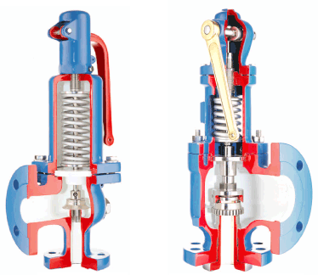
Fig. 1 Typical safety valves

Safety valve design
The basic spring loaded safety valve, referred to as ‘standard’ or ‘conventional’ is a simple, reliable self-acting device that provides overpressure protection.
The basic elements of the design consist of a right angle pattern valve body with the valve inlet connection, or nozzle, mounted on the pressure-containing system. The outlet connection may be screwed or flanged for connection to a piped discharge system. However, in some applications, such as compressed air systems, the safety valve will not have an outlet connection, and the fluid is vented directly to the atmosphere.
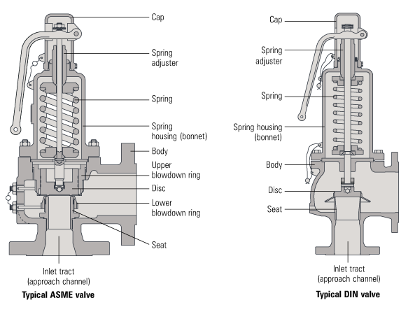
Fig. 2 Typical safety valve designs
The valve inlet (or approach channel) design can be either a full-nozzle or a semi-nozzle type. A full-nozzle design has the entire ‘wetted’ inlet tract formed from one piece. The approach channel is the only part of the safety valve that is exposed to the process fluid during normal operation, other than the disc, unless the valve is discharging.
Full-nozzles are usually incorporated in safety valves designed for process and high pressure applications, especially when the fluid is corrosive.
Conversely, the semi-nozzle design consists of a seating ring fitted into the body, the top of which forms the seat of the valve. The advantage of this arrangement is that the seat can easily be replaced, without replacing the whole inlet.
The disc is held against the nozzle seat (under normal operating conditions) by the spring, which is housed in an open or closed spring housing arrangement (or bonnet) mounted on top of the body. The discs used in rapid opening (pop type) safety valves are surrounded by a shroud, disc holder or huddling chamber which helps to produce the rapid opening characteristic.
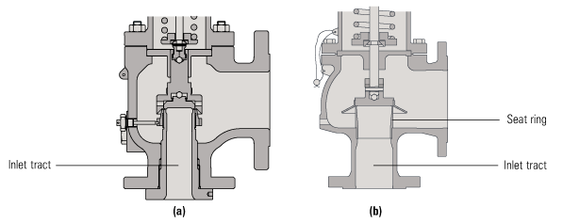
Fig. 3 A full-nozzle valve (a) and a semi-nozzle valve (b)
The closing force on the disc is provided by a spring, typically made from carbon steel. The amount of compression on the spring is usually adjustable, using the spring adjuster, to alter the pressure at which the disc is lifted off its seat.
Standards that govern the design and use of safety valves generally only define the three dimensions that relate to the discharge capacity of the safety valve, namely the flow (or bore) area, the curtain area and the discharge (or orifice) area (see Figure 4).
1. Flow area - The minimum cross-sectional area between the inlet and the seat, at its narrowest point. The diameter of the flow area is represented by dimension ‘d’ in Figure 4.
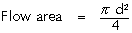
Equation 9.1.1
2. Curtain area - The area of the cylindrical or conical discharge opening between the seating surfaces created by the lift of the disk above the seat. The diameter of the curtain area is represented by dimension ‘d1’ in Figure 4.
Equation 9.1.2
3. Discharge area - This is the lesser of the curtain and flow areas, which determines the flow through the valve.
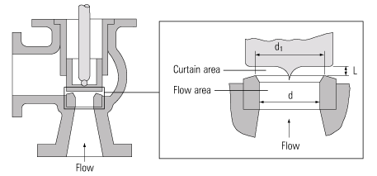
Fig. 4 Illustration of the standard defined areas
Valves in which the flow area and not the curtain area determines the capacity are known as full lift valves. These valves will have a greater capacity than low lift or high lift valves.
Although the principal elements of a conventional safety valve are similar, the design details can vary considerably. In general, the DIN style valves (commonly used throughout Europe) tend to use a simpler construction with a fixed skirt (or hood) arrangement whereas the ASME style valves have a more complex design that includes one or two adjustable blowdown rings. The position of these rings can be used to fine-tune the overpressure and blowdown values of the valve.
For a given orifice area, there may be a number of different inlet and outlet connection sizes, as well as body dimensions such as centreline to face dimensions. Furthermore, many competing products, particularly of European origin have differing dimensions and capacities for the same nominal size.
An exception to this situation is found with steel ASME specification valves, which invariably follow the recommendations of the API Recommended Practice 526, where centreline to face dimensions, and orifice sizes are listed. The orifice area series are referred to by a letter. It is common for valves with the same orifice letter to have several different sizes of inlet and outlet connection. For example, 2” x J x 3” and 3” x J x 4” are both valves which have the same size (‘J) orifice, but they have differing inlet and outlet sizes as shown before and after the orifice letter respectively. A 2” x J x 3” valve would have a 2” inlet, a ‘J’ size orifice and a 3” outlet.
This letter series is also referenced in other standards, for example, BS 6759 part 3, which deals with valves for process type applications and NFE- E 29-414.
Basic operation of a safety valve

Lifting
When the inlet static pressure rises above the set pressure of the safety valve, the disc will begin to lift off its seat. However, as soon as the spring starts to compress, the spring force will increase; this means that the pressure would have to continue to rise before any further lift can occur, and for there to be any significant flow through the valve.
The additional pressure rise required before the safety valve will discharge at its rated capacity is called the overpressure. The allowable overpressure depends on the standards being followed and the particular application. For compressible fluids, this is normally between 3% and 10%, and for liquids between 10% and 25%.
In order to achieve full opening from this small overpressure, the disc arrangement has to be specially designed to provide rapid opening. This is usually done by placing a shroud, skirt or hood around the disc. The volume contained within this shroud is known as the control or huddling chamber.
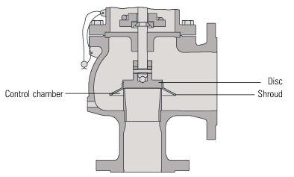
Fig. 5 Typical disc and shroud arrangement used on rapid opening safety valves
As lift begins (Figure 6b), and fluid enters the chamber, a larger area of the shroud is exposed to the fluid pressure. Since the magnitude of the lifting force (F) is proportional to the product of the pressure (P) and the area exposed to the fluid (A); (F = P x A), the opening force is increased. This incremental increase in opening force overcompensates for the increase in spring force, causing rapid opening. At the same time, the shroud reverses the direction of the flow, which provides a reaction force, further enhancing the lift.
These combined effects allow the valve to achieve its designed lift within a relatively small percentage overpressure. For compressible fluids, an additional contributory factor is the rapid expansion as the fluid volume increases from a higher to a lower pressure area. This plays a major role in ensuring that the valve opens fully within the small overpressure limit. For liquids, this effect is more proportional and subsequently, the overpressure is typically greater; 25% is common.

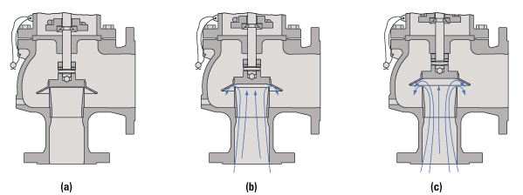
Fig. 6 Operation of a conventional safety valve
Reseating
Once normal operating conditions have been restored, the valve is required to close again, but since the larger area of the disc is still exposed to the fluid, the valve will not close until the pressure has dropped below the original set pressure. The difference between the set pressure and this reseating pressure is known as the ‘blowdown’, and it is usually specified as a percentage of the set pressure. For compressible fluids, the blowdown is usually less than 10%, and for liquids, it can be up to 20%.
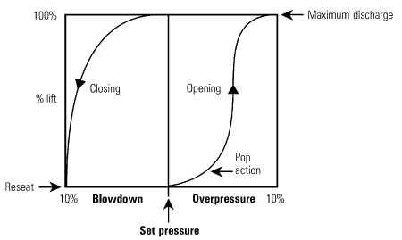
Fig. 7 Relationship between pressure and lift for a typical safety valve
The design of the shroud must be such that it offers both rapid opening and relatively small blowdown, so that as soon as a potentially hazardous situation is reached, any overpressure is relieved, but excessive quantities of the fluid are prevented from being discharged. At the same time, it is necessary to ensure that the system pressure is reduced sufficiently to prevent immediate reopening.
The blowdown rings found on most ASME type safety valves are used to make fine adjustments to the overpressure and blowdown values of the valves (see Figure 8). The lower blowdown (nozzle) ring is a common feature on many valves where the tighter overpressure and blowdown requirements require a more sophisticated designed solution. The upper blowdown ring is usually factory set and essentially takes out the manufacturing tolerances which affect the geometry of the huddling chamber.
The lower blowdown ring is also factory set to achieve the appropriate code performance requirements but under certain circumstances can be altered. When the lower blowdown ring is adjusted to its top position the huddling chamber volume is such that the valve will pop rapidly, minimising the overpressure value but correspondingly requiring a greater blowdown before the valve re-seats. When the lower blowdown ring is adjusted to its lower position there is minimal restriction in the huddling chamber and a greater overpressure will be required before the valve is fully open but the blowdown value will be reduced.
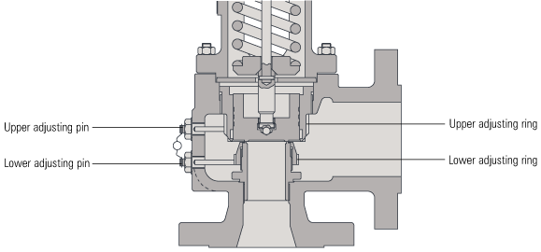
Fig. 8 Blow Down Ring Adjustment

The ASME / ANSI PTC25.3 standards applicable to the USA define the following generic terms:
- Pressure relief valve - A spring-loaded pressure relief valve which is designed to open to relieve excess pressure and to reclose and prevent the further flow of fluid after normal conditions have been restored. It is characterised by a rapid-opening ‘pop’ action or by opening in a manner generally proportional to the increase in pressure over the opening pressure. It may be used for either compressible or incompressible fluids, depending on design, adjustment, or application.
This is a general term, which includes safety valves, relief valves and safety relief valves.
- Safety valve - A pressure relief valve actuated by inlet static pressure and characterised by rapid opening or pop action.
Safety valves are primarily used with compressible gases and in particular for steam and air services. However, they can also be used for process type applications where they may be needed to protect the plant or to prevent spoilage of the product being processed.
- Relief valve - A pressure relief device actuated by inlet static pressure having a gradual lift generally proportional to the increase in pressure over opening pressure.
Relief valves are commonly used in liquid systems, especially for lower capacities and thermal expansion duty. They can also be used on pumped systems as pressure overspill devices.
- Safety relief valve - A pressure relief valve characterised by rapid opening or pop action, or by opening in proportion to the increase in pressure over the opening pressure, depending on the application, and which may be used either for liquid or compressible fluid.
In general, the safety relief valve will perform as a safety valve when used in a compressible gas system, but it will open in proportion to the overpressure when used in liquid systems, as would a relief valve.

