Emma Mærsk

From Wikipedia, the free encyclopedia
Jump to: navigation, search
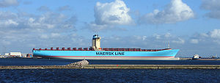
Emma Maersk
Career (Denmark) | 
Name: | Emma Maersk
Owner: | A. P. Moller-Maersk Group
Builder: | Odense Steel Shipyard Ltd, Denmark
Homeport: | Taarbæk, Denmark
Identification: | Callsign: OYGR2
General characteristics
Type: | Container ship
Tonnage: | 170,974 GT  55,396 NT
Length: | 397 metres (1,300 ft) LOA
Beam: | 56 metres (180 ft)
Draft: | 15.5 metres (51 ft)
Depth: | 30 metres (98 ft) (deck edge to keel)
Propulsion: | 80 MW (109,000 hp) Wärtsilä 14RT-Flex96c plus 30 MW (40,000 hp) from five Caterpillar 8M32
Speed: | over 25.5 knots (47.2 km/h; 29.3 mph)
Capacity: | 156,907 metric tons deadweight (DWT)  11,000+ TEU  1000 TEU (Reefers)
Crew: | 13, with room for 30
Emma Mærsk is a container ship owned by the A. P. Moller-Maersk Group. When she was launched, Emma Mærsk was the largest container ship ever built. As of 2009 she and her 7 sister ships are the longest container ships constructed and the longest ships currently in use.^{[1]} Officially, Emma Mærsk is able to carry around 11,000 twenty-foot equivalent units (TEU) according to the Maersk company's method of calculating capacity,^{[2]} which, at her introduction into service, was about 1,400 more containers than any other ship is capable of carrying.^{[3]} The Emma Mærsk was also featured on an entire episode of Mighty Ships.

Contents
[hide]
- 1 Capacity
- 2 History
- 3 Sailing schedules
- 4 Engine and hull
- 5 Criticism
- 6 Notes
- 7 References
- 8 External links

[edit] Capacity
By normal calculations, Emma Mærsk's cargo capacity is significantly greater than the listed capacity — between 13,500 twenty-foot equivalent units (TEU)^{[4]} and 15,200 TEU.^{[5]} The difference between the official and estimated numbers is because Maersk calculates the capacity of a container ship by weight (in this case, 14 tons/container) that can be carried on a vessel. For the Emma Mærsk, this is 11,000+ containers.^{[6]} Other companies calculate the capacity of a container ship according to the maximum number of containers that can be put on the ship, independent of the weight of the containers. This number is always greater than the number calculated by the Maersk method.
Comparing the size of ships can be done in various ways. Comparing ships in different trades often comes down to simple dimensions or weight of cargo carried. Ships in the same trade can, usually, be compared more directly. One measure of the 'size' of a vessel is the Gross Tonnage, which is a measure of volume. Here the Emma Maersk, and her sisters, at about 170,000 gross tons, are clearly much bigger than - for example - the MSC Daniela class, which are about 135,000 gross tons; a point to note is that the MSC ships are of a different design, with Bridge well forward, and Engine Room and funnel well aft; this is claimed - by Builder and operator - to be (slightly) more efficient. The Maersk ships are some thirty metres longer, four metres wider, and have a slightly greater full load draft than the MSC vessels.

[edit] History
The ship was built at the Odense Steel Shipyard in Denmark. In June 2006, during construction, welding work caused a fire within her superstructure.^{[7]} It spread rapidly through the accommodation section and bridge.
Emma Mærsk was named in a ceremony on 12 August 2006. The ship is named after Emma Mærsk, Mærsk Mc-Kinney Møller's late wife. The ship set sail on her maiden voyage on 8 September 2006 at 02:00 hours from Aarhus, calling at Gothenburg, Bremerhaven, Rotterdam, Algeciras, the Suez Canal, and arrived in Singapore on 1 October 2006 at 20:05 hours.
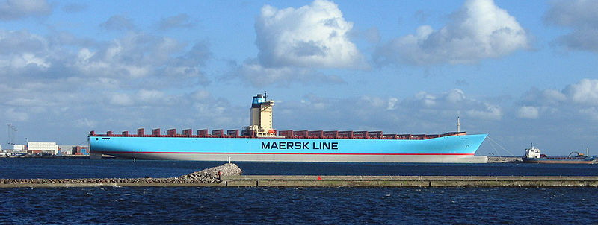
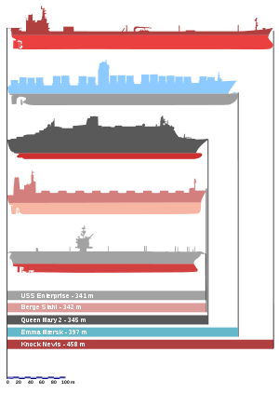
Size comparison of some of the longest ships. From top to bottom: Knock Nevis (no longer in seagoing service), Emma Mærsk, RMS Queen Mary 2, MS Berge Stahl, and USS Enterprise.
Emma Mærsk departed Singapore the next day, headed for Yantian in Shenzhen. She sailed on to Kobe, Nagoya, arrived at Yokohama on 10 October 2006, and returned via Shenzhen, Hong Kong, Tanjung Pelepas, the Suez Canal, Felixstowe, Rotterdam, Bremerhaven, Gothenburg and finally to Aarhus, with arrival at that port 11 November 2006 at 16:00 hours.^{[8]}
She appeared in headlines prior to Christmas 2006, when she was dubbed SS Santa because she was bound for the United Kingdom from China loaded with Christmas goods. The return journey after Christmas 2006 saw her return to southern China, loaded with UK waste destined for recycling in China.^{[9]}
Her appearance in the news prompted China's State Environmental Protection Administration to promise to "closely watch the progress of investigation into the dumping of garbage in south China by Britain". It added that no official approval had been given to any company in the area to import waste.^{[10]}

[edit] Sailing schedules
Emma Maersk's regular round trip involves Ningbo, Xiamen, Hong Kong (westbound), Yantian (westbound), Tanjung Pelepas (westbound), Algeciras (westbound), Rotterdam, Bremerhaven, Algeciras (eastbound), Tanjung Pelepas (eastbound), Yantian (eastbound), Hong Kong (eastbound) and Ningbo.

[edit] Engine and hull
The Emma Mærsk is powered by a Wärtsilä-Sulzer 14RTFLEX96-C engine, currently the world's largest single diesel unit, weighing 2,300 tons and capable of 109,000 horsepower (82 MW).^{[11]} The ship has several features to protect the environment, some of which include exhaust heat recovery and cogeneration. The exhaust gases of the engine are passed through a steam generator which then powers electrical generators to generate electricity. This creates an electrical output equivalent to about 12% of the main engine power output. Some of this steam is also used directly as shipboard heat.^{[12]} Instead of biocides, used by much of the industry to keep barnacles off of the hull, a special silicone-based paint is used.^{[3]} This increases the ship's efficiency by reducing drag while also protecting the ocean from biocides that may leak. The silicone paint covering the part of the hull below the waterline is credited for lowering the water drag enough to save 1200 tons of fuel per year. The ship has a bulbous bow, a standard feature for cargo ships.

[edit] Criticism
The Emma Mærsk and similar ships have been criticised for their burning of bunker fuel, which has a high sulphur content.^{[13]} Sources in the article estimate the fuel sulphur content at 2.5% to 4.5%, which is over 2000 times more than allowed in current automotive fuel.^{[13]}

[edit] Notes
- ^ The largest ship ever built was the supertanker Knock Nevis, but now she serves as a floating storage and offloading unit (FSO).
- ^ Odense Steel Shipyard (2006-12-08). "Namegiving of newbuilding L 203". Press release. http://media.maersk.com/en/PressReleases/2006/namegiving+L203.htm.
- ^ ª ^{b} Koepf, Pam (2006), "Overachievers We Love", Popular Science 269 (6): 24
- ^ Alexander Bakker (2006-09-12). "Big, bigger, biggest". port of Rotterdam. http://www.portofrotterdam.com/en/news/newsservice/12092006_10.jsp.
- ^ Emma Maersk (PDF)
- ^ "Giant Christmas goods ship docks". BBC News. 2006-11-05. http://news.bbc.co.uk/2/hi/uk_news/england/suffolk/6117080.stm.
- ^ "Emma Maersk Fire". gCaptain. http://gcaptain.com/maritime/blog/emma-maersk-from-shipyard-fire-to-world-records/.
- ^ "Sailing schedule". Maersk Line. http://sailingschedules2.maerskline.com/MaerskSailingSchedulesCustomerWeb/CustomerWebServlet?ssaction=com.saf.ss.cust.action.search.SearchSchedulesByVesselAction&liveworking=LIVE&pageAction=search&isWildcardSearch=true&searchVessel=EMMA+MAERSK&searchVoyageNumber=&searchFromDate=01-Mar-2005&searchToDate=14-Jan-2010.
- ^ Gaoming Jiang (2007-02-08). "China must say no to imported waste". Chinadialogue. http://www.chinadialogue.net/article/show/single/en/756-China-must-say-no-to-imported-waste.
- ^ Chinese State Environmental Protection Administration (2007-01-25). "SEPA Warns of Crackdown on Foreign Waste Imports". Press release. http://english.sepa.gov.cn/zwxx/xwfb/200701/t20070125_100228.htm.^{[dead link]}
- ^ "Inside The Engine Room Of The Emma Maersk". gCaptain. http://gcaptain.com/maritime/blog/emma-maersk-engine/.
- ^ Wärtsilä Corporation (2006-09-12). "The world's most powerful Engine enters service". Press release. http://www.wartsila.com/,en,press,0,tradepressrelease,8F51527F-00A3-4C5F-ABEA-B543789ACA1B,26EE6684-06C9-48B3-920A-3B238B7C302A,,.htm.
- ^ ª ^{b} Pearce, Fred (2009-11-21). "How 16 ships create as much pollution as all the cars in the world". The Daily Mail. http://www.dailymail.co.uk/sciencetech/article-1229857/How-16-ships-create-pollution-cars-world.html. Retrieved 2009-11-23. "The most staggering statistic of all is that just 16 of the world’s largest ships can produce as much lung-clogging sulphur pollution as all the world’s cars."

[edit] References
- Mærsk fact sheet

[edit] External links
Wikimedia Commons has media related to: Emma Mærsk
- A satellite image of the Emma Maersk or one of her sister ships from Google Maps
Retrieved from "http://en.wikipedia.org/wiki/Emma_M%C3%A6rsk"
Categories: Post-Panamax | Merchant ships of Denmark | Container ships | Maersk ships

