Container Ships
PURPOSE BUILT CONTAINER SHIPS
Today, most small size general cargo will be on a containership, also known as "box" ships. The "boxes" they carry are containers that generally are found in twenty and forty foot lengths. The market power of the United States was influential in determining the imperial dimensions of today's containers. Initial ISO external container dimensions, standardised in the early 1960's, are still for the most part intact today. The twenty-foot equivalent (TEU) is the standard by which container volume is measured. This refers to a container with external dimensions of 8'x8'x20'. Volume is sometimes measured by FEU's, forty-foot equivalents, 8'x8'x40', as well. Since the 1960's, numerous other container sizes have emerged. Over 20 recognized ISO container sizes are in use today. Fortunately the most important container dimension, width, has been resistant to change. ISO container widths have stayed constant for two reasons. First, widths wider than eight feet cause navigational problems in regions of the world where narrow roads are common, such as Europe. Second, a standardised container width enables containerships to use cells more efficiently to stack containers. They can be filled with just about any type of cargo, from televisions sets to fruit or meat.
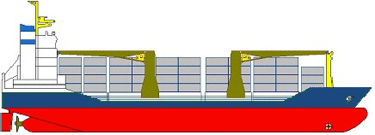
Feeder container ship.
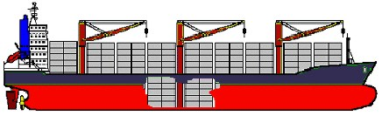
Container ship with own unloading gear.
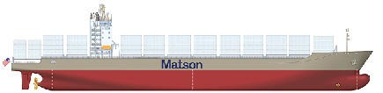
Medium size purpose built container ship.
Large purpose built container ship.
The capacity of a container ship is measured in TEU. Container ships come in all sizes up to 8,000 TEU, with vessels in build of up to 9,200 TEU, and projected up to 12,000 TEU. Many vessels have a number of container slots that will accept refrigerated containers. The smaller ships engaged on coastal and short sea routes are known as feeders. Containers preloaded with goods for export can be locked and sealed before they are loaded onto the ship. With the use of shore based independent moving gantry cranes, the loading and unloading work is extremely fast. In line with the fast cargo handling work, container ships are usually built for speed, so that cargo can arrive at their destinations fast. The general arrangement of a pure container ship has changed over the years, with the first vessels being general cargo ships modified to carry containers, and usually had their own cargo gear in the form of derricks or cranes, but the holds were not specially designed with cell guides. Some of the medium sized modern vessels are geared, and call at ports that have no infrastructure for unloading containers.
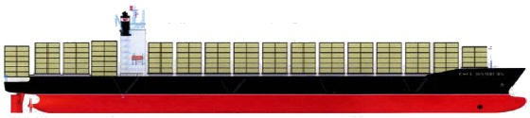
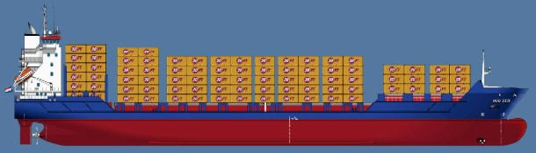
Typical modern medium size feeder container ship of 900 TEU. Usually ungeared like this one, but sometimes fitted with cranes so they can load from ports with limited infrastructure.
Comparatively high speeds and swift turn arounds in port are vital in maintaining the liner schedules of container ships. Cargo handling efficiency is sought from large dockside gantry cranes at the terminals serving large long haul ships which are generically non-geared (without their own cranes). Feeder container ships, however, are often geared, their deck cranes, commonly of the slim-line type to maximise container stowage spacefacilitating cargo handling in ports with limited infrastructure. To facilitate loading, some ships have stacking guides arranged in rows along the deck.
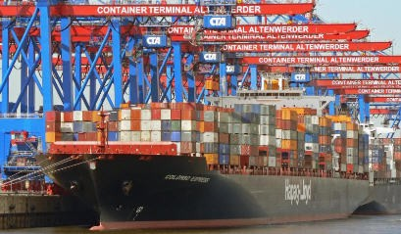
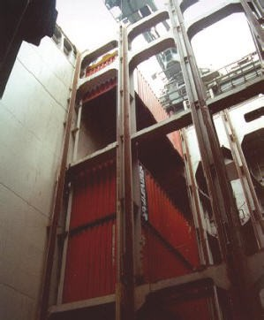 | 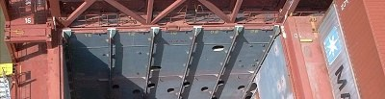
 | All the cargo holds contain guides for the containers so that it is easy to slide them in place. The containers are made so that the corners can be locked in place very easily. Because the containers are lowered in place precisely and the corners are matched for interlocking, it is important to keep the ship at even keel during the cargo work. For this purpose, container ships have remotely controlled ballast pumps and valves that can be controlled by deck officers.

MULTI PURPOSE CONTAINER SHIPS
Typical general cargo/container ship. These were the fore runners of the true modern multi purpose vessels, and are general cargo ships that have been converted the carry containers as well as general cargo. Almost all have retained deck gear by way of cranes or sometimes derricks, but some ships have had their gear removed.
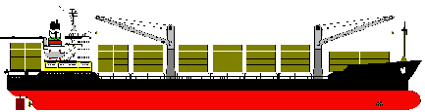
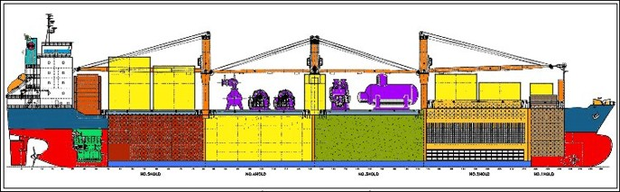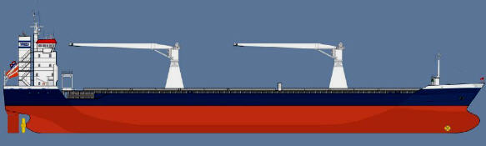
Many operators are now using multi-purpose container ships (MPP). These vessels are capable of carrying general, bulk, and deck cargo as well as containers, and are normally geared with cranes. Both cable luffing and hydraulic cranes are shown in these examples.
Such ships maximise capacity as they can still be well loaded with other cargo even though there is not enough containers to fill the ship.
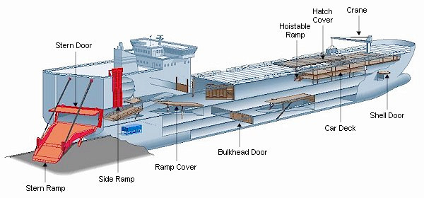
Shown here is another type of general purpose ship that is designed to carry containers and vehicles. It also carries containers on ro-ro cassettes. The stern is the same as a pure vehicle/truck carrier with a large stern ramp. It also has its own cranes.
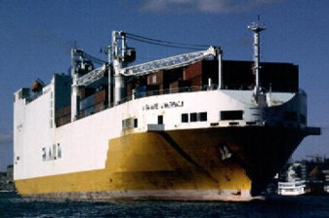 | 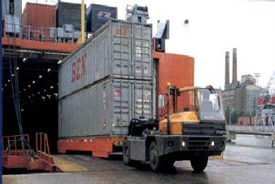

CONTAINER SHIP SIZES
Five Generations of Containerships
The first containerships were modified bulk vessels or tankers that could transport up 1,000 TEUs. Indeed, the container was at the beginning of the 1960s an experimental transport technology and modifying existing ships proved out to be the least expensive solution. These ships were carrying onboard cranes. Once the container was massively adopted at the beginning of the 1970s, the construction of the first containerships (second generation) entirely dedicated for handling containers started. They carry the cellular denomination since they are composed of cells lodging containers up to stacks of 12. Cranes were removed from the ship design so more containers could be carried. Containership speeds have peaked to an average 20-25 knots and it is unlikely that speeds will increase due to energy consumption.
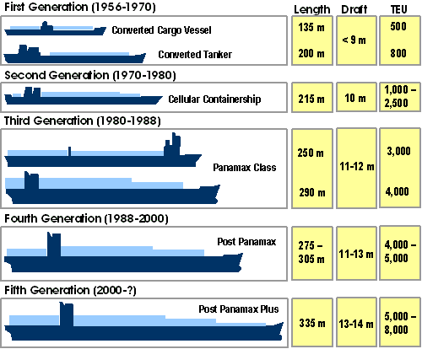
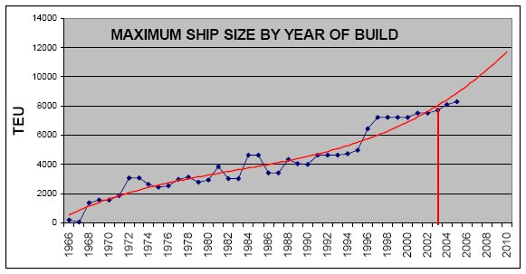
Economies of scale pushed the construction of larger containerships in the 1980s until the Panamax (1985) and Post Panamax (1988) standards, transporting between 4,000 and 5,000 TEUs were reached. The fifth generation (Post Panamax Plus) are now in service and will be able to transport between 5,000 and 8,000 TEUs. A limited number of harbours are able to handle them, because these ships will require deep water ports and highly efficient, but costly, shore infrastructures.
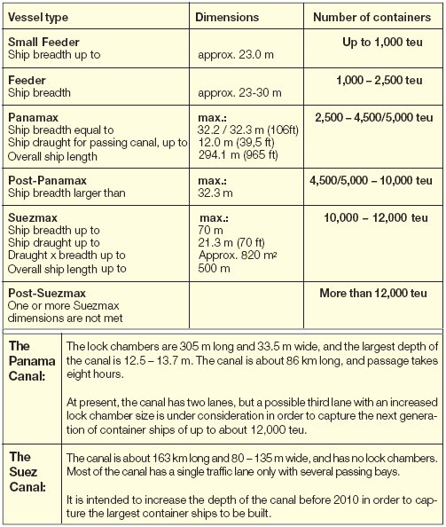
Depending on the teu size and hull dimensions, container vessels can be divided into the following main groups or classes. However, adjacent groups will overlap.
- Small Feeder <1,000 teu
- Feeder 1,000-2,500 teu
- Panamax 2,500-4,500/5,000 teu
- Post-Panamax 4,500/5,000-10,000 teu
- Suezmax 10,000-12,000 teu
- Post-Suezmax >12,000 teu
Small Feeder
The small feeder container vessels are normally applied for short sea container transportation. The beam of the small feeders is, in general, less than 23 m.
Feeder
The feeder container vessels greater than 1,000 teu are normally applied for feeding the very large container vessels, but are also servicing markets and areas where the demand for large container vessels is too low. The beam of the feeders is, in general, 23-30 m.Panamax
Until 1988, the hull dimensions of the largest container ships, the so-called Panamax-size vessels, were limited by the length and breadth of the lock chambers of the Panama Canal, i.e. a max. ship breadth (beam) of 32.3 m, a max. overall ship length of 294.1 m (965 ft), and a max. draught of 12.0 m (39.5 ft) for passing through the Canal. The corresponding cargo capacity was between 4,500 and 5,000 teu. These max. ship dimensions are also valid for passenger ships, but for other ships the maximum length is 289.6 m (950 ft). However, it should be noted that, for example, for bulk carriers and tankers, the term Panamax-size is defined as 32.2/32.3 m (106 ft) breadth, an overall length of 225.0 m for bulk carriers and 228.6 m (750 ft) for tankers, and no more than 12.0 m (39.5 ft) draught. The reason for the smaller length used for these ship types is that a large part of the world’s harbours and corresponding facilities are based on these two lengths,respectively.
Post-Panamax
In 1988, the first container ship was built with a breadth of more than 32.3 m. This was the first post-Panamax container ship. The largest vessels on order with a capacity of approx. 9,600 teu have exceeded the Panamax beam by approx. 13 m.
Suezmax
It is probable that Ultra Large Container Ships (ULCS) carrying some 12,000 teu containers can be expected. This ship size, with a breadth of 50 m / 57 m, and corresponding max. draught of 16.4 m /14.4 m for passing through the Suez Canal, may just meet the present Suezmax size.
Post-Suezmax
It is pssible that in about 10 years the ULCS will perhaps be as big as 18,000 teu, with a ship breadth of 60 m and a max. draught of 21 m. Today, this ship size would be classified as a post-Suezmax ship, as the cross-section of the ship is too big for the present Suez Canal. It is claimed that the transportation cost per container for such a big ship may be about 30% lower than that of a typical 5,000-6,000 teu container vessel of today.
A draught of 21 m is the maximum permissible draught through the Malacca Strait. The name “Malaccamax” has therefore been used.
With the intended increase of the cross- section breadth and depth of the Suez Canal over the coming ten years, the 18,000 teu container ship will also be able to pass the Suez Canal. On the other hand, a future container ship with a draught of 21 m would require existing harbours to be dredged. Today, only the harbours of Singapore and Rotterdam are deep enough.

