Year 9 Interactive Maths

Content: Circle

Length of circumference
For more details on this topic, see Pi.
The ratio of a circle's circumference to its diameter is π (pi), a constant that takes the same value (approximately 3.141592654) for all circles. Thus the length of the circumference (c) is related to the radius (r) by
or equivalently to the diameter (d) by

Area enclosed
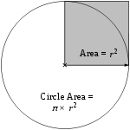
Area of the circle = π × area of the shaded square
Main article: Area of a disk
The area enclosed by a circle is π multiplied by the radius squared:
Equivalently, denoting diameter by d,
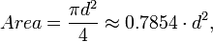
that is, approximately 79% of the circumscribing square (whose side is of length d).
The circle is the plane curve enclosing the maximum area for a given arc length. This relates the circle to a problem in the calculus of variations, namely the isoperimetric inequality.

Circumference of a circle
The circumference of a circle is the length around it. The circumference of a circle can be calculated from its diameter using the formula:
Or, substituting the radius for the diameter:
where r is the radius and d is the diameter of the circle, and π (the Greek letter pi) is defined as the ratio of the circumference of the circle to its diameter (the numerical value of pi is 3.141 592 653 589 793...).

Circumference of a Circle

The perimeter of a circle is called the circumference. The circumference is the distance around the circle.
The circumference, C, of a circle is given by the formula  where r is the radius of the circle, and  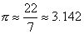 | 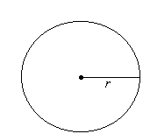

Example 4
A circular swimming pool has a radius of 14 m. Find the circumference of the pool.

Solution:
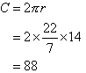  So, the circumference of the pool is 88 m. | 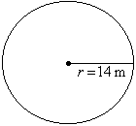

Note:

Example 5
A circular flower-bed has a radius of 9 m. Find the circumference of the flower-bed.

Solution:
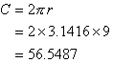  So, the circumference of the flower-bed is 56.5487 m. | 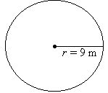

Radius from circumference
The radius of the circle with perimeter (circumference) C is
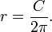

[edit] Radius from area
The radius of a circle with area A is
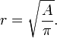

[edit] Radius from three points
To compute the radius of a circle going through three points P₁, P₂, P₃, the following formula can be used:
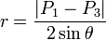
where θ is the angle

Area and surface formulas:
Shapes | Formula
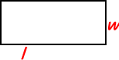 | Rectangle:  Area = Length X Width  A = lw  Perimeter = 2 X Lengths + 2 X Widths  P = 2l + 2w
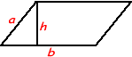 | Parallelogram  Area = Base X Height  a = bh
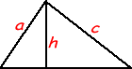 | Triangle  Area = 1/2 of the base X the height  a = 1/2 bh  Perimeter = a + b + c  (add the length of the three sides)

Sponsored Links
Surface TensionHigh Precision Tensiometers & Spinning Drop Systemswww.dataphysics.de
Fat Transfer BrisbaneFacial fat transfer lipoplasty fat transfer surgery volume liftwww.RejuvenationClinics.com.au
Surface PretreatmentSurface pretreatment via Corona, Plasma and Flame treaters.www.arcotreat.com
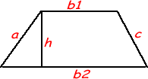 | Trapezoid  Perimeter = area + b1 + b2 + c  P = a + b1 + b2 + c
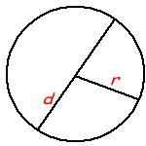 | Circle Try the Online tool.  The distance around the circle is a circumference. The distance across the circle is the diameter (d). The radius (r) is the distance from the center to a point on the circle. (Pi = 3.14) More about circles.  d = 2r  c = πd = 2 πr  A = πr²  (π=3.14)
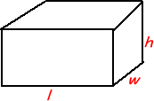 | Rectangular Solid  Volume = Length X Width X Height  V = lwh  Surface = 2lw + 2lh + 2wh
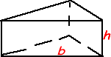 | Prisms  Volume = Base X Height  v=bh  Surface = 2b + Ph (b is the area of the base P is the perimeter of the base)
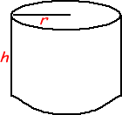 | Cylinder  Volume = πr^{2 x} height  V = πr² h  Surface = 2π radius x height  S = 2πrh + 2πr²
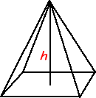 | Pyramid  V = 1/3 bh  b is the area of the base  Surface Area: Add the area of the base to the sum of the areas of all of the triangular faces. The areas of the triangular faces will have different formulas for different shaped bases.
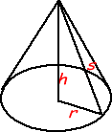 | Cones  Volume = 1/3 πr² x height  V= 1/3 πr²h  Surface = πr² + πrs  S = πr² + πrs  =πr² + πr
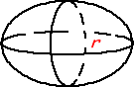 | Sphere  Volume = 4/3 πr³  V = 4/3 πr³  Surface = 4πr²  S = 4πr²

Area of a Circle

A circle with radius r units has an area of A square units given by the formula  where  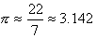 | 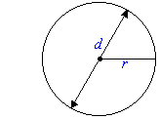

Example 17
Find the area of a circle whose diameter is 28 m.

Solution:
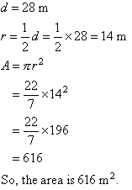 | 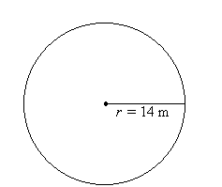

Example 18
Find the area of a circle whose diameter is 19 cm.

Solution:
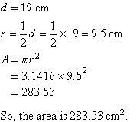 | 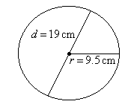

Volume of a Cylinder

A cylinder with radius r units and height h units has a volume of V cubic units given by | 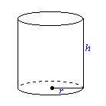

Example 27
Find the volume of a cylindrical canister with radius 7 cm and height 12 cm.

Solution:
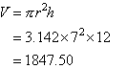 |  | 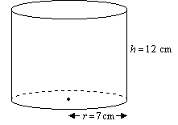

Perimeter

Recall that:
Perimeter is the distance around a closed figure.
Perimeters can be measured in millimetres (mm), centimetres (cm), metres (m) and kilometres (km). These units are related as follows:
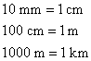
Perimeters of the following figures are often required to solve real world problems.
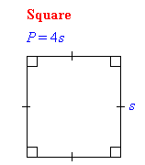 | 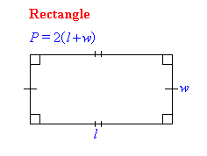
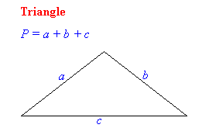 | 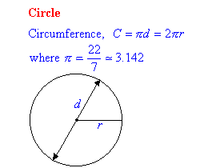

Perimeter of a Square

Recall that:
The perimeter, P, of a square is given by the formula:  P = 4s  where s is the length of any side of the square. | 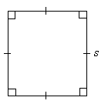

Example 1
Find the perimeter of a square paddock of side 35 m.

Solution:
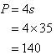  So, the perimeter is 140 m. | 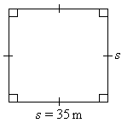

Perimeter of a Rectangle
The perimeter, P, of a rectangle is given by the formula  P = 2(l + w)  where l is the length and w is the width of the rectangle. | 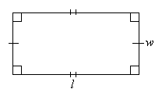

Example 2
Find the perimeter of a rectangular field of length 50 m and width 40 m.

Solution:
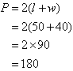  So, the perimeter is 180 m. | 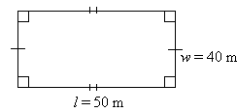

Perimeter of a Triangle
The perimeter, P, of a triangle is given by the formula:  P = a + b + c  where a, b and c are the side lengths of the triangle. | 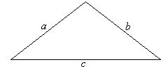

Example 3
Find the perimeter, P, of the triangle shown.
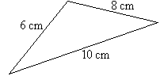

Solution:
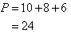
So, the perimeter is 24 cm.

