Applying Circle Knowledge
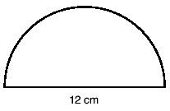  Find the area  Find the circumference | 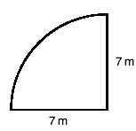  Find the area  Find the circumference | 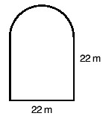  Find the area  Find the circumference
Find the shaded area  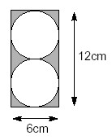 | Find the shaded area  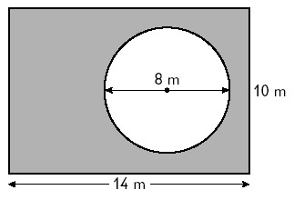 | Find the shaded area

