Other Notes on H-Bonding

Concept Name : Hydrogen bond

Definition : A hydrogen bond is a type of attractive (dipole-dipole) interaction between an electronegative atom and a hydrogen atom bonded to another electronegative atom.

Critical Attributes : C1 three atoms are involved in the bond, and the central one must be hydrogen
C2 the other two atoms must be more electronegative than hydrogen
C3 the hydrogen must be covalently bonded to only one of the other more electronegative atoms

Variable Attributes : V1 hydrogen bonds can occur in one molecule, or between different molecules
V2 the two more electronegative atoms can be different

Examples :
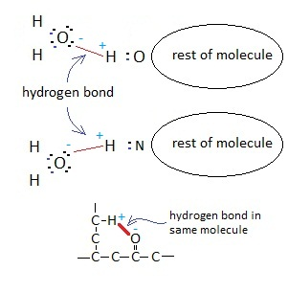
Non-example :
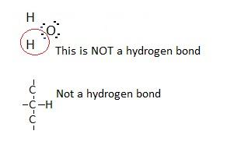

Subordinate concepts : atoms
electrons
sharing electrons
electronegativity - unequal sharing
polarity

Coordinate concepts : covalent bond
polar covalent bond
ionic bond
metallic bond

Supraordinate concepts : surface tension of water
boiling point of water
polar solvent properties of water

Notes on H-Bonding

Mostly from Chemistry in Use (Book 1)

Chapter 2 - Water : A Unique Material
About 70% of the Earth is covered by water. About 97% of water is found in the oceans, and only 0.001% is found in the atmosphere as water vapour. Water is an unusual material with lots of peculiar properties, without which life on Earth would be impossible.
Some important properties include ...
- water exists as a liquid over an important range of temperatures from 0°C to 100°C
- Solid water (ice) has a lower density than it’s liquid phase (water)
- The cohesive property between water molecules allows for transport of water from root to leave in plants
- The solvent properties of water allow for a large and wide range of substances to dissolve in water, and thus for the reactions for life to take place
- Polar organic molecules are able to have dipole-dipole interactions with water molecules, and thus dissolve to varying degrees in water. Once again allowing for life reactions to take place.
- Water allows for dissolution of oxygen and carbon dioxide, once again needed for life processes.
- Precipitates form when the ionic bonding between ions in solution is greater than the attraction between the ions and the charged ends of the water molecules.

Soap molecules consist of a sodium ion attached to a long hydrocarbon chain, referred to as a stearate ion.
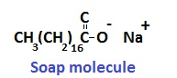

Chapter 2 - Mainly About Compounds
Bonding forces such as covalent bonds, holding atoms together are very strong. The intermolecular forces between different molecules are quite weak. Boiling involves separating molecules from one another. It overcomes intermolecular forces, not covalent bonds within the molecules. Melting, like boiling overcomes intermolecular forces.

Intermolecular forces vary from one molecule to another. The stronger the intermolecular forces, the higher the melting and boiling points.

Chapter 4 - Chemistry in Use Book 1

Intermolecular forces - forces of attraction between pairs of molecules

Structure of Water
Water has an oxygen molecule covalently bonded to two hydrogen atoms.
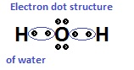
This tells us how valence electrons are arranged, and how many covalent bonds are formed, but little about the shape of the water molecule.
Polar Covalent Bonds
In heteroatomic molecules eg. H-Cl or H-O-H the sharing of the electrons is unequal. In the H-Cl molecule, the electrons spend more time on avereage around the Cl atom, and less around the H atom. This means that the Cl end of the molecule has a slightly negative charge, and the H end a slightly positive charge. The magnitude of the negative and positive charges are small and equal. Covalent bonds like this, in which the sharing of the electrons is unequal, are called Polar Covalent Bonds.

A pair of equal and opposite charges separated by a small space, is called a dipole.

By shape we mean the geometrical arrangement of atoms that make up the molecule.
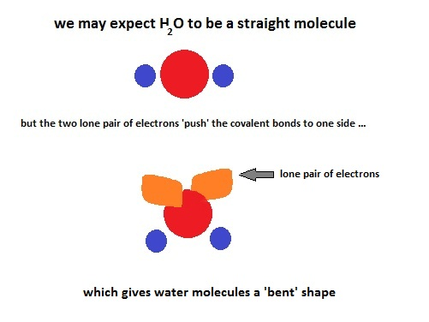
this results in the water molecule having a distinct polar character, with the oxygen atom being slightly negative, and the two hydrogen atoms having a slightly positive character.

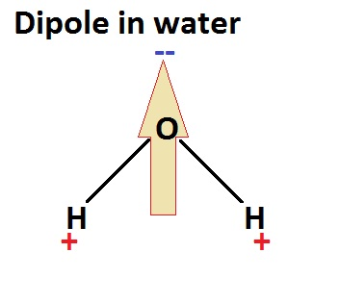

Inter-molecular Forces
Dipole - Dipole Forces

Because polar molecules have positive and negative ends, they are able to line up so that the positive end of one molecule attracts the negative end of another molecule. This electrostatic attraction holds the molecules together more strongly than if they were non-polar molecules without this electrostatic attraction. These electrostatic attractions are called dipole-dipole forces.

Dispersion Forces

Dispersion forces are weak electrostatic forces that are always found between molecules. They arise from the attraction of the nucleus of one atom for the electron cloud of another atom in a different molecule. This attractive force is opposed by the repulsive force between the two electron clouds, giving a net small attractive force.

However the strength of dispersion forces does increase as the size of the electron cloud increases. Therefore dispersion forces increase as the molecular weight increases. There are always dispersion forces, even in the absence of other inter-molecular forces.

Hydrogen Bonding

This is the third and strongest inter-molecular force. When hydrogen is bonded to a more electronegative atom such as O,N,F the sharing of the bond electrons is unequal. This sets up a dipole as seen above, with the hydrogen atom being positive, and simple a small proton for the nucleus. The more electronegative atom attracts the electrons so that they spend more time closer to that atom, which consequently takes on a negative charge.

This dipole with a very small proton as the positive center sets the first requirement for hydrogen bonding. If a neighbouring molecule has an exposed negative center, the small hydrogen proton is attracted and gets close to that negative center, forming the hydrogen bond. It is an electrostatic attraction in which there is no sharing of electrons.

The hydrogen bond is typically formed between the bare proton of one molecule and an O,N or F in a second molecule. It’s strength is much greater than other inter-molecular forces and typically a tenth of a covalent bond.

Evidence for Hydrogen bonding

As seen in Chapter 2 above, the melting and boiling points of substances indicate how strong the molecules are attracted to each other. We have seen above that as the molecular weight of a molecule increases, so the dispersive forces increase, and we would expect an increase in melting and boiling points. We have also seen that molecules need hydrogen to form hydrogen bonds. So if we put this all together and look at the boiling points of hydrides, with increasing molecular weights, we should see a corresponding increase in boiling points as we progress down a period.

Lets tale Period 6 O,S,Se,Te. The boiling points are as follows ...

H₂O | 100 °C
H₂S | -60 °C
H₂Se | -41 °C
H₂Te | -2 °C
If we plot the hydrides we get a graph like this ...

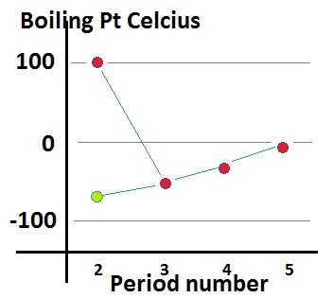

where the green data point above period 2 is the extrapolates data point.

So the big question is why does the hydride of oxygen not have a boiling point of around -80 °C, but rather the 100 °C that we can measure in the laboratory. This unexpected increase is due to the molecules of oxygen hydride being more strongly attracted to each other than we expect, and this is due to the addition inter-molecular force of HYDROGEN BONDING.

If there were no such bonds as hydrogen bonds, water would boil at around -80 °C and there would be no liquid water on the Earth to sustain life as we know it.

