Robert Hemingway Chemistry STA Assignment 1
s42290427 Presented on 21st April 2010

Task Description:
(from Course profile)
In this task you will select a chemical concept to investigate. You will write a guide for teaching the concept and present a demonstration illustrating the concept. You will write a reflection on your work. The teaching guide, presentation and the reflection will be weighted equally. Details of the task will be handed out at the start of the course.
(from Chemistry Trail Handout)
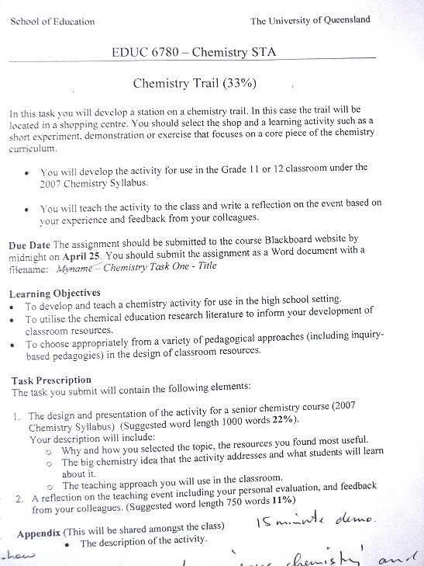

Chemical Trail document - handed out 3/3/2010
1. Your description will include:
- Why and how you selected the topic, the resources you found most useful.
- The big chemistry idea that the activity addresses and what students will learn about it.
- The teaching approach you will use in the classroom.
2. A reflection on the teaching event including your personal evaluation and peer feedback.

How and why did I choose this topic ?
First I looked at the QSA Chemistry 2007 Syllabus document to get an idea of what chemical topics are covered. Then I browsed around a shopping centre, looking for anything that “caught my eye”, and thinking if this ‘thing’ could be used to demonstrate some chemical concept covered in the syllabus. Finally I brainstormed with my wife about possible “chemical” related items she could come up with, from a shopping centre point of view.
In the end I chose Funny Putty from the toys section to demonstrate how microscopic details like bonding, affects the macroscopic properties of the compound. Something covered in Organiser 1 of the syllabus.

Resources most useful :
The internet was the most useful tool with which I discovered various resources for this assignment. Googling Funny Putty led onto Slime and Gak. This in turn led to two very useful documents covering the chemistry of slime, and how to make slime with varying macroscopic properties. Both resources are listed in the Reference section.

This in turn led to research into hydrogen bonding, and other intermolecular forces, for which there are uncountable number of online references.

Description of Concept : The Big Idea
Unit : Organiser 1 : Structure
Topic : Materials can be categorised and represented symbolically and their macroscopic properties can be explained and predicted from understandings about electronic structure and bonding.

Key Concepts Covered :
- S2 : Materials can be categorised and represented symbolically and their macroscopic properties can be explained and predicted from understandings about electronic structure and bonding.
- S2.2—The macroscopic properties are related to their microscopic properties
- S2.3—Pairs of atoms may be bound together by the sharing of electrons between them in a covalent bond.
- S2.4—Two or more atoms bound together by one or more covalent bonds form a molecule, with definite size, shape and arrangement of bonds.
- S2.7—When chemical bonds, whether ionic or covalent, are formed between different elements, a chemical compound is obtained, which can be represented by a chemical formula.
- S2.8—Forces weaker than covalent bonding exist between molecules. .
- S2.11—In compounds containing carbon-hydrogen bonds (known as organic compounds), the carbon atoms bind to one another through single, double or triple covalent bonds to form chains or rings.

Key Learning’s :
I want my students to understand that the macroscopic properties of materials can be explained and often predicted from understanding their electronic structure and bonding.

Student learning objectives:
Students will be able to :
Identify plastic flow vs. elastic behaviour
Demonstrate variations in viscosity as a function of composition
Specify the effect of cross-linking on macroscopic properties

The Teaching Approach :
- Brief revision of required knowledge with whiteboard work, and questions and answer session.
- Describe the experiment that the students will perform
- Get students to think about the chemistry, and to predict what they expect to happen
- Students perform the experiment and record the results
- Students explain the results and how they relate to their original prediction
- I conclude by summarising the expected outcome and the chemistry involved

Therefore teaching approach is primarily hands-on student experimentation, with prior group discussion on expected outcomes, and student explanation of results. With a small portion of ‘chalk & talk’ to summarise and conclude the lesson.

My Reflection on the event :
Choosing the topic, and researching possible demonstrations, and explanations, was time consuming, but stimulating. Preparing for the lesson was straight forward with Anne’s help and assistance. I spent many a time mentally visualizing how the lesson would play out, and finally decided on a particular flow.

On the day - Setting up the activity was fine. Getting the students to focus on the task at hand, and to pay attention, was difficult. I don’t know if it was the small class size, the rain, the time of the lesson or what, but some of the students were a little over active and distracted.

I believe I prepared well, and had decided on a reasonable lesson flow, but the actual flow was somewhat different in that the ‘predicting’ part of the lesson, never got done. Why ? – well almost the whole class was involved in performing the experiment, and there was no one else to get predicting !

The chemical outcome of mixing PVA and Borax is pretty bullet-proof, which is good for a student demonstration, as nothing generates nicknames for the teacher, as failed demonstrations in the class. The experiment, and the lesson as a whole went okay, but I feel the predicting was an essential part of the lesson – so from that point of view I never completed what I set out to do. Perhaps a smaller “working group” would have cut down on the number of those around the table, leaving more students to try predictions. I also feel that due to the limited time, I started talking too fast – trying to say too much in less time.

I would have preferred more time to analyse and record and explain the five slime samples that were made. Again I feel this is an important aspect of the lesson, and I needed more time to complete this.

Peer feedback :
There were only five (5) feedback sheets returned, but they were appreciated. Mostly the hands-on experimenting was enjoyed – no negative comments. Overall the responses were all positive, and some constructive comments included :-
- Better more explicit explanation of the borax chemistry
- More careful use of the term polymerisation when in fact it was cross-linking

References :
1) Chemistry of Slime by Tony Alfrey - Lucille M. Nixon Elementary School Parent
my local file link is
file://localhost/C:/Users/Robert/Documents/UQ%20stuff/EDUC6780-ChemistrySTA/Assignment1Stuff/ChemistryOfSlime.mht

2) Property of Slime details

Andrew Nydam
Olympia High School
1302 North Street
Olympia Washington 98501
and
Debbie Goodwin
Chillicothe High School 2801 Hornet Road
Chillicothe MO. 64601
(document reference not available, but titled
Slime: Classroom demonstration of property change due to cross linking
(More fun than you should ever have teaching science or technology)
)

3) Wikipedia - Borax link http://en.wikipedia.org/wiki/Borax
- Polyvinyl Alcohol link http://en.wikipedia.org/wiki/Polyvinyl_alcohol

BOOKING AND RISK ASSESSMENT SHEET
24 Hours Notice Required

Name: Robert Hemingway Date submitted: 15th April 2010
Day & date required: 21st April 2010 Time required: 09:00
Procedure attached (Yes/No) Yes
List of materials needed
Chemical Amount / packaged
1. 4% Polyvinyl Alcohol 300 ml
2. 4% Borax 50 ml
3. 5 different food colors couple of drops of each
4. 250 ml glass beaker 5
5. ziplock bags and stirring sticks 5 and 6
6. 25 ml Measuring Cylinder 1
7.
Hazard Checklist : Borax is classified as biologically hazardous - keep off skin^{(see Appendix A)}
CHEMICAL |  | THERMAL |  | BIOLOGICAL |  | MECHANICAL |  | OTHER
Toxic | X | Fire/Flames |  | Bacteria |  | Projectiles |  | Gas
Corrosive |  | Hot objects |  | Bites |  | Glassware | X | Electrical
Flammable |  | Cold objects |  | Stings |  | Sharps |  | Long hair
Carcinogenic |  | Explosion |  | Uncertain | X
Dust/Vapor
Waste/Spills

Control Measures
Warning signs |  | Fume cupboard |  | Disposable gloves | X
Check MSDS |  | Safety Glasses | X | Dissection safety instructions
Demonstrate |  | Apron |  | Wash hands after activity | X
Supervision |  | Tongs |  | Read risk and safety details to all involved | X

Risk Assessment
RISK LEVEL | RISK TYPE
Low | Activities that do not involve heat, pressure, vacuums, hazardous chemicals, electricity, biological materials or animals.
Medium | Activities that involve heat, pressure, vacuums, fumes, hazardous chemicals, electricity, biolo^{g}ical material, low-speed mechanical or moving  devices/objects. | X
High | Activities that involve high temperatures, very low temperatures, high pressure, low vacuums, toxic fumes, corrosive substances, volatile/flammable chemicals, high voltage electricity, radiation emitters, dangerous biological materials, high speed moving devices and objects.
Very | High risk of injuries that could be sustained during activity which could
High | result in a permanent disability or death. This activity must not be done.
Signature Lab.Officer Signature

Summary of Activity :
Introduction
- Show Cmap of QSA 2007 Senior Chemistry Syllabus framework.
- Show slide 1 to provide a framework within which the students can position this lesson.
- Show slide 2 to inform students of today’s lesson - what they will be doing.
- students will predict what effect cross-linking has on macroscopic properties of slime - texture, viscosity, firmness, stretchability
- students will make 5 sets of slime with different amounts of cross-linker
- Show slide 3 to show students what it is I expect them to achieve by the end of the lesson

Required knowledge
- PVA - its chemical structure
- borate ion chemical structure
- cross-linking and it’s effects
(use 2 sheets of paper and Blu-Tac to demonstrate cross-linking)

Activity
- Explain the chemistry of PVA and Borax using PowerPoint and whiteboard
- Get students to predict what will happen in each of the 6 zip-lock bags
- Make sure students are wearing eye protection, and gloves
- Students pour 50 ml 4% PVA into 5 clean 250 ml beakers
- Students add 2 drops of food color to beakers 2,3,4,5,6 (beaker 1 is the original beaker in which the 300 ml PVA is prepared)
(different colors in different beakers)
- Students add the following volumes of 4% Borax to the beakers :
(with immediate and vigorous stirring for 30 seconds)
Beaker | Volume 4% Borax
1 | 0 ml
2 | 1 ml
3 | 2 ml
4 | 5 ml
5 | 10 ml
6 | 20 ml

- After 30 seconds of stirring, transfer the contents of the beaker to a marked zip-lock bag and continue to mix the reactants for another 30 seconds.
- Students record their findings in the same table as their predictions
- Students explain how accurate they were in their predictions
- Students clean the equipment
Conclusion
Question time, and possibly explain how hydrogen bonding (intermolecular bonds) affect the macroscopic properties of water, as compared to H₂S for example - boiling point, surface tension, specific heat etc.

Some observations / questions:
“The biochemist in our group contends that the cross-linking reaction is endothermic; that is, that the linking reaction sucks energy from the surrounding volume of slime and making the slime cool to the touch. However, the physicist in our group points out that the whole blob of slime is largely water, imperfectly trapped within a matrix of polymer, so water evaporation goes on continuously over the surface of the slime, cooling the surface. Additionally, because of the high water content of the slime, the thermal conductivity of the slime is essentially that of water, and feels cool to the touch, even if it is the same temperature as the ambient. So, like good scientists, we'll have to get out our thermometer and actually TEST the temperature of the slime to see if it ended up at a lower temperature than when it started.”

During the mixing stage, did the ziplock bag heat up or cool down, or was there no change in temperature ? What is a possible explanation for your observations ?

Gently lay a fork (prongs down) onto the surface of the slime. In several hours, the fork will have sunk into the slime, and the slime will encapsulate the fork. The fork will tear the slime if it is removed rapidly.

Similarly, if pulled slowly, slime can be stretched into thin sheets or strings. But if pulled quickly, the slime can be forced to break or fracture along a relatively flat plane.

Possible Misconceptions

The linking between separate PVA molecules, by borate ions, is cross-linking not polymerisation.
Cross-linking occurs by hydrogen bonds between PVA molecules and borate ions, whereas polymerisation occurs by covalent bonding of repetitive monomer units.

Macroscopic Properties of Slime Recording Sheet

Beaker | 4% PVA | 4% Borax | Color | Predicted  Macroscopic  Properties | Observed  Macroscopic  Properties
1 | 50 ml | 0 ml | Transparent | Viscosity :  Plastic or Elastic:  Fast stretch:  Slow stretch:  Bounce:
2 | 50 ml | 1 ml | Red | Viscosity :  Plastic or Elastic:  Fast stretch:  Slow stretch:  Bounce:
3 | 50 ml | 2 ml | Blue | Viscosity :  Plastic or Elastic:  Fast stretch:  Slow stretch:  Bounce:
4 | 50 ml | 5 ml | Yellow | Viscosity :  Plastic or Elastic:  Fast stretch:  Slow stretch:  Bounce:
5 | 50 ml | 10 ml | Green | Viscosity :  Plastic or Elastic:  Fast stretch:  Slow stretch:  Bounce:
6 | 50 ml | 20 ml | Aqua  (Blue + Green) | Viscosity :  Plastic or Elastic:  Fast stretch:  Slow stretch:  Bounce:

The Concept Explained :
My Simplified Explanation :
PVA (polyvinyl alcohol) has long carbon chains with alternate carbons bonding to free ending hydroxyl groups ( C-OH). The oxygen in these hydroxyl groups are the sites for bonding to hydrogen atoms in the cross-linking ions, by means of hydrogen bonds. (and the hydrogen atoms can bond to oxygen atoms in the ions)

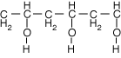

The borate ion has lots of hydroxyl ions exposed, which provide the hydrogen and oxygen atoms needed to form hydrogen bonds with the hydroxyl groups in the PVA chains.

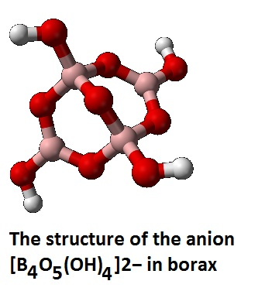 or 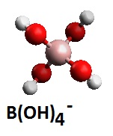(both species may co-exist)

The result is multiple sites of cross-linking between long chains of PVA, by means of the borate ions, with the hydrogen bonds being the ‘glue’ that holds the mass together. Hydrogen bonds being about one tenth the strength of a conventional covalent bond, can break and reform more easily, than the covalent bonds, and this allows for shape deformation (plasticity) and flowing of the mass (viscosity).
The less cross-linking, the more fluid the mass, and the lower the viscosity. The more cross-linking the more rigid the mass and the less flowing or stretchability, and hence the higher viscosity.

The degree of cross-linking (or hydrogen bonding) is thus responsible for the macroscopic properties of fluidity and stretchability of the PVA mass.

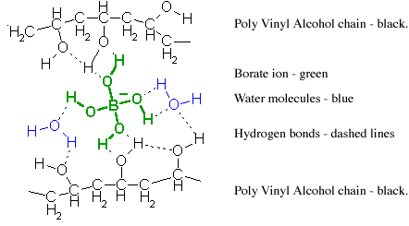

The More Detailed Chemical Explanation :
The following is taken from work by :-
Edmonds Community College 2009 and
Tony Alfrey - Lucille M. Nixon Elementary School Parent

Abstract
This fun experiment explores what slime can offer in terms of the scientific exploration of a variable. PVA is 96% water, Borax solution is 96% water. When mixed together they are still 96% water. Here, we examine the variations students can get by mixing the polymer and the borax “cross linker” together. The resultant slime will be everything from runny to hard and brittle. The lab demonstrates plastic flow vs. elastic behaviour, hydrogen bonding, viscosity, and how this simple polymer demo applies to metals, ceramics, and composites.

The Chemistry
Polymer chains are formed by covalent bonds which are strong bonds. In making slime, individual polymer chains are “hooked” together by weak hydrogen bonds. It is evident that this cross-linking is weak because of the ease with which the slime pulls apart. It is sort of like “tying” together strong strands of string with limp strands of cooked spaghetti. Even though this cross-linking is weak, it does alter the properties of the polymer

Cross-Linking Polyvinyl Alcohol

A single Vinyl Alcohol molecule
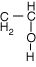
and string a bunch of them together to form Poly Vinyl Alcohol

By dissolving some Borax (Na₂B₄O₇.10H2O) in water, it dissociates into sodium ions and tetraborate ions. The tetraborate ion reacts with water (hydrolyses) to produce boric acid and the OH- ion.

B₄O₇⁻²(aq) + 7 H₂O <—> 4 H₃BO₃(aq) + 2 OH⁻(aq)

The boric acid further reacts with water to form the borate anion.

H₃BO₃(aq) + 2 H₂O <— > B(OH)⁴⁻(aq) + H₃O⁺(aq)

The B(OH)4– ion is shaped like a tetrahedron (four sides, each side is an equilateral triangle) with the boron in the centre and the OH groups at each corner. Hydrogen bonds form between the borate ion and the OH groups on the sides of the Poly Vinyl Alcohol.

These bonds are not very strong, and are broken and reformed easily, allowing the slime to sag and move slowly under stress.

The more cross-linking, the firmer and more rigid the slime, the less it can flow and stretch.
----------
(From Wikipedia - Borax Chemistry)
The term borax is often used for a number of closely related minerals or chemical compounds that differ in their crystal water content:
Anhydrous borax (Na2B4O7)
Borax pentahydrate (Na2B4O7·5H2O)
Borax decahydrate (Na2B4O7·10H2O)

Borax is generally described as Na2B4O7·10H2O. However, it is better formulated as Na2[B4O5(OH)4]·8H2O, since borax contains the [B4O5(OH)4]2− ion. In this structure, there are two four-coordinate boron atoms (two BO4 tetrahedra) and two three-coordinate boron atoms (two BO3 triangles).

Borax is also easily converted to boric acid and other borates, which have many applications. Its reaction with hydrochloric acid to form boric acid is:
Na2B4O7·10H2O + 2 HCl → 4 B(OH)3 [or H3BO3] + 2 NaCl + 5 H2O

Appendix A Safety Issues

From Wikipedia on Borax Toxicity
Borax, sodium tetraborate decahydrate, is not acutely toxic. [11] Its LD50 (median lethal dose) score is tested at 2.66 g/kg in rats. [12] This does not mean that it is safe, merely that a significant dose of the chemical is needed to cause severe symptoms or death. The median lethal dose for humans tends to differ for a given compound from that of rats. Simple exposure can cause respiratory and skin irritation. Ingestion may cause gastrointestinal distress including nausea, persistent vomiting, abdominal pain, and diarrhoea. Effects on the vascular system and brain include headaches and lethargy, but are less frequent. "In severe poisonings, a beefy red skin rash affecting palms, soles, buttocks and scrotum has been described. With severe poisoning, erythematous and exfoliative rash, unconsciousness, respiratory depression, and renal failure." [13]

A reassessment of boric acid/borax by the United States Environmental Protection Agency Office of Pesticide Programs found potential developmental toxicity (especially effects on the testes).[14] Boric acid solutions used as an eye wash or on abraded skin are known to be especially toxic to infants, especially after repeated use because of its slow elimination rate.[15]

