Concise summary of materia
This week we looked at Positive Classroom Behaviour Management. Peter introduced four different styles under the categories of philosophy, strategy and skills, then introduced Liz Fynes-Clinton and Julie Bower to talk on their experiences in this field.
The four styles of behaviour management presented were ...
- the GURU
- the BEHAVIOURIST
- the DEMOCRAT
- the COMMUNITY PARTICIPANT

Peter discussed the philosophy, strategy and skills of and used by these four classes of management.

Connection to CF and STA and other relevant courses

Managing the classroom, and specifically the individuals behaviour will be crucial to successful learning outcomes for all in the class. An analogy is a car travelling sedately down a road, versus the same car spinning out of control in a corner. One will arrive at it’s destination, and one will end up in the ditch ! The road is the school community, the car the individual, and the driver is the teacher.

Thoughtful focussed commentary using self-reflective questions
At the start of the lesson, Peter asked us to reflect on our understanding of philosophy, strategy and skills, in the context of behaviour management. My thoughts were as follows ...

Philosophy | Strategies | Skills
- there must be a reason why the child behaves in this manner !  - try to find out why  - what is the behaviour and why is it used | - slow the situation down  - divide & conquer  - use reasoning and discussion  - try and get consensus and agreement on alternative behaviour | - patience  - understanding  - calmness

Am I able to achieve these goals ? I do believe patience and calmness will be tested, but I have had many years working with different people in testing situations. As such I have had to develop skills in both my and their behaviour management.
At this time I do not see myself as “the disciplinarian”. I am the teacher, not the enforcer! If I cannot use my skills and techniques to “turn” a wayward individual, then someone with more authority (in discipline) will need to take over and allow me to get on with teaching the rest of the students.
In terms of the four styles presented by Peter today, I do believe I would like to use behaviour modification techniques, but mostly democratic discussion and agreement, to achieve good classroom behaviours. At this time I am not knowledgeable nor skilled enough in “restorative justice” to know what this is all about. (I think I will do some reading into this topic before week 6 journal entry !)
The overall behaviour principles will need to come from the school documents on behaviour, and modified by peers and parents attitudes, but I do not see myself as the person to meter out punishment - ‘the teacher teaches, the heads deal with punishment’

In-depth reflection on ones values and commitments as a teacher and the implications of the ideas more broadly for schooling and society

By week 5 my beliefs on teaching, students and society are as follows...
I believe my role is to allow students to achieve advancement in content knowledge (after all, you do want to know more on leaving school than when you first went to school!), but if not more importantly, new and better techniques in thinking, and development in their path to becoming effective and engaged members of society.

So the three corner-stones of my philosophy at this point in time are ...
- advancement of knowledge
- improvement in thinking skills
- development of the individual into a member of society

I will need to be a role model, a tutor, a guide and confidant. However I will need to resist imparting my thoughts and ideas directly onto the young minds. I am there to guide development, NOT direct development towards my points of view. Current world issues and current society values will be corner-stones in this development.

Below is my ‘philosophy’ of education at the moment

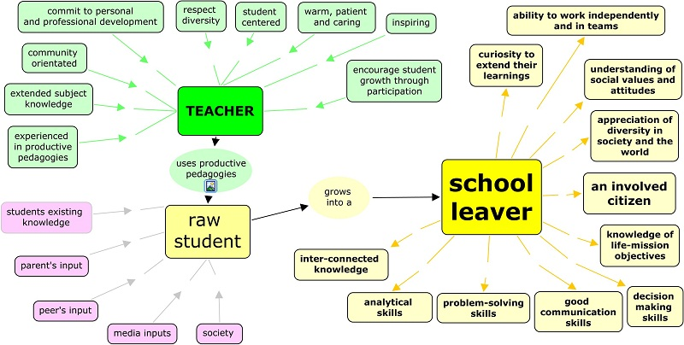
Every student deserves content, development of thinking skills and conversion into a useful member of society !

