Unit: | Earth & Space : Solar system & the universe | Date: | 19th March 2010
Topic: | Motion of components of the solar system accounts for diurnal cycles, eg. tides.
I have: |  | Notes: Robert Hemingway
Read through the relevant textbook chapter q |  | done
Checked the Study Guide content for this topic q |  | done
Completed a Risk Assessment sheet
Reviewed the lecture slides/notes for this topic q |  | done
Decided which key concepts I want to cover q |  | done
Clarified how this topic relates to other topics q
Listed my learning objectives using action verbsI q |  | done
Designed my learning activities q |  | done
Allocated approximate times to activities q |  | done
Set some questions to guide general class discussion q |  | done
Prepared my overheads or slides q |  | done
Photocopied my handouts q |  | na
Planned how the room will be arranged q |  | done
Planned a short activity in case we finish early q |  | na
Printed a list of student names q |  | na
Determined required reading for the next topic q |  | done
Checked on important dates coming up q |  | na
I must remember to:
take colored whiteboard pens
the two sets of activities
the ppt slides
Diurnal cycle, any pattern that recurs daily

First draft completed on 7th April 2010

1. Preliminary Information
The development of a lesson plan begins somewhere, and a good place to start is with a list or description of general information about the plan. This information sets the boundaries or limits of the plan. Here is a good list of these information items:
(a) the grade level of the students for whom the plan is intended;
(b) the specific subject matter (mathematics, reading, language arts, science, social studies, etc.);
(c) if appropriate, the name of the unit of which the lesson is a part; and
(d) the name of the teacher.

2. The Parts
Each part of a lesson plan should fulfill some purpose in communicating
the specific content,
the objective,
the learning prerequisites,
what will happen,
the sequence of student and teacher activities,
the materials required,
and the actual assessment procedures.

Taken together, these parts constitute
an end (the objective),
the means (what will happen and the student and teacher activities),
and an input (information about students and necessary resources).
At the conclusion of a lesson, the assessment tells the teacher how well students actually attained the objective.

Six Common Mistakes in Lesson Planning
1. The objective of the lesson does not specify what the student will actually do that can be observed. Remember, an objective is a description of what a student does that forms the basis for making an inference about learning. Poorly written objectives lead to faulty inferences.

2. The lesson assessment is disconnected from the behavior indicated in the objective. An assessment in a lesson plan is simply a description of how the teacher will determine whether the objective has been accomplished. It must be based on the same behavior that is incorporated in the objective. Anything else is flawed.

3. The prerequisites are not specified or are inconsistent with what is actually required to succeed with the lesson. Prerequisites mean just that -- a statement of what a student needs to know or be able to do to succeed and accomplish the lesson objective. It is not easy to determine what is required, but it is necessary. Some research indicates that as much as 70% of learning is dependent on students having the appropriate prerequisites.

4. The materials specified in the lesson are extraneous to the actual described learning activities. This means keep the list of materials in line with what you actually plan to do. Overkilling with materials is not a virtue!

5. The instruction in which the teacher will engage is not efficient for the level of intended student learning. Efficiency is a measure that means getting more done with the same amount of effort, or the same amount with less effort. With so much to be learned, it should be obvious that instructional efficiency is paramount.

6. The student activities described in the lesson plan do not contribute in a direct and effective way to the lesson objective. Don't have your students engaged in activities just to keep them busy. Whatever you have your students do should contribute in a direct way to their accomplishing the lesson objective.

Unit: | Earth & Space : Solar system & the universe |  | Date: | 19th March 2010
Lesson / Topic: | Motion of components of the solar system accounts for  diurnal ³ cycles, eg. tides. |  | Year :  Teacher : | Year 12  Robert Hemingway
Content : | Content: This is a statement that relates to the subject-matter content. The content may be a concept or a skill. Phrase this as follows: I want my students to: (be able to [name the skill]) OR (I want my students to understand [a description of the concept]). Often times, this content is predetermined or strongly suggested by the specific curriculum you are implementing through your teaching.  ----------  I want the students to understand why there are two high and two low tides every 24 hours¹
Key concepts: | How this relates to syllabus / curriculum key learnings  ----------  - Movement of astral bodies²  - Gravitational attraction  - Vector analysis of forces on water particles  - Diurnal³ nature of the tides, due to motion of the moon
Learning  objectives: | Instructional Objective: Indicate what is to be learned - this must be a complete objective. Write this objective in terms of what an individual student will do, not what a group will do. Limit your objective to one behavioral verb. The verb you choose must come from the list of defined behavioral verbs on my web site. Make sure your objective relates to the content statement above.  ----------  The student(s) must be able to describe the 24 hour pattern of the tides, and why this pattern occurs.
Lesson Assessment: | This must connect diretly with the behaviour indicated in the Learning Objectives  ----------  One member of each group (selected at random by myself, at the end of their group time) will explain their solution to the class. Each member of the group will receive the assessment assigned to this explanation. The assessment will be based on the content of the explanation, not the manner in which it is presented.
Prior knowledge  Needed ...  Future work based on this : | Prerequisites: Indicate what the student must already know or be able to do in order to be successful with this lesson. (You would want to list one or two specific behaviors necessary to begin this lesson). Some research indicates that up to 70% of what a student learns is dependent on his or her possessing the appropriate prerequisites.  ----------  Students need to understand ...  - the fluid property of liquids  - vector analysis of forces  - gravitational force is inversely related to the distance between the bodies squared  Future work ...  - Explain the additional effect of the sun on our ocean tides
Materials needed: | Each group needs a set of activity items. A set consists of ...  - Cardboard moon with data {mass, diameter, distance from earth}  - Cardboard earth with data {mass, diameter, distance from moon}  - Blue wool tied in a loop that represents the ocean around the earth  - 10 paper strips, with arrow head on one side (force vectors)  - Sticky-tape and blu-tac  I will need colored whiteboard pens for the reviewing of prior knowledge
Comments on lesson plan : | Eg. If it’s based on someone else’s plan; the version number; etc.  ----------  This lesson deals with the moon-earth system. No account is taken of the sun.  The explanation herein (of two tides) is based on an article in Wikipedia on Tides, and on discussions with Tony Wright. It relies on vector force analysis of the gravitational force on particles at different positions on the earth, by the moon.  The lesson flow is as follows ...  Introduce the lesson topic - pose the question  Review the movement of the moon around the earth & gravitation attraction  Review the compounding & resolution of forces  Let the students know what I expect them to learn, and how I will assess them  Allow students to investigate the problem - in groups  Get one from each group to explain their solution  Conclude the lesson with a summary and explanation (if necessary)
Sequence of  content: | Teaching activities: | Learning activities: | Resources required: |  | Time  allocated
1. Introduction | Using the ppt slides, introduce myself, the unit of work, and the lesson.  Then explain the problem in the form of a question.  Follow this up with what I expect the students to learn, and finally how they will be assessed. | Students must be able to conceptualise the context of the lesson, within the unit of work.  Also, what I expect them to learn, and how I will assess their learning. | Series of 4 ppt slides |  | 3 minutes  (This will be tight !)
2. Review prior knowledge needed for this lesson. | 1. the motion of the moon around the earth ⁴  2. equation for gravitation attraction ⁵  3. addition and subtraction of forces ⁶ | Students will watch and listen as I review concepts verbally with diagrams on the board | Colored whiteboard pens |  | 2 minutes  (This will be tight)
3. Student problem solving activity | I sit with each group and listen and observe. Where necessary ask leading questions to maintain team direction | Students work in two groups, with the activity items provided, to solve the problem by discussion and inquiry | Cardboard moons and earth, with blue wool (water), and paper arrows (force vectors) |  | 5 minutes
4. Group explanation time | One student from each group (selected by me after the activity) has 2 minutes to explain their solution. | I listen and watch whilst the chosen group representative explains the group’s solution. | Student can use the activity items, and / or the whiteboard and pens |  | 2 x 2  minutes
5. Closure / conclusion | I summarize the two solutions, reinforcing the positive outcomes and correcting any misconceptions if they were presented. Hand out a sheet with references for them to research the topic at home. | Students listen and take notes | Whiteboard and pens, and the activity items. |  | 2 minutes  (This will be tight)
Closure / Conclusion | How you plan to bring the lesson to an orderly and conclusive ending (or not!).  ----------  I will make revisionary statements of the groups solutions, and if necessary reinforce the important points, or advise that I would like them to re-think their solutions for the next lesson.
How to monitor / assess : | Assessment/Evaluation: Describe how you will determine the extent to which students have attained the instructional objective. Be sure this part is directly connected to the behavior called for in the instructional objective.  ----------  During the student group activity I will sit with each group in turn, and observe their interaction, as a form of monitoring. Each member of the group will get the same assessed mark. Both teamwork and presentation of the solution content (not style) will be used to arrive at a mark.
Homework : | Follow-up Activities: Indicate how other activities/materials will be used to reinforce and extend this lesson. Include homework, assignments, and projects.  ----------  Non assessed homework : read about the effect of the sun on the tides.  A useful web site is http://geography.about.com/od/physicalgeography/a/tides.htm
Evaluation / Reflection : | Self-Assessment (to be completed after the lesson is presented): Address the major components of the lesson plan, focusing on both the strengths, and areas of needed improvement. Determine here how you plan to collect information that will be useful for planning future lessons. A good idea is to analyze the difference between what you wanted (the objective) and what was attained (the results of the assessment).  ----------
References : | 1. for most coastal areas, but not all  2. astral bodies - heavenly body  3. diurnal cycle, any pattern that recurs daily  4. motion of the moon around the earth  5. equation for gravitational attraction  6. force vector addition  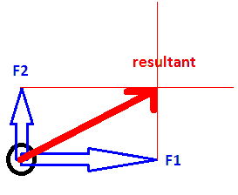  http://en.wikipedia.org/wiki/Tide - Wikipedia article on tides  http://www.youtube.com/watch?v=CTQ6ciHENgI biscuit, plate explanation  And Tony Wright for discussion and explanation
Comment : | 15 minutes for this lesson is tight. There will be no allowance for questions, or discussion after the student presentations. This will have to take place in the follow-up lesson which deals with the effect of the sun on the tides.

Lesson flow ...

Introduction : 3 minutes
Have a ppt slide with my name, the unit and lesson.
Introduce myself and todays lesson
Add the ‘poser question’ and explain it
Add the expected learning outcomes and explain them
Add the assessment for the lesson and explain the assessment technique

Review prior knowledge : 2 minutes
Review the motion of the moon around the earth
Review the equation for gravity
Review vector addition and subtraction

Student activity : 5 minutes
Allow students to problem-solve in two groups

Assessment time : 4 minutes
Get one student from each group to come up and explain their solution

Conclusion : 1 minute
I will summarise the two groups solution, and if necessary add my solution.
Conclude with what this leads into in the next lesson.

Possible Questions
1. If the Moon is attracting our water so strongly, why doesn’t the water just get ‘sucked’ onto the moon ?
2. If there was no Moon, what would happen to tides ?
3. If the Moon was as massive as the Earth, but at the same distance as it is now, what would happen to the tides ?
4. Does the Moon have a gravitation effect on you ?
5. What stops the Moon from hurtling off into space ?

The explanation
Consider three bodies of mass ...
- The water body closest to the moon (sub-lunar point)
- The earth
- The water body furthest from the moon (anti-podal point)

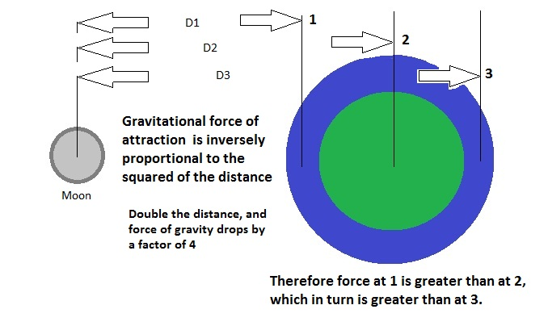
The body of water at 1 is attracted the strongest and moves to this new position ...
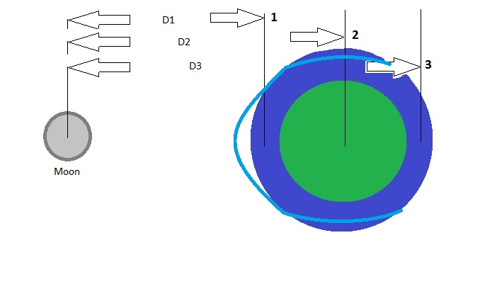
The earth is also attracted, but with a lesser force, so moves towards the moon but not as much ...
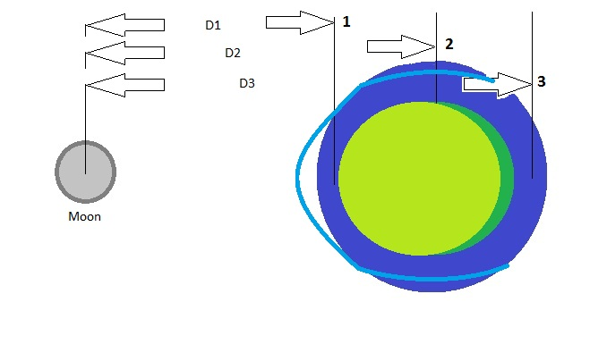
The body of water at 3 is also attracted, but with a weaker force than the earth, so moves towards the moon but again to a lesser extent...
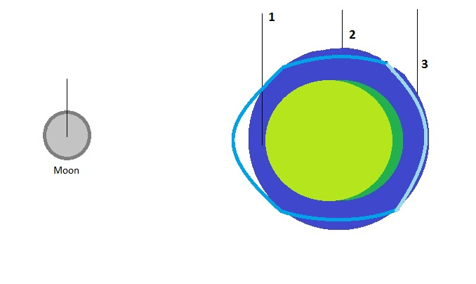
Which results in the buldge (high tide) at 1, and a second buldge (high tide) at 3.
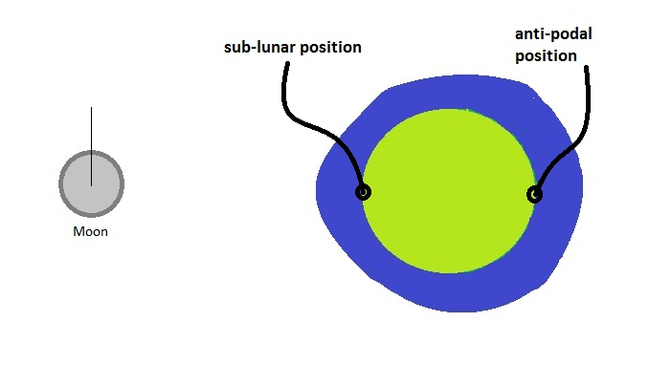
So with one revolution of the moon around the earth, each port will experience two high tides - the one when it is at the sub-lunar position, and the second when at the anti-podal position.

Tides : http://geography.about.com/od/physicalgeography/a/tides.htm
The Sun and Moon Affect the Oceans
By Matt Rosenberg, About.com Guide

The moon is the primary tidal force.
The gravitational pull of the moon and the sun creates tides on the earth. While tides are most commonly associated with oceans and large bodies of water, gravity creates tides in the atmosphere and even the lithosphere (the surface of the earth). The atmospheric tidal bulge extends far into space but the tidal bulge of the lithosphere is limited to approximately 12 inches (30 cm) twice a day.

The moon, which is approximately 240,000 miles (386,240 km) from the earth, exerts a greater influence on the tides then does the sun, which sits 93 million miles (150 million km) from the earth. The strength of the sun's gravity is 179 times that of the moon's but the moon is responsible for 56% of the earth's tidal energy while the sun claims responsibility for a mere 44% (due to the moon's proximity but the sun's much larger size).

Due to the cyclic rotation of the earth and moon, the tidal cycle is 24 hours and 52 minutes long. During this time, any point on the earth's surface experiences two high tides and two low tides.

The tidal bulge that occurs during high tide in the world ocean follows the revolution of the moon, and the earth rotates eastward through the bulge once every 24 hours and 50 minutes. The water of the entire world ocean is pulled by the moon's gravity. On the opposite side of the earth simultaneously there is a high tide due to the inertia of the ocean water and because the earth is being pulled toward the moon by its gravitational field yet the ocean water remains left behind. This creates a high tide on the side of the earth opposite the high tide caused by the direct pull of the moon.

Points on the sides of the earth between the two tidal bulges experience low tide. The tidal cycle can begin with high tide. For 6 hours and 13 minutes after high tide, the tide recedes in what is known as ebb tide. 6 hours and 13 minutes following high tide is low tide. After low tide, the flood tide begins as the tide rises for the next 6 hours and 13 minutes until high tide occurs and the cycle begins again.

Tides are most pronounced along the coastline of the oceans and in bays where tidal range (the difference in height between low tide and high tide) is increased due to the topography and other factors.

The Bay of Fundy between Nova Scotia and New Brunswick in Canada experiences the world's greatest tidal range of 50 feet (15.25 meters). This incredible range occurs two times ever 24 hours 52 minutes so every 12 hours and 26 minutes there's a single high tide and a low tide.

Northwestern Australia is also home to very high tidal ranges of 35 feet (10.7 meters). Typical coastal tide range is 5 to 10 feet (1.5 to 3 meters). Large lakes also experience tides but the tidal range is often less than 2 inches (5 cm)!

The Bay of Fundy tides are one of 30 locations worldwide where the power of tides can be harnessed to turn turbines to produce electricity. This requires tides greater than 16 feet (5 meters). In areas of higher than usual tides a tidal bore can often can be found. A tidal bore is a wall or wave of water that moves upstream (especially in a river) at the onset of high tide.

When the sun, moon, and the earth are lined up, the sun and moon are exerting their strongest force together and tidal ranges are at their maximum. This is known as spring tide (spring tides are not named from the season but from "spring forward") This occurs twice each month, when the moon is full and new.

At the first quarter and third quarter moon, the sun and moon are at a 45° angle to each other and their gravitational energy is diminished. The lower than normal tidal range that takes place at these times is call neap tides.

Additionally, when the sun and moon are at perigee and are as close to the earth as they get, they exert a greater gravitational influence and produce greater tidal ranges. Alternatively, when the sun and moon as far as they get from the earth, known as apogee, tidal ranges are smaller.

What causes high tide and low tide?

Why are there two tides each day?
from: http://science.howstuffworks.com/tide-cause.htm

The following diagram shows how the moon causes tides on Earth:

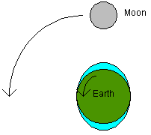

In this diagram, you can see that the moon's gravitational force pulls on water in the oceans so that there are "bulges" in the ocean on both sides of the planet. The moon pulls water toward it, and this causes the bulge toward the moon. The bulge on the side of the Earth opposite the moon is caused by the moon "pulling the Earth away" from the water on that side.

If you are on the coast and the moon is directly overhead, you should experience a high tide. If the moon is directly overhead on the opposite side of the planet, you should also experience a high tide.

During the day, the Earth rotates 180 degrees in 12 hours. The moon, meanwhile, rotates 6 degrees around the earth in 12 hours. The twin bulges and the moon's rotation mean that any given coastal city experiences a high tide every 12 hours and 25 minutes or so.

Stick on data for ‘Moon’ plate

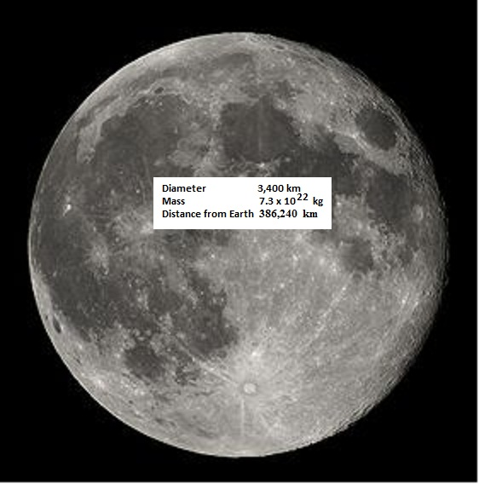

Stick on data for ‘Earth’ plate
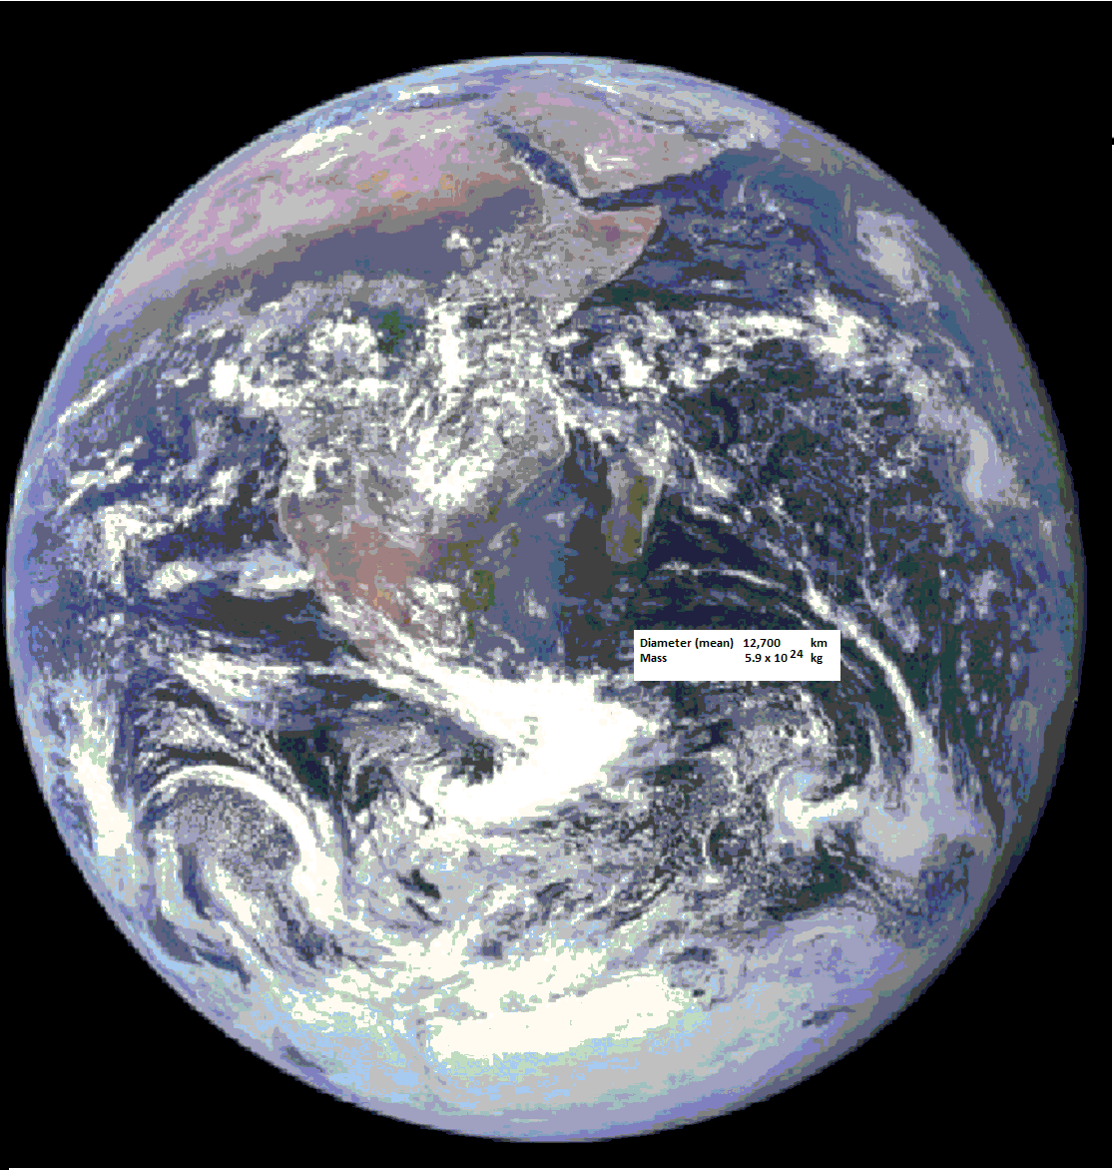

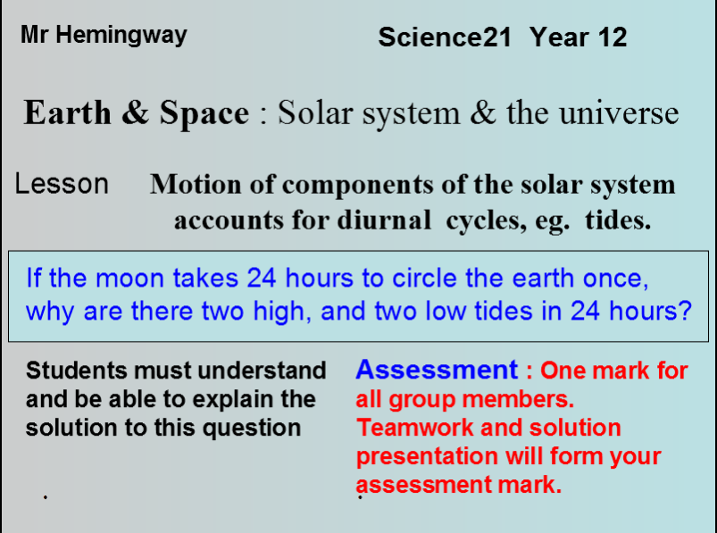

Presented on 13th April 2010

Description of Concept :
Unit : Earth & Space : Solar system & the universe
Topic : Motion of components of the solar system accounts for diurnal cycles eg. tides

The moon orbits the earth and has a significant effect on the ocean tides. Intuitively we might think that there would be one high and one long low tide for every lunar rotation, but most coastal areas will experience two high and two low tides for every one rotation of the moon about the earth.

Key Learning :
Students must understand and be able to explain how most coastal areas experience two high and two low tides for every lunar rotation.

Summary of Activity :
Introduction (set of 4 powerpoint slides)
- I stated the Unit and Topic titles, in order to allow the students to position the lesson in the overall course framework
- Presented the concept in the form of a question
- Explained what I expected the students to understand and be able to do by the end of the lesson
- Explained how each student will be assigned an assessment symbol
Activity
- The students formed two groups
- Each group was given a folder with activity items inside
- 2D model of Earth, and Moon
- green circular ocean sheet
- blue wool representing the surface of the ocean
- three force arrows (of different lengths)
- Blu-Tac to hold the items in place
and given 5 minutes to work out a ‘group’ solution to the Key Learning question.
- One member of each group (selected by me) presented their group solution to the class
- This was followed by question time and then
Conclusion
- I concluded by demonstrating / (possibly re-voicing) the accepted solution and stating what we would be covering in the next lesson.

The Concept Explained :
Consider three bodies of mass ...
- The water body closest to the moon (sub-lunar point)
- The earth
- The water body furthest from the moon (anti-podal point)

The body of water at 1 is attracted the strongest and moves to this new position ...
The earth is also attracted, but with a lesser force, so moves towards the moon but not as much ...
The body of water at 3 is also attracted, but with a weaker force than the earth, so moves towards the moon but again to a lesser extent...
Which results in the buldge (high tide) at 1, and a second buldge (high tide) at 3.
So with one revolution of the moon around the earth, each port will experience two high tides - the one when it is at the sub-lunar position, and the second when at the anti-podal position.

Reflection on the demonstration :
- the topic needed a whole 60 minutes to cover properly
- the post-grads had trouble with the concept as presented, so what would the year 8’s have done ?
- the lesson flow was good, with group investigations, but the students were not keen to stand up and explain their solutions
- there was a lot of confusion in the class about tides and moon orbit - this needs more explanation before tackling the issue of two high tides
- the instructions (or lack of) with the activity folders slowed the students. They were unsure what some of the props represented.
- three of the seven post-grads were confused by the equation for gravitational attraction. At the year 8 and 9 level, I would describe the attraction as being stronger the closer the two objects are, and the weaker the further away they are - leaving the equation and inversely proportional to the square of the distance, for a later lesson. This would simplify the conceptual understanding of differential attraction due to distance from the moon.
- I believe this topic is appropriate for a junior science class, but more scaffolding on gravitational attraction (without equations), and the activity items, would be required.
- Specifically in this demonstration of 13th April 2010 I believe I only partially succeeded with the lesson. All students came away with increased knowledge and understanding of the moon’s orbit and effect on our ocean tides, BUT I failed to get ALL of them to understand how gravitational attraction works, and how this force is acting on the earth and oceans to effect the tides. The reason being the limited time available, and not simplifying the gravitational equation, as well as not explaining the items inside the activity folders.

Analysis of feedback sheets
The first section was a ‘tick the box’ section, with Disagree to Agree
The presentation was clear and easy to follow | - | - | 2 | 2 | 3
The presentation was well timed & included time for queries * | - | - | - | 4 | 2
The concept being addressed was introduced suitably | - | - | 1 | 3 | 3
The concept was clearly explained & well structured | - | - | 3 | 1 | 3
The questions checked my understandings suitably | - | - | 2 | - | 5
The audience was actively involved in the activity | - | - | - | 1 | 6
The presentation used an inquiring pedagogy | - | - | - | 2 | 5
The activity was interesting and motivating. | - | - | - | 2 | 5
The activity was pitched appropriately for a Science 21 course. | - | - | 2 | 2 | 3
Totals | - | - | 10 | 17 | 35
* there was one no comment

Comments provided :
Person 1 | Great overall no need for comments. Great questions. Got us thinking on our prior & current knowledge and what we didn’t know.
Person 2 | Assessment not clear. Great job mate. Maybe need more instructions at start of activity.
Person 3 | Good board work. Lost me with the forces equation.
Person 4 | I was a bit confused with all the equations, but great presentation! Good eye contact, confident, well done.
Person 5 | Could have spent more time explaining the force equation. Great group demonstration.
Person 6 | Very good activity - allowed students a hands on approach. Clear voice - friendly approach (apart from assessment). Items inside activity not clear for year 8 level (ie vector lines) Great use of group work with presentation. Very clear final explanation.
Person 7 | Bit above my head but allowed a lot student inquiry & investigation.

It appears the class enjoyed the presentation style and content, but found the lack of explanation of the gravitational attraction equation, and activity items, a significant omission. If this was to be presented to a class living inland, I would spend more time discussing and describing the oceans, tides etc.

Reflective evaluation of project (with reference to PISA definition of scientific literacy)
In terms of scientific literacy, and how it relates to the definition with the 2006 PISA document ^{(see References)} I believe the following applies :

- “Scientific knowledge and use of that knowledge to identify questions, acquire new knowledge, explain scientific phenomena and draw evidence-based conclusions about science-related issues” - this demonstration and topic allows for acquisition of scientific knowledge, explanation and conclusions on evidence taken from real world situations.
- “Awareness of how science and technology shape our material, intellectual, and cultural environments” - understanding of this topic, the science behind tides and ocean flows, and how this relates to lunar activity, is crucial for many cultures that rely on the sea for a living, or simply exist on a coastal region.
- “Scientific literacy is the capacity to use scientific knowledge, to identify questions and to draw evidence-based conclusions in order to understand and help make decisions about the natural world and the changes made to it through human activity” - this demonstration and topic aligns directly with this definition of scientific literacy. It looks at empirical evidence from natural phenomena and allows for scientific reasoning to make assumptions about the natural world, that can be tested against the evidence.

Therefore I believe this presentation and topic align well with the definitions of scientific literacy as given in the 2006 PISA framework, covering areas of evidence-based, natural world, cultural environments, science-related issues, knowledge and explanations.

References
Assessing Scientific, Reading and Mathematical Literacy A Framework for PISA 2006

Box 1.2 • PISA 2006 Scientific literacy
For the purposes of PISA 2006, scientific literacy2 refers to an individual’s:
• Scientific knowledge and use of that knowledge to identify questions, acquire new knowledge, explain scientific phenomena and draw evidence-based conclusions about science-related issues
• Understanding of the characteristic features of science as a form of human knowledge and enquiry
• Awareness of how science and technology shape our material, intellectual, and cultural environments
• Willingness to engage in science-related issues and with the ideas of science, as a reflective

Scientific literacy is the capacity to use scientific knowledge, to identify questions and to draw evidence-based conclusions in order to understand and help make decisions about the natural world and the changes made to it through human activity. (Oe , 1999, 2000, 2003a)

For purposes of assessment, the PISA 2006 definition of scientific literacy may be characterised as consisting of four interrelated aspects:
• Context: recognising life situations involving science and technology.
• Knowledge: understanding the natural world on the basis of scientific knowledge that includes both knowledge of the natural world, and knowledge about science itself.
• Competencies: demonstrating competencies that include identifying scientific issues, explaining phenomena scientifically, and drawing conclusions based on evidence.
• Attitudes: indicating an interest in science, support for scientific enquiry, and motivation to act responsibly towards, for example, natural resources and environments.

