Robert Hemingway Science21 Assignment 1
s42290427
Presented on 13th April 2010

Description of Concept :
Unit : Earth & Space : Solar system & the universe
Topic : Motion of components of the solar system accounts for diurnal cycles eg. tides

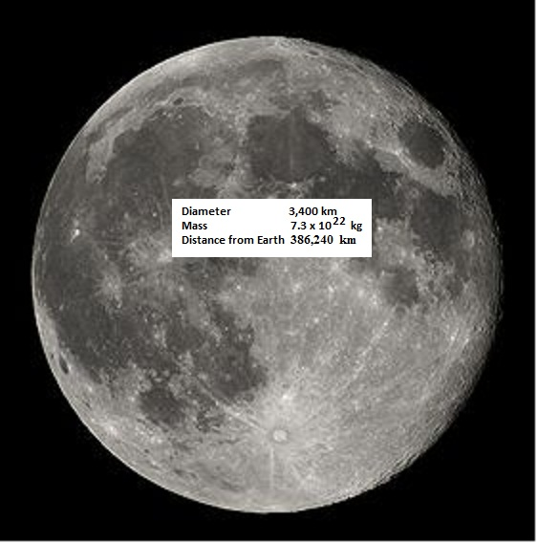

The moon orbits the earth and has a significant effect on the ocean tides. Intuitively we might think that there would be one short high and one long low tide for every lunar rotation, but most coastal areas will experience two high and two low tides for every one rotation of the moon about the earth.

Key Learning :
Students must understand and be able to explain how most coastal areas experience two high and two low tides for every lunar rotation.

Summary of Activity :
Introduction (set of 4 powerpoint slides)
- I stated the Unit and Topic titles, in order to allow the students to position the lesson in the overall course framework
- Presented the concept in the form of a question needing investigation.
- Explained what I expected the students to understand and be able to do by the end of the lesson
- Explained how each student will be assigned an assessment symbol
- Briefly went over required prior knowledge
- the lunar orbit
- the gravitational force equation
- addition and resolution of forces
Activity (with folder items described below)
- The students formed two groups
- Each group was given a folder with activity items inside
- separate 2D model of Earth, and Moon
- green circular ‘ocean’ sheet
- blue wool representing the surface profile of the ocean
- three force arrows (of different lengths)
- Blu-Tac to hold the items in place
and given 5 minutes to work out a ‘group’ solution to the Key Learning question.
- One member of each group (selected by me) presented their group solution to the class
- This was followed by question time and then the conclusion to the lesson.
Conclusion
- I concluded by explaining and demonstrating the “scientifically accepted” solution and stating what we would be covering in the next lesson.

The Concept Explained :
Consider three bodies of mass ...
- The water body closest to the moon (sub-lunar point)
- The earth
- The water body furthest from the moon (anti-podal point)

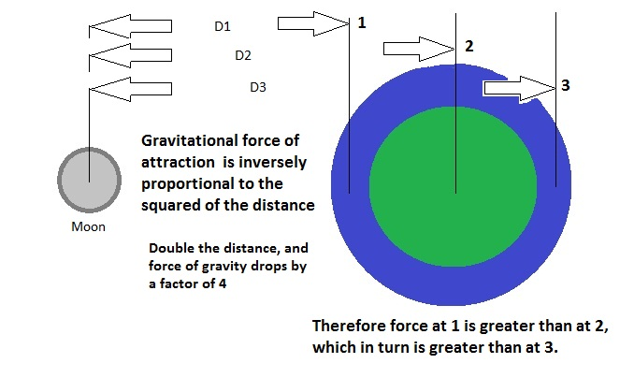
The body of water at 1 is attracted the strongest and moves to this new position ...
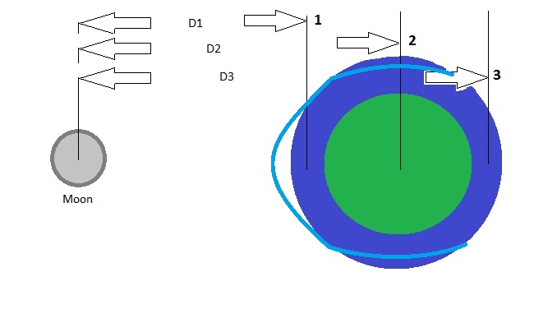
The earth is also attracted, but with a lesser force, so moves towards the moon but not as much ...
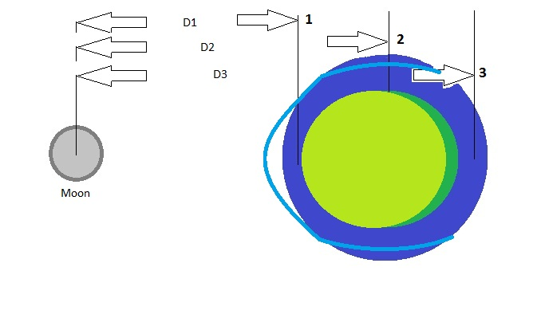
The body of water at 3 is also attracted, but with a weaker force than the earth, so moves towards the moon but again to a lesser extent...
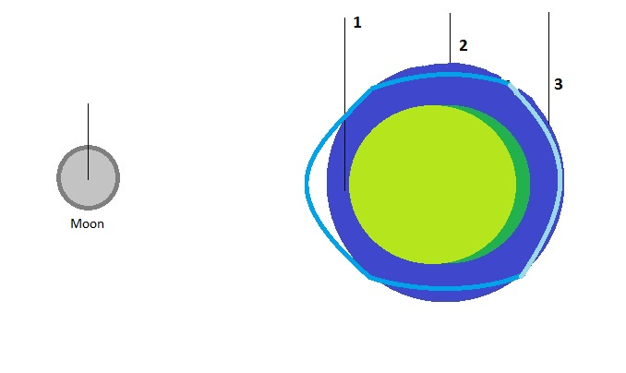
Which results in the buldge (high tide) at 1, and a second buldge (high tide) at 3.
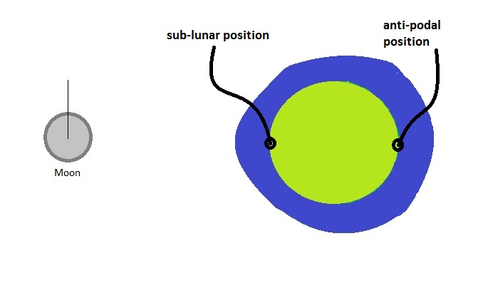
So with one revolution of the moon around the earth, each port will experience two high tides - the one when it is at the sub-lunar position, and the second when at the anti-podal position.

Reflection on the demonstration :
- the topic needed more time to cover properly
- the post-grads had trouble with the concept as presented, so what would the year 8’s to year 12’s have done ?
- the lesson flow was good, with group investigations, but the students were not keen to stand up and explain their solutions
- there was a lot of confusion in the class about tides and moon orbit - this needs more explanation before tackling the issue of two high tides
- the instructions (or lack of) with the activity folders slowed the students. They were unsure what some of the props represented.
- three of the seven post-grads were confused by the equation for gravitational attraction. At the year 8 and 9 level, I would describe the attraction as being stronger the closer the two objects are, and the weaker the further away they are - leaving the equation and inversely proportional to the square of the distance, for a later lesson. This would simplify the conceptual understanding of differential attraction due to distance from the moon.
- I believe this topic is appropriate for a junior science class, but more scaffolding on gravitational attraction (without equations), and the activity items, would be required.
- Specifically in this demonstration of 13th April 2010 I believe I only partially succeeded with the lesson. All students came away with increased knowledge and understanding of the moon’s orbit and effect on our ocean tides, BUT I failed to get ALL of them to understand how gravitational attraction works, and how this force is acting on the earth and oceans to effect the tides. The reason being the limited time available, and not simplifying the gravitational equation, as well as not explaining the items inside the activity folders.

Analysis of feedback sheets
The first section was a ‘tick the box’ section, with Disagree to Agree
The presentation was clear and easy to follow | - | - | 2 | 2 | 3
The presentation was well timed & included time for queries * | - | - | - | 4 | 2
The concept being addressed was introduced suitably | - | - | 1 | 3 | 3
The concept was clearly explained & well structured | - | - | 3 | 1 | 3
The questions checked my understandings suitably | - | - | 2 | - | 5
The audience was actively involved in the activity | - | - | - | 1 | 6
The presentation used an inquiring pedagogy | - | - | - | 2 | 5
The activity was interesting and motivating. | - | - | - | 2 | 5
The activity was pitched appropriately for a Science 21 course. | - | - | 2 | 2 | 3
Totals | - | - | 10 | 17 | 35
* there was one no comment

Comments provided :
Person 1 | Great overall no need for comments. Great questions. Got us thinking on our prior & current knowledge and what we didn’t know.
Person 2 | Assessment not clear. Great job mate. Maybe need more instructions at start of activity.
Person 3 | Good board work. Lost me with the forces equation.
Person 4 | I was a bit confused with all the equations, but great presentation! Good eye contact, confident, well done.
Person 5 | Could have spent more time explaining the force equation. Great group demonstration.
Person 6 | Very good activity - allowed students a hands on approach. Clear voice - friendly approach (apart from assessment). Items inside activity not clear for year 8 level (ie vector lines) Great use of group work with presentation. Very clear final explanation.
Person 7 | Bit above my head but allowed a lot student inquiry & investigation.

It appears the class enjoyed the presentation style and content, but found the lack of explanation of the gravitational attraction equation, and activity items, a significant omission. If this was to be presented to a class living inland, I would spend more time discussing and describing the oceans, tides etc. More time, better instructions and simplify the math !

Reflective evaluation of project (with reference to PISA definition of scientific literacy)
In terms of scientific literacy, and how it relates to the definition with the 2006 PISA document ^{(see References)} I believe the following applies :

- “Scientific knowledge and use of that knowledge to identify questions, acquire new knowledge, explain scientific phenomena and draw evidence-based conclusions about science-related issues” - this demonstration and topic allows for acquisition of scientific knowledge, explanation and conclusions on evidence taken from real world situations.
- “Awareness of how science and technology shape our material, intellectual, and cultural environments” - understanding of this topic, the science behind tides and ocean flows, and how this relates to lunar activity, is crucial for many cultures that rely on the sea for a living, or simply exist on a coastal region.
- “Scientific literacy is the capacity to use scientific knowledge, to identify questions and to draw evidence-based conclusions in order to understand and help make decisions about the natural world and the changes made to it through human activity” - this demonstration and topic aligns directly with this definition of scientific literacy. It looks at empirical evidence from natural phenomena and allows for scientific reasoning to make assumptions about the natural world, that can be tested against the evidence.

Therefore I believe this presentation and topic align well with the definitions of scientific literacy as given in the 2006 PISA framework, covering areas of evidence-based work, natural world phenomena, cultural environments issues, science-related issues, knowledge and explanations through inquiry.

References

Tony Wright invaluable assistance on determining the ‘accepted scientific explanation’
Wikipedia Tides site http://en.wikipedia.org/wiki/Tide
YouTube video http://www.youtube.com/watch?v=CTQ6ciHENgI biscuit, plate explanation

Assessing Scientific, Reading and Mathematical Literacy A Framework for PISA 2006

Box 1.2 • PISA 2006 Scientific literacy
For the purposes of PISA 2006, scientific literacy2 refers to an individual’s:
• Scientific knowledge and use of that knowledge to identify questions, acquire new knowledge, explain scientific phenomena and draw evidence-based conclusions about science-related issues
• Understanding of the characteristic features of science as a form of human knowledge and enquiry
• Awareness of how science and technology shape our material, intellectual, and cultural environments
• Willingness to engage in science-related issues and with the ideas of science, as a reflective

Scientific literacy is the capacity to use scientific knowledge, to identify questions and to draw evidence-based conclusions in order to understand and help make decisions about the natural world and the changes made to it through human activity. (Oe , 1999, 2000, 2003a)

