Soil
Jamie Fryrear
How does global warming affect the soil via melting ice sheets? When the temperature increases it thaws the frozen water that is underground. This thawing causes changes in the soil structure. The soil can lose the nutrients it has making it less fertile for future plants to grow. The change in the soil can also affect the diversity in the ecosystem. Many different types of species rely on a certain type of habitat. If their habitat is damaged due to either the thawing or freezing of the soil then it can be detrimental to the ecosystem.

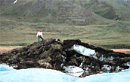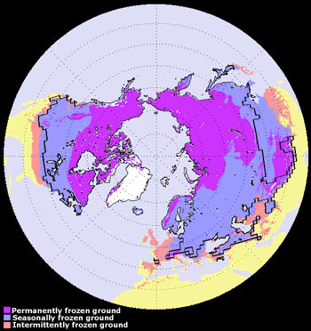
The image above shows the distribution of permafrost and average maximum extent of seasonally and intermittently frozen ground in the Northern Hemisphere. "Seasonally frozen ground" (blue regions) refers to those areas where soil is frozen for 15 days or more per year, while "intermittently frozen ground" (pink regions) refers to areas where the soil is frozen for fewer than 15 days per year. The solid line indicates the average maximum extent of the seasonal snow cover. Permafrost occupies about 22.79 million km-squared or 23.9 percent of the exposed land surface. On average, the maximum extent of seasonally frozen ground is about 55 million km-squared or 55 percent of the total land area, while the maximum snow cover extent is about 47 million km-squared or about 47 percent of the total land surface in the Northern Hemisphere.

Additionally, the continued freezing and thawing of the soil affects the decomposition of leaves and branches thus changing the amounts of carbon being put back into the soil or being put back into the atmosphere. When the ground is frozen the gases are only released in small amounts but when the grounds thaw, the amount of gases released increases. These gases are known as the Greenhouse Gases.
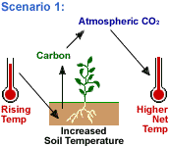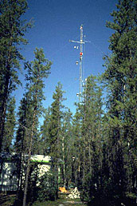

When water and ice in the ground thaw, the ground and soil can take on different shapes and forms. Ice can push the soil up to form hills and humps. This then can cause landslides, rockslides and mudslides.
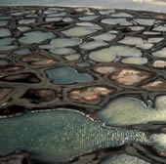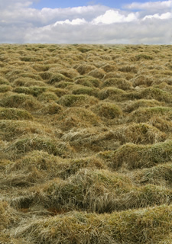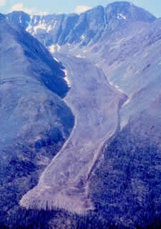

Resources:
http://nsidc.org/frozenground/how_fg_affects_land.html
http://earthobservatory.nasa.gov/Features/FrozenSoils
http://earthobservatory.nasa.gov/Features/DirtCarbon

E>L: Melting ice sheets changes the structure of the soil
E>L>B: Melting ice sheets affects the nutrients in the soil leading to more or less animals and plants in the region.
E>A>H>L>B: Melting ice sheet leads to more or less water in the atmosphere. This then affects the water cycle and how much precipitation a region might receive. The melting ice sheets also affects the soils and soil erosion which then affects the plants and animals.

