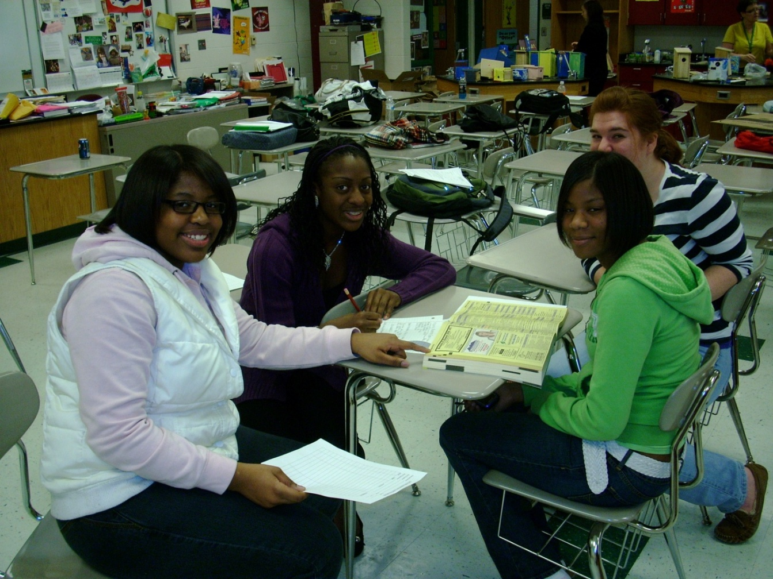

HSTA Ladies plan fashion show