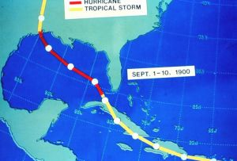

Reflection – Marijane Recob
Galveston Hurricane 1900

Galveston, Texas, was on the rise in 1900. With a population of nearly 37,000 it was a major seaport for shipping cotton and it was in a race with Houston for prominence on the Texan coast. Sixteen foreign country consulates and millionaires' mansions graced the city.

. In late August and early September a tropical storm tracked across the Caribbean Sea and passed between Cuba and Florida. Many believed the storm would turn to the northeast as it passed the Florida Straits north of Cuba. This was a commonly accepted notion of how tropical cyclones were supposed to behave. It was unheard of for them to continue to the west.

However, after passing through the Florida Straits the storm turned to the northwest. The hurricane pushed a wall of water over 15 feet deep onto the island that, at its highest point, was only 8.7 feet above sea level. The wind whipped through Galveston at what was later estimated to be Category 4 speeds (131-155 mph). A 150 mph gust would have a pressure of 100 pounds per square foot. The lowest barometric pressure recorded during the storm was 28.44 inches. (NOAA later estimated that the pressure near the storm's eye was probably closer to 27.49 inches.) This was the deadliest hurricane to ever hit the United State and more than 6,000 people perished although some estimates were as high as 12,000.

According to the National Hurricane Center (NHC), which forecasts, tracks and records information about hurricanes, the storm is tied for the seventh most intense U.S. hurricane with a minimum central pressure of 931 millibars, or 27.49" of mercury. By mid-afternoon on Sept. 8, high water forced in from the hurricane had washed out the four bridges to the mainland, downed telephone lines and flooded the entire island, cutting Galveston off from the mainland.

. 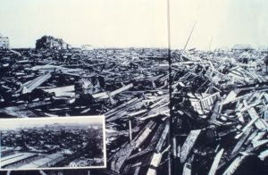

Galveston is now protected by a huge levee system to guard against future storms. Also, after the disaster, a six-mile long seawall was erected and has since been extended and the island was raised by pumping sand from the floor of the Gulf of Mexico.

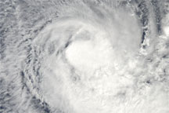

Sphere-Event

A>E Atmospheric moisture from seawater evaporation combines with heat and energy

A>E Wind pattern must be near ocean surface to spiral air inward

A>E Low atmospheric pressure moves over ocean
Hurricanes begin when areas of low atmospheric pressure move off Africa and into the Atlantic, where they grow and intensify in the moisture-laden air above the warm tropical ocean. Air moves toward these atmospheric lows from all directions and curves to the right under the influence of the Coriolis effect, thereby initiating rotation in the converging windfields. When these hot, moist air masses meet, they rise up into the atmosphere above the low pressure area, potentially establishing a self-reinforcing feedback system that produces weather systems known to meteorologists as tropical disturbances, tropical depressions, tropical storms, and hurricanes.

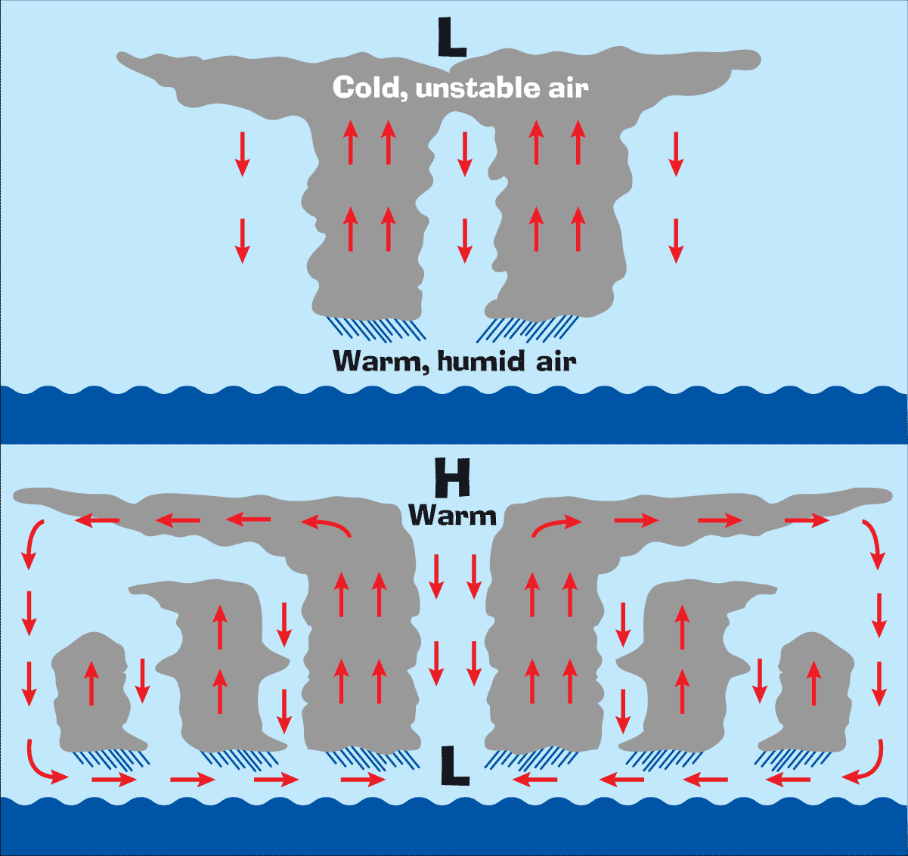

Event-Sphere

E>A>H Decrease of barometric pressure causes air to rise
In an area of low pressure the air has a tendency to rise. This general upward motion means that there is less pressure from the air pulling down on the earth, in other words there is low pressure. As air rises, it cools and if there is enough water vapour it may condense to form clouds and rain.

E>A Increase moisture in air
Harvard University scientists have discovered that tall clouds in hurricanes can add moisture to the stratosphere and increase global warming, which in turn can cause hurricanes to get stronger, adding more moisture to the stratosphere
Researchers David M. Romps and Zhiming Kuang found that water vapor in the stratosphere has increased 50% over the last 50 years. They believe it's because strong hurricanes have very tall clouds which can punch into the stratosphere.

E>A>L High winds causing flooding/erosion
The only constant in beach geology is constant change. When storms come to the coast, the sand sharing system responds by extending both landward and seaward of the intertidal beach. Routine storms erode the beach and carry sand offshore, where subsequent periods of small waves gradually carry it back to the beach. the only constant in beach geology is constant change. When storms come to the coast, the sand sharing system responds by extending both landward and seaward of the intertidal beach..

E>A>L>B High winds and increased rainfall can cause flooding/landslides endangering plants/animals

E>B>A Increase of plankton causing absorption in carbon dioxide-plankton die, drift to ocean floor allowing carbon to go to deep ocean

E>B>A kill/damage trees.
Decomposition releases millions of tons of carbon dioxide into atmosphere

Reference:

- http://www.nasa.gov/centers/goddard/news/topstory/2004/0817trmmhurricane.html
- http://kids.earth.nasa.gov/archive/hurricane/creation.html
- http://www.nasa.gov/mission_pages/hurricanes/main/index.html
- http://www.cpo.noaa.gov/education/hurricanes/hurricane_basics.pdf
- http://www.sciencenews.org/view/generic/id/43244/title/Climatic_effects_of_tree-killing_hurricanes
- http://earthobservatory.nasa.gov/Newsroom/view.php?id=21142
- http://www.learnnc.org/lp/editions/cede_hurricanes/148
- http://www.nhc.noaa.gov/HAW2/english/history.shtml
- http://science.howstuffworks.com/hurricane2.htm

