EVENT - ICE SHEET MELTING
Hydrosphere
ESS Analysis

Resources:

NASA Goddard Space Flight Center
NG1 - http://www.gsfc.nasa.gov/topstory/20020606greenland.html
NG2 - http://www.nasa.gov/centers/goddard/news/topstory/2008/greenland_speedup.html
NG3 - http://www.nasa.gov/centers/goddard/news/topstory/2003/1023esuice.html

NASA
N1 - http://www.nasa.gov/vision/earth/environment/cryosphere.html
N2 - http://www.nasa.gov/topics/earth/features/greenland_temps.html

National Public Radio (NPR) – Science Friday
NPR - http://www.sciencefriday.com/pages/2006/Jun/hour1_060206.html

We are the Weathermakers
WATW - http://www.theweathermakers.org/

EHOW
EHOW - http://www.ehow.com/how-does_4741329_ice-affect-ocean-water-levels.html

GREENPEACE
GP - http://archive.greenpeace.org/climate/arctic99/reports/seaice3.html

ECOLOGY.COM
ECOL - http://ecology.com/featuresarchive/earthwarms/

GREENFACTS.ORG

GF - http://www.greenfacts.org/en/arctic-climate-change/l-2/3-sea-level-rise.htm

WOODS HOLE OCEANOGRAPHIC INSTITUTION
WO - http://www.whoi.edu/page.do?pid=12317

E > H > H (Ice sheet melting creates melt water which results in increased ice sheet velocity)

Using periodic Global Positioning Satellite measurements from 1996 through 1999, the researchers discovered that the ice flow speeds up from 31.3 cm (12.3 inches) per day in winter to a peak of 40 cm (15.7 inches) per day in the summer when surface melting is largest. "This study demonstrates that surface meltwater travels quickly through the 1200 meter (approx. 3/4 mile) thick ice to the bedrock to make the ice slide faster. This process was known for decades to enhance the flow of small mountain glaciers, but was not known to occur in the large ice sheets,"
The meltwater makes its way from the surface to the bedrock by draining into crevasses and large tunnels called moulins that may be as large as 10 meters (approx. 33 feet) in diameter. More meltwater underneath the ice sheet provides lubrication to allow the ice sheet to move faster toward the coastline of Greenland.
Over time, as ice melts from the top of the ice sheet, the ice thins and spreads out toward lower elevations closer to the coast.
The meltwater also carries heat (in the form of water) from the top of the ice to the base of the ice that sits on the bedrock.
A separate study by Abdalati and Konrad Steffen of the University of Colorado showed that the melting of the ice sheet surface has been increasing at a rate of nearly 20% over the last 21 years, while summer temperatures in that same period have increased by one quarter of a degree Celsius (.45º Fahrenheit). The link between ice sheet melt and ice flow suggest that the increasing melt may be more significant than previously believed.
The faster ice flow, ice thinning and consequent lowering of the surface elevation of the ice sheet can open a feedback to more melting that has not been considered in computer models that predict ice sheet response to climate change. (NG1)

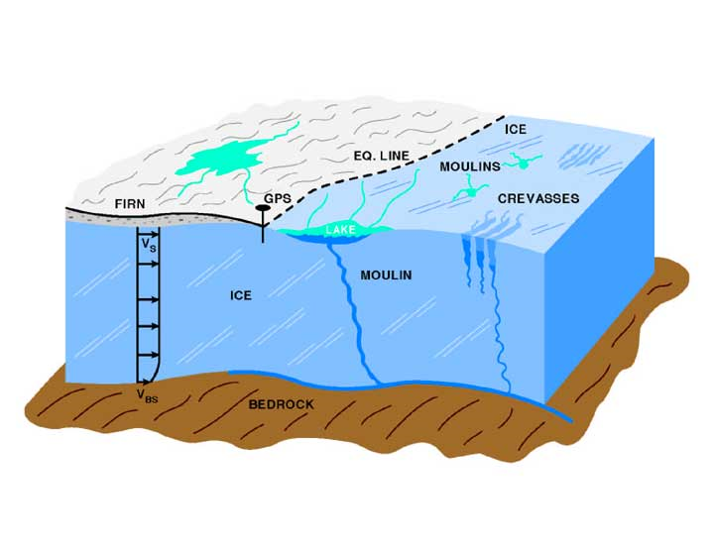
This schematic highlights glaciological features of the ice sheet including surface lakes, crevasses, and large openings called moulins, that stretch up to 10 meters in diameter and drain to the bedrock. Meltwater descends through the moulins, down to the bedrock, contributing to the movement of the ice sheet. The Equilibrium Line (EQ LINE), similar to a snow line on the glacier, is at about 1200 meters elevation in west-central Greenland. In the ablation zone below the EQ LINE, all the winter snow plus some of the ice flowing from higher elevations melts each summer. "GPS" is the marker where the "Global PositioningSystem" was located to observe the movement of the ice sheet. The "V" indicates the velocity of the movement of the ice, some of which is from sliding over the bedrock.
Their first-of-a-kind observations confirm the structure of the Greenland Ice Sheet plumbing, and go further to show that summertime melt indeed contributes to the speed up of ice loss. They also conclude, however, that summertime melt is not as critical a factor as other causes of ice loss. Research by Joughin and colleagues, published April 17 in Science Express, was funded in part by NASA and the National Science Foundation. (NG2)
Scientists have used computer models to show how melt could contribute to the observed speed up of the ice sheet. Meltwater travels through cracks in the ice down to the base of the mile-thick ice sheet where it forms a lubricating layer between the ice and the land. The fluid layer then makes it easier for the ice to slip away toward the ocean. The effect, however, had never been observed in Greenland on a large-scale, a fact that motivated Joughin and colleagues to get a closer look. (NG2)

