Commentary:
Students should learn about probability as a measurement of the likelihood of events (NCTM, 2000). Opportunities to explore simple experiments using spinners or number cubes develop the foundation for identifying and understanding possible outcomes. In grade five, students are expected to relate likelihood to 0 (impossible), 1 (certain) and the ratios in between. They should use these ratios to quantify the likelihood of events in real-world applications.

Pre-Assessment:
The pre-assessment is based on the grades three and four grade-level indicators in the Mathematical Academic Content Standards for Data Analysis and Probability. Students conduct simple probability experiments and list and count possible combinations.
Distribute Tricky Trio, Attachment A and/or Picnic Possibilities, Attachment B to each student.

Instructional Tip:
The two attachments have very different levels of difficulty. Attachment B has much more sophisticated vocabulary and tasks, choose to do “A and/or B”, depending on which will serve the needs best.

Have students complete the task to demonstrate their level of understanding of counting and listing all possible outcomes in a given situation.
Observe the methods students use to create the list of outcomes. Students may choose to use lists, tree diagrams, arrays, pictures or invented counting methods.
Collect the papers to determine instruction and intervention and compare to post-assessment to show growth in student understanding.
Ohio Standards Connection

Data Analysis and Probability

Benchmark H
Find all possible outcomes of simple experiments or problem situations, using methods such as lists, arrays and tree diagrams.

Indicator 7
List and explain all possible outcomes in a given situation.

Benchmark I
Describe the probability of an event using ratios, including fractional notation.

Indicators
8. Identify the probability of events within a simple experiment, such as three chances out of eight.

9. Use 0, 1 and ratios between 0 and 1 to represent the probability of outcomes for an event, and associate the ratio with the likelihood of the outcome.

Benchmark J
Compare experimental and
theoretical results for a variety of simple experiments.

Indicator 10
Compare what should happen (theoretical/expected results) with what did happen (experimental/actual results in a simple experiment.

Lesson Summary:
Students list and explain all possible outcomes using a tree diagram while exploring simple probability experiments. Students rotate through stations experimenting with games, recording experimental results, and then determining the theoretical probability. Students analyze the games and determine if the games are fair or if the games favor a player.

Estimated Duration: Four hours

Ohio Standards Connection

Mathematical Processes Benchmarks:

E. Use deductive thinking to construct informal arguments to support reasoning and to justify solutions to problems.
F. Inductive thinking to generalize a pattern of observations for particular cases, make conjectures, and provide supporting arguments for conjectures.
H. Use representations to organize and communicate mathematical thinking and problem solutions.
K. Recognize and use mathematical language and symbols when reading, writing and conversing with others.

Scoring Guidelines:
Use Pre-Assessment Rubrics, Attachment C to assess student
level of understanding and need for intervention.

Post-Assessment:
- Distribute Game Design, Attachment J.
- Explain to the students that they are to design a game or redesign a game from the lesson. The game can be a number card game, number cube game, spinner game, chip game or anything else that is available.
- Instruct students that they can either create game pieces or use pre-constructed materials for the game.
- Show examples of rules that explain playing and winning the game. Limit the playing time and number of rules and make the rules easy to understand.
- Suggest that students use rules from other games they have at home.
- Allow students to experiment with the game. Play the game enough times to predict the outcome of the game. Record the results after each round for ease of prediction.
- Ask students to re-evaluate and adjust the game pieces or rules as needed.
- Review the rubric with the students. Stress that the most important part of the game design is writing a report on the probability of winning the game. In their reports, students need to include their experimental results and accurate tree diagrams or arrays displaying the possible outcomes of the game.

Instructional Tips:
- This activity works well in groups of three or four, but can be adapted for individuals or pairs. Another option is for students to work in groups to design the game then complete the written work individually.
- Students need to have access to mathematical materials (rulers, geometric templates, spinners, number cubes, etc.) and construction materials (glue, tape, note cards, computers, etc).
- This activity may take several class periods to complete. Another option is to spend one day going over the requirements, allowing students to get started and requiring them to complete the rest outside of class. Provide class time to assess progress and have students collaborate on the game.

Scoring Guidelines:
Use Post Assessment Scoring Guidelines, Attachment K to assess student understanding of probability. The rubric compares student performance to expectations. Develop a rubric with the students as an alternative. Make sure content and processes related to the Mathematics benchmarks and indicators are included.

Instructional Procedures:
1. Conduct pre-assessment activity.
2. Demonstrate how to complete a tree diagram using a simple game Spin Off, Attachment D.
a. Ask students questions such as:
- What are the possible outcomes for spinner one?
- Are the possible outcomes equally likely to occur?
Show students how to represent these possible outcomes in a tree diagram on the board or overhead projector.

Spinner 1 Spinner 2

A

B

- What are the possible outcomes for spinner number two? (C and D)
- Are the possible outcomes equally likely to occur? (Yes)
b. Pose scenarios to engage students in thinking about possible outcomes when spinning both spinners.
Let’s say we are going to play a game in which Player One gets one point if two consonants are spun and Player Two gets one point if a vowel and consonant are spun. Do both players have an equal chance of winning?
c. Have students discuss the chances of winning. Select students to share their thinking and explain their prediction. Explain the next step of the scenario.
Suppose Player One spins an A on the first spinner, Ask
- What could the player spin on the second spinner? (C or D)
- What are the possible combinations for the two spins?(AC or AD)
d. Draw the branches from A to C and A to D to complete the top half of the tree diagram.

Spinner 1 Spinner 2

C
A
B
D

e. Ask questions such as:
- Do both players have an equal chance of getting a point? (No) Describe the probability. (Player 2 is certain to get a point and Player 1 will never get a point.)
- If an A is spun what ratio/fraction represents the probability of spinning A and C? (one-half) A and D? (one-half) One way to represent a ratio is to compare a part to a whole, like a fraction. Discuss what the numerator and what the denominator each represent in terms of the ratio.
f. Pose a scenario to complete the bottom portion of the tree diagram.
Suppose Player Two spins a B on the first spinner.
- What are the possible combinations Player Two could spin with the second spinner?(BC and BD)
- Do both players have an equal chance of scoring a point when the first spinner is B? (No, there are no possible outcomes with a vowel.) Describe the probability for both players if B is spun on the first spinner. (It is certain Player 1 will win a point and it is impossible for Player Two to win a point.)
g. Complete the bottom half of the tree diagram. Draw lines from B to C and B to D.

Spinner One Spinner Two Possible Outcomes
A
B
D
C
D
C
AC

AD

BC

BD

h. Ask students questions to summarize the game. Have students discuss with a partner or in a small group. Select students to share their thinking with the class.
- Describe the probability for both players. (Both players have a fair chance to win.)
- What ratios/fractions represent each possible outcome? (one-fourth)
- What ratio/fraction represents Player One’s chances of winning? (one-half)
- What ratio/fraction represents Player Two’s chance of winning? (one-half)
- Modify the spinners so Player 1 has an unfair advantage to win.
3. Have the students alter the spinners and rules for Spin Off, Attachment D, and play the game ten times. In their mathematics journals, explain the task.
- Make a tree diagram for the new game.
- Describe the probability of each player winning.
- Represent the probability with a ratio.

Part Two (two days)
4. Set up four stations in the room. Name the stations Card Game, Spinner Game, Bag of Coins Game and Number Cube Game. (The games are designed for two players.) Make enough copies for each station to accommodate the number of students in the class. Place Discussion Questions, Attachment I, at each station.
- Card Game, Attachment E: Use index cards (cardstock or tag board, something that is not visible through both sides) and the shapes identified on the attachment to make the game cards. Use different colored index cards for each stack.
- Spinner Game, Attachment F: Make the spinners as seen on the attachment on card stock. Use clear spinners, a paper clip and pencil, or use a fastener and paper clip for the spinner.
- Bag of Coins Game, Attachment G: Use play money. Place one of each coin (penny, nickel, dime and quarter) in two bags.
- Number Cube Game, Attachment H: Label one number cube with the numerals zero, zero, three, five, seven and nine. Label a second number cube with the numerals one, two, four, six, eight and 10.
5. Write the terms “theoretical probability” and “experimental probability” on the board or place terms on cards for a word wall.
  - Ask students to suggest definitions for the two words. Students may relate the word experimental to science and doing an experiment. Suggest to students the results of a game played determine experimental probability.
  - Explain that a tree diagram shows what should happen and how often, and describes the theoretical probability of the game or experiment. It is how the game should turn out. For example,
If a coin was tossed the theoretical probability of landing heads-up is one-half and the theoretical probability of landing tails-up is one-half. Flipping the coin 10 times, the coin lands heads-up seven times and tails-up three times. The experimental probability for heads-up is seven out of 10 and for tails-up is three out of 10.
What is the theoretical probability of landing heads-up when flipping a coin 10 times? (five out of ten or one-half)
c. Explain to students that they are to compare the theoretical probability and the experimental probability in the games they are going to play. Ask students to compare the theoretical and experimental probabilities of the coin scenario.
6. Explain how to play each game. (Optional: Ask students to help demonstrate how to play each game.) Divide the class into four groups. Within the four groups, have students pair up. Assign each group to the different stations.
7. Explain the expectations for students.
- Record the outcome for each game and create a tree diagram for each game at the station.
- Determine the theoretical or experimental ratio for each player’s chance to win.
- Describe the probability of winning using appropriate mathematical language.
8. Direct students to reread the directions for the games and begin playing. Provide five minutes to play each game and 10 minutes to answer the questions on Discussion Questions, Attachment I, in their mathematics journals. Direct the groups through all of the stations, two games on the first day and two games on the second game. Circulate through the stations to address any concerns or questions.
Part Three
9. Lead a class discussion about each game. Have students use, Discussion Questions, Attachment I, to guide the discussion. Ask students to share the tree diagrams they created for each game with the class. Have students note any similarities or differences between the tree diagrams (theoretical) and their experimental results.
10. Assign the post-assessment activity. Add samples of students’ tree diagrams and comparisons of probabilities to a mathematics bulletin board.

Differentiated Instructional Support:
Instruction is differentiated according to learner needs, to help all learners either meet the intent of the specified indicator(s) or, if the indicator is already met, to advance beyond the specified indicator(s).
- Assign one game to each group to play and analyze the probabilities. The group creates a presentation to explain the game and analysis to the rest of the class.
- Design a new game or use a game that they have already played, but change the rules.
- The experiences in the lesson allow all students to have access to the same information to develop the concept of probability. Students are engaged in real-world experiences and motivated by the use of games. Different learning modalities are address throughout the lesson.

Extensions:
- For each of the games played, have the students calculate the probability of all the outcomes. Express the quantities as ratios.
- Create probability trees for events that have more than two types of possible outcomes in new situations.
- Use tree diagrams to make predictions about other events.

Home Connections:
- Ask students to research games that they enjoy playing at home and create tree diagrams to determine the probability of winning or not winning.
- Have students create tree diagrams showing the different combinations of choices that involve a situation at home. For example, ordering off menus, students could choose a main course, drink and dessert. What are all the possible meal combinations?
- Have parents play the games used in this lesson with their children at home.

Materials and Resources:
The inclusion of a specific resource in any lesson formulated by the Ohio Department of Education should not be interpreted as an endorsement of that particular resource, or any of its contents, by the Ohio Department of Education. The Ohio Department of Education does not endorse any particular resource. The Web addresses listed are for a given site’s main page, therefore, it may be necessary to search within that site to find the specific information required for a given lesson. Please note that information published on the Internet changes over time, therefore the links provided may no longer contain the specific information related to a given lesson. Teachers are advised to preview all sites before using them with students.

For the teacher: paper clips, mathematical tools (rulers, geometric templates, spinners, number cubes, coins, bags, etc.), construction materials (glue, tape, index cards, computers, etc.), card stock

For the student: spinners, construction materials (glue, tape, index cards, computers, etc.)

Vocabulary:
  - event
- experimental probability
- outcome
- probability
- theoretical probability
- tree diagram

Research Connections:

Arter, Judith and Jay McTighe. Scoring Rubrics in the Classroom: Using Performance Criteria for Assessing and Improving Student Performance. Thousand Oaks, Calif.: Corwin Press, 2001.

"BSCS Science: An Inquiry Approach." BSCS Biological Sciences Curriculum Study. 23 Dec. 2003 <http://63.225.114.218/bscsdotorg/curriculum/InquiryFAQs.htm>

Daniels, Harvey and Marilyn Bizar. Methods that Matter: Six Structures for Best Practice Classrooms. Me: Stenhouse Publishers, 2000.

Marzano, Robert J., Jane E. Pollock and Debra Pickering. Classroom Instruction that Works: Research-Based Strategies for Increasing Student Achievement, Alexandria, Va.: Association for Supervision and Curriculum Development, 2001.

National Council of Teachers of Mathematics. Principles and Standards for School Mathematics. Reston, Va.:2000.
Stiggins, Richard J. Student-Involved Classroom Assessment. Upper Saddle River, N.J.: Merrill Prentice Hall, 2001.

General Tips:
Allow students to spend time experimenting with the games. The more the students play and record the results of game, the closer they come to the theoretical probability of the game.

Attachments:
Attachment A, The Tricky Trio Pre-Assessment
Attachment B, Picnic Pre-Assessment
Attachment C, Pre-Assessment Rubrics
Attachment D, Spin Off
Attachment E, Card Game
Attachment F, Spinner Game
Attachment G, Bag of Coins Game
Attachment H, Number Cube Game
Attachment I, Discussion Questions
Attachment J, Game Design
Attachment K, Post-Assessment Scoring Guidelines
Attachment A
The Tricky Trio Pre-Assessment

Name: _______________________________ Date: _______________________

It’s time for the magical magicians—The Tricky Trio—to have their photos taken for the promotion of their tour this summer. The manager of The Tricky Trio wants the photographer to photograph all the possible ways the three members of the group could be arranged in a row to determine which order he likes best.

Your challenge…
List and count all possible ways The Tricky Trio could be ordered for their poster.

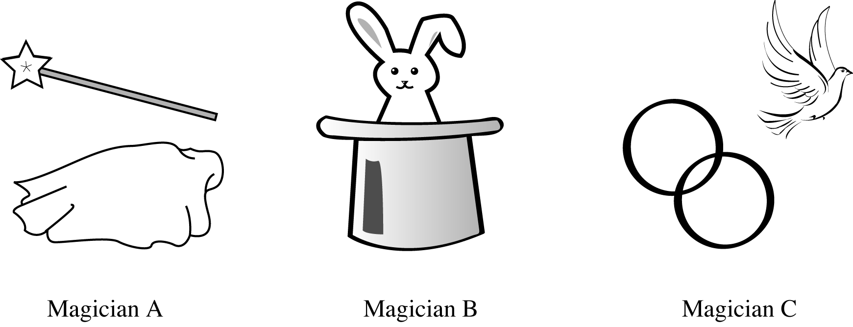

Examples of possible outcomes include:

Poster 1 Magician A | Magician B | Magician C
Poster 2 Magician B | Magician A | Magician C

Attachment B
Picnic Possibilities Pre-Assessment

Name _____________________ Date ______________

Directions: Read the scenario below and find all possible combinations.

Anna is going to a picnic. She has decided to bring hot dogs, a dessert and something to drink. Anna is at the grocery store and has a choice of foot-long hot dogs or bun-size hot dogs; a pie or cake for dessert; a cherry flavored drink, root beer, or cola to drink. Use a diagram, to find all the possible combinations.

Type of Hot Dog | Dessert | Drink
Foot-Long Hot Dog  Bun-Size Hot Dog | Pie  Cake | Cherry  Root Beer  Cola

Attachment C
Pre-Assessment Rubrics

The Tricky Trio Pre-Assessment Rubric
2  Ready for instruction | - Lists all possible outcomes correctly for the three members. Students may use their own notations to represent the three members. A key for notation may or may not be included. (123, 132, 213, 231, 312, 321 or ABC, ACB, BAC, BCA, CAB, CBA)  - Correctly identifies six possible arrangements.  - Demonstrates of a logical method for organizing and listing all possible combinations.
1  Monitor during lesson | - Correctly lists six possible arrangements.  or  - Provides a correct but incomplete list.  - Correctly lists all possible outcomes for the three members but the list is unorganized.
0  Intervention needed | - List is incomplete and inaccurate.  - Incorrectly states the number of outcomes.

Picnic Possibilities Rubric
2  Ready for Instruction | - Provides a complete list, diagram or other representation for counting all possible outcomes in an organized method.
1  Monitor during lesson | - Provides a partial list or diagram showing four to 10 correct combinations.  - Provides an incomplete but correct method for counting possible outcomes. For example: omits one of the drinks
0  Intervention needed | - Provides a limited diagram or list with fewer than three possible outcomes.  - Lists foot-long, pie and cherry drink and bun-sized, cake and root beer only.

Attachment D
Spin Off

Name_________________________ Date__________________________

Directions: Spin each spinner. Player 1 gets one point if two consonants are spun. Player 2 gets a point if a consonant and vowel are spun. Play the game 10 times.
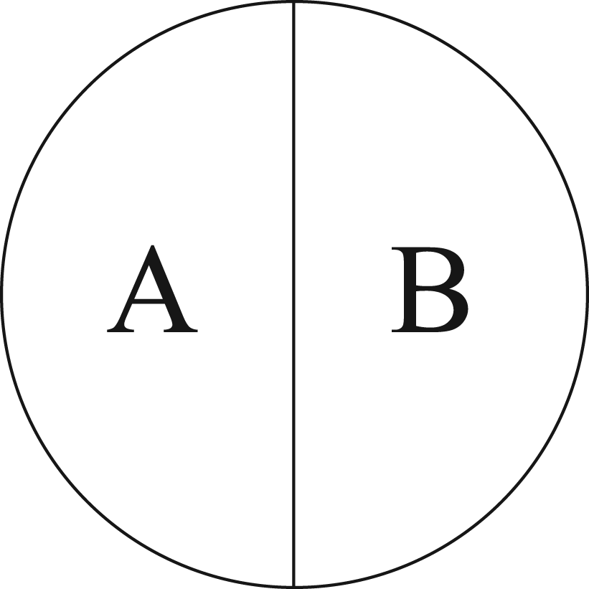
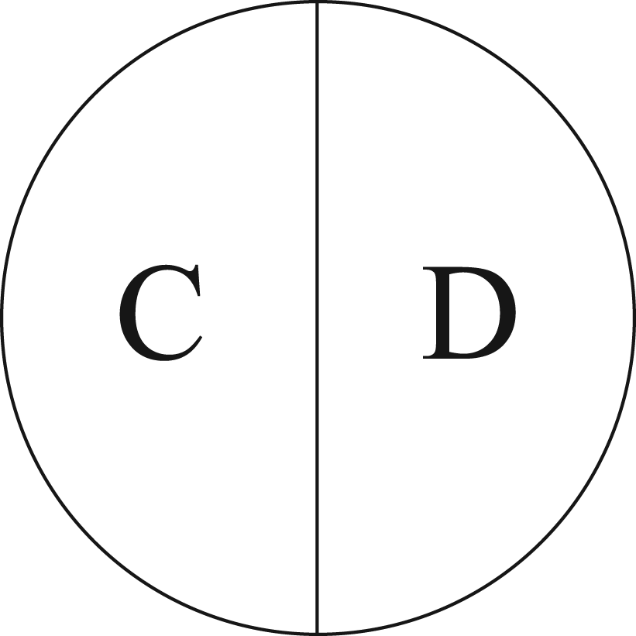

Player 1 | Player 2

Attachment E
Card Game

Name_________________________ Date__________________________

Directions: Draw one card from each stack. Player A gets a point if the cards match. Player B gets a point if the cards do not match. Cards are reshuffled after each turn, making sure the cards stay in the correct piles. Play the game 20 times.

Stack One:



Stack Two:


Player A | Player B

Attachment F
Spinner Game

Directions:
Player 1 begins by spinning both spinners. If the spinner stops on two consonants then put a tally in the CC column. If one of the spinners stops on a vowel put a tally in the VC column.

Player 2 then takes a turn by spinning both spinners and records in the same manner as player 1.

Continue to take turns spinning the spinners until instructed to rotate.

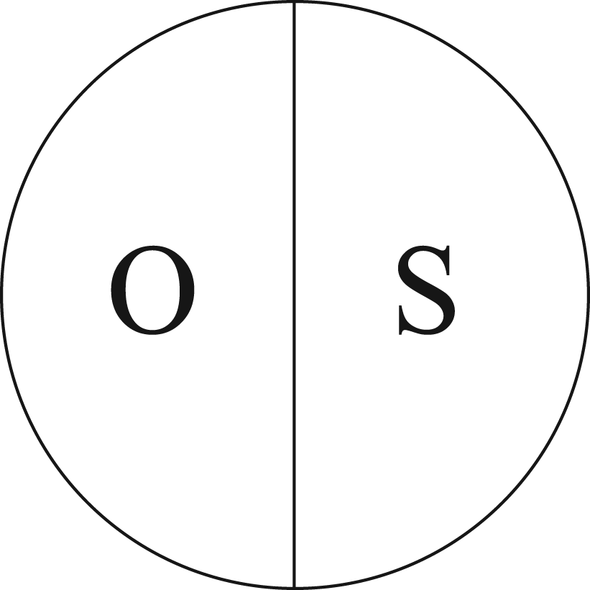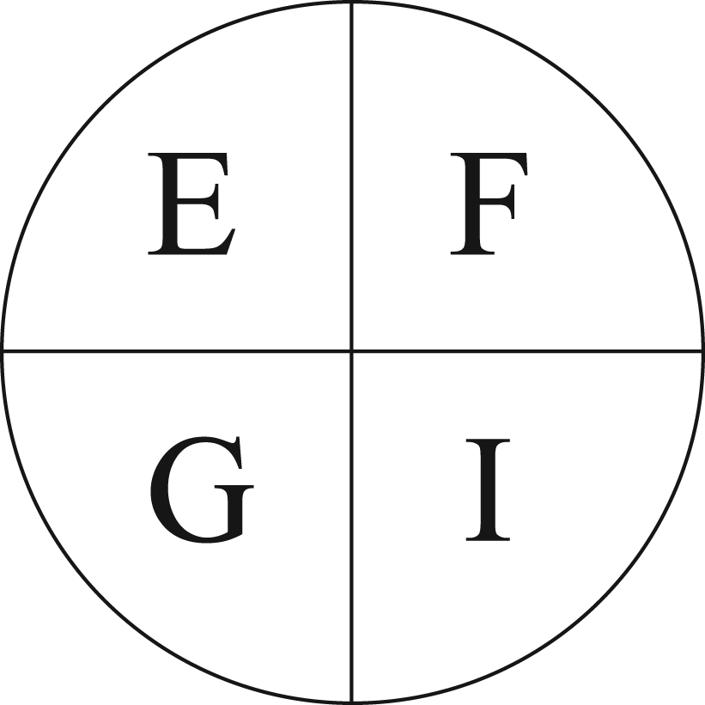

Player 1 CC | Player 2 VC
Attachment G
Bag of Coins Game

Directions:
Each player gets a bag containing a penny, nickel, dime and quarter. Each player draws a coin from their bag. If the sum of the coins is even, Player One gets a point. If the sum of the coins is odd, Player Two gets a point. Draw from the bag 20 times.

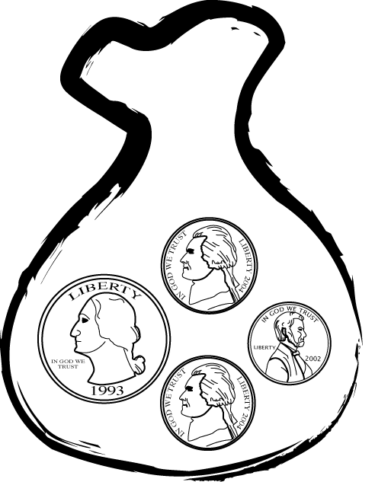

Odd | Even
Attachment H
Number Cube Game

Directions:
Player 1 rolls both cubes. Add the numbers from both cubes. If the sum is greater than 12, put a tally in >12 column. If the sum is less than 12, put a tally in the <12 column.

Player 2 then rolls both cubes and records the results in the appropriate column.

Continue to take turns until instructed to rotate. Remember to record the results after each time the cubes are rolled.

First six-sided cube:

3, 5, 7, 9, 0, 0

Second six-sided cube:

1, 2, 4, 6, 8, 10

Player 1 <12 | Player 2 >12

Attachment I
Discussion Questions

Name_______________________________ Date__________________________

Directions: Read and answer each of the following statements and questions.

1. Which player won? How can you tell for H and F? Why do you think that player won?

2. Make a tree diagram of the possible outcomes.

3. List the possible outcomes.

3a.

3b.

4. Compare the possible outcomes on the tree diagram (theoretical) and the results of the game (experimental).

Alike | Different

4. Is this game fair? Explain how you know. Describe the probability for each player winning (or losing?) and represent the probability for each player winning (or losing?) using a ratio/fraction.

Attachment J
Game Design

Name_______________________________ Date__________________________

- Design a game or redesign a game that is used in the lesson. The game can be a number card game, number cube game, spinner game, chip game or anything else that is available.
- Create game pieces or use preconstructed materials for the game.
- Write rules that explain how the game is played and how a player wins. The game should not take long to play; rules should be easily understood and limited.
- Experiment with the game. The game should be played enough times that the outcome can be predicted. Record the results after each round for ease of prediction.
- Re-evaluate the game and make any adjustments to the game pieces or rules, as needed.
- Write a report that on the probability of winning the game. In the report, include your experimental results. Also, include an accurate tree diagram or array displaying the possible outcomes of the game.

Attachment K
Post-Assessment Scoring Guidelines

Use the rubrics to describe and classify the student performance and understanding.
Written Report
4 | - Explains the game’s experimental results.  - Includes a tree diagram listing all possible outcomes.  - Relates the experimental results with the tree diagram.  - Writing is well organized and easy to understand.
3 | Report includes all the above but has one of the following:  - Few error(s) with the tree diagram,  - Only the experimental results are correct,  - Connection between experimental results and the tree diagram has minor flaws,  - Report is disorganized or not understandable.
2 | - Provides an inaccurate experimental probability or tree diagram.  - Does not connect the experimental and the tree diagram.  - Report is unorganized, difficult to understand and contains minor flaws in content.
1 | - Provides an inaccurate experimental probability and tree diagram.  - Experimental probability is not connected to tree diagram.  - Report is unorganized, difficult to understand and contains major flaws in content.

Game Design
4 | Rules for the game are clear and easy to understand and include how to play and win the game.
3 | Rules for the game are clear, but are missing either how to play or win the game.
2 | Rules for the game are not clear (e.g. out of sequence or missing steps) and do not address how to win the game.
1 | Rules for the game are not included and do not address how to win the game.

