Lesson Summary:
In this lesson, students learn to identify relationships among the properties of a circle. In the pre-assessment, students individually demonstrate their background knowledge by drawing, labeling and describing the parts of a circle. Students use colored yarn to discover relationships between the parts. Students use the relationships to develop ratios leading to the discovery of pi. Students solve problems using the relationships. Students individually complete an activity and generate appropriate statements describing the relationships between the radius, diameter and circumference of the circle.

Estimated Duration: Two hours

Ohio Standards Connection

Geometry and Spatial Sense

Benchmark B
Draw circles, and identify and determine the relationships among the radius, diameter, center and circumference.

Indicator 1
Draw circles, and identify and determine relationships among the radius, diameter, center and circumference: e.g., radius is half the diameter, the ratio of the circumference of a circle to its diameter is an approximation of π.

Mathematical Processes

Benchmarks
J. Communicate mathematical thinking to others and analyze the mathematical thinking and strategies of others.
K. Recognize and use mathematical language and symbols when reading, writing and conversing with others.

Commentary:
Using models and visual representations allow students to investigate the parts of circles and develop relationships among the measurements of the parts. Students develop a clear understanding of pi (π) as the ratio of the circumference to the diameter in any circle through exploration. (Van de Walle) During initial experiences, students use informal descriptions to describe the relationships. Throughout the lesson encourage the use of mathematical terminology through discourse and writing tasks when describing the relationships.

Pre-Assessment:
Informally assess students’ background knowledge of the properties of a circle.
Distribute Properties of Circles, Attachment A, and tools such as compasses, circular lids or circular templates.
Have students draw a circle and its parts, then label the parts. Observe students during the task, taking notes to identify misconceptions or incomplete understanding.
Have students share and discuss the work with partners.
Ask the class to identify and describe each part and record information on chart paper.

Scoring Guidelines:
Students should be able to identify the center, circumference, diameter and radius of the circle. The parts may be described using informal language. Use the visual representations and observe discussions to determine understanding and readiness for the lesson.

Post-Assessment:
Students show understanding of the relationships among parts of a circle using paper plates. Students apply the relationships to problems situations.
- Provide each student with a small paper plate, colored writing tools (red, blue, and green) and Circle Relationships Post-Assessment, Attachment C.
- Collect and evaluate for understanding. Provide intervention as indicated by students’ responses.

Scoring Guidelines:
Use the following rubric to score each property illustrated on the paper plates.
Score | Criteria
Adequate Understanding | Correctly labels and appropriately describes relationships between parts of a circle. Solves problem situations using the relationships. A student who is successful on problem 3c., is probably exceeding expectations.
Partial Understanding | Correctly labels parts of a circle, describes some relationships between parts of a circle and takes initial steps to use the relationships to solve the problems.
Needs Intervention | Provides inadequate evidence of labeling parts of the circle and describes relationships between parts of a circle with multiple errors

Instructional Procedures:
1. Pose a scenario using parts of circles in real-world situations.
Mr. Rose was creating a circular pond in his backyard. He wanted to place a fountain in the center of the pond. How would Mr. Rose determine where the center of the pond is located?
2. Have partners discuss methods for locating the center of the pond. Provide students with lids and string to build models or grid paper to draw visual representations. Students may draw a circle on the grid paper and show where the center is by counting the number of squares across and dividing the number by two. They symbolically use the diameter, divide it in half and determine the radius. Students may also say that all points on the outside of the pond (circle) are an equal distance to the center.
3. Have students share their strategies. Ask students what relationships may be evident among the parts of the circle from solving the scenario. Sample responses may include:
- The radius is half of the diameter or the diameter is twice as long as the radius.
- The distance from the center to any point on the circle is congruent or equal.
- The length of two diameters is equal to the circumference. (common misconception)
4. Have students write conjectures describing the relationship between the parts of a circle. Encourage students to use mathematical terminology by reminding them of the posted words from the pre-assessment. Pose the scenario to engage students in discovering the relationship between the diameter and the circumference of the circle.

Mr. Rose wants to place a small decorative fence around the outside of the pond. He knows the distance across the pond is 24 feet. He decides to order 48 feet of fence. Does Mr. Rose order enough fence? Is that reasonable? How do you know?

Provide time for students to make a prediction and discuss with a partner. Select students to share their prediction and reasoning.

Instructional Tip:
Collect a variety of lids and label each lid with a letter beginning with A. Precut yarn before giving to each group. Cut at least 36 inches of yarn for the color representing the circumference and 18 inches of yarn for the color representing the diameter.

5. Explain the procedures to determine if a relationship exists between the diameter and circumference of a circle.
a. Distribute a variety of lids and the colored yarn representing the circumference and diameter to small groups of students. If the number of lids is minimal, rotate lids through the groups.
b. Ask students to think of and discuss a procedure for finding the relationship between the diameter and circumference in small groups.
c. Select groups to share procedures. The procedure should include measuring the diameter and the circumference with yarn and then comparing by laying the two next to each other. Tell students it will be important that when they work with the yarn not to pull or stretch it. Ask what may happen if some students stretch the yarn and some do not.
d. Have students make a table in their journals. Explain the table is used to record their work and observations.
Lid | Comments
A | It took a little more than three of the diameter strings to equal the circumference string.
B | Three diameter strings equaled the circumference

e. Summarize the activity and how it will be managed in the classroom.
6. Have students complete the task. Observe students and their oral and written comments. Assist students who may need assistance finding the diameter. Ask questions about what parts of the circle is included in the diameter (center and radius).
7. Select students to share what relationships they discovered between the diameter and circumference of the lids. Ask if Mr. Rose ordered enough decorative fence, and how much should he order. No, more than 72 feet is needed.
8. Explain to students that mathematicians have a special name for the relationship between diameter and circumference. The relationship is called Pi.
9. Have students describe the relationship of the parts of a circle in a journal. Collect the journals to informally assess student progress.

Part Two
10. Review the relationships between parts of a circle. Have students share journal entries with partners, correcting any misunderstanding. Allow students to check relationships using the yarn and lids.

11. Present problems to students. Have students copy problems in their notebooks and find the answer before discussing with partners. Discuss answers as a class. Select students to solve the problems on the board or overhead projector. Correct any misconceptions.
a. The circumference of a circular swimming pool is 75 feet. What does this mean? (The distance around the pool is 75 feet.) What is the distance across the pool? (The distance across the pool is about 25 feet.) What does this represent? (This represents the diameter of the pool.)
b. The circular face of a clock is 18 inches. What is the approximate circumference of the clock? (The approximate circumference of the face of the clock is about 54 inches.)
c. The diameter of the world’s largest pizza was 37.4 meters in 1990. What was the approximate circumference of the pizza? (The approximate circumference of the pizza was about 112 meters.)
d. A water sprinkler for the yard has a radius of 20 feet. What is the distance across the circular area that the sprinkler waters the yard? (The approximate distance of that the sprinkler will water the yard is about 120 feet.) What does this distance represent? (This distance represents the circumference of the yard.)

Differentiated Instructional Support:
Instruction is differentiated according to learner needs, to help all learners either meet the intent of the specified indicator(s) or, if the indicator is already met, to advance beyond the specified indicator(s).
- Have students present and explain their plates to another child or to the class after the assessment.
- Scribe notes or pictures from the overhead or board that were discussed.
- Have students research the history and uses of pi (π).

Extensions:
- Read children’s literature that is available that discusses the relationships between the properties of a circle.
- Have students create a poem, rap or story about pi, diameter, radius, circumference and center of a circle. Have students present their poem, rap or story to the class.

Materials and Resources:
The inclusion of a specific resource in any lesson formulated by the Ohio Department of Education should not be interpreted as an endorsement of that particular resource, or any of its contents, by the Ohio Department of Education. The Ohio Department of Education does not endorse any particular resource. The Web addresses listed are for a given site’s main page, therefore, it may be necessary to search within that site to find the specific information required for a given lesson. Please note that information published on the Internet changes over time, therefore the links provided may no longer contain the specific information related to a given lesson. Teachers are advised to preview all sites before using them with students.

For the teacher: board or overhead projector, chart paper, small round paper plates, rulers, compasses, circular lids, or various-sized templates for circles, yarn (precut non elasticity) or ribbon

For the student: pencils, small paper plates, colored yarn (red, blue, green) or ribbon, colored writing tools (red, blue, green), calculators, scissors, journals, compasses, various-sized circle templates or circular lids

Vocabulary:
- center of the circle
- circumference
- diameter
- pi
- radius (radii)

Research Connection:
Edelson, Daniel C., Douglas N. Gordin and Roy D. Pea. “Addressing the Challenges of Inquiry-Based Learning, Technology and Curriculum Design.” Journal of the Learning Sciences, 8(3-4), 391-450, 1999.

General Tips:
- Circulate around the room frequently to assess knowledge or clarify misconceptions.
- Allow students to help each other with the manipulatives.

Attachments:
Attachment A, Pre-Assessment of Properties of Circles
Attachment B, Pre-Assessment of Properties of Circles Answer Key
Attachment C, Circle Relationships Post-Assessment
Attachment D, Circle Relationships Post-Assessment Answer Key

Attachment A
Pre-Assessment Circle Relationships

Name_______________________________ Date__________________________

Directions: Draw a large circle. Label and draw the radius, diameter, center and circumference on the circle.

Directions: Write a sentence that describes the radius, diameter, center and circumference of your circle at the bottom of this page.

Radius ___________________________________________________________

___________________________________________________________

Diameter___________________________________________________________

___________________________________________________________

Circumference______________________________________________________

___________________________________________________________

Center of a Circle____________________________________________________

___________________________________________________________

Attachment B
Pre-Assessment Circle Relationships, Answer Key

Name_______________________________ Date__________________________

Directions: Draw a large circle. Draw and label the radius, diameter, center and circumference on the circle.
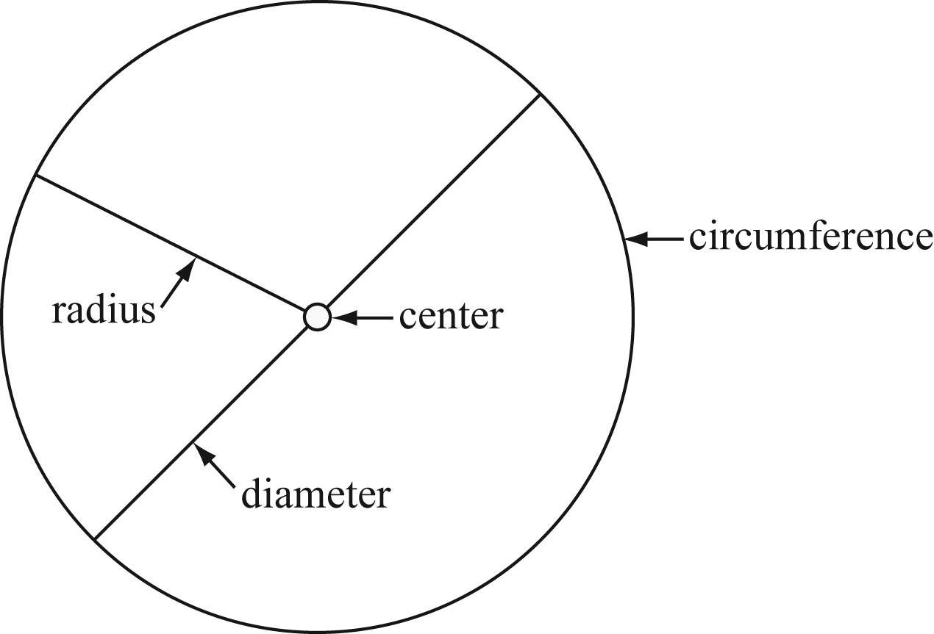

Sample descriptions

Radius is the distance from the center of the circle to the edge.

Diameter is the distance from one edge of the circle to the other through the center of the circle.

Circumference is the distance around the outside edge of the circle.

Center of a Circle is a point such that every point on the circles is the same distance from it.

Attachment C
Circle Relationships Post-Assessment

Name_______________________________ Date__________________________

Directions: Use a colored writing tool to complete the paper plate activity.

1. Use the colored pencils to do the following:
a. color the diameter blue
b. color the radius red
c. color the circumference green

2. Describe the relationship of the properties of the circle.
a. the radius and the diameter

______________________________________________________________________

b. the diameter and the circumference

______________________________________________________________________

c. pi (π)

______________________________________________________________________

3. A bicycle tire has a radius of 12 inches.
a. What is the diameter of the tire? _________________________________________

b. What is the approximate circumference of the tire? __________________________

c. If the radius of the tire is 14 inches, how far will the bike travel if the tire makes 5 complete rotations?

4. The circular fence around the swimming pool is approximately 110 feet. What is the
approximate diameter of the fence?

Attachment D
Circle Relationships Post-Assessment Answer Key

Name_______________________________ Date__________________________

Directions: Use a colored writing tool to complete the paper plate activity.

1. Accept correct representations.

2. a. the radius and the diameter The diameter is half of the radius.

b. the diameter and the circumference The circumference is about 3 times the diameter.

c. pi (π) pi (π) is the ratio of the circumference to the diameter of a circle.

3. a. The diameter is 12 inches.
b. The circumference is about 36 inches.
c. More than 140 inches (14 × 2 = 28, 28 × 5 = 140 inches)

4. The circular fence around the swimming pool is approximately 105 feet. What is the diameter of the fence? The diameter of the fence is about 35 feet.

