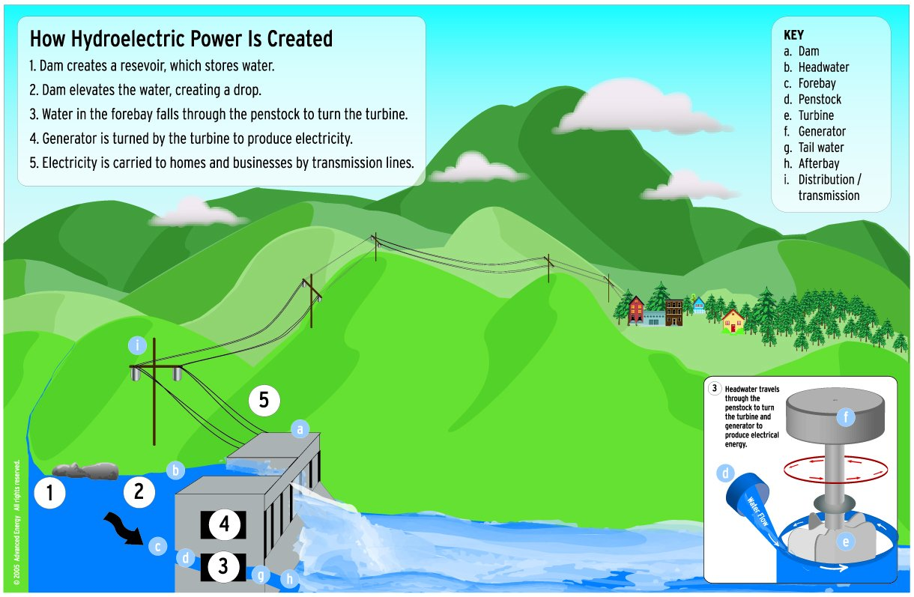

Hydroelectric Energy – comes from dams in mountains that use water turbines to produce electricity.



Tidal/Wave Energy – Captures energy from waves built across rivers or streams

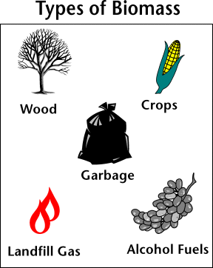

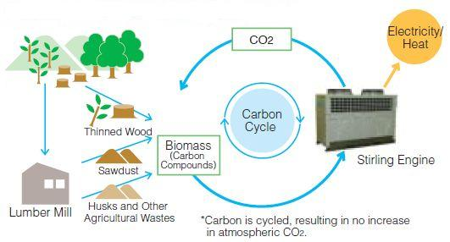

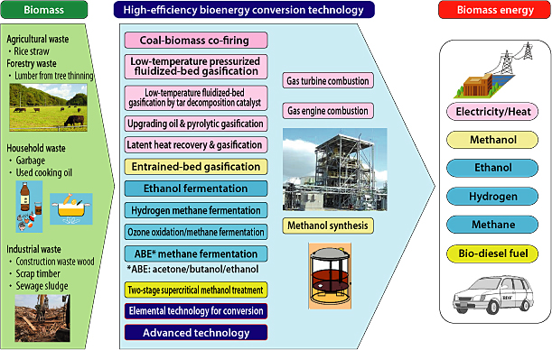 Biomass uses energy from plants and animals

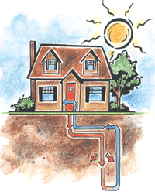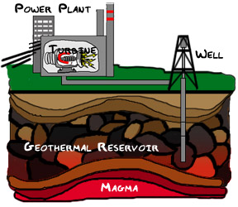

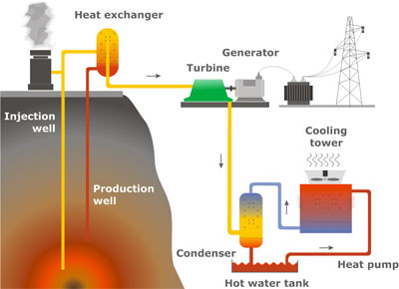 Geothermal energy uses heat from beneath the surface of the Earth.

Biomass is organic material made from plants and animals. Biomass contains stored energy from the sun. Plants absorb the sun's energy in a process called photosynthesis. The chemical energy in plants gets passed on to animals and people that eat them. Biomass is a renewable energy source because we can always grow more trees and crops, and waste will always exist. Some examples of biomass fuels are wood, crops, manure, and some garbage.
When burned, the chemical energy in biomass is released as heat. If you have a fireplace, the wood you burn in it is a biomass fuel. Wood waste or garbage can be burned to produce steam for making electricity, or to provide heat to industries and homes.
Burning biomass is not the only way to release its energy. Biomass can be converted to other usable forms of energy like methane gas or transportation fuels like ethanol and biodiesel. Methane gas is the main ingredient of natural gas. Smelly stuff, like rotting garbage, and agricultural and human waste, release methane gas - also called "landfill gas" or "biogas." Crops like corn and sugar cane can be fermented to produce the transportation fuel, ethanol. Biodiesel, another transportation fuel, can be produced from left-over food products like vegetable oils and animal fats.
Biomass fuels provide about 3 percent of the energy used in the United States. People in the USA are trying to develop ways to burn more biomass and less fossil fuels. Using biomass for energy can cut back on waste and support agricultural products grown in the United States. Biomass fuels also have a number of environmental benefits.

