Name: ____________________________ Class:_____ #_____ Date:______________

Electricity Test – Student Test Booklet

*Make sure to put your answer in the answer document.

1. Which electric circuit produces light?

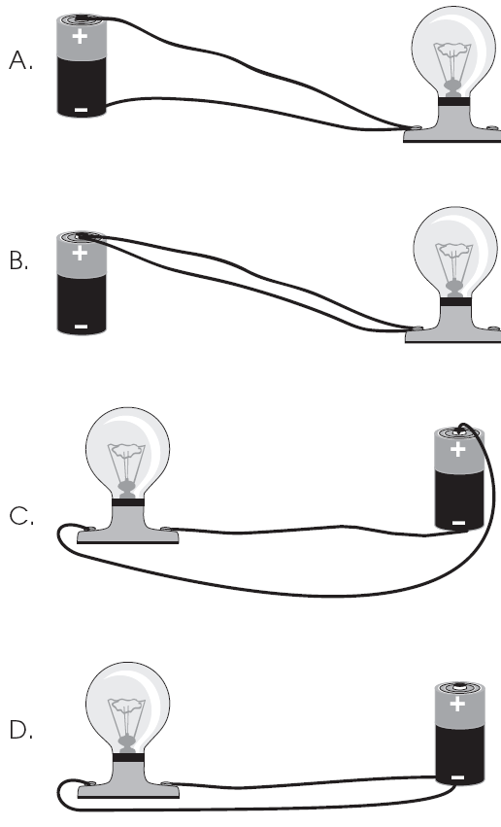

2. A student wraps wire around an iron nail. The student then connects the wire to a battery. The nail attracts another nail and they stick together.

What force holds the two nails together?

A. gravitational force

B. magnetic force

C. electric force

D. friction force

3. Which object is an energy source for circuits?

A. a light bulb

B. copper wire

C. a battery

D. a switch

4. Electric energy flows through the wire filament in a light bulb. The energy causes the wire to glow and give off light.



Which type of energy produces this light?

A. sound

B. gravity

C. thermal

D. magnetic

5. The table shows materials that conduct electricity and some materials that do not conduct electricity.

|  |  |
| --- | --- |
| **Conductors** | **Insulators** |
| copper | wood |
| aluminum | paper |
| brass | glass |
| steel |  |

Which of these materials belongs in the blank box in the column labeled “Insulators?”

A. rubber

B. electrical wire

C. gold

D. water

6. The drawing shows a type of electric circuit.

Kamico pg. 72

In your **Answer Document**, name the type of circuit shown and then explain how you would be able to tell electricity is flowing through the circuit *using only the materials available* in the drawing. (2 points)

7. A student set up the electricity experiment shown below.

picture from pg. 95

Which of these was a variable in the student’s experiment?

A. the wattage of light bulbs

B. the voltage of the batteries

C. the number of light bulbs

D. the number of batteries

8. Why is a parallel circuit a special kind of circuit?

A. it has only one path for electrons to flow

B. it can work even if one of its parts is broken

C. it can light only one bulb at a time

D. it does not need an energy source

9. Elijah is sitting in his room one day after school listening to his radio, talking with friends on

his computer, and has his desk lamp on so he can study for his math test. Elijah’s room gets

its electricity through a series circuit.

In your **Answer Document**, what would happen if he turned off his radio? Explain your answer.

Then, name the kind of circuit he should have in his room. Explain your answer using pictures or words. (4 points)

10. Which of the following is typically used to control the flow of electric current in a circuit?

A. wire

B. batteries

C. buzzers

D. switches

11. What are electric currents used to produce?

A. heat and light only

B. light and sound only

C. heat, light, sound, and motion

D. light and magnetic fields

12. Billy pulled his clothes from the dryer and noticed they were sticking together. What caused

this?

A. static electricity

B. current electricity

C. open circuits

D. closed circuits

13. A student connects a bulb to a battery as shown, but the light produced is dim.



Which diagram shows how a second battery can be connected to make the bulb brighter?



14. In Diagram 1, two identical magnets (Y and Z) appear as shown. The magnets can only

move up and down in a clear plastic tube. In Diagram 2, a third identical magnet (X) is

going to be added.



What will happen when the third identical magnet is placed in the top of the clear plastic tube?

A. Magnet X will flip over.

B. Magnet X will be attracted to Magnet Y.

C. Magnets (X, Y and Z) will move closer together so that all touch.

D. Magnets (X, Y and Z) will form a stack with spaces between each magnet.

15. Which diagram shows a circuit with a lit bulb?

Kamico pg 52

16. What is the path an electric current follows called?

A. an insulator

B. an electric circuit

C. potential energy

D. kinetic energy

17. When an alarm clock beeps in the morning, to what kind of energy is electricity being

changed?

A. heat

B. light

C. motion

D. sound

18. Julie walked across a carpeted floor and felt a shock when she touched a doorknob. What

caused this?

A. The knob was an electromagnet.

B. The knob was an insulator.

C. Julie developed a static charge.

D. The carpet was a conductor.