CmapTools: Free Concept Mapping Software

Getting started:
- At school: Double click the CmapTools icon on the Desktop. If one does not exist that proceed to Network Applications and launch it from there.
- At home, Double click on the CmapTools icon where ever you stored it to open it (either the Desktop or Start Menu). In the Start Menu, look for “IHMC CmapTools” folder to open the program.

Creating your first Concept Map:
      - To begin, select File and “New Cmap” in the “Views – CmapTools” window.
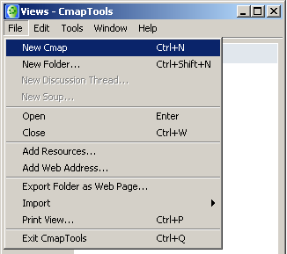
      - Double-click on the white space to create the first box. You can move it anywhere on the page by clicking on box, holding down the mouse, and dragging it to where you want to place it.
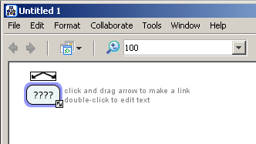
      - Double-click the question marks inside the box to add text. Click outside the box when you are finished.
      - Resize the box by clicking once on the box, then click and holding down the mouse button on the double arrow icon on the bottom-right corner of the box.
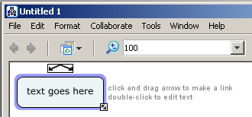
      - To create arrows, click on the double-arrow icon on top of the box. Move your mouse to where you want the arrow to point.
      - Select the question marks in the middle of the line to type in the relationship.
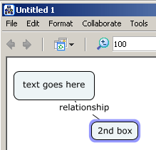

You can edit text and objects like you can in Word: Select “Format” then “Styles” on the Tool Bar to open the Styles window. You can change the font, size, color, and alignment of text. You can also change the color, shadows, and shapes of the boxes (objects), as well ad the color, thickness, and style of the arrows.
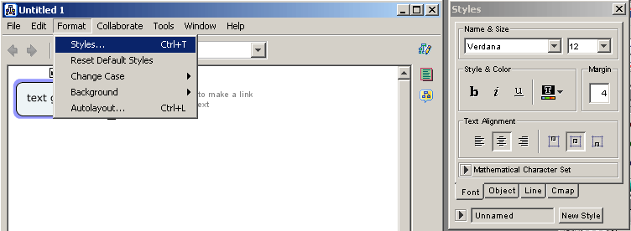
Most importantly – adding links, files, and images: For help, you can go to the help online (http://cmap.ihmc.us/Support/Help/), OR click “Help” on the top Tool Bar and go to CmapTools Help; then select on Import Resources (10th from the top).

To add documents, images, audio files:
- Click on “File” on the top Tool Bar of the “Views – CmapTools” window – and select “Add Resources.”
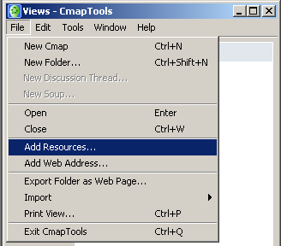
- Browse your files. When you find what you want to add, click on the file and then click “Add.”
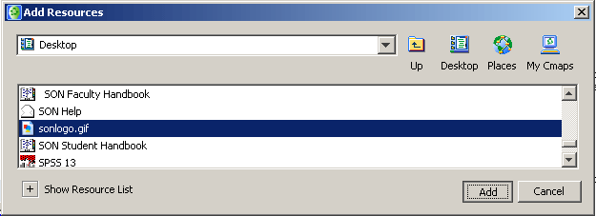
- A window will appear asking you to edit the properties of your file. You can skip this by clicking OK, or you can fill out the fields and then click OK.
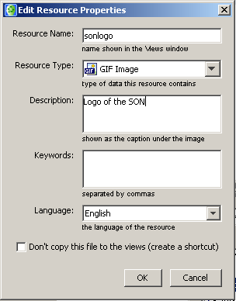
- The file will appear in the “View – CmapTools” window.
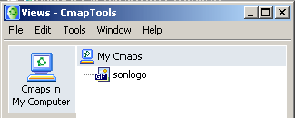

To add a website:
- Click on “File” on the top Tool Bar of the “Views – CmapTools” window – and select “Add Web Address.”
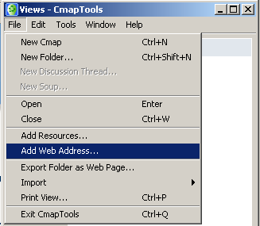
- Make sure you enter a Resource Name and the correct URL (i.e. http://www.unc.edu); then click “OK.” 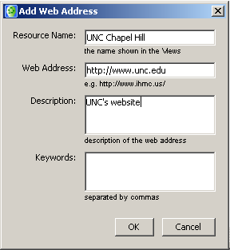
- The name will appear in the “View – CmapTools” window.
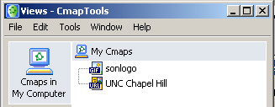

Inserting these resources into your Concept Map:
- Click on the object (box) in the Concept Map that you want to insert the resource so its border is highlighted.
- Then, you can either:
  - Drag and drop from the resource list to the selected box in concept map (make sure the appropriate object is clicked on). A dialogue box titled “Adding Resource Links to [title of your box]” will pop up. Add whatever information you want to and click “OK.”
  - OR you can either right click on the box or click Edit on the top Tool Bar and select “Add & Edit Links to Resources.” 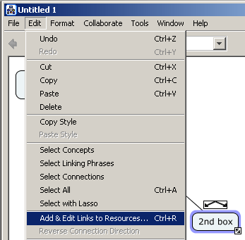
  - Go to the location on your computer that you have stored your resources (most likely in the “My Cmaps” folder which is automatically created – but you can create a new folder). Click on the resource you want to add, then click “Add to List,” and finally, click “Update.”
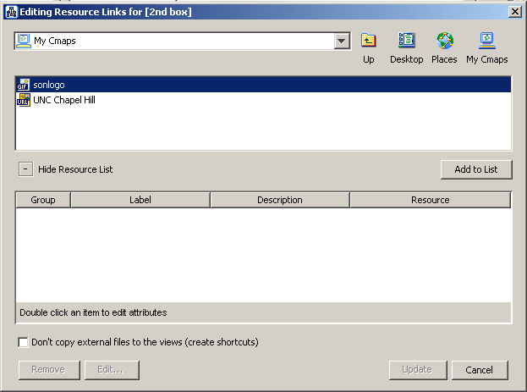

Saving your work
- Click on “File” in Tool Bar in the concept map window.
- Select “Save Cmap as” the first time you save your file. Make sure you know the location you are saving the file (most like in “MyCmaps” folder which is the default – but you can create a new folder). Insert a recognizable file name and insert other identifying information as needed.
- You can just select “Save” (or CTRL+S) next time unless you want to save each version with a different name.
- Select “Export Cmap as” to save in another format such has a webpage, image (JPG), etc.

Reopening files
- When you click on the Icon “CmapTools,” from the Desktop or Start Menu, the “Views – CmapTools” window will automatically come up.
- Click on the file you want to open.
- If you saved the file as a webpage, open your web browser, click on “File” on the top Tool Bar, select “Open file” and find your file at the location you stored it.

Starting a new concept map:
- Click on the Icon “CmapTools,” from the Desktop or Start Menu and the “Views – CmapTools” will automatically come up.
- Click on “File” on the top Tool Bar and select “New Cmap.”

