Angle Measures of Triangles
Name ______________________________________

The sum of the measures of the angles of triangle ALWAYS equals ________________.

Find Angle Measures of a Triangle
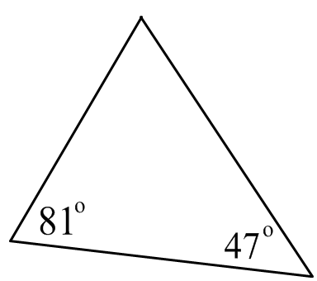
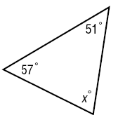
1. 2.

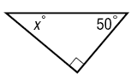
3.

4. If the measures of two interior angles in a triangle are 35º and 128º, what is the measure of the third angle?

5. The supports of a wood table are in the shape of a right triangle. Find the third angle of the triangle if the measure of one of the angles is 23.

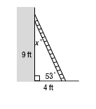
6. LADDER The figure shows a ladder leaning against a wall, forming a triangle. Classify the triangle by its angles and by its sides. What is the value of x in the figure?

7. If X equals Y and angle A equals 32, what is the value of angle C?
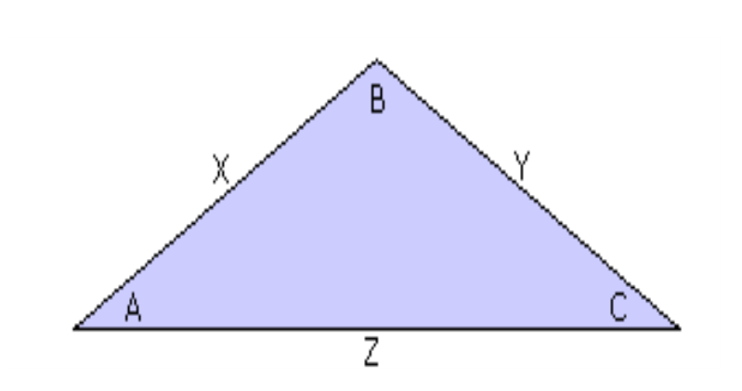

8. The triangle above is an equilateral triangle. What is the value of angle C?
