Directions: Using a protractor, measure the angles of each triangle and record. Add up all the angles for each triangle and write your answer in the box. Next, using the ruler side of your protractor, measure each side of the triangles, in centimeters, and record in the box.
What’s with these triangles?
Attachment A
Triangle ABC
What I found:
Angle A=
Angle B=
Angle C=
Are there any angles that are equal?

Sum of Angles A, B, and C=

Length of AB =
Length of BC =
Length of AC=
Are there any side lengths that are equal?

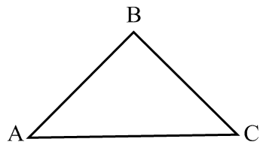

Triangle DEF
What I found:
Angle D=
Angle E=
Angle F=
Are there any angles that are equal?

Sum of Angles D, E, and F=

Length of DE =
Length of EF =
Length of DF=
Are there any side lengths that are equal?

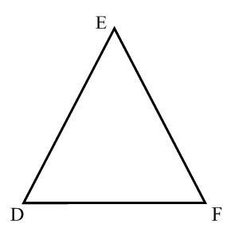

What I found:
Angle G=
Angle H=
Angle I=
Are there any angles that are equal?

Sum of Angles D, E, and F=

Length of GH =
Length of HI =
Length of GI=
Are there any side lengths that are equal?

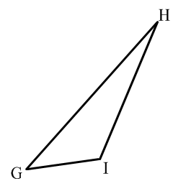
Triangle GHI

