INSTRUCTIONAL DESIGN PROJECT

EDTL 7100

STEVEN RILEY

JUNE 23, 2009

RATIONALE

According to the 2006 Geographic Literacy Study, 37% of American’s aged 18-24 years old could not find Iraq on a map. This was three years into the war in Iraq, where many of the troops fighting over there were of the same age group of the people who took part in the survey. This troubling data begs the following question to be asked: How can America continue to lead the world, demonstrate the blessing of freedom and democracy, and solve global problems when many of its own citizens cannot find where other places are on a map?
A paradigm shift is occurring in education for the current generation and future generations of American students. Our students will be interacting and competing in a global marketplace that will have them vying for jobs with people throughout the world. They will embark in careers where they will work for employers from far off lands and have employees with different background and beliefs. In this global community they will face cultural divides that must be crossed and historical trends that must be overcome but not forgotten. Through the use of human geography education, our children will be better prepared for this global environment.
I propose to enhance the High School Social Studies curriculum by including a unit that focuses on the diversity of the world. This course will target the Social Studies benchmark and learning outcomes for the Social Studies Academic Content Standards for the Ohio Department of Education. This unit will help students use critical thinking skills and solve practical problems they will face it today’s global economy. Students will be able to demonstrate their knowledge of geographic locations, patterns and processes to show the interrelationship between the physical environment and human activity, and to explain the interactions that occur in an increasingly interdependent world. (Ohio Department of Education, 2003) Students will also gain knowledge of perspectives, practices, and products of cultural, ethnic, and social groups to analyze the impact of their commonality and diversity within a global setting. (Ohio Department of Education, 2003) These are skills that will place our students at the forefront of a changing world environment.
The subunit that will be highlighted in the following instructional design will be the region in Asia known as the Middle East. As the survey demonstrated above, there is definitely a need for geography education in America’s public schools. The lesson planning models used in this instructional design relies heavily on the basic model demonstrated in Chiarelott’s Curriculum in Context. This model does a good job breaking the lesson into distinct segments allowing the teacher to the grab the attention of the students with an introductory activity, present the material in a variety of formats during the developmental activity, and to make sure all students have mastered the material during the concluding activity.
This instructional design also uses several cooperative learning activities from Chiarelott, such as, the Jigsaw model and the Project based lesson model. These learning activities allow the instructor to contextualize the learning objectives for the teacher and to build communication and teamwork skills that will be necessary in the work place.

REFERENCES

2006 Geographic Literacy Study. (2006). National Geographic-Roper Public Affairs. Washington D.C.: Author.

Chiarelott, L. (2006). Curriculum in Context: Designing Curriculum and Instruction for Teaching and Learning in Context. Thomas Wadsworth. Bowling Green, OH.

Ohio Department of Education. (2003). Academic content standards for social studies. Columbus, OH: Author.
Unit 2- Asia
Sub-Unit The Middle East
The student will be able to:
- Locate which landforms and bodies of water dominate the region. (Comprehension)
- Relate the geographic factors that affect climate in Asia. (Application)
- Explain why parts of Asia are densely populated compared to other parts of the continent. (Comprehension)
- Describe the main achievements of the ancient civilizations of Asia. (Comprehension)
- Explain how European colonization disrupted Asian patterns of life. (Comprehension)
- Discuss challenges countries of the region have faced after independence. (Comprehension)
- Compare the ethnic differences of Asia. (Analysis)
- Compare the major religions of the region. (Analysis)
- Examine similarities and differences in the lifestyles of people in the region. (Analysis)
- Categorize the types of government systems and economic systems used in Asia. (Synthesis)
- Rate how mineral resources benefit the people of the region. (Evaluation)
- Describe how seasonal weather patterns present challenges to the region’s economy. (Comprehension)
- Compile examples of economic interdependence in Asia. (Synthesis)
- Predict environmental consequences of rapid industrialization in Asia. (Evaluation)
PREASSESSMENT

- Provide the students with a KWL chart and have them fill out the “What I Think They Know” section with the topic being the region about the Middle East. Students should have a minimum of 6 items in this section, with 3 items focusing on the physical geography of the region and 3 focusing on the human geography of the region. Have students share their items with the class. (10 minutes)

- Next, have students complete the section of the KWL chart “What I want to Know” about the Middle East. Have students share what they wrote in this section and explain when that information will be covered in the upcoming unit. (20 minutes)

Name_____________________________________ Date____________________

KWL Chart

Topic: _________________________________________________________
What I Think I Know | What I Want to Know | What I have Learned
LESSON 1 THE MIDDLE EAST (Physical Geography)

Objectives- After this lesson the students will be able to:
- Locate which landforms and bodies of water dominate the region. (Comprehension)
- Relate the geographic factors that affect climate in Asia. (Application)
- Analyze the impact the physical geography has on the people of the region. (Analysis)

Materials-
- Reserve the mobile computer lab.
- Handout “Middle East Physical Map”
- Handout “Middle East Landform Chart”

Duration- Two 50-minute class periods

Procedures
Introductory Activity- Begin class by having pictures of the following landforms posted at 5 different stations throughout the room. The stations will show the following landforms and bodies of water: Mountains, Deserts, Plateaus/Steppes, Rivers, and Seas/Oceans. Once everyone has view the pictures, have students identify what features are represented by the stations. Explain to the class that these features are found in the Middle East and they will become experts on one of the features. (10 minutes)

Developmental Activity- Provide students with the handout “Middle East Physical Map” and handout “Middle East Landform Chart”. Next, divide the class into 5 different groups and assign the groups one of the features or bodies of water discussed above. Each group will create a PowerPoint presentation that locates the major features found in the region. They should place these areas on their individual maps. For the PowerPoint Presentations, students will include the location of the major landforms/bodies of water, compare how the features are similar and different from one another, and analyze the impact the feature has on the people of the region. (40 minutes)

Concluding Activity- Each group will present their PowerPoint presentations to the rest of the class. Other groups will add the information presented to their individual maps and charts. (30 minutes)

Assessment
When all groups are finished, poll the class to find out what they feel are the most important points from the presentations. Clear up any misconceptions and re-teach material if necessary. Have the students add these points to their KWL Charts. (10 minutes )
Name_____________________________________ Date____________________

Middle East Physical Map

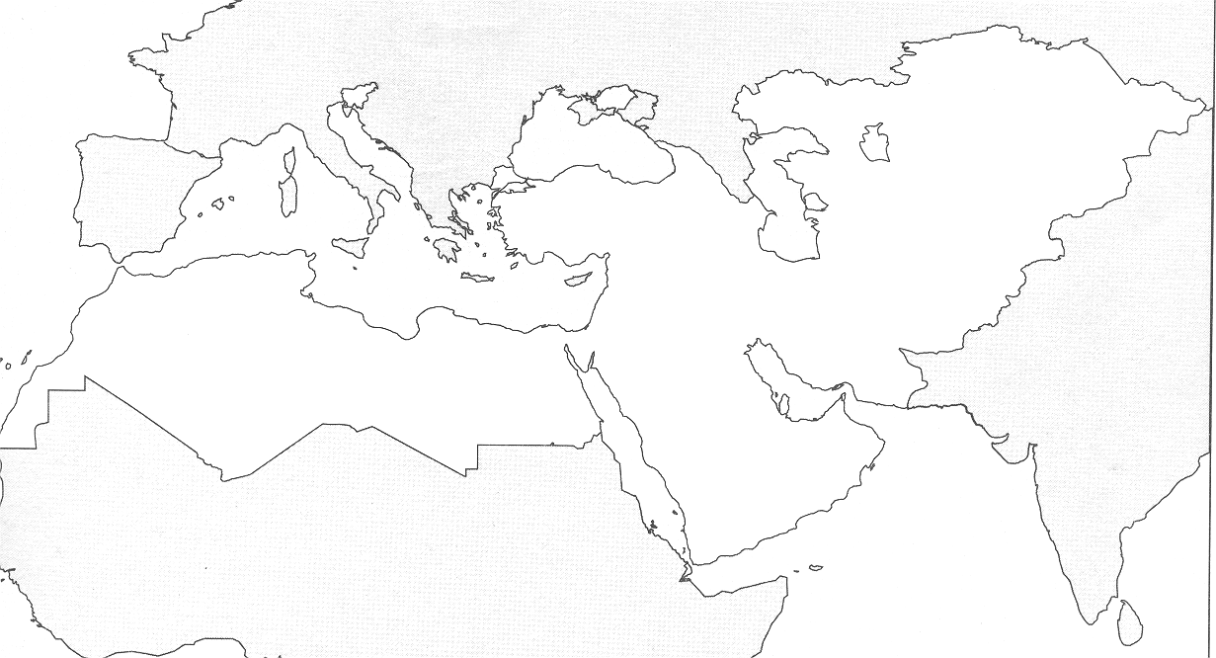

Key
Mountains |  | Plateaus/Steppes |  | Deserts
Rivers |  | Seas/Oceans

Name_____________________________________ Date____________________

Middle East Landform Chart

Landform/Body of Water | Major Features in the Middle East | Comparison of Different Features | Impact on People of the Middle East
Mountains
Deserts
Plateaus/Steppes
Rivers
Seas/Oceans
LESSON 2 THE MIDDLE EAST (Population Patterns)

Objectives- After this lesson the students will be able to:
- Compare the ethnic differences of Asia. (Analysis)
- Examine similarities and differences in the lifestyles of people in the region. (Analysis)
- Explain why parts of Asia are densely populated compared to other parts of the continent. (Comprehension)

Materials-
- Projector for PowerPoint Presentation
- Handout “Middle East Ethnic Group Chart”

Duration- 1- 50 minute period

Procedures
Introductory Activity- As students enter the classroom; have a PowerPoint presentation repeat pictures show individuals with traditional dress from the following ethnic groups: Arab, Israeli Jew, Turks, Iranian, Afghanis, Armenians, Georgian, and Kurds. Explain to students that clothing styles and customs are an example of a trait that makes up the culture of a group. Discuss the various reasons that may result in the way a group chooses to dress (i.e. geographic, climate, religious) and identify which of the factors discussed is having the biggest impact on those in the picture. (10 minutes)

Developmental Activity- Show a PowerPoint presentation that highlights the different ethnic groups in the region and the traits that define them as separate groups. Provide students with a chart that names the different ethnic groups in the region and have students add relevant information to their chart. (25 minutes)

Concluding Activity- Discuss with the class the items they found to be important about each ethnic group from the PowerPoint. Have the students vote on the top three items from the presentation that they feel should be included on their KWL chart and have them add those items. (10 minutes)

Assessment
Have students complete for homework questions 1-7 from Glencoe World Geography on page 443. The questions relate to the class discussion on the ethnic groups found in the region and will be used to address the level of retention the students achieved from the lesson.

Copy of Section 1 Assessment from Glencoe World Geography page 443

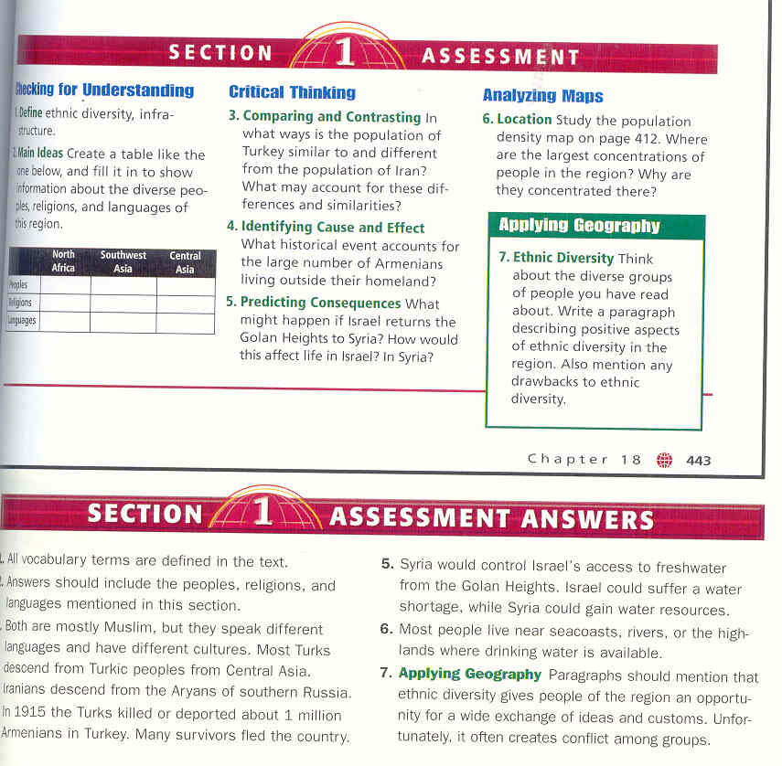
Name_____________________________________ Date____________________

Middle East Ethnic Group Chart

Ethnic Groups | Language | Religion | Other interesting details.
Arabs
Israeli Jews
Turks
Iranian
Afghanis
Armenians
Georgian
Kurds

LESSON 3 THE MIDDLE EAST (History)

Objectives- After this lesson the students will be able to:
- Describe the main achievements of the ancient civilizations of Asia. (Comprehension)
- Explain how European colonization disrupted Asian patterns of life. (Comprehension)
- Discuss challenges countries of the region have faced after independence. (Comprehension)
- Compare the major religions of the region. (Analysis)
- Compile examples of economic interdependence in Asia. (Synthesis)

Materials-
- Glencoe World Geography Textbook
- Handout “Middle East Early Civilizations Chart”
- Video “Conflict in the Middle East”

Duration- Two 50-minute periods.

Procedures
Introductory Activity- Have students volunteer answers from Lesson 2’s homework. Have students correct any misconceptions and then collect the assignment. Have students again recall the factors that define a culture. Have students identify items that can cause a culture to change (trade, war, technological advances). Relate these factors with historical events that have shaped and influenced cultural groups of the Middle East for thousands of years. (15 minutes)

Developmental Activity- Use the jigsaw cooperative learning model to help students learn about the different historical civilizations and their major accomplishments. Divide students into 5 groups and assign each group one of the following historical groups from the Middle East: Sumerians, Egyptians, Phoenicians, Persians, and Mongols. Provide students with Middle East Early Civilizations Chart and have the students read from their Glencoe World Geography Textbook pages 446-452. Students should investigate how the people adapted to the environment and identify major accomplishments or technological advancements made by their civilization. After groups have adequately completed their section of the chart with relevant information, check each group’s work; reassemble the groups so that the 5 new groups are represented by a member of the original groups. Now, have the new groups teach their area of expertise to the other members of the new groups. Students should place this information on their Middle East Early Civilizations Chart. (45 minutes)

Introductory Activity- Discuss problems that the students may have seen in the news regarding the Middle East (i.e. Israeli-Palestinian conflict, Taliban in Afghanistan, Sunni-Shiite rivalry in Iraq.) List on the board what they believe is the root of the conflict for each topic discussed. (10 minutes)

Developmental Activity- Provide students with the handout “Conflict in the Middle East” and have students watch the video “Conflict in the Middle East.” Students should complete the handout as they watch the video a will be given 5 minutes to complete it at the conclusion of the video. Discuss student answers from the video handout and clear up any misconceptions the students may about the material. (30 minutes)

Concluding Activity- Have students volunteer what they believe to be the most important information from the lesson on conflict in the Middle East. Have students vote on the issues they volunteered and have students add the top 3 items to their KWL chart. (10 minutes)

Assessment
Have students take the section 2 quiz provided by Glencoe World Geography.

Name_____________________________________ Date____________________

Middle East Early Civilizations Chart

Early Civilizations | How did they adapt to the environment? | Major accomplishments or technological advancements.
Sumerians
Egyptians
Phoenicians
Persians
Mongols

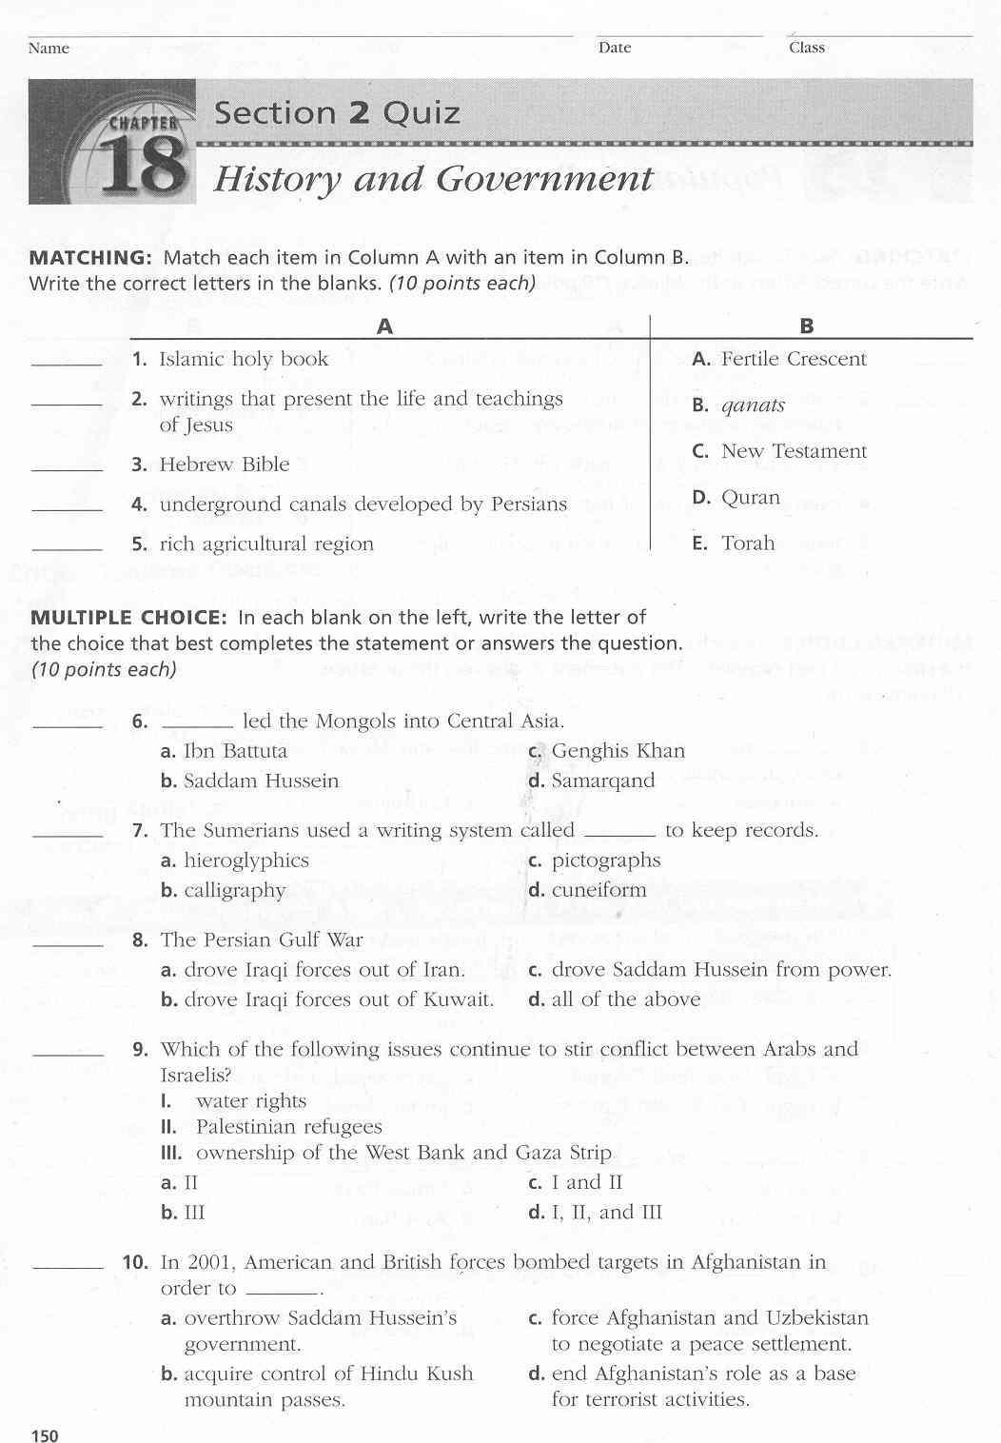
LESSON 4 THE MIDDLE EAST (Birthplace of 3 Major Religions)

Objectives- After this lesson the students will be able to:
- Compare the major religions of the region. (Analysis)

Materials-
- Glencoe World Geography Textbook
- Handout “Religions Comparison Diagram”

Duration- One 50-minute class period

Procedures
Introductory Activity- Begin class by having students brainstorm over the different religions they are aware of and have them identify characteristics they “Think they Know” about those religions. Next, explain to the students that the Middle East is the birthplace of three major religions that they have identified. (10 minutes)

Developmental Activity- Provide students with Handout “Religions Comparison Diagram” and have each individual in the group’s research using their textbook on one the following religions that developed in the Middle East: Judaism, Christianity, and Islam. Once students have found approximately 5 important features of their religion, have them compare their research item with the other students in their group. At this time students can complete the “Religions Comparison Diagram” placing items that are not similar on the outer edge of the circles and items that are similar in the middle portion that are in the shared portion of the circles. (20 minutes)

Concluding Activity- After all groups are done with their charts, have groups present their charts to the class. Discuss with the class if the various groups had similar items that they identified and if they placed those items in similar positions on the chart. (10 minutes)

Assessment
Play a review game covering material from this sub-unit over the Middle East by dividing the class into five teams. Students will answer questions from the review game in a Jeopardy game format. Correct any misconceptions during the review game and re-teach material if necessary. (One 50-minute period)
Name_____________________________________ Date____________________

Religions Comparison Diagram
Christianity
Islam
Judaism
GEOGRAPHY
Ch 17-18
“The Middle East/North Africa”

Name______________________________

Matching: Write the letter of the word in the blank that best matches the statement

_______1. Any grain, such as barley, oats, or wheat, grown for food.
- Alluvial Soil
- Oasis
- Cereal
- Infrastructure
- Monotheism
- Domesticate
- Cuneiform
- Hieroglyphics
- Mosque
- Embargo
- Bazaar
- Bedouin

_______2. Sumerian writing system using wedge-shaped symbols pressed into clay tablets.

_______3. A traditional, open-air, marketplace.

_______4. Member of the nomadic desert peoples of North Africa and Southwest Asia.

_______5. Small area in a desert where water and vegetation are found

_______6. A ban on trade.

_______7. Belief in one God.

_______8. The basic urban necessities, like streets, running water, sewer systems, electricity, etc.

_______9. Rich soil, made up of sand and mud, deposited by running water.

_______10. To adapt plants and animals from the wild to make them useful to people.

_______11. Egyptian writing system using pictures and symbols to represent words or sounds.

_______12. An Islamic house of worship.

Multiple Choice: Write the letter of the best answer in the blank. (1pt each)

_______13. What percentage of the Middle East and North Africa is covered by desert?
A. 5 % C. 50 %
B. 10 % D. 70 %

_______14. In which country is the Earth’s longest river located?
A. Iran C. Saudi Arabia
B. Egypt D. Turkey

_______15. What landform connects the Arabian Peninsula with Africa?
A. Anatolian Plateau C. Atlas Mountains
B. Sinai Peninsula D. Taurus Mountains

_______16. People have farmed the Tigris-Euphrates River valley for about…
A. 7,000 years. C. 1,000 years
B. 3,000 years. D. 100 years

_______17. People living in the steppe climate zone of Central Asia make their living through…
A. Mining C. Industry
B. Tourism D. Pastoralism

_______18. What religion do most people in the Middle East and North Africa practice?
A. Christianity C. Hindu
B. Islam D. Judaism

_______19. Most people who live in Israel today do so because…
A. the government offers money to immigrants. C. profits can be made quickly in oil.
B. it was created as a homeland for the Jews. D. it has experienced peace since its creation as a nation.

_______20. What group wants an independent state of their own in the West Bank and Gaza Strip areas?
A. Israelis C. Palestinians
B. Christians D. Kurds

_______21. Limited freshwater resources have forced countries to use the process of …
A. reservoirs. C. desalination.
B. aqueducts D. aquifers.

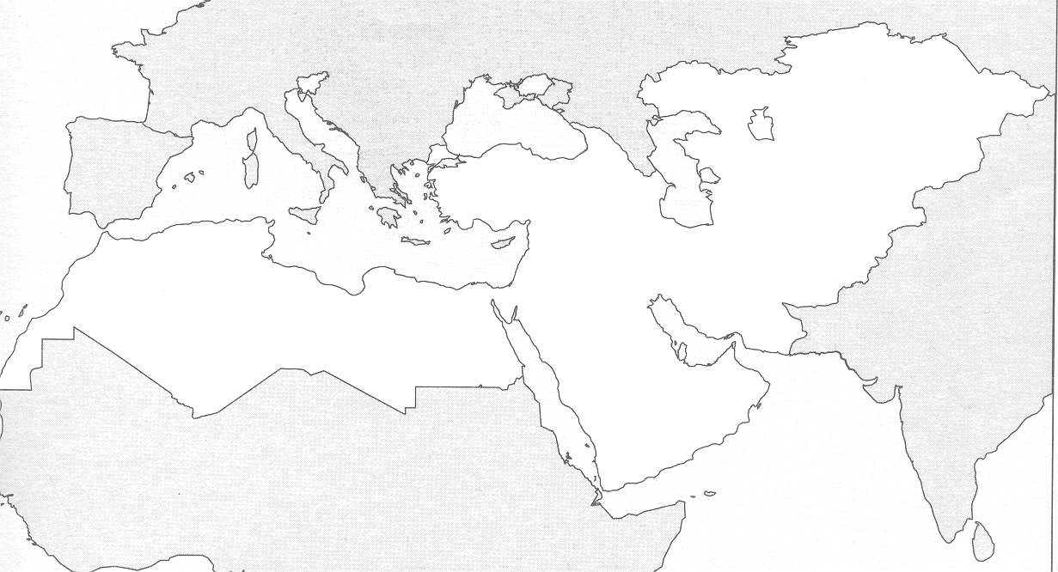
MAP: Match the letter of the following landforms (Letters)and bodies of water (Numbers) from the Map below.

A

B

C

D

E
F
G
1
2
3
4
5
6

Mountains

Deserts/Depressions

Rivers

Landforms

_______22. Taurus Mountains _______23. Sahara _______24. Caucasus Mountains _______25. Rub’ Al Kahali

Bodies of Water

_______26. Persian Gulf _______27. Black Sea _______28. Tigris River _______29. Red Sea

Map: Match the letter of the following countries on the map below.

A
B
C
D
E
G
F
Countries

_______30. Afghanistan _______31. Israel _______32. Iraq _______33. Turkey _______34. Egypt
Short Answer: Write a paragraph describing 3 of the 5 topics below showing knowledge of the subject. (2 pts each)

- Describe 3 of the 5 “Pillars of Islam”.
- Give a brief description of Judaism, Christianity, and Islam.
- Explain how the country of Israel was created. Why has this situation caused problems in the region?
- Identify 2 early civilizations in the region and describe their accomplishments?
- Name and briefly describe 3 ethnic groups found in the region.

________________________________________________________________________________________________________________________________________________________________________________________________________________________________________________________________________________________________________________________________________________________________________________________________________________________________________________________________________________________________________________________________________________________________________________________________________________________________________________________________________________________________________________________

____________________________________________________________________________________________________________________________________________________________________________________________________________________________________________________________________________________________________________________________________________________________________________________________________________________________________________________________________________________________________________________________________________________________________________________________________________________________________________________________________________________________________________________________________________________________________________________________________________________________________________

__________________________________________________________________________________________________________________________________________________________________________________________________________________________________________________________________________________________________________________________________________________________________________________________________________________________________________________________________________________________________________________________________________________________________________________________________________________________________________________________________________________________________________________________________________________________________________________

BONUS: The lowest dry point on earth is located in the Middle East along the shores of what body of water?

