Instructional Design – Abstract Expressionism
Art History – 9th Grade
Angela McClue

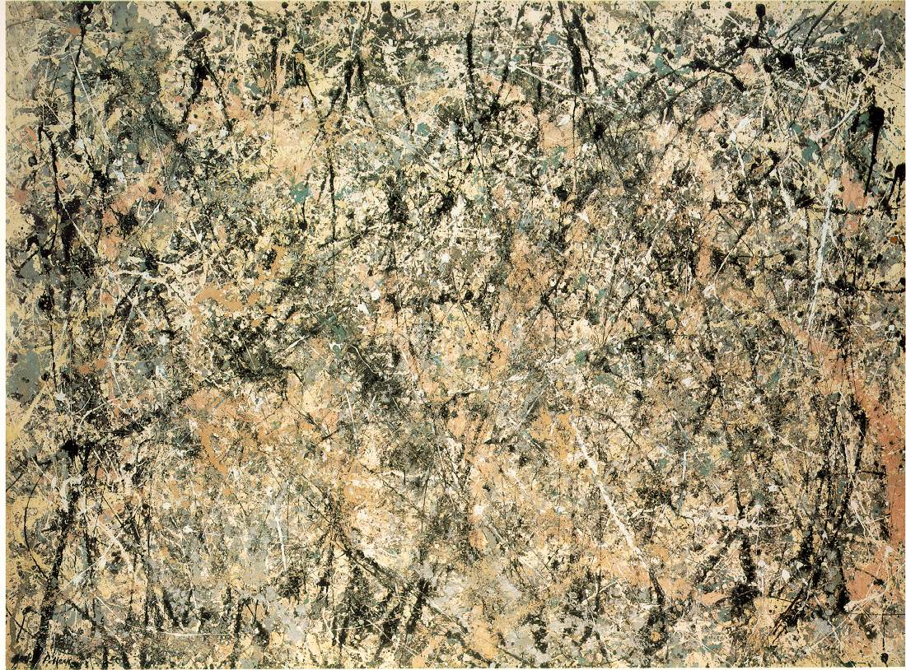

Art Quotes
On the floor I am more at ease, I feel nearer, more a part of the painting, since this way I can walk around in it, work from the four sides and be literally `in' the painting.
-- Jackson Pollock, 1947

Art is long and time is fleeting
--Henry Wordsworth Longfellow

I’ve been 40 years discovering that the Queen of all colours is black.
--Auguste Renoir

This would be a distortion of their meaning, since the pictures are intimate and intense, and are the opposite of what is decorative; and have been painted in a scale of normal living rather than an institutional scale.
Mark Rothko

An artist is someone who makes art... He didn't invent it... (Willem de Kooning)

“ | The stuff of thought is the seed of the artist. Dreams from the bristles of the artists brush. As the eye functions as the brain's sentry, I communicate my innermost perceptions through the art, my worldview. | ”
 | — Arshile Gorky

Rational
The subunit that is my focus for this instructional design is Abstract Expressionism. The reason I chose it was because it was both a significant movement for the United States in terms of it coinciding with the Cold War, (which is covered on the Ohio Graduation Test) but it’s was also a major art movement for the United States.
The curriculum committee at my school district approved this class as a pilot to be taught to supplement the students’ World Studies (Social Studies) class. I have always had an interest in Art History and basically minored in it as an undergrad, my main goal is that my students will have an interest in it as well. I know that my students are very visually inclined and this Art History class will aid them in associating certain works of art with certain events in history.
Getting students excited about art, in general, is no easy task. Many students, especially at the high school age, think that art is painting what they want and or drawing whatever they want and not talking about its origins or history or learning where it comes from and why we do it. It is my intention to relate the material in this class to real life situations and making it relevant to their everyday lives.
The learning environment for this instructional design will primarily be using the Inductive Model. I believe that this model works best considering both the subject that I am teaching as well as the population of students that I will be teaching. This model is introduced in chapter 10 of Curriculum in Context: Designing for Teaching and Learning in Context. The author describes the Inductive Model as “including specific, defined outcomes and use a teacher-directed strategy to guide students through the inductive thinking process,” (Chiarelott, 114).
The lesson plan format that I plan to use is the 5-E Learning Cycle, which was introduced in chapter 8 of Curriculum in Context: Designing for Teaching and Learning in Context, (Chiarelott, 91). I feel that this model lends itself well to what I am teaching and get the students in the habit of thinking at high levels of Blooms Taxonomy as opposed to simply memorizing a list of paintings and their dates. I think that using the phases in the 5-E Learning Cycle (Engage, Explore, Explain, Extend, and Evaluate) will prove to be a successful template for planning my class.

References
Chiarelott, Leigh (2006). Curriculum in Context: Designing for Teaching and Learning in Context. Bowling Green, OH: Wadsworth.

Unit Outcomes
Art History
- Students will identify Abstract Expressionist paintings.
- Students will be able to identify characteristics of Abstract Expressionist paintings (United States) and how they differ from other Expressionist (Germany) paintings.
- Students will be able to list at least 5 Abstract Expressionist painters and be able to tell where they are from.
- Students will be able to separate at least 5 Abstract Expressionism paintings and conclude which ones best represent that movement and explain why.
- Students will be able to compare and contrast characteristics of Abstract Expressionist painters (American) to that of Expressionist painters (European).
- Students will be able to design their own version of Abstract Expressionism through a different media besides painting.
- Students will be able to create their own Abstract Expressionist-inspired work of art.
- Students will be able to judge their own and their classmates work through critique in a thoughtful manner.
- Students will be able to analyze why the United States became the new center for art.

Social Studies
- Students will be able to identify what movement in history that is associated with Abstract Expressionism.
- Students will be able to connect what events led up to the Cold War.
- Students will be able to relate the effects of McCarthyism to the Cold War.
- Students will be able to summarize the effects of World War II.
- Students will be able to compile key events in the post-war United States.
- Students will be able to explain the WPA Federal Arts Project

Preassessment
I find that it would work best with the students that I will have to do a warm -up activity such as a game. An activity to do on the first day would be to put the students into groups of four. This will help the students get to know each other and also help them to work together. Each student is given a piece of an art postcard which has been cut into four puzzle pieces. When I give the signal, students are to find the students that have the other pieces of their puzzle. Once the students find their partners, then their group can be assembled. The students will then get together and get acquainted and come up with a name for their group.
Another activity that would help to get the students engaged on the first day would be to have to students look on the smart board at the list of famous artists and their birthdays (see next pages )and see which artist or artist that the students share their birthday with and then compile a list on a poster to refer to later to research or to do a report on. This would help the students understand their artist and perhaps want to learn more about that person.
Perhaps one of the most successful types of preassessments would be to conduct a survey to see what the students know and understand regarding the subject at hand. This can be done for every subunit and could be accompanied by a post-test after the subunit is completed.

Pre-assessment Art Survey
Circle the answer that applies to you.
- I’m familiar with the term Abstract Art. Yes No Sort of
- I’ve heard of Jackson Pollock. Yes No Sort of
- I know all about Action Painting. Yes No Sort of
- I’m pretty sure I know what happened during the Cold War. Yes No Sort of
- I could pick out a painting by Willem de Kooning if given the opportunity. Yes No Sort of
- I’m fairly certain I don’t what Abstract Expressionism is. Yes No
- I could recreate an Abstract Expressionism painting if given the chance. Yes No Sort of
- True or False: World War II led to the movement of Abstract Expressionism.
- True or False: New York City became the center of art during the Cold War.
- Without knowing a whole lot about these two works, compare the characteristics of these two paintings.

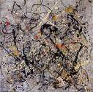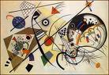
- Without knowing the details of these two works, contrast the characteristics of each painting.
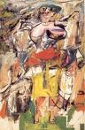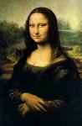
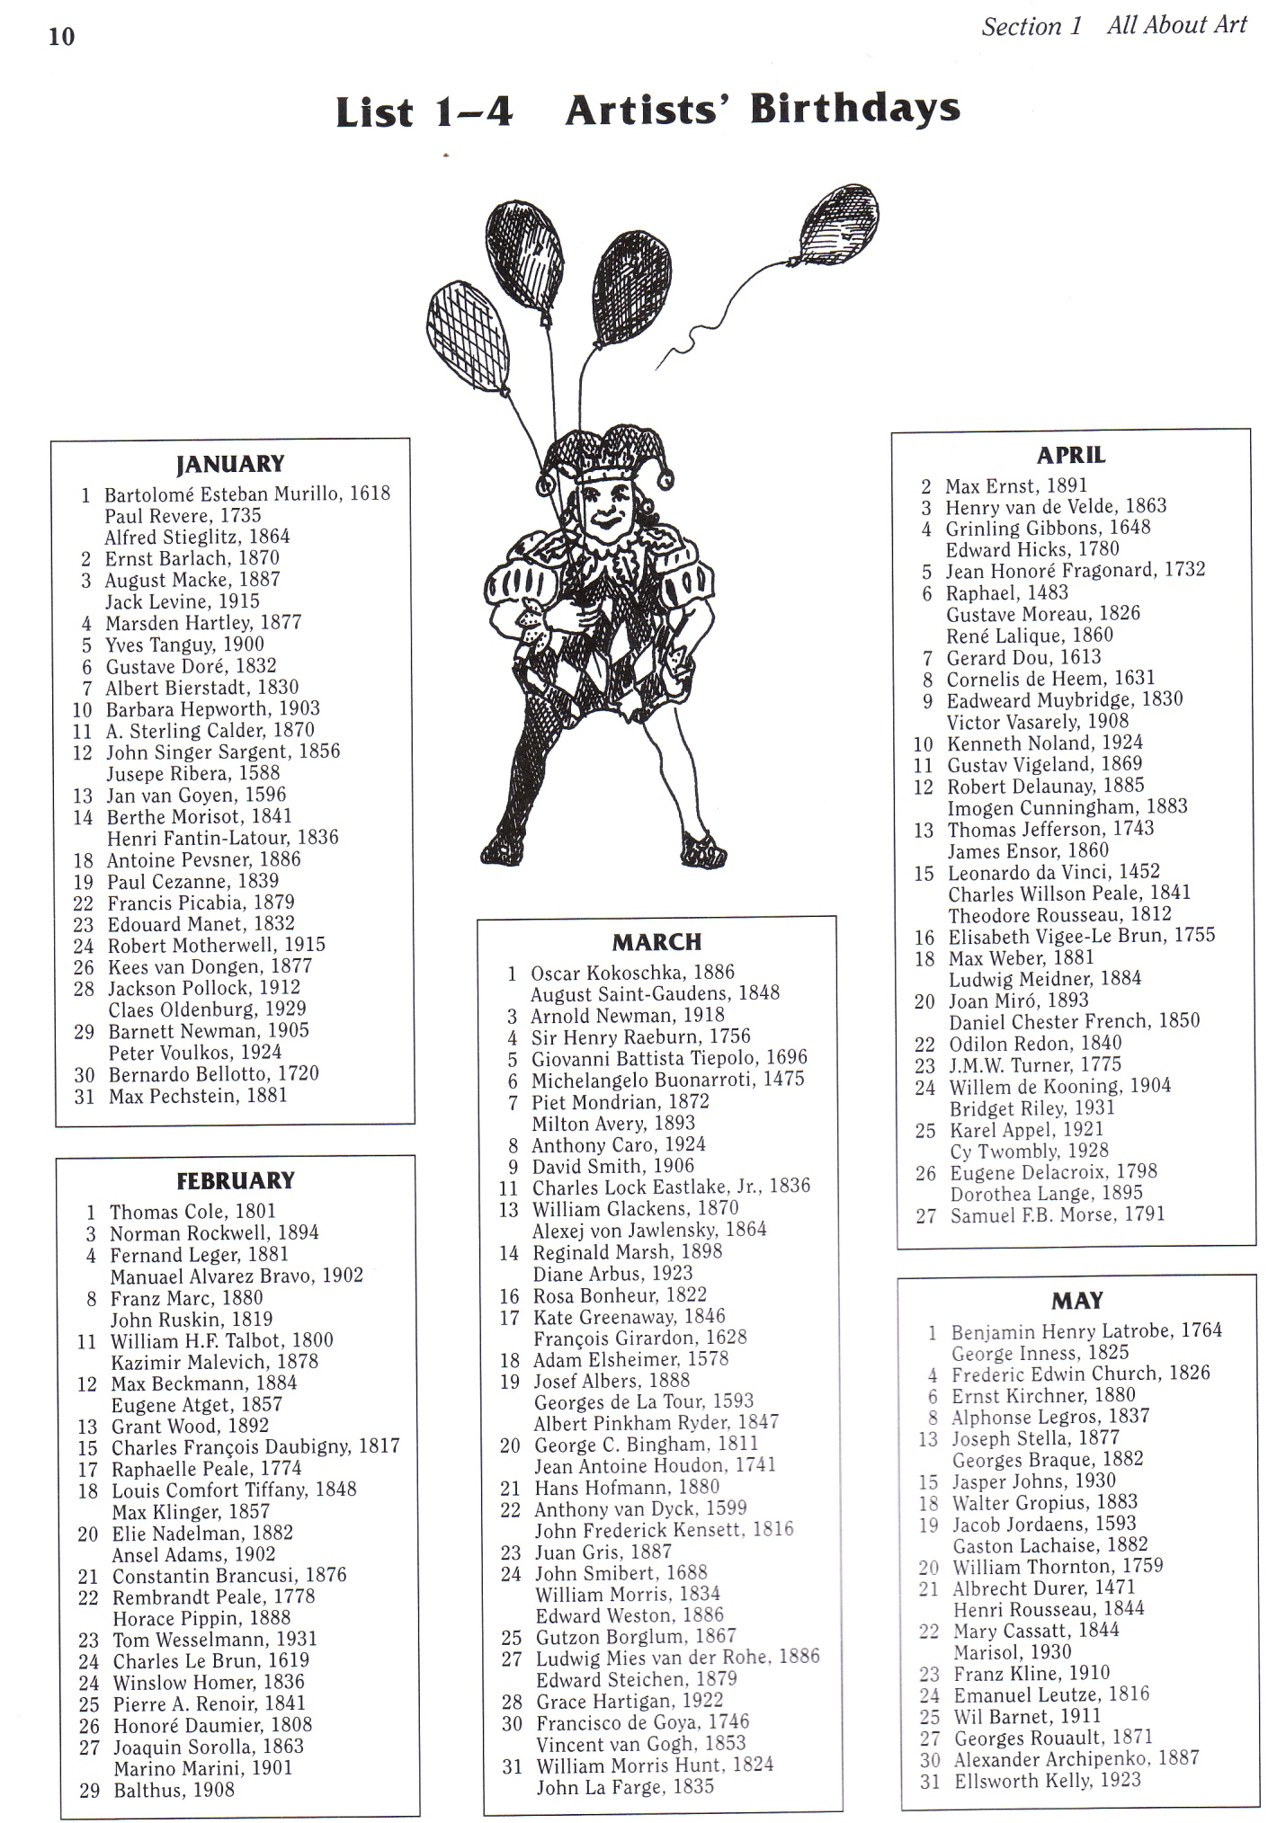
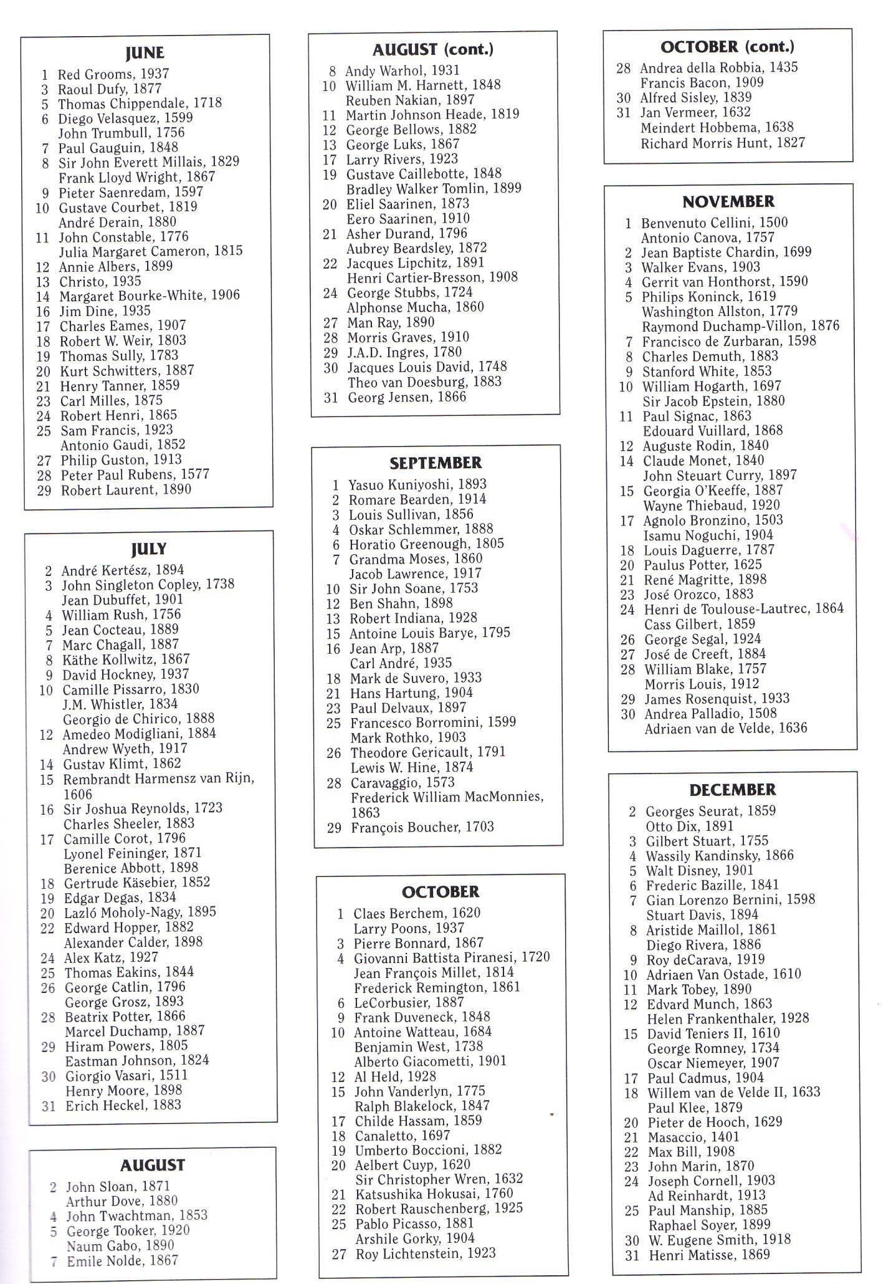
Lesson Plan One
Artists Birthday Activity
Time Allotted for lesson: One class period (60-90 minutes)
Concept or Skill to be learned: Students will research the artist that they share a birthday with according to the previous pages.
Students will be able to look up information on their artist by doing a Google search and compile that information into a report.
Lesson Objectives: Students will analyze the works of a matching birthday artist and write down key features of their artists work to share with the class to construct a birthday card for a class timeline.
Engagement:
Identify what artist has the same birthday as you, write down the artists name on a large index card.
Exploration:
Using the library computers, students will look up their matching birthday artist and do a Google search and write down a variety of facts related to their artist.
Explanation:
Students will choose a partner at random and share their information and compare and contrast their artist and a few of their works.
Extension:
Students will create an informational birthday card on their particular artist.
Once the cards are completed the students, as a class, will construct a visual timeline to either display in the hallway or in the class. As the course progresses, additional information will be added.
Students will look at the timeline and choose an artist that is not the one that they share a birthday with and do another Google search to find one historical event that took place during the time of that artist.

Evaluation:
Write a brief journal entry regarding the assignment. Choose one interesting fact about the artists’ life. Describe what it might be like to live during the time of the particular artist. Discuss your favorite painting or work of art by that artist and explain why.

Materials and Resources:
Markers, pencils, index cards, card stock, clothes line, clothespins or paper clips, access to library computers that have internet, journals.

Lesson Plan Two
Concept to be learned: What is Abstract Expressionism?
Time Allotted: Two 90 Minute Class Periods
Lesson Objectives:

- Students will create two examples of Abstract Expressionism before and after the lesson.
- Students will create a critique about an artist after watching a video clip.
- Students will be able to identify events in history that led up to Abstract Expressionism.
- Students will be able to list characteristics of Abstract Expressionism paintings.

Engagement Activity
Show students several examples of Abstract Expressionism via slide show and have them use markers or crayons (these will be on their tables) and replicate them on the butcher paper that is on their tables. They will have 5 minutes for this activity. Then show them a clip of Jackson Pollock’s technique on You Tube.
Exploration
- On the index cards on their tables, have students write one comment about the video clip from what they observed about Jackson Pollock’s painting technique.
- Students will then be shown another slide show of various Abstract Expressionism paintings and go over the characteristics that make them belong to this category.
- Students will be asked to discuss the differences between Abstract Expressionism of the 1950’s and Expressionism Art that took place in the early 1900’s.
- Students will be given a worksheet that will also be displayed on the Smart Board and be asked to highlight any words that they do not know the meaning of and as a class we will compile a list and define them.
Explanation
Students will get with their partner and compare their T Charts to make sure that they have similar information and anything to add or delete.
Extension
Students will make a second Abstract Expressionist work using the worksheet provided and follow the instructions.
Evaluation
As a class, the students will put the two “paintings” that they created together and discuss the differences before and after and which one is more successful and why.
Materials and Resources:
Pencils, markers, crayons, worksheets, butcher paper, images of Abstract Expressionist work (particularly Jackson Pollock), paper for T Charts.

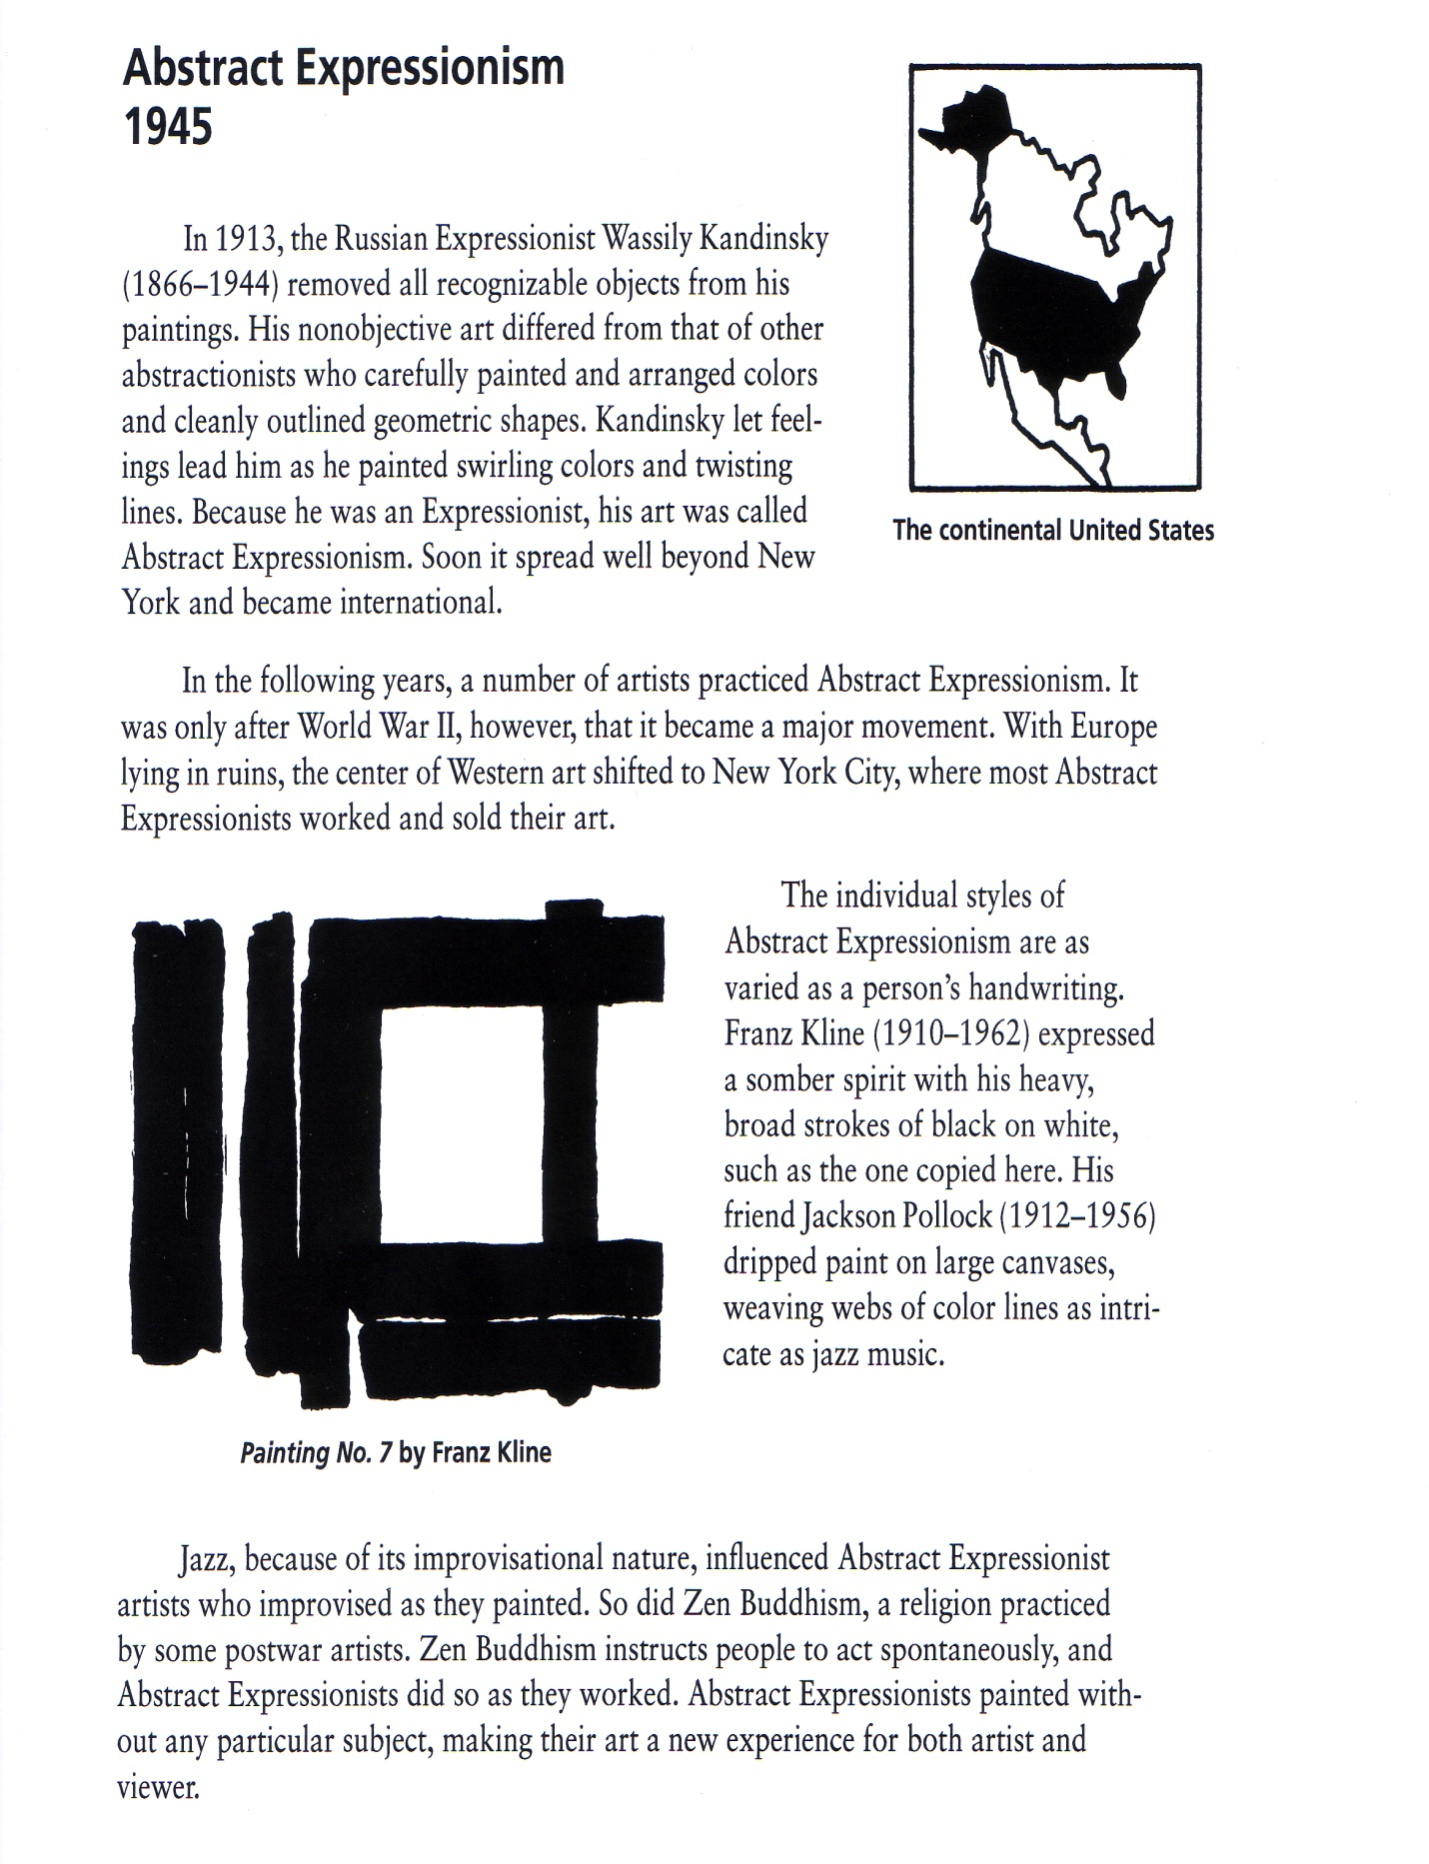

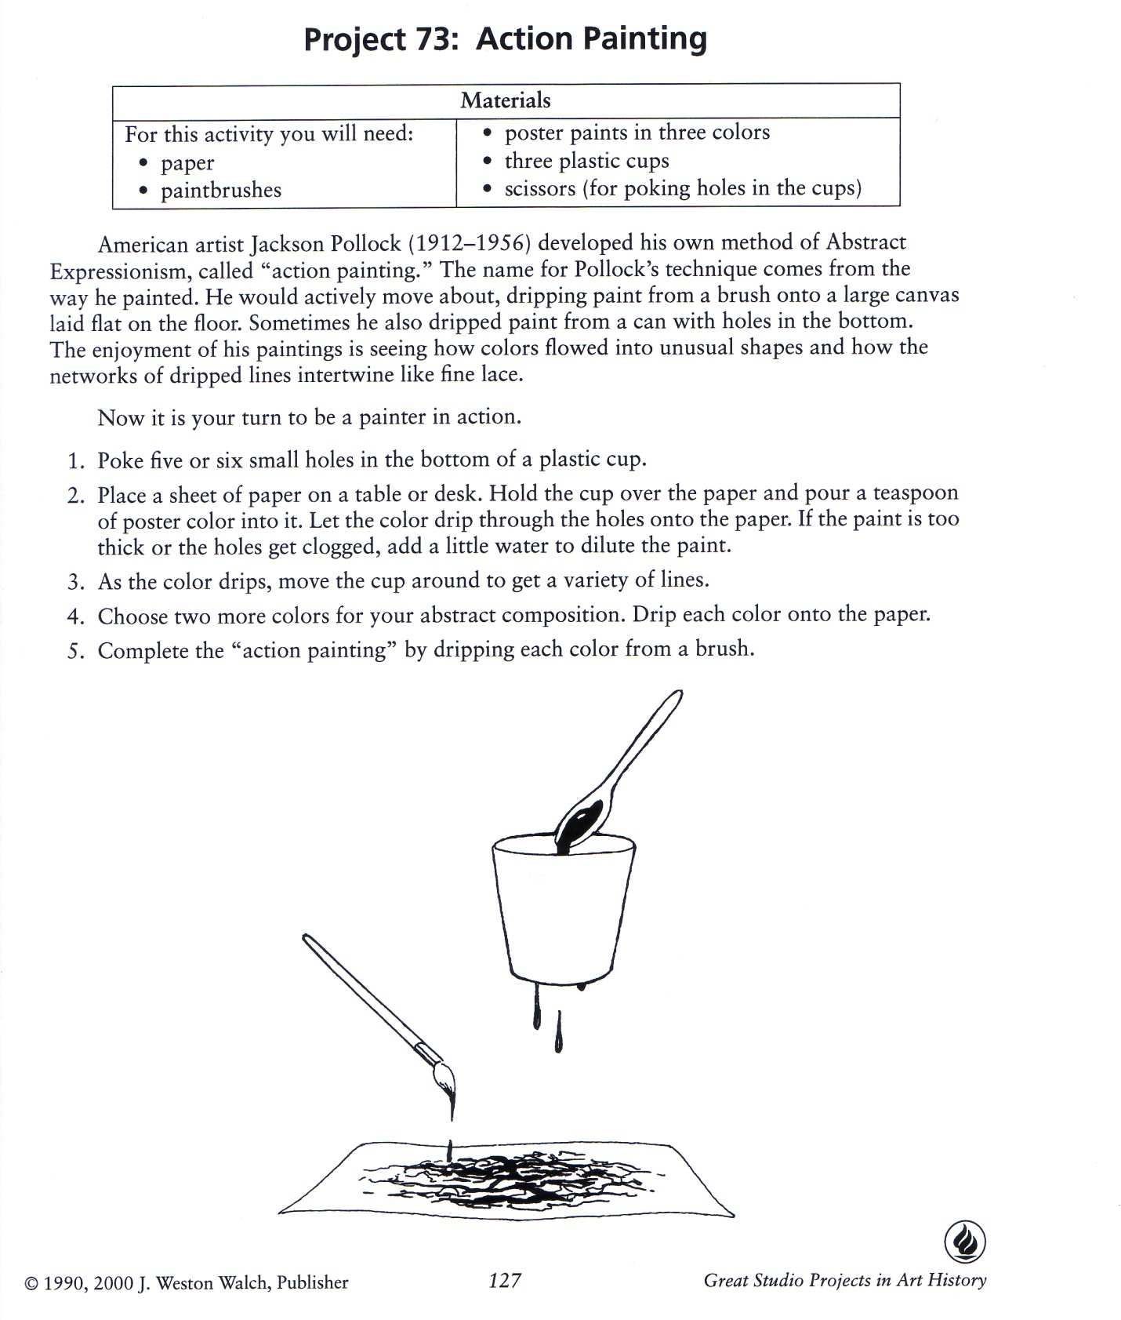

(T Chart)
20th Century Art Movements
Discuss key attributes of each as well as key artists and their work
German Expressionism Abstract Expressionism

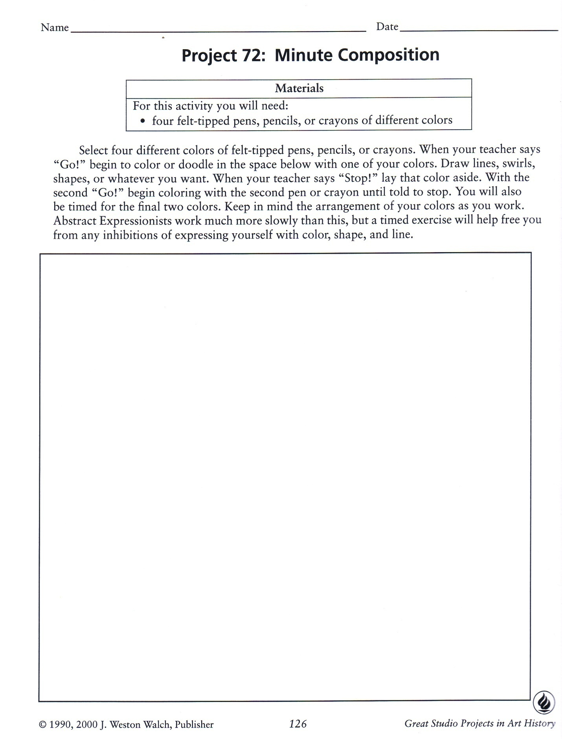
Lesson Plan Three

‘Who the x%%%.# is Jackson Pollock’

Allotted Time: Two 90 Minute Class periods

Concept of Skill to be learned: Discuss the documentary of the above title and how it fits into popular culture and history. (The documentary is about a truck driver who bought a painting at a thrift store for $5 and was told by an art teacher that it was painted by Jackson Pollock. The film goes on to show how an everyday woman takes on the art world and investigates the theories of why it could be an actual Jackson Pollock painting, including hiring someone in forensics to look for fingerprints that belonged to the artist.)

Lesson Objectives:
- To learn about a current topic and discuss it’s relevance into looking toward the past.
- To learn how science can relate to art.
- To learn how to predict the results of the video and draw conclusions on what could happen.
- To ask and answer well thought out questions that have to do with the video

Engagement:
- Students will watch the documentary ‘Who the %&*#$ is Jackson Pollock?’
- As the students watch the video, have them come up what at least 3 questions or concerns related to the video.

Exploration:
- Have students get into partners and share their questions about the documentary and combine their questions into one question to share

Explanation:
- Come together as a class and write down all of the questions on the Smart Board (one of the students can volunteer as the secretary).

Extension:
- Have students right down the various questions in their journals and as a class formulate the answers by looking at key parts of the video.
Evaluation:
- Possible field trip and or scavenger hunt to look for famous art either from the movement of Abstract Expressionism or otherwise.
- Students can choose from a series of garage sale or thrift store paintings and try to persuade the students to believe that it could be famous by presenting facts. (Students could partner up for this activity).

Materials and Resources:
Pencils, journals, video of ‘Who the $%#&@ is Jackson Pollock?’, variety of garages sale paintings.

Lesson Plan Four
Museum Trip: Guess the Abstract Expressionist
Time Allotted for Lesson: Two 90 minute class periods

Concept or skill to be learned: Students will look at real works of art and discuss and explain the characteristics that make them actual Abstract Expressionist works of art. (Not just because they might be in the same gallery).
Lesson Objectives:
- To view actual works of art so the students can get a feel of the grand scale on which the artists worked.
- To break down areas of the painting and understand the brushwork that the artist used.
- To sketch out various ideas from the paintings to create them when they get back to the classroom for a culminating project.

Engagement:
- Students will be briefed on the field trip and what it is that they will be looking for and what paintings to look for without looking at the title or which artist painted it.
- Students will then gather at the appropriate gallery and identify each of the following paintings. (Imagine that these paintings are in the same museum, for purposes of the lesson, they are).

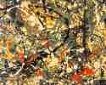Jackson Pollock,Number 8, 1949 (detail)
1949 (280 Kb); Oil, enamel, and aluminum paint on canvasNeubergerMuseum,State University of New York

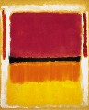Mark Rothko
Untitled (Violet, Black, Orange, Yellow on Red

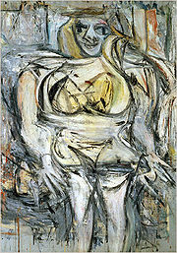
Willem de Kooning, Woman III, (1953), private collection

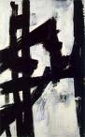Franz Kline – Painting – New York, …
561 x 899 – 73k – jpg

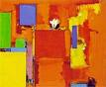Hans Hoffman

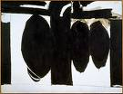Robert Motherwell – Grandfathers and ..

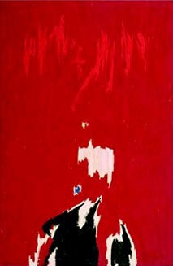
Clyfford Still, 1964

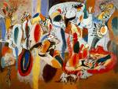Arshile Gorky, The Liver …

Exploration:
- The students will identify artistic attributes of each work by color, line, shape, composition, size of painting and plug those characteristics into the appropriate painting.
- The students will stand by their favorite painting of the choices and think of one feeling word to describe why it is their favorite.
- The students will in turn stand or sit by their least favorite painting of the choices and state in one phrase starting with “it reminds me of…” why they dislike it.

Explanation:
- While still in the gallery, the students will sketch an 8 x 8 square of one of the paintings discussed onto their notebook. (The students need to also be aware of the colors that appear in the section that they chose.)

Extension:
- After returning to school, i.e. during the next 90 minute class period, the students will review the information from the museum and discuss the differences between going to the museum and looking at a group of slides on a Smart Board.
- The students will take out their notebooks and get their sketches out.
- The students will each receive one piece of 8 x 8 canvas paper and recreate their chosen section from the museum painting that they chose. The will draw it out first and use acrylic paint and various types of brushes.

Evaluation:
- Students will take their finished 8 x 8 painting and put them together for a culminating Abstract Expressionist mural project.
- After the students have decided as a group how they want the pieces put together, the teacher will then assemble it in the school library.
- A post-assessment for this project is to number each 8 x 8 piece of the mural and have students take an identification quiz for each piece and give the name of the artist for each individual piece that was chosen and recreated by their classmates.

Materials and Resources:
- Journals, pencils for museum trip, 8 x 8 piece of canvas paper for each student, acrylic paint, assorted brushes.

Post-assessment

Name:____________________________ Date:_______________
Personal Art Collection

Assume you can own any art object anywhere in the world. Choose from either something we’ve looked at in class or something you have looked at on your own. You may choose to wear it, hang it on your wall, live in it, or display it. You have three choices for your personal collection. Share your results with you groups.

- Title________________________ Location____________________________

Why?___________________________________________________________

_________________________________________________________________

- Title_______________________ Location______________________________

Why?____________________________________________________________

___________________________________________________________________

- Title_______________________ Location_______________________________

Why?____________________________________________________________

_________________________________________________________________

